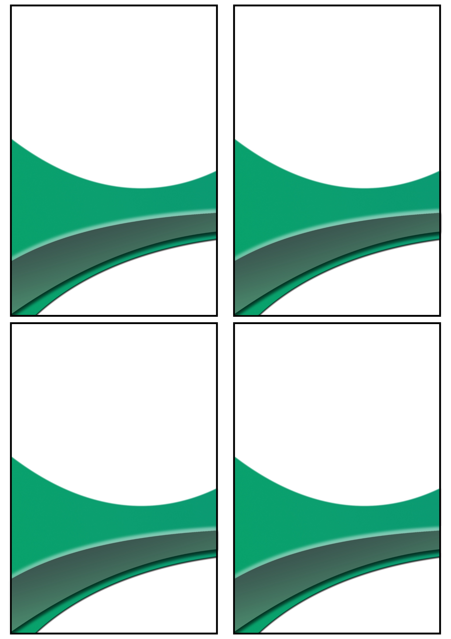

**${division}**

**${pic1}**

**${pic1}**

**${position2}**

**${name2}**

**${name}**

**${position}**

${nname2}

${nname}

**${name4}**

**${name3}**

**${position4}**

**${position3}**

${nname3}

${nname4}

|  |  |
| --- | --- |
|  | ${id} |
|  | ${name} |
|  | ${email} |
|  | ${address} |