

**Real time system Project**

Module code: 21CSSE03H

Module Leader: Amr Ghoneim

|  |  |  |
| --- | --- | --- |
| **Name** | **ID** | **Contribution** |
| Doha Saleh | 181528 | Equal |
| Abdelrahman Osama | 188668 | Equal |

**Stimuli response diagram:**

|  |  |  |
| --- | --- | --- |
| Event | Response | Time |
| BeverageNumber | this event selects a specific beverage and sends it to the machine class. | 1 ms |
| water_weight_Sensor | measures the amount of water in heater tank. if weight of water drops under a certain level,  the tank is refiled. The water amount decreases each time an order is started. | 0.1 ms |
| WaterHeaterSensor | measures the temperature of the water in the water  heater tank. The maximum temperature of the water 100.  When it goes below 20 the heater starts heating the water again.. | 0.2 ms |
| WaterHeateroff | When the water temperature reaches above 100 the heater sensor alerts the heater to stop heating | 0.2 ms |

**Class diagram:**

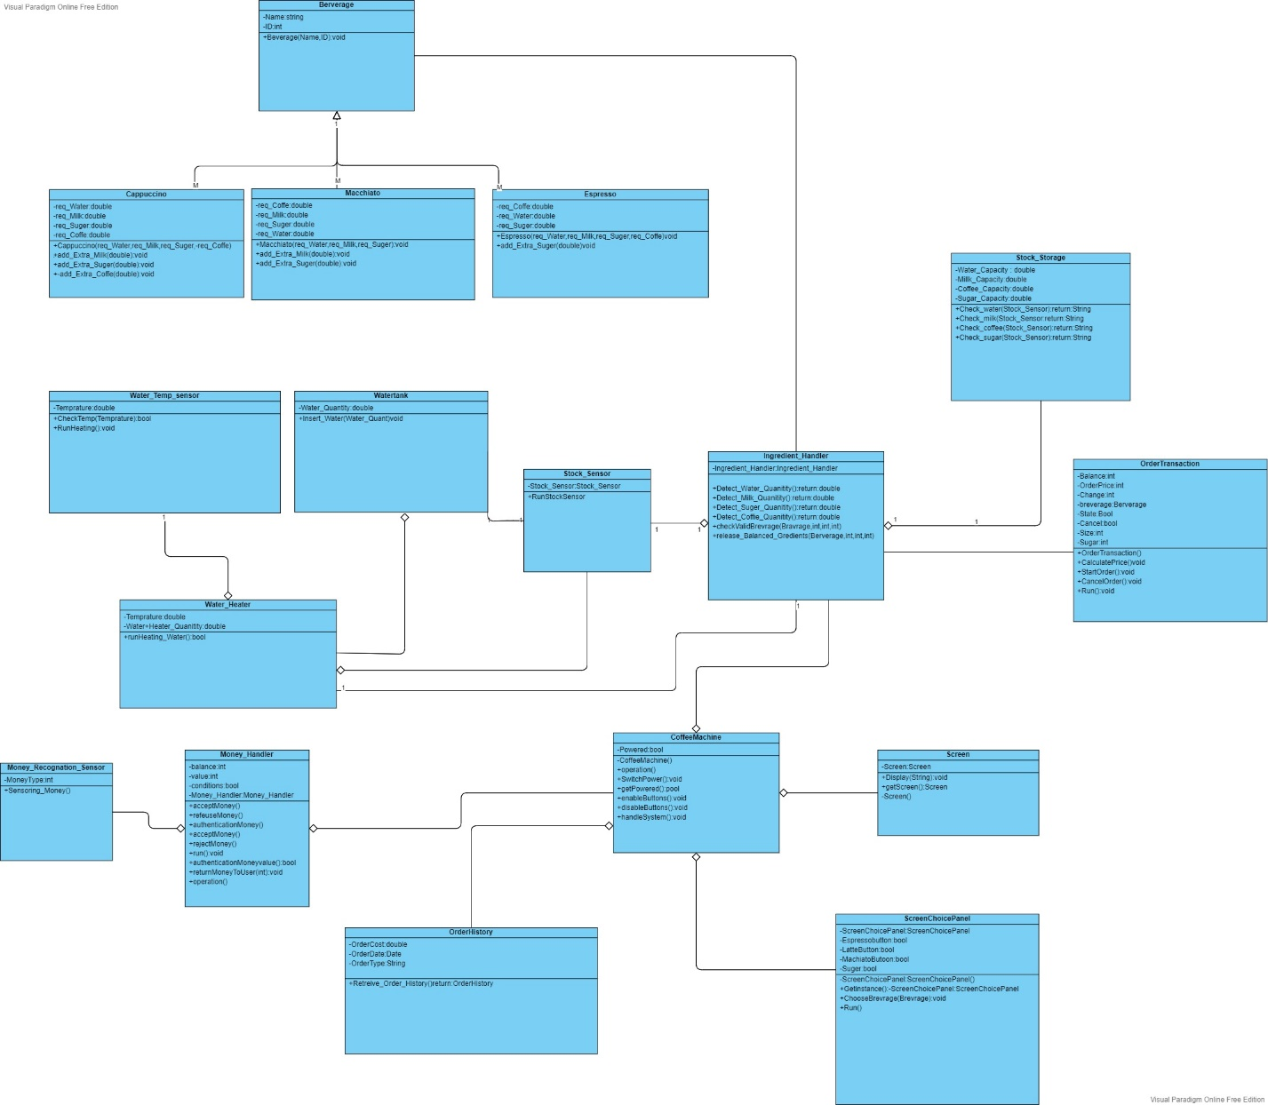

**Use case Diagram:**

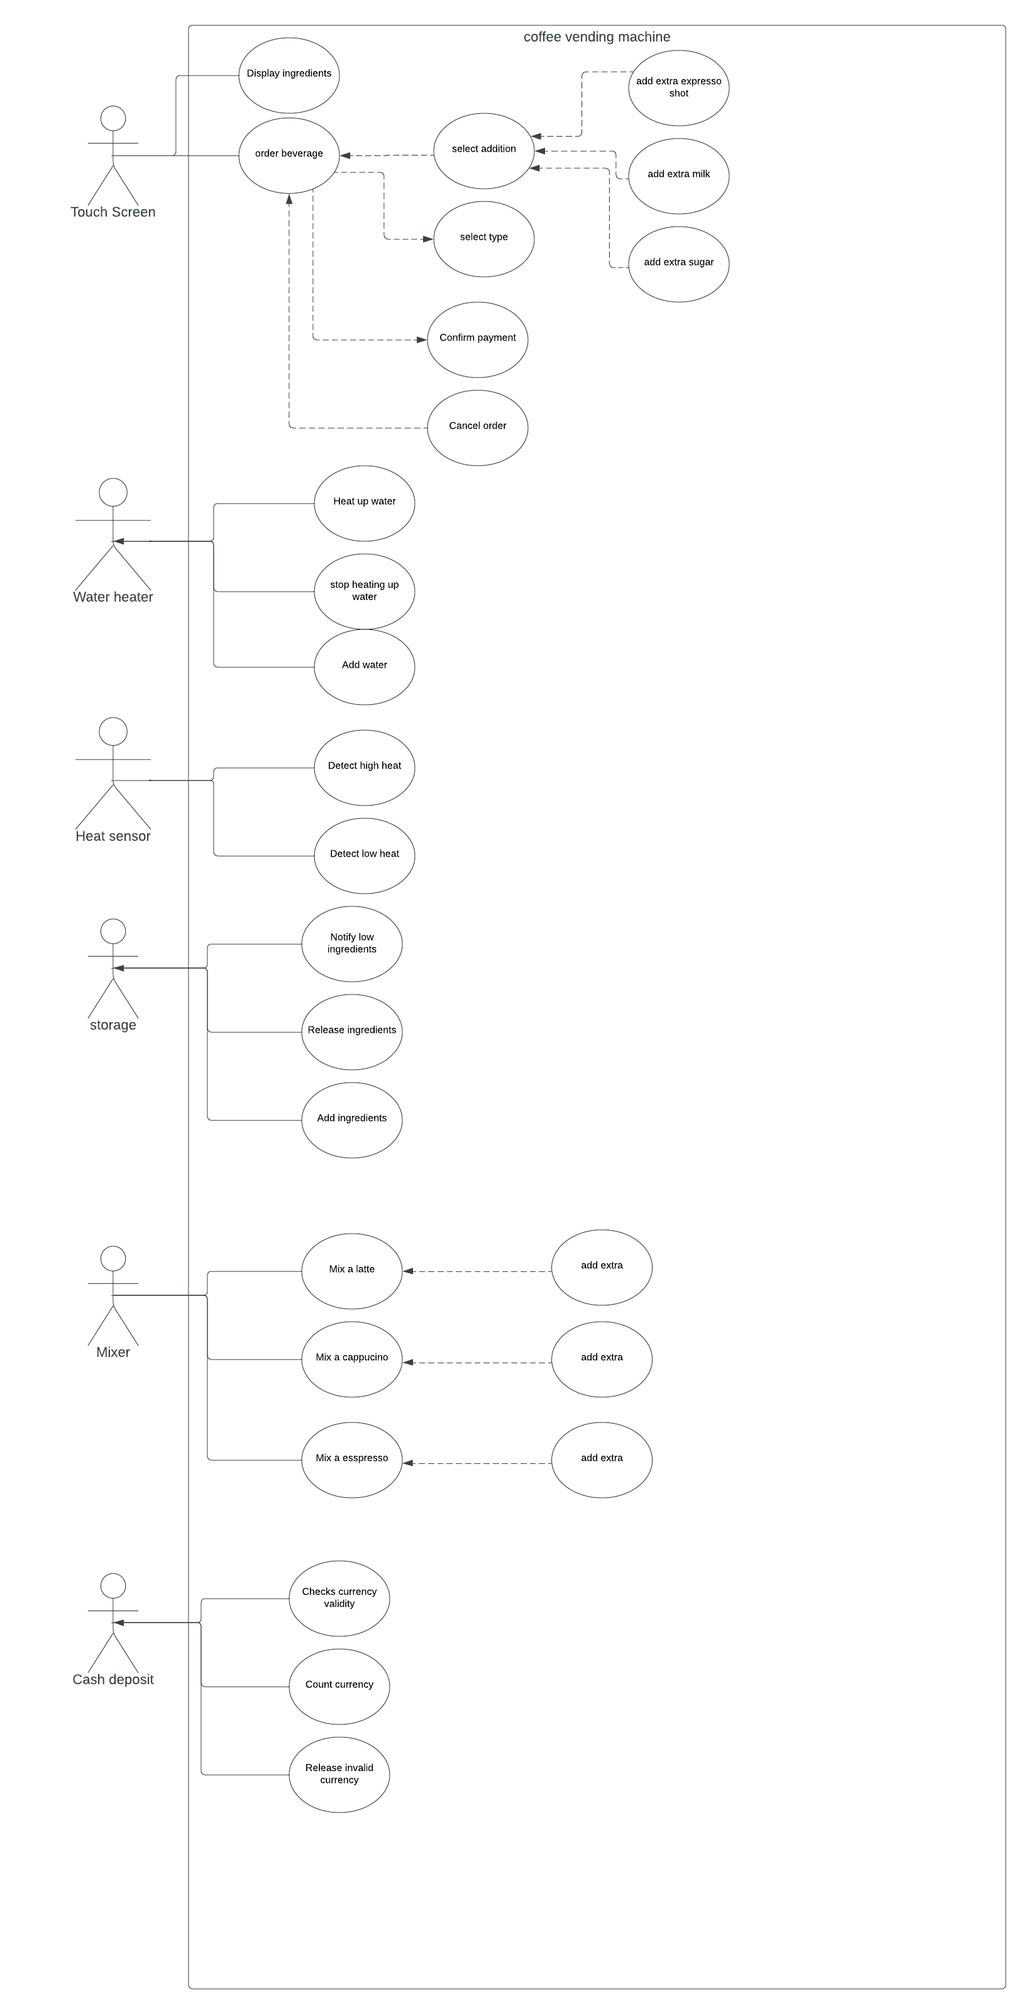

**State machine diagram:**

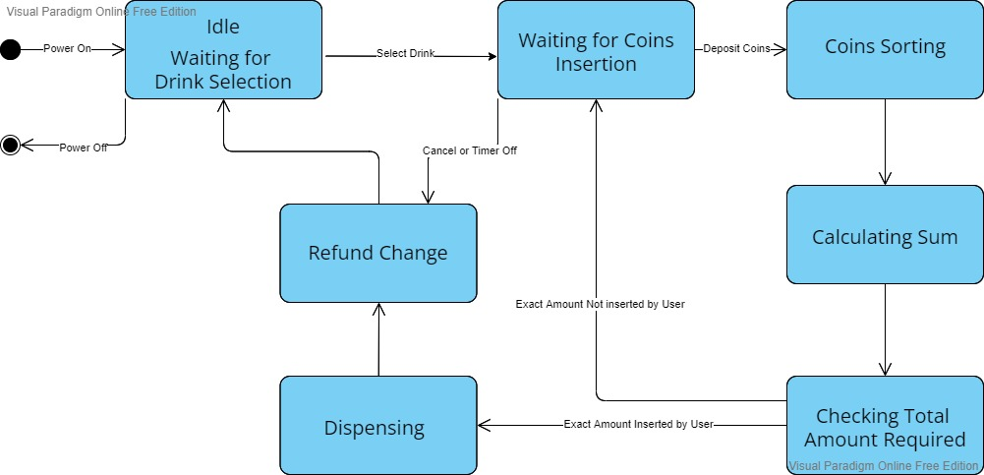

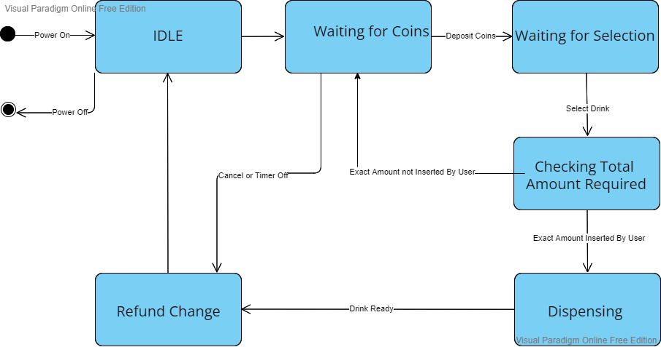

**Collab diagram:**

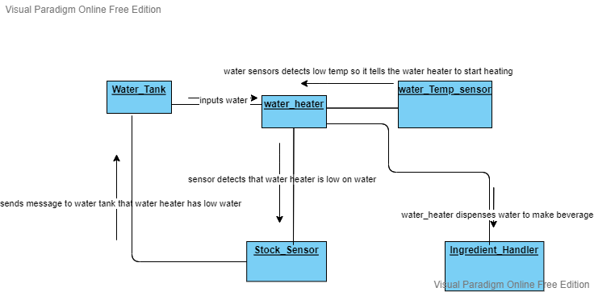

**Sequence diagram:**

**extra_coffee and cancel_order:**

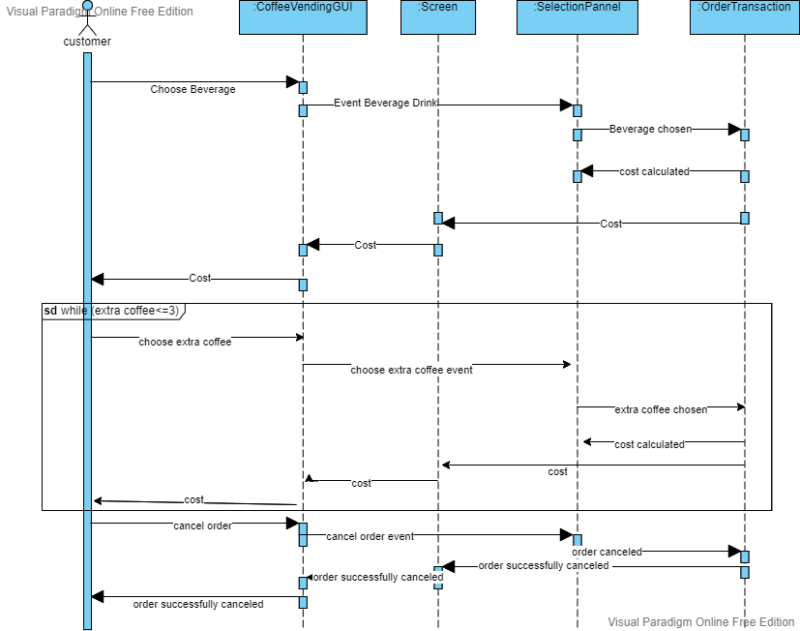

Invalid money sensor: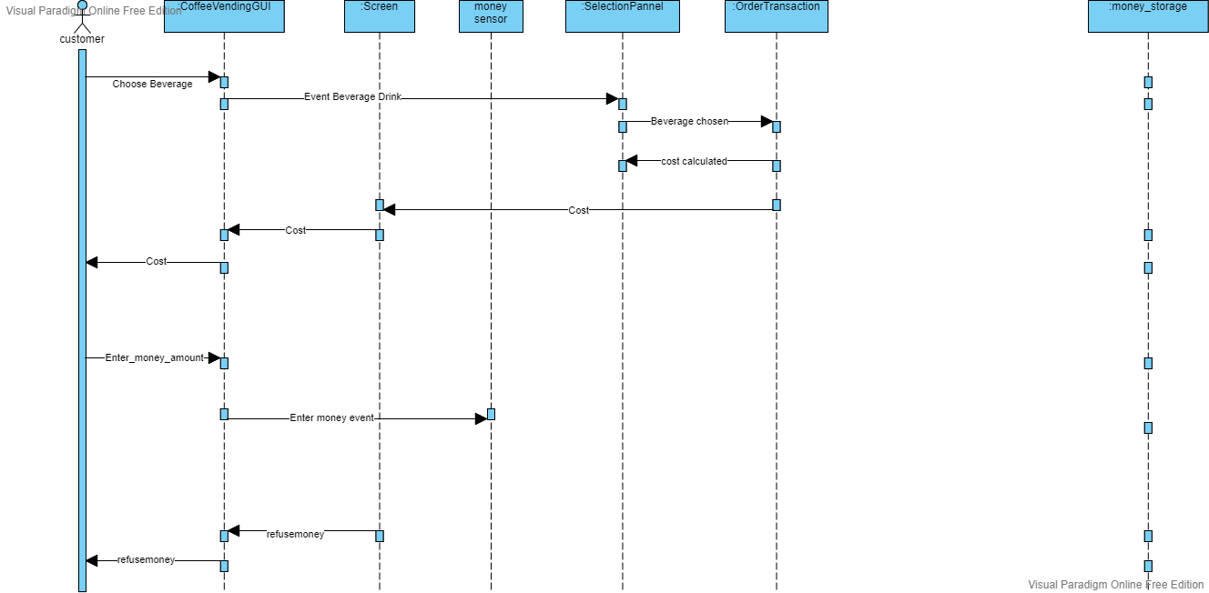

money storage and sensor valid:

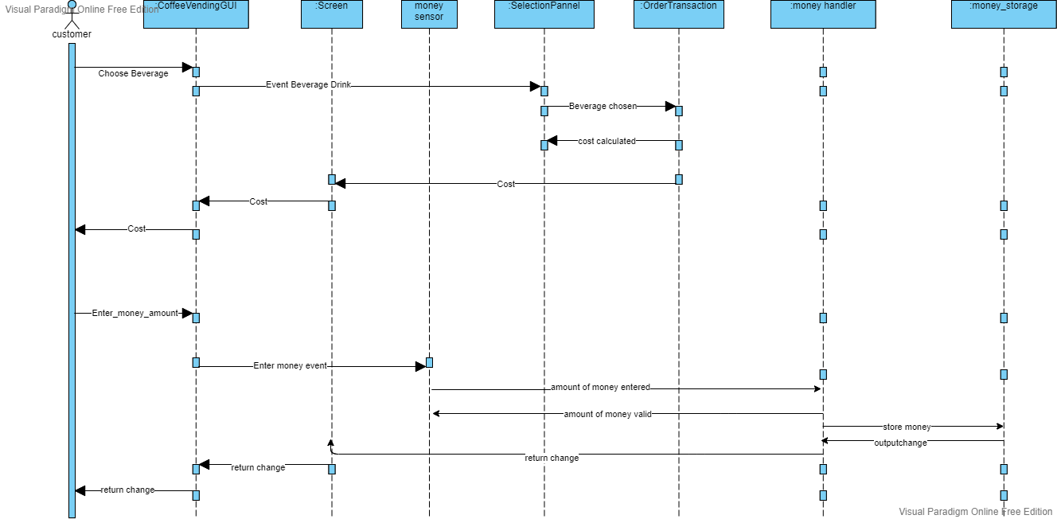

**purchase_beverage:**

