**Group 13**



21CSSE01H

# Advanced Object-Oriented Software Engineering

|  |  |
| --- | --- |
| **ID** | **Name** |
| **185206** | Amr Mohamed Hassan |
| **178243** | Rawaan Wael |
| **183971** | Ramiz Gamal |
| **188668** | Abdelrahman Osama |
| **181528** | Doha Mohamed Ibrahim |

|  |  |
| --- | --- |
| **Name** | **Contribution** |
| Amr Mohamed Hassan | Use case: UC_06 – UC_10,  functional requirements:7-9 |
| Rawaan Wael | Use case: UC_15 – UC_19,  functional requirements:4-6 |
| Ramiz Gamal | Use case: UC_11– UC_14, Non-functional requirements:1-3 |
| Abdelrahman Osama | Use case: UC_20 – UC_23,  Non-functional requirements:13-15 |
| Doha Mohamed Ibrahim | Use case: UC_01 – UC_05,  Non-functional requirements:10-12 |

## Assumptions:

1.Shipping is not done by our company and is handled by an outside Shipping company.

2. Admin accounts are not deleted but are recycled and handed to new admins.

3. A moderator has more privileges than an accountant.

4. Reports made about the shipping company is first sent to the admin then forwarded to the shipping company.

5. to become a vendor the aspiring vendor must first create an account as a customer and then request to be a vendor and start selling.

6. Only 1 moderator can exist at any given time. (singleton)

**Non-functional requirements:**

**Ramiz:**

1. The website must load in 1 minute.

2. If the website crashes it must reset in ten minutes.

3. A user cannot place an order unless they log in.

**Rawaan:**

4. The site is closed at night for maintenance.

5. All images load when the website is loaded.

6. If an image fails to load within a minute it is replaced with a place holder.

**Amr:**

7. The servers must be able withhold 300 concurrent users.

8. Verify a secure website connection.

9. Verify that all information entered is accurate during registration.

**Doha:**

10. The system must be easy to navigate and retrace through.

11. A vendor cannot edit their store page without being logged in.

12. System usage must be intuitive and straightforward.

**Abdelrahman:**

13. The system appearance must be appealing to all age groups.

14. The system must be navigable by the visually impaired (text to speech friendly)

15. The text should be of a visible size for individuals who have reading difficulties.

## 2. Use case Diagram:

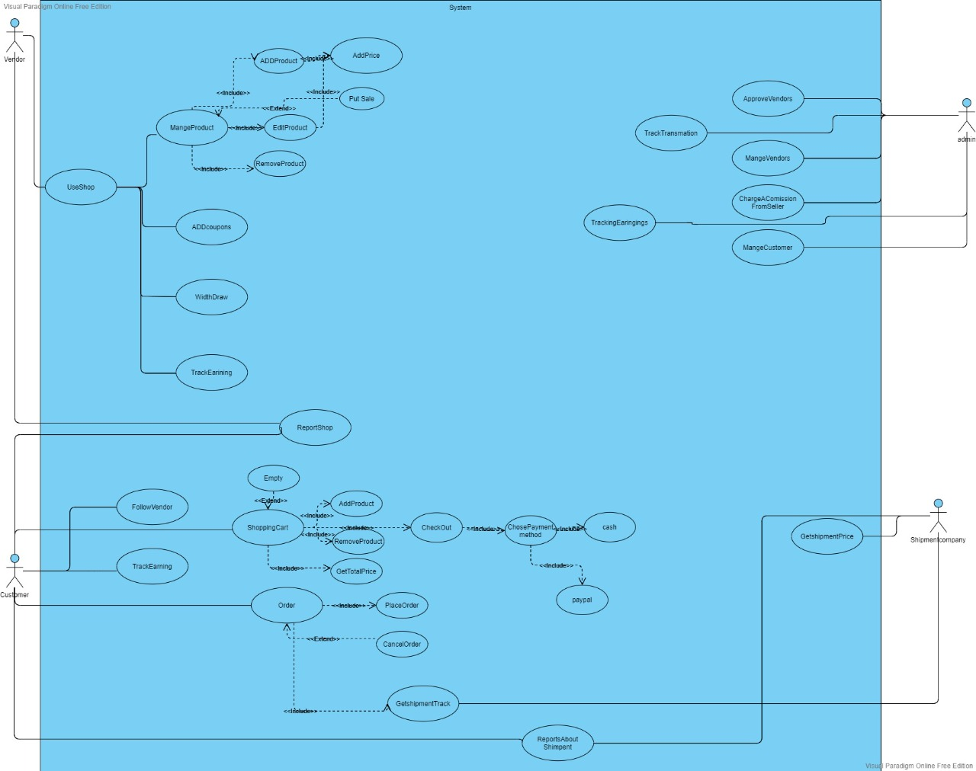

1. **Package diagram:**

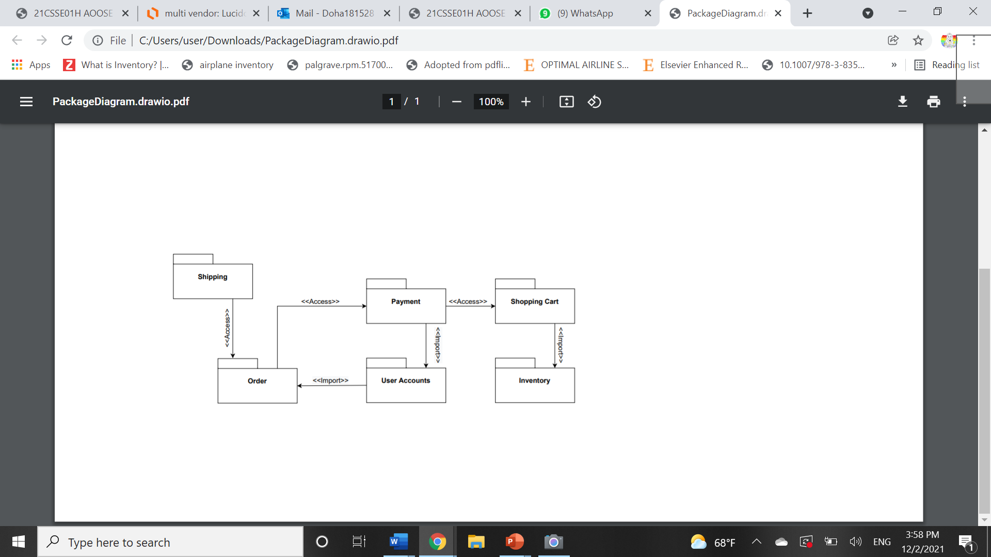

1. **Class diagram:**

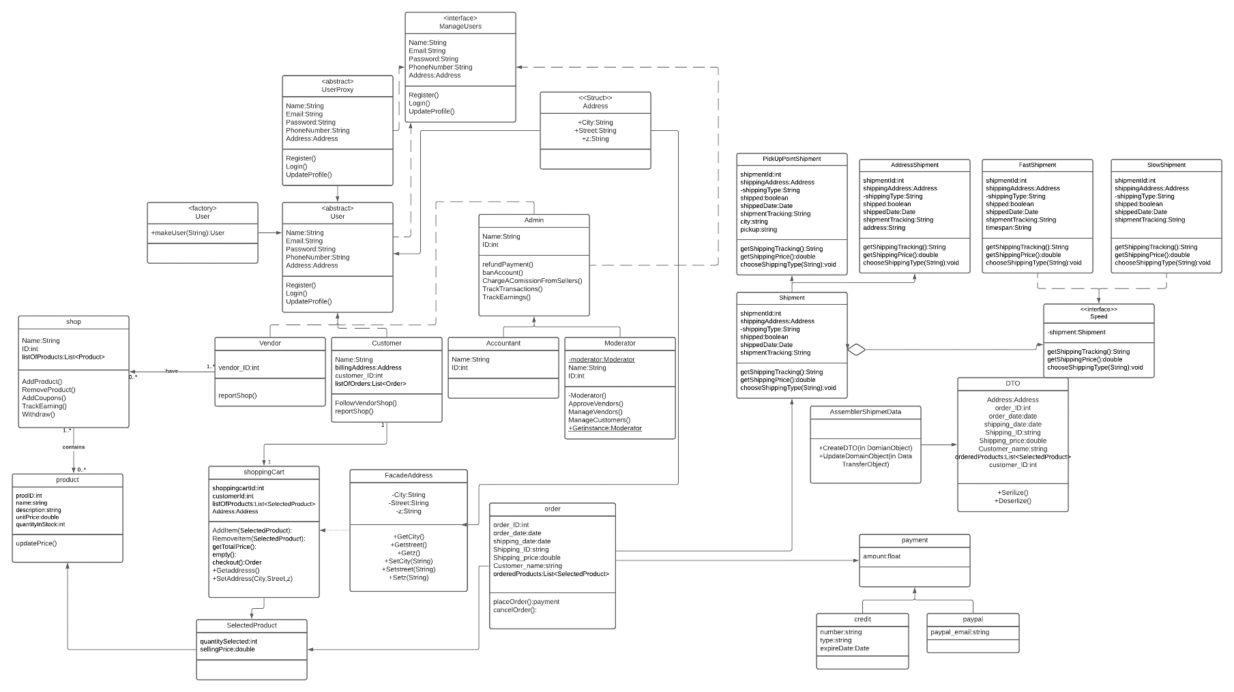

1. **Design patterns:**

* **Bridge pattern:** The bridge pattern is used in the shipment class to be able to form shipments that are either fast or slow AND either pickup point based or address based. The bridge pattern enables us to combine those 4 combinations effectively without having to have a coupled inheritance.

**Screenshot:**

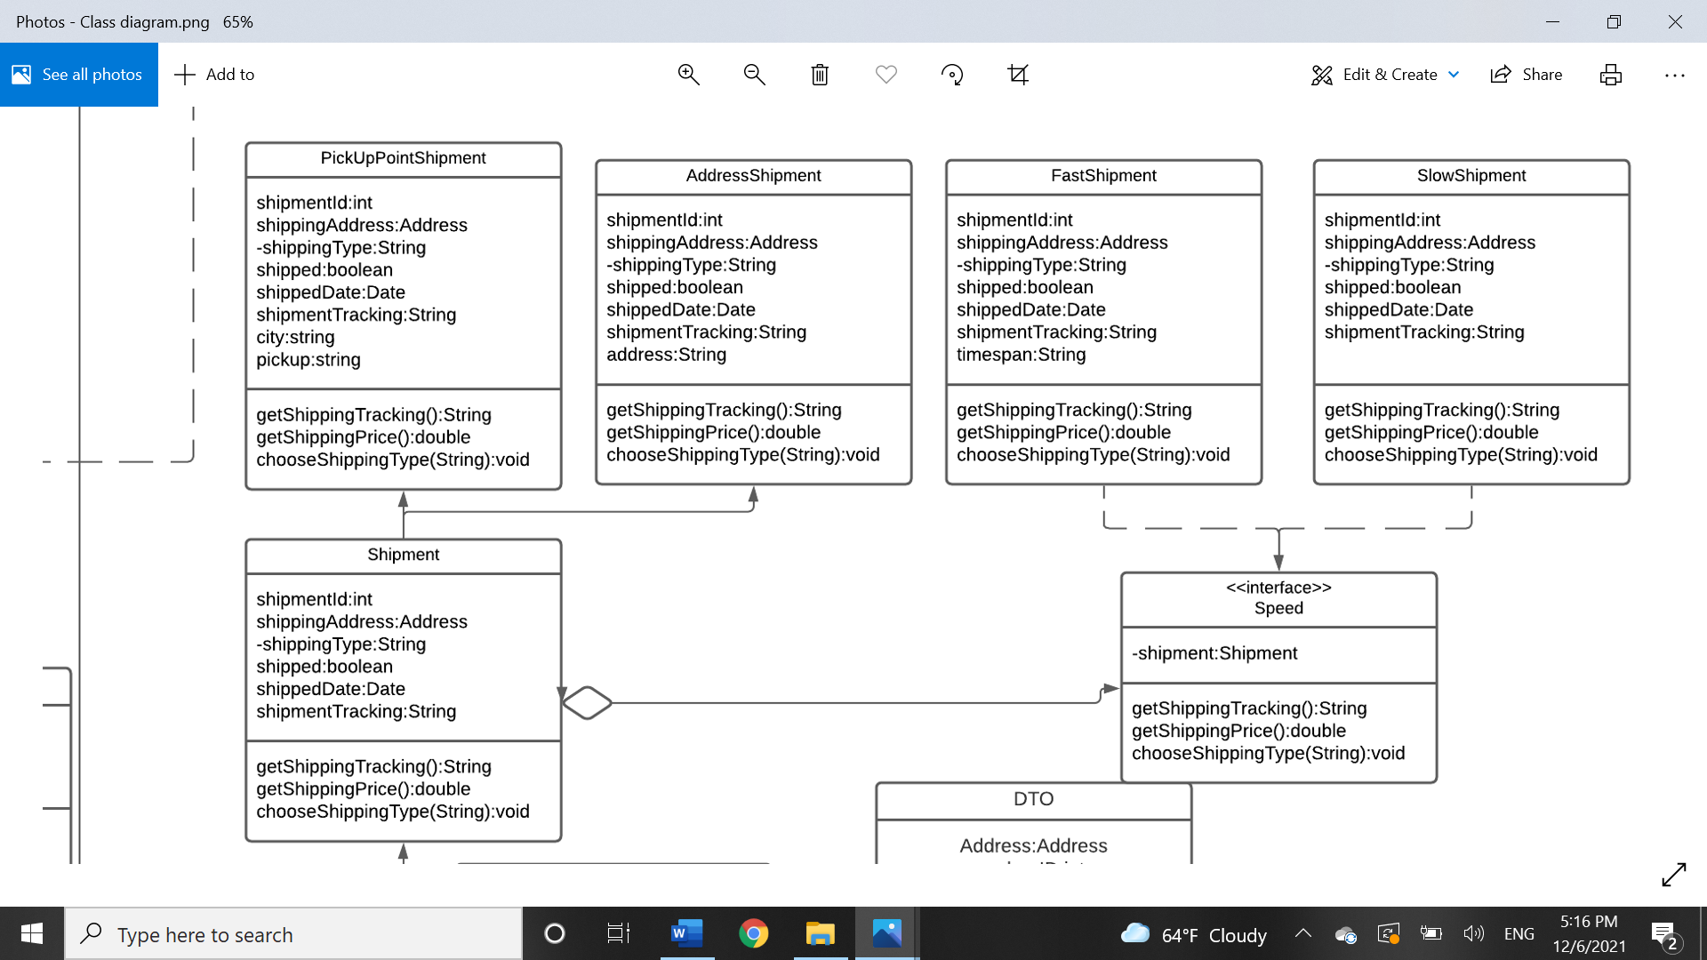

* **Protection (Access) Proxy pattern:** We used this pattern in accountant and moderator to ensure one class (moderator) has full access of all their functionalities while accountant only has limited ones.

**Screenshot:**

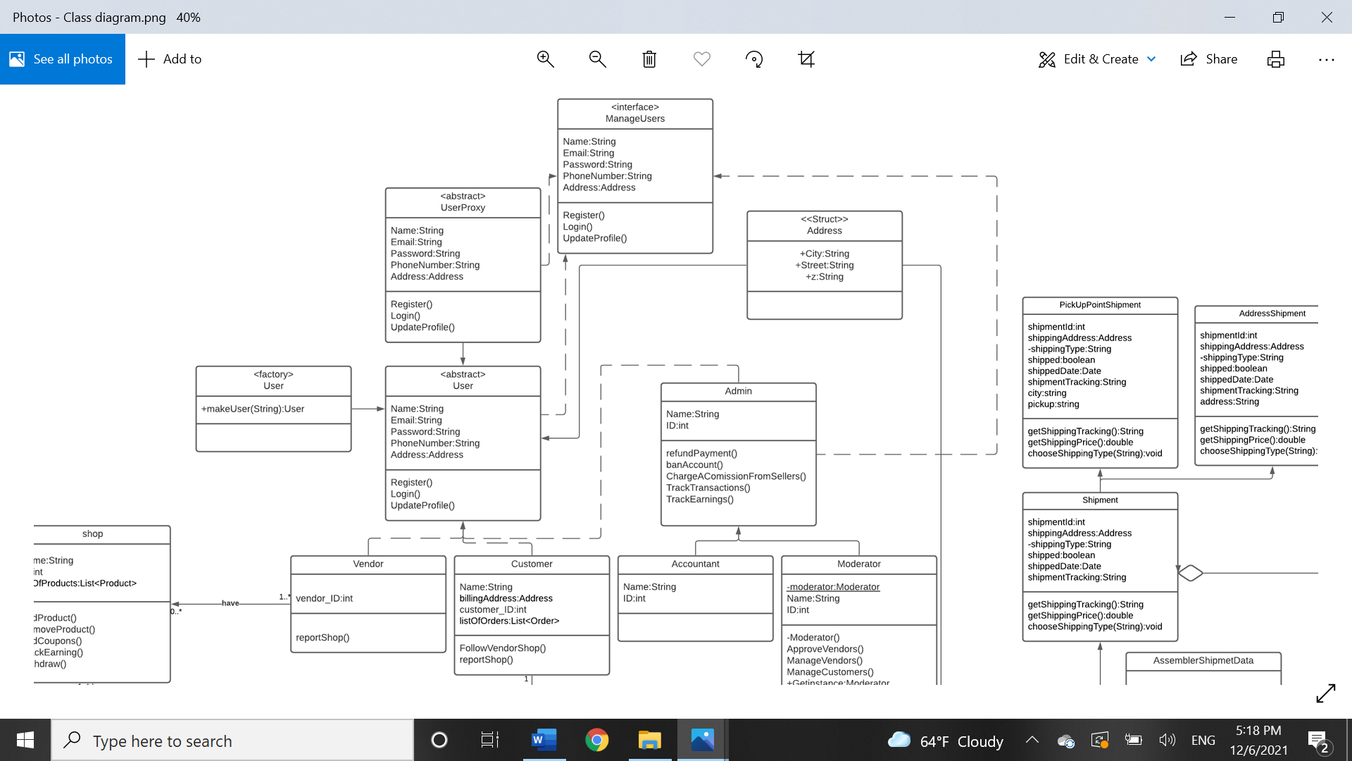

* **Singleton pattern:** We used the singleton pattern in moderator to ensure they have full access over other accounts and since there will be only 1 moderator instance created at any given time.

**Screenshot:** 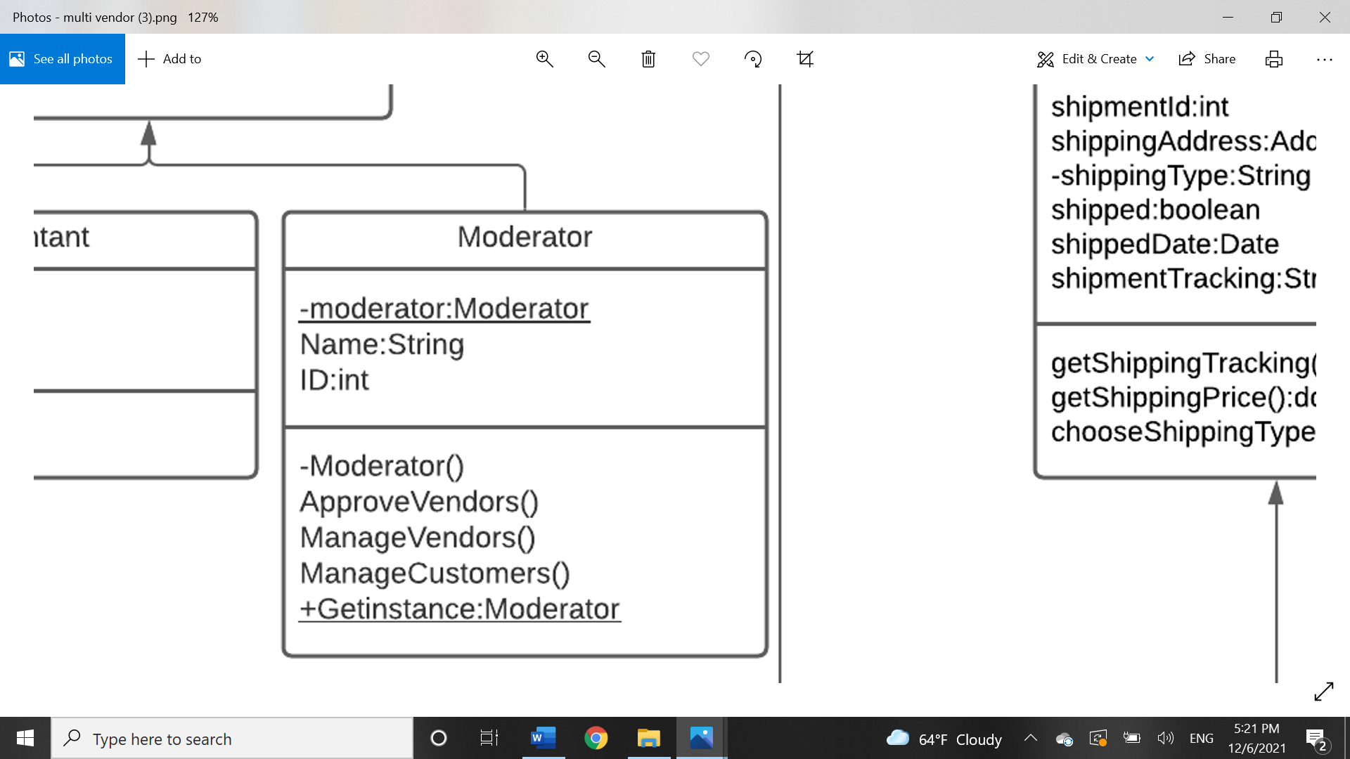

* **DTO pattern:** We needed to combine attributes from the order class as well as the shipment class and send it remotely if needed. We therefore used the DTO pattern to enable us to do this effectively.

**Screenshot:**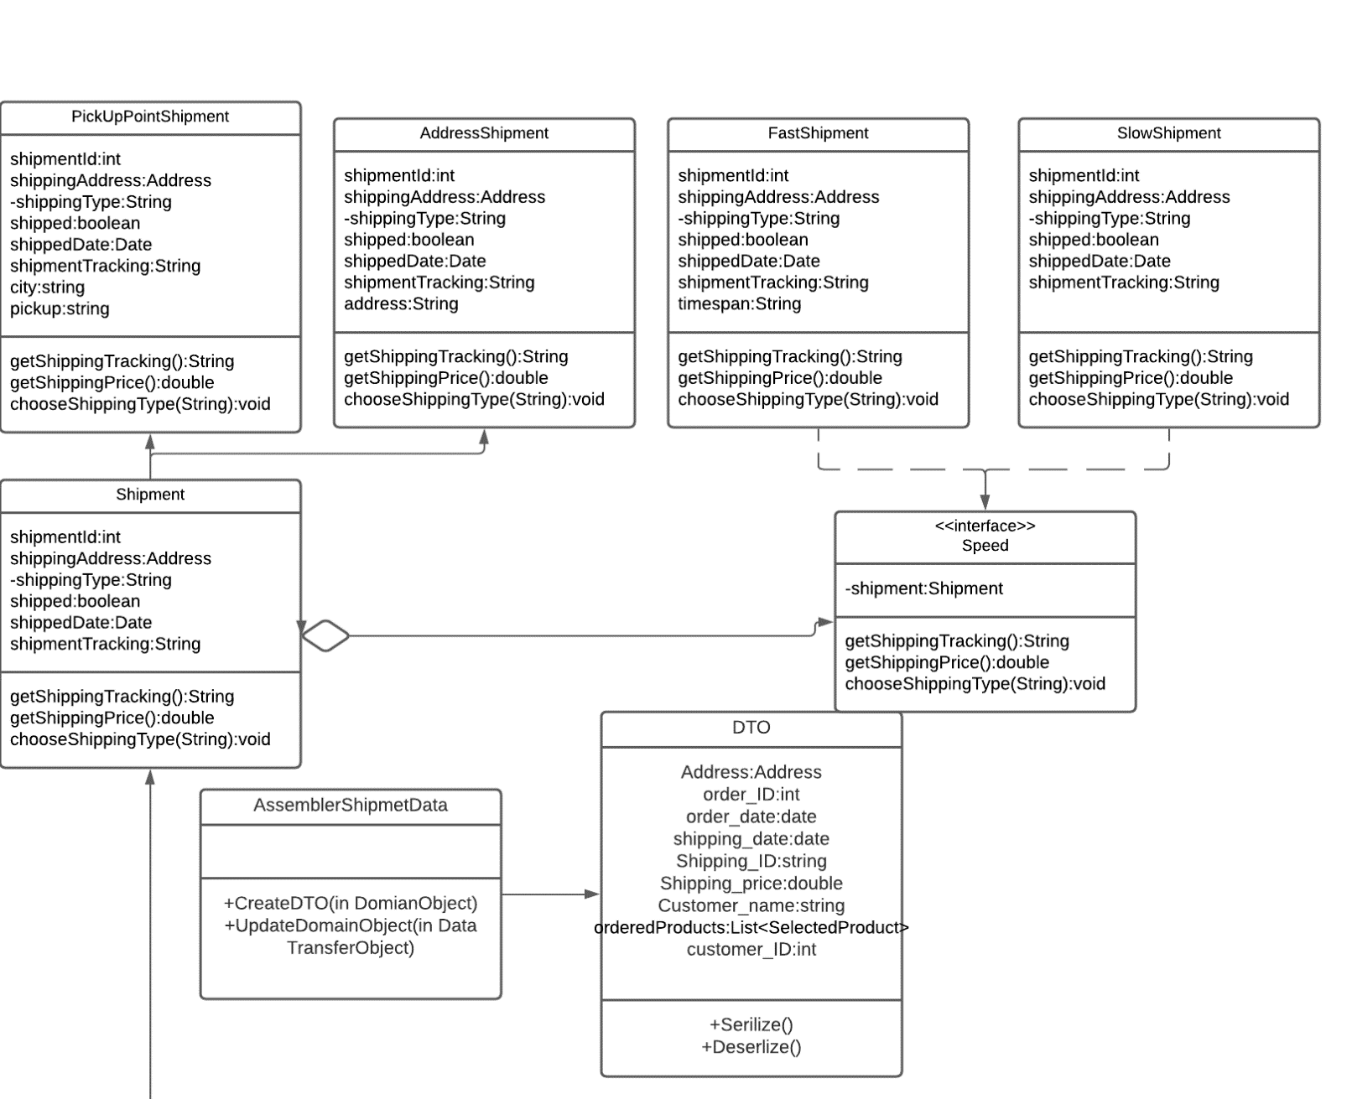

* **Remote Façade pattern:** We used this pattern to more efficiently enable us to send addresses as a struct but store the details of street, city and zip individually and therefore have greater editing and altering abilities.

**Screenshot:**

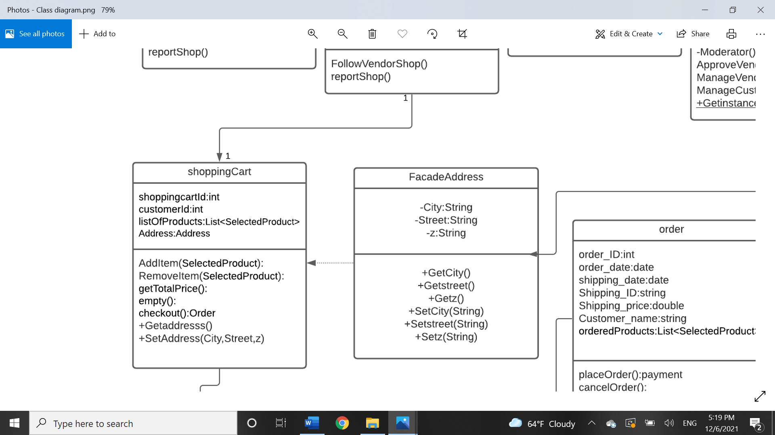

* **Abstract Factory pattern:** We used the abstract factory pattern to not assign an account to either vendor, customer or accountant until all the information is given by the user for account creation. Therefore, enabling us to create the class post-information collection.

**Screenshot:** 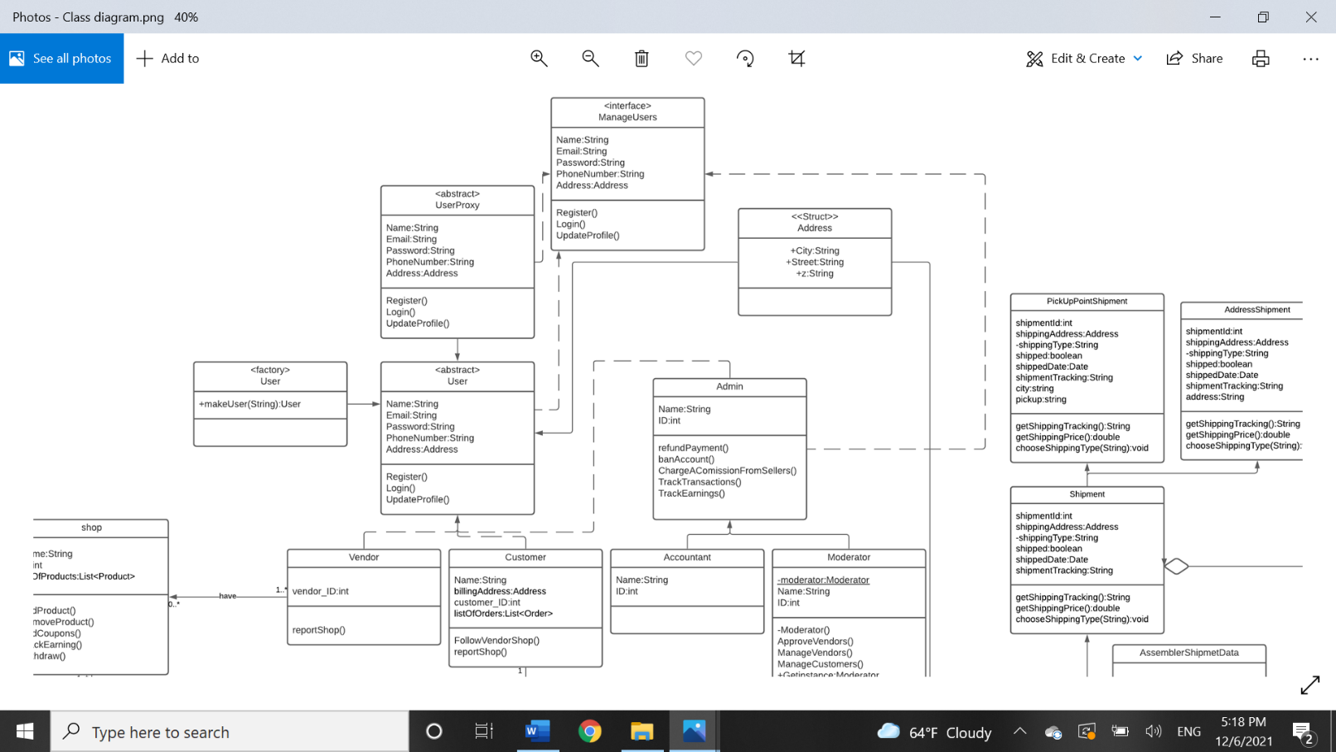

## 6. Use case Scenarios:

|  |  |
| --- | --- |
| ID | UC_01 |
| Title | Placeorder |
| Description | When the customer is done browsing a vendor’s page and selecting his or her desired items, they proceed to confirm the order by selecting place order. |
| Priority | High |
| Primary Actors | Customer |
| Secondary Actors | N/A |
| Preconditions | * Items exist in the cart of the customer. * All items selected are available. * Customer is logged in. * The account is not currently suspended. |
| Post-conditions | An order is created, collected from the vendor and then shipped to the customers desired location. |
| Main Success Scenario | 1. The customer must be logged in to his or her account. 2. The customer searches for desired item(s). 3. The customer selects desired item(s) from a shop or a variety of shops. 4. The customer selects “place order”. 5. An email is sent to confirm the order. |
| Extensions | 2a. the system does not find the item  The system displays text that states that the item is not found  3a.the item that was selected is not currently available.  The system alerts the customer that the item is not available.  4a. an error occurs and the request fails  The system alerts the user that the request failed to occur , the order failed to be placed ,and to try again |

|  |  |
| --- | --- |
| ID | UC_02 |
| Title | cancelorder |
| Description | A customer does not wish to receive the items the previously order so the select cancel order. |
| Priority | High |
| Primary Actors | Customer |
| Secondary Actors | N/A |
| Preconditions | * Customer is logged in.   -An order is already placed by the customer.  -The customer has not already received their order. |
| Post-conditions | The order is no longer in the order database and the customer is refunded is needed. |
| Main Success Scenario | 1. The customer logs in to their account 2. The customer selects the order section in their account. 3. The customer selects the order that they wish to cancel 4. The customer selects “cancel order”. 5. An email is sent to the customer to confirm that the order has been canceled. 6. The customer is refunded if they have paid by credit card or PayPal. |
| Extensions | 2a. an error occurs when the customer selects the order section  The system informs the customer that an error has occurred and to try again  4a. an error occurs and the request fails  The system alerts the user that the request failed to occur , the order failed to be placed ,and to try again |

|  |  |
| --- | --- |
| ID | UC_03 |
| Title | Trackshipment |
| Description | The customer tracks the shipment of the order they placed to know state of the order and the time it will take for it |
| Priority | Medium |
| Primary Actors | customer |
| Secondary Actors | Shipping company |
| Preconditions | 1. The customer must be logged in 2. The customer must have an existing order 3. The order must not be delivered yet |
| Post-conditions | The time and state of the order must be displayed to the customer. |
| Main Success Scenario | 1. The customer logs in to their account 2. The customer selects the order section in their account. 3. The customer selects the order that they wish to track. 4. The customer selects “track shipment”. 5. The order time and state is displayed. |
| Extensions | 2a. an error occurs when the customer selects the order section  The system informs the customer that an error has occurred and to try again.  5a. it states that the order has been delivered when it has not been.  The customer must report a problem.  5b. an error occurs and the time and state of the order failed to load.  The system displays an error and asks the user to try again. |

|  |  |
| --- | --- |
| ID | UC_04 |
| Title | ReportsAboutShipment |
| Description | The customer reports a problem regarding the shipment of their order or the delivery man of their shipment |
| Priority | High |
| Primary Actors | Customer |
| Secondary Actors | Shipping company |
| Preconditions | 1. The customer must be logged in . 2. The customer must have an existing order. 3. The order can be already delivered |
| Post-conditions | A report must be sent to an admin containing a report regarding the customers shipment. |
| Main Success Scenario | 1. The customer logs in to their account 2. The customer selects the order section in their account. 3. The customer selects the shipment of the desired order. 4. The customer selects “ReportsAboutShipment” 5. The customer describes their problem.it can be that the order shipping is late, the order state says it has been delivered when it hasn’t, the order is incorrect or the order is damaged. 6. The customer selects the submit button. 7. The report is sent to the admin. 8. An email is sent to the customer to inform them that their report has been sent. |
| Extensions | 2a. an error occurs when the customer selects the order section  The system informs the customer that an error has occurred and to try again.  4a. Customer does not pick any shipment.  The system urges the customer to pick a shipment to report.  5a. User does not enter any complaint.  The system shows a prompt notifying the user that they cannot send an empty report.  6a. an error occurs and the request fails  The system alerts the user that the request failed to occur, the report failed to be sent ,and to try again |

|  |  |
| --- | --- |
| ID | UC_05 |
| Title | Reportshop |
| Description | The customer can report a shop including the reason to their report. (Scam/misrepresented items or illegal items) |
| Priority | Medium |
| Primary Actors | Customer |
| Secondary Actors | Admin |
| Preconditions | * Customer must be logged into the system. * Shop must exist. |
| Post-conditions | Admin is sent a report from the customer. |
| Main Success Scenario | 1. Customer logs in. 2. Customer views a store. 3. Customer clicks report store. 4. Customer inputs their complaint. 5. The report is submitted to the admins and the customer is returned to the previous page. |
| Extensions | 1a. Customer’s log in info times out.  The system will urge the user to relog in.  4a. Customer does not enter any text into their report.  The system will show a prompt urging the user to input text into the report. |

|  |  |
| --- | --- |
| ID | UC_06 |
| Title | RemoveProduct |
| Description | The vendor removes a product from their shop |
| Priority | High |
| Primary Actors | Vendor |
| Secondary Actors | N/A |
| Preconditions | * Vendor is logged into the system correctly. * Shop already established in the system * A product already exists |
| Post-conditions | The product is removed from the store |
| Main Success Scenario | 1. Vendor logs in. 2. Vendor chooses to remove a product from their shop. 3. Vendor is prompted to choose a product to remove. 4. Vendor clicks remove. 5. Product is then removed from their shop. |
| Extensions | 3.a. Vendor cancels after the first prompt.  System takes the vendor back.  4.a Vendor doesn’t pick a product to remove.  System displays prompt urging them to pick a product.  5.a Connection issue  System displays a connection error and restarts the function when a connection is established. |

|  |  |
| --- | --- |
| ID | UC_07 |
| Title | UpdatePrice |
| Description | The vendor adjusted a product’s price. |
| Priority | Medium |
| Primary Actors | Vendor |
| Secondary Actors | N/A |
| Preconditions | * Vendor is logged into the system correctly. * Shop already established in the system * A product exists in the system |
| Post-conditions | The product’s price is adjusted. |
| Main Success Scenario | 1. Vendor logs in. 2. Vendor enters their shop. 3. Vendor chooses a product to adjust. 4. Vendor enters new price. 5. The product is then adjusted. |
| Extensions | 3.a. Vendor cancels after the first prompt.  System takes the vendor back.  4.a Vendor enters an invalid price.  System displays prompt urging them to reenter information.  4.b Connection issue  System displays a connection error and restarts the function when a connection is established. |

|  |  |
| --- | --- |
| ID | UC_08 |
| Title | PutSale |
| Description | The vendor adds a sale to products in their shop. |
| Priority | Medium |
| Primary Actors | Vendor |
| Secondary Actors | N/A |
| Preconditions | 1. Vendor is logged into the system correctly. 2. Shop already established in the system. 3. Products already exist in system. |
| Post-conditions | A sale is added on specific products in the store. |
| Main Success Scenario | 1. Vendor logs in. 2. Vendor opens their store. 3. Vendor chooses to add a sale. 4. Vendor chooses products. 5. Vendor enters sale percentage. 6. The product is adjusted in the store page. |
| Extensions | 4.a. Vendor cancels after clicking on adding sale.  System takes the vendor back.  4.b Vendor doesn’t choose a valid amount of products. (Products <0)  A prompt notifies the vendor they did not pick any products.  5.a Vendor enters invalid information  System displays prompt urging them to reenter a valid percentage.  5.b Connection issue  System displays a connection error and restarts the function when a connection is established. |

|  |  |
| --- | --- |
| ID | UC_09 |
| Title | EditProduct |
| Description | The vendor edits general information about a product on the store. |
| Priority | Medium |
| Primary Actors | Vendor |
| Secondary Actors | N/A |
| Preconditions | 1. Vendor is logged into the system correctly. 2. Shop already established in the system. 3. Products already exist in system. |
| Post-conditions | The product’s information is updated/adjusted. |
| Main Success Scenario | 1. Vendor logs in. 2. Vendor opens store page. 3. Vendor chooses to edit a product. 4. Vendor enters information they wish to change. 5. Product is then updated in the system. |
| Extensions | 3.a. Vendor cancels after choosing to edit.  System takes the vendor back.  4.a Vendor enters invalid information  System displays prompt urging them to reenter the information.  4.b Connection issue  System displays a connection error and restarts the function when a connection is established. |

|  |  |
| --- | --- |
| ID | UC_10 |
| Title | GetShipmentPrice |
| Description | The shipping company receives the price of a shipment. |
| Priority | Medium |
| Primary Actors | Customer |
| Secondary Actors | Shipping company |
| Preconditions | 1. The customer is logged into the system correctly. |
| Post-conditions | A report is sent to the moderators |
| Main Success Scenario | 1. Customer logs in. 2. Customer chooses to report shipping company. 3. Customer chooses shipment to report. 4. Customer enters their complaint. 5. Customer is returned to home page. |
| Extensions | 3.a. Customer cancels after choosing to report.  System takes the customer back.  3.b Customer doesn’t pick a shipment.  System displays prompt urging them to pick a shipment to report an issue with.  4.a Customer does not enter any information.  System urges them to write their complaint.  4.b Connection issue  System displays a connection error and restarts the function when a connection is established. |

|  |  |
| --- | --- |
| ID | UC_11 |
| Title | AddProduct |
| Description | This use case allows vendors to add products to the shop that they opened. Adding product title, Category, Description, Tags, Price, Quantity and shipping details. |
| Priority | High |
| Primary Actors | Vendor |
| Secondary Actors | None |
| Preconditions | 1. Vendor login successfully 2. shop Interface is loaded |
| Post-conditions | 1. The new product is saved in the database and listed in his shop. |
| Main Success Scenario | 1. The vendor selects ‘Add product’ from the menu 2. The vendor enters the product details. 3. The vendor click publish or save as draft to his entered product data. 4. A Fee $0.20 is added to the vendor Payment account. 5. The System transfer the vendor to payment page. 6. The vendor choose the payment method credit or paypal 7. The System check if the money transferred successfully. 8. The System adds the new product to the database and it listed in his shop 9. The System generates an ID for the new product |
| Extensions | 3.a- The vendor click publish but he isn’t fill out all of required fields correctly:  System displays error message and request to fill out all of required fields correctly to publish the product.  7.a the vendor has no enough cash to pay the fee in his account:  System displays error message and request to charge the account and try again. |

|  |  |
| --- | --- |
| ID | UC_12 |
| Title | AddCoupons |
| Description | This use case allows vendors to add coupons to make discounts to the products they add in their shop in a duration. The coupon code must be unique and only capital letters and numbers. |
| Priority | medium |
| Primary Actors | Vendor |
| Secondary Actors | None |
| Preconditions | 1. Vendor login successfully 2. shop Interface is loaded |
| Post-conditions | 1-The coupon is added to the vendor is shop in a duration he selected. |
| Main Success Scenario | 1. The vendor selects ‘add coupons’ from menu. 2. The vendor selected the percentage of the discount should he offer 3. The vendor selected the minimum order quantity to make the discount. 4. The vendor selected the duration date. Or there is no end date. 5. The vendor entered the coupon code. 6. The vendor clicked confirm 7. The System generates the code and saves it in the database. |
| Extensions | 6- a The vendor click confirm but he isn’t fill out all of required fields correctly:  System displays error message and request to fill out all of required fields correctly to publish the coupon. |

|  |  |
| --- | --- |
| ID | UC_13 |
| Title | Withdraw |
| Description | This use case allows vendors to withdraw their money after reaching at least 20usd in their account. |
| Priority | High |
| Primary Actors | Vendor |
| Secondary Actors | None |
| Preconditions | 1. Vendor login successfully 2. shop Interface is loaded |
| Post-conditions | 1. The system is successfully creates payout of the available account balance. |
| Main Success Scenario | 1. The vendor selects ‘withdraw’ from menu. 2. The vendor entered the amount of money to withdraw. Min 20$ in account balance to withdraw 3. The vendor clicked confirm 4. The system checks account balance 5. The System transfer the vendor to payment page. 6. The vendor choose the payment method credit or paypal 7. The System check if the money transferred successfully. 8. The System confirmed the payout and saved in the database |
| Extensions | 4- a The vendor account balance less than 20$:  System displays error message, |

|  |  |
| --- | --- |
| ID | UC_14 |
| Title | Withdraw |
| Description | This use case allows vendors to withdraw their money after reaching at least 20usd in their account. |
| Priority | high |
| Primary Actors | Vendor |
| Secondary Actors | none |
| Preconditions | 1. Vendor login successfully 2. shop Interface is loaded |
| Post-conditions | 1-The system is successfully creates payout of the available account balance. |
| Main Success Scenario | 1. The vendor selects ‘withdraw’ from menu. 2. The vendor entered the amount of money to withdraw. Min 20$ in account balance to withdraw 3. The vendor clicked confirm 4. The system checks account balance 5. The System transfer the vendor to payment page. 6. The vendor choose the payment method credit or paypal. 7. The System check if the money transferred successfully. 8. The System confirmed the payout and saved in the database |
| Extensions | 4- a The vendor account balance less than 20$:  System displays error message, |

|  |  |
| --- | --- |
| ID | UC_15 |
| Title | Add Item |
| Description | This function lets the customer add an item to his shopping cart |
| Priority | High |
| Primary Actors | Customer |
| Secondary Actors | NA |
| Preconditions | -Customer must have an account  -Customer must be logged in |
| Post-Conditions | -Item is added to cart successfully |
| Scenario | The customer:  -logs in to his account  -Select an item  -Click on Add to cart button |

|  |  |
| --- | --- |
| ID | UC_16 |
| Title | Remove Item |
| Description | This function lets the customer remove an item from his shopping cart |
| Priority | High |
| Primary Actors | Customer |
| Secondary Actors | NA |
| Preconditions | -Customer must be logged in  -There must be an item in the cart to remove. |
| Post-Conditions | -Item is removed |
| Scenario | The Customer  -logs in to his account  -Opens the shopping cart page  -Select an item  -Clicks on Remove Item  -Clicks “Ok” |

|  |  |
| --- | --- |
| ID | UC_17 |
| Title | Get total price |
| Description | This function calculates the total price of shopping cart |
| Priority | High |
| Primary Actors | NA |
| Secondary Actors | Customer |
| Preconditions | -Cart must have at least one item |
| Post-Conditions | -Total price is calculated |
| Scenario | The Customer:  -Logs in to his account  -Add items to shopping cart  The system calculates the total price for the customer |

|  |  |
| --- | --- |
| ID | UC_18 |
| Title | Empty |
| Description | This function lets the customer remove items from cart all at once |
| Priority | Medium |
| Primary Actors | Customer |
| Secondary Actors | NA |
| Preconditions | -Customer must be logged in  -There should be an item in the cart |
| Post-Conditions | All items are removed |
| Scenario | The Customer  -logs in to his account  -Opens the shopping cart page  -Clicks on “Empty cart”  -Clicks “Ok” |

|  |  |
| --- | --- |
| ID | UC_19 |
| Title | Checkout |
| Description | This function lets the customer proceed to payment page after adding all the products to cart |
| Priority | High |
| Primary Actors | Customer |
| Secondary Actors | NA |
| Preconditions | -Customer must have an account  -Customer must be logged in  -There must be at least one item in the cart  -Total price must be calculated |
| Post-Conditions | -Customer should be redirected to the Payment page |
| Scenario | The Customer:  -logs in to his account  -Add items to cart  -Check total price  -Click on “Checkout” |

|  |  |
| --- | --- |
| ID | UC_20 |
| Title | refundPayment |
| Description | This function refunds payments to customers that want to cancel their order or return their order. |
| Priority | High |
| Primary Actors | admin |
| Secondary Actors | N/A |
| Preconditions | * The admin is logged in * The customer that is to be refunded has returned an item or canceled an order * The item returned is not damaged. * The customer has paid online |
| Post-conditions | The amount the customer paid is added to their account balance. |
| Main Success Scenario | * + - 1. admin logs in to their account.       2. admin receives request to cancel order or return an order.       3. Admin verifies that the refund is valid.       4. The admin adds the needed amount to the account of the customer. |
| Extensions | 2a. the system does not find the item  The system displays text that states that the item is not found  3a.the item that was selected is not currently available.  The system alerts the customer that the item is not available.  4a. an error occurs and the request fails  The system alerts the user that the request failed to occur , the order failed to be placed ,and to try again |

|  |  |
| --- | --- |
| ID | UC_21 |
| Title | TerminateCustomer |
| Description | The admin permanently disables the account of a customer for violating the websites rules and services. An example of this would be ordering serval items and refusing to pay for them when they are delivered. |
| Priority | High |
| Primary Actors | Admin |
| Secondary Actors | N/A |
| Preconditions | * Customer account exists * Customer has violated rules of website * Admin is logged in * Admin account exists |
| Post-conditions | The account of the customer is banned and the customer can no longer log in or buy items with that account. |
| Main Success Scenario | 1. admin logs in 2. admin receives request to terminate the account of a customer 3. admin reviews the basis of request 4. admin selects “terminateCustomer” 5. admin enters the Id of the customer 6. admin selects submit 7. customer account is no longer functional |
| Extensions | 1.a Admin enters wrong log in information.  System urges them to reenter log in information.  5.a Admin enters invalid ID.  System shows a prompt urging the admin to reenter the vendor’s ID.  6.a Internet connection is unavailable to terminate the account.  The system urges the admin to retry when there is a valid internet connection. |

|  |  |
| --- | --- |
| ID | UC_22 |
| Title | TerminateVendor |
| Description | The admin permanently disables the account of a vendor for violating the websites rules and services. An example of this would be attempting to sell illegal items on their page which would violate the rules and services of the website. |
| Priority | High |
| Primary Actors | Admin |
| Secondary Actors | N/A |
| Preconditions | * Vendor account exists * Vendor has violated rules of website * Admin is logged in * Admin account exists |
| Post-conditions | The account of the Vendor is banned and the vendor can no longer log in or sell items on that account. |
| Main Success Scenario | 1. admin logs in 2. admin receives request to terminate the account of a Vendor 3. admin reviews the basis of request 4. admin selects “terminateVendor” 5. admin enters the Id of the Vendor 6. admin selects submit 7. Vendor account is no longer functional. |
| Extensions | 1a. Admin enters wrong log in information.  The system shows a prompt urging the admin to reenter log in information.  5a. Admin enters incorrect information.  The system shows a prompt urging the admin to reenter the information.  6a. There is no internet connection at the time of pressing submit.  The system will show a prompt asking the admin to retry when there is an internet connection. |

|  |  |
| --- | --- |
| ID | UC_23 |
| Title | ApproveVendors |
| Description | The admin approves a request of a new vendor to start selling on the website. |
| Priority | High |
| Primary Actors | Admin |
| Secondary Actors | N/A |
| Preconditions | * Admin is logged in. * Vendor already has an account * Vendor has requested to start selling. |
| Post-conditions | The account of the vendor will now be enabled to sell products |
| Main Success Scenario | 1. admin logs in 2. admin receives request from customer to become a vendor 3. admin selects “ApproveCustomer” 4. admin enters the Id of the customer 5. admin selects submit 6. customer account has now become a vendor |
| Extensions | 1a. Admin enters wrong log in information.  The system will show a prompt urging the admin to reenter log in information  4a. Admin enters invalid ID.  The system will urge the admin to enter a valid ID.  5a. There is no internet connection at the time of pressing submit.  The system will show a prompt telling the admin to retry when there is internet connection. |