# UC2: Add new an agreement

This function is to add new an agreement, it contains 6 main steps(except step 5) to allow user to input all the information of new agreement. All the steps should be executed in sequence.

## Pre-condition

N/A

## Functional description

The Use case includes following use case:

|  |  |  |
| --- | --- | --- |
| ID | Description | Comments |
| UC2.1 | Select applicable Customer uses to search customer from CRM system. User will select one customer from search result for new agreement | Mandatory |
| UC2.2 | Basic Agreement Details allows user to update basic information of an agreement. | Mandatory  The use case may execute from CSM system by send http request to RFO system with parameters including Customer information. |
| UC2.3 | Select applicable Dealer allows user to select the dealer for a specific agreement. All the dealers will be displayed based on the “Dealer Visibility” field on the Basic Agreement Details | Mandatory |
| UC2.4 | Select Volume Banding is used for creating and update volume banding value for dealer or customer of current agreement. If the “Payment To” on Basic Agreement Details step is customer, all the banding value of agreement will be used for customer only. | It is optional when user choose “none” value of Volume Discount Type on the Basic Agreement Details screen |
| UC2.5 | Model Support is used for adding the car models to the selected agreement. | Mandatory |
| UC2.6 | Misc Text is used to update Credit note and justification comment for an agreement. | - Credit note if optional  - Justification comment is mandatory |
| UC2.7 | Confirmation allows user to review the summary of an agreement and submit it to get approval. | Mandatory |

## UML Activity diagram



## UC 2.1: Select applicable customer

This function allows user to select one appropriate customer to discount. The customer details are stored in Sage CRM database and it can be sent to the RFO system with the request to create a new Agreement from Sage CMR application.

### Actors in UC2.1

* Dealer Proposer
* CSM/ LSM
* System Administrator

### Pre-condition

N/A

### Functional description

|  |  |  |
| --- | --- | --- |
| ID | Description | Comments |
| UC2.1_001 | Clicks on ‘Add New’ link on the main menu, the ‘select customer’ screen will be displayed with search criteria |  |
| UC2.1_002 | Input data in the free text and clicks on ‘search’ button. If exist eligible customers, the results is displayed with customers details are stored information Sage CRM. If the customer does not exist, a show message will be shown to inform | If user doesn’t input data, the search results will get all customers in database |
| UC2.1_003 | User select a customer for a new agreement |  |
| UC2.1_004 | Clicks on the ‘create Agreement’ in the ‘Create agreement’ screen will be displayed.  The ‘create agreement’ only is active when user select a customer from search result. | If user doesn’t select Customer, a show message will be shown to inform. |

### UML Activity diagram



### Screen flow

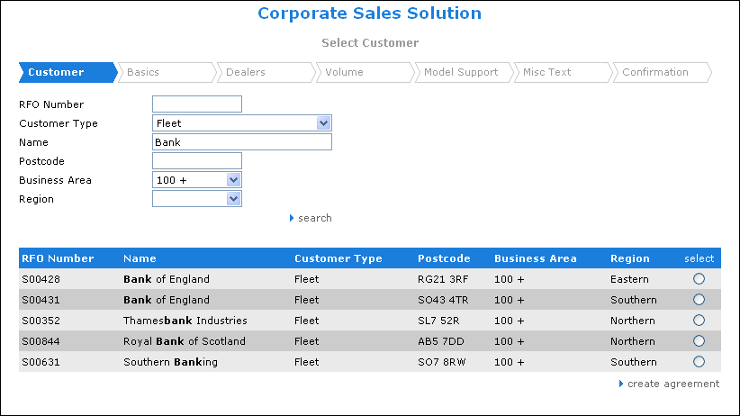

### Data requirements

|  |  |  |  |  |  |
| --- | --- | --- | --- | --- | --- |
| Field Name | Mandatory | Control Type | Data Type | Rules | Screen |
| **Input** | | | | | |
| RFO Number |  | Text box | Number | Range(1 – 99,999,999) | Select customer |
| Customer Type |  | Combo box | Text | Include 2 values “Fleet” and “Leasing” | Select customer |
| Name |  | Text box | Text | Max length 100 | Select customer |
| Postcode |  | Text box | Text | Max length 10(Alpha numeric only) | Select customer |
| Business Area |  | Combo box | Text | Include 3 values “0-100”, “100+” and “All” | Select customer |
| **Output** | | | | | |
| RFO Number | Yes | Label | Text |  | Select customer |
| Name | Yes | Label | Text |  | Select customer |
| Customer Type | Yes | Label | Text |  | Select customer |
| Postcode | Yes | Label | Text |  | Select customer |
| Business Area | Yes | Label | Text |  | Select customer |

## UC 2.2: Basic agreement details

The function displays the main Agreement details such as name, description, start and end date.

(Note: There is an issue on this screen in the prototype. The field “signed agreement required” must be after the dropdown for “funding method” as the selected funding method will determine whether the “signed agreement required” field is editable or not.)

### Actors in UC2.2

* Dealer Proposer
* CSM/ LSM
* System Administrator

### Pre-condition

* After user select the customer from the first step – “select customer” screen.
* The use case can be executed from CRM system by send http request with customer information in the session

### Functional description

|  |  |  |
| --- | --- | --- |
| ID | Description | Comments |
| UC2.2_001 | User enters basic information for the current agreement |  |
| UC2.2_002 | Clicks on ‘save as draft’ or ‘next’ button.  If user doesn’t input enough data, a show message will be shown to inform.  A show message will be shown to confirm after user clicks on Save as Draft or Next. | If user clicks on the ‘save as draft’ button, all the information in this screen will be save to database and the status of agreement will be “draft’.  If user clicks on ‘next’ button, Dealer select screen will be display. If user doesn’t click on ‘save as draft’ button, data will not be saved to database. |
| UC2.2_002 | Application will validate input data   * Start date * End date  1. Show the message if the input date is not valid 2. Go to next step if input data are valid in case user clicks on the ‘next’ button. |  |

### UML Activity diagram



### Screen flow

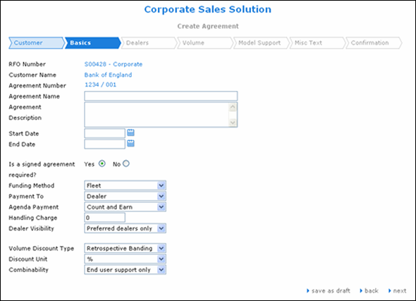

### Data requirements

|  |  |  |  |  |  |
| --- | --- | --- | --- | --- | --- |
| Field Name | Mandatory | Control Type | Data Type | Rules | Screen |
| **Input** | | | | | |
| Agreement name | Yes | Textbox | Text | 100 characters | Create Agreement |
| Agreement Description | Yes | Text area | Text | 800 characters | Create Agreement |
| Start date | Yes | Text box | Date | Last 30 days to Current Date and Current Date to next 30 days | Create Agreement |
| End date | Yes | Text box | Date | Range: 90 – 3650 days from Start Date | Create Agreement |
| Is a signed Agreement | Yes | Option | Boolean | Depend on FundingMethod Type. Yes(Enable) : YES/NO  Yes(Protected):  YES only,  No: NO | Create Agreement |
| Funding method | Yes | Combo box | Text |  | Create Agreement |
| Payment to | Yes | Combo box | Text | Include 2 values: “Dealer”, “Customer” | Create Agreement |
| Handling Charge | Yes | Text box | Number | Range: 0 –  1 000 000 000  unit: USD | Create Agreement |
| Dealer visibility | Yes | Combo box | Text | Include 4 values:  “All”, “Selected dealers only”, “'Preferred dealers only”, “'Leasing co. Preferred dealers only” | Create Agreement |
| Volume Discount type | Yes | Combo box | Text | Include 3 values: “None”, “Banding”, “Retrospective Banding” | Create Agreement |
| Discount Unit | Yes | Combo box | Text | Use “%” & "£" discount | Create Agreement |
| Combinability | Yes | Combo box | Text | Include three values: "End user support only", "Leasing support only", "End user and Leasing" | Create Agreement |
| **Output** | | | | | |
| RFO number | Yes | Label | Text |  | Create Agreement |
| Customer Name | Yes | Label | Text |  | Create Agreement |
| Agreement Number | Yes | Label | Text |  | Create Agreement |

## UC 2.3: Select applicable dealer

This function is use to select the Dealers for the current agreement.

### Actors in UC2.3

* Dealer Proposer
* CSM/ LSM
* System Administrator

### Pre-condition

* After executing use case 2.2 to update Basic information.

### Functional description

|  |  |  |
| --- | --- | --- |
| ID | Description | Comments |
| UC2.3_001 | User clicks on ‘next’ button on “Create agreement’ screen or choose the ‘Dealer’ tab, the dealer selection screen is displayed |  |
| UC2.3_002 | Input data Dealer name and Dealer code to search the dealer in the list and click ‘search’ button | As a default when entering the screen all dealers should be displayed. The search is just to allow a “quick find” of a dealer. In addition to dealer codes the options for “all business to business dealers” and “All corporate dealers should be available. |
| UC2.3_003 | The search results is showed, clicks dealer in ‘Matching Dealers’ list to add to applicable list and click on dealers in ‘Applicable Dealers’ panel to remove them from selected list. User can choose one or more dealer for an agreement | If the dealer does not exist, a show message will be shown to inform. |
| UC2.3_004 | User can click on ‘save as draft’ or ‘next’ button.  If user doesn’t input enough data, a show message will be shown to inform.  A show message will be shown to confirm after user clicks on Save as Draft or Next. | If user clicks on the ‘save as draft’ button, all dealer selected will be save to agreement.  If user doesn’t click on ‘save as draft’ button, data will not be saved to database.  If user clicks on ‘next’ button, Retro banding screen will be display. |
| UC2.3_005 | if no dealer is selected, RFO application will check and show message: ‘You should select at least one dealer for an agreement’  If the input data is valid, the next screen – Retro banding will be displayed in case user clicks on the ‘next’ button. |  |

### UML Activity diagram



### Screen flow

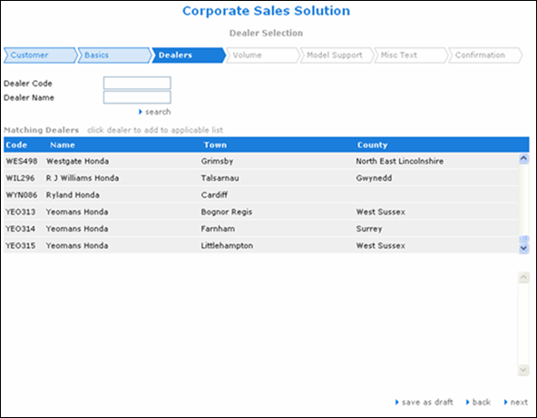

### Data requirements

|  |  |  |  |  |  |
| --- | --- | --- | --- | --- | --- |
| Field Name | Mandatory | Control Type | Data Type | Rules | Screen |
| **Input** | | | | | |
| Dealer code |  | Text box | Number | Range(1 – 99,999,999) | Dealer selection |
| Dealer name |  | Textbox | Text | Max length 50 | Dealer selection |
| **Output** | | | | | |
| Code | Yes | Label | Text |  | Dealer selection |
| Name | Yes | Label | Text |  | Dealer selection |
| Town | Yes | Label | Text |  | Dealer selection |
| Country | Yes | Label | Text |  | Dealer selection |

## UC 2.4: Volume banding

This function is to specify the banding value for dealer and customer. This screen will not be displayed if the user selects “None” from the “Volume discount type” field on the basics screen.

### Actors in UC2.4

* Dealer Proposer
* CSM/ LSM
* System Administrator

### Pre-condition

* After finish selecting the dealer for the current agreement

### Functional description

|  |  |  |
| --- | --- | --- |
| ID | Description | Comments |
| UC2.4_001 | From ‘dealer selection’ screen, user clicks on ‘next’ button, the ‘Retro banding’ will be displayed. |  |
| UC2.4_002 | User can create, update or delete Banding value. Here is the rule for adding banding value:  1. First band should start at 0  2. There should be no gaps. For example, one is 0-10 and next one is 5-20 would not be permitted.  3. No overlap data of banding value. For example, one is 0-10 and next one is 10-20 would not be permitted. | When user choose a link to add, edit or delete, a popup will be shown. |
| UC2.4_003 | User can choose the customer or dealer for ‘Trigger Credit’ and ‘Payable to’ | The fields “trigger credit” and “payable to” will always show. |
| UC2.4_004 | Clicks on ‘save as draft’ or ‘next’ button.  If user doesn’t input enough data, a show message will be shown to inform.  A show message will be shown to confirm after user clicks on Save as Draft or Next. | If user clicks on the ‘save as draft’ button, “trigger credit” and “payable to” will be save to database and the status of agreement will be “draft’.  If user doesn’t click on ‘save as draft’ button, data will not be saved to database.  If user clicks on ‘next’ button, Model Support screen will be display. |
| UC2.4_005 | the next screen – Model Support will be displayed in case user clicks on the ‘next’ button. |  |

### UML Activity diagram



### Screen flow

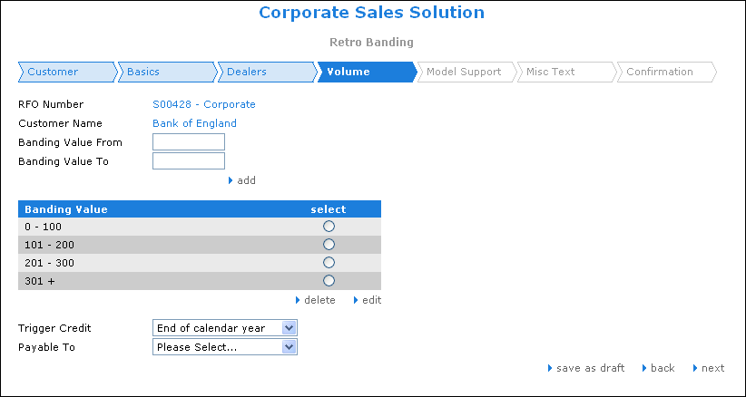

### Data requirements

|  |  |  |  |  |  |  |
| --- | --- | --- | --- | --- | --- | --- |
| Field Name | Mandatory | Control Type | Data Type | Rules | Screen | |
| **Input** | | | | | | |
| Banding Value From | Yes | Text box | Number | Range 0-901 | Retro banding | |
| Banding value to | Yes | Textbox | Number | Range 10 – 1000. BandingValueTo must be greater than BandingValueFrom at least 10, and max 100 | Retro banding | |
| Banding Value | Yes | List Checkbox | Banding | Min: 1 banding values. | Retro banding | |
| Trigger Credit | Yes | Combo box | Text | Include 6 values: "'end of quarter", "End of ki", "'End of month", "'June 30th & Dec 31st", "'End of calendar year", "Move to next Banding" | | Retro banding |
| Payable to | Yes | Combo box | Text | Include 2 values: "Customer" and Dealer | Retro banding | |
| **Output** | | | | | | |
| RFO Number | Yes | Label | Text |  | Retro banding | |
| Customer Name | Yes | Label | Text |  | Retro banding | |
| Banding Value | Yes | Label | Text |  | Retro banding | |

## UC 2.5: Model support

This function is out of scope, it will be implemented by Honda-UK

## UC 2.6: Misc text

This function is used to add the comments and justification for an agreement.

### Actors in UC2.6

* Dealer Proposer
* CSM/ LSM
* System Administrator

### Pre-condition

* After finishing the step UC 2.5 – Model Support

### Functional description

|  |  |  |
| --- | --- | --- |
| ID | Description | Comments |
| UC2.6_001 | Input note text into text areas | The users should be able to specify the text they wish to appear on the credit note. This text should be limited to 200 characters and will be in addition to the standard text of either “Corporate Sales Support” or “Leasing Sales Support” depending on the support type. |
| UC2.6_002 | User clicks on ‘save as draft’ or ‘next’ button.  If user doesn’t input enough data, a show message will be shown to inform. |  |
| UC2.6_003 | If the justification is not input, the message will be shown.  If the input data is valid, the next screen will be displayed in case user clicks on the ‘next’ button. |  |

### UML Activity diagram



### Screen flow

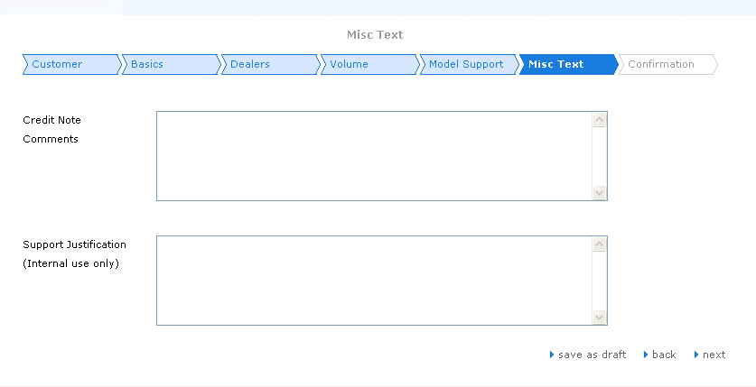

### Data requirements

|  |  |  |  |  |  |
| --- | --- | --- | --- | --- | --- |
| Field Name | Mandatory | Control Type | Data Type | Rules | Screen |
| **Input** | | | | | |
| Credit note comments |  | Text area | Text | Max length 200 characters | Misc text screen |
| Support justification (Internal use only) | Yes | Text area | Text | Max length 200 characters | Misc text screen |

## UC 2.7: Confirmation

This function will allow user to view all the information of an agreement and save/submit an agreement for approval

### Actors in UC2.7

* Dealer Proposer
* CSM/ LSM
* System Administrator

### Pre-condition

* After finishing the UC 2.6 – Misc Text

### Functional description

|  |  |  |
| --- | --- | --- |
| ID | Description | Comments |
| UC2.7_001 | User can select separate taps (Overview, Dealers, Model Support, and Misc. Text) to view agreement details | The screen must not refresh when moving from tab to tab.  The tabs should contain all the fields entered earlier in the agreement wizard |
| UC2.7_002 | User can click on “save as draft” to save agreement with draft status.  A show message will be shown to confirm after user clicks Save as Draft. |  |
| UC2.7_003 | User can click on “submit” button to save current agreement with “Awaiting approval” status.  A show message will be shown to confirm after user clicks submit. | When user click submit, agreement status will be “Awaiting for approval” and email will be sent to inform approver to approve it. |
| UC2.7_004 | User can click on “print” to print agreement document | When user click on “print”, Generate Agreement Document screen will be displayed to allow user to print agreement with a specific template |

### UML Activity diagram



### Screen flow

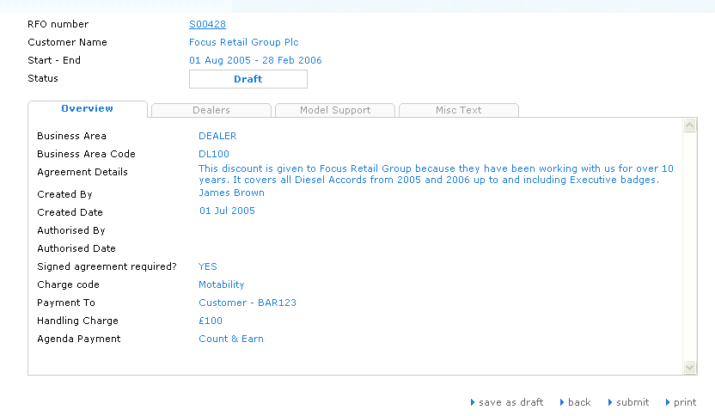

# UC4: Edit an agreement

This function is to allow user to update all the information of exiting agreement and can save/submit it anytime. The status agreement will be “draft” when user does “save as draft” and “Awaiting” when user submit for approval.

## Actors in UC4

* Dealer Proposer (Restricted to discounts proposed by the dealership)
* CSM/ LSM (Restricted to discounts proposed by the CSM/LSM)
* Corporate management Team
* System Administrator

## Pre-condition

- After executing UC search agreement with the “approved” status

## Functional description

|  |  |  |
| --- | --- | --- |
| ID | Description | Comments |
| UC4_001 | User selects “edit” button on View Agreement screen. |  |
| UC4_002 | User can navigate from Basic screen to Confirmation screen to review and update any information of the current agreement. |  |
| UC4_003 | If user clicks on “save as draft” button, a new variant will be created and the status of the new variant will be draft, that the existing approved agreement will remain in force until this new agreement is approved and then this variant will automatically replace it (i.e. the old one will be set to “discontinued” and the new one will become active)  If user clicks on “submit” button, status of new variant agreement will be “Awaiting” | For each screen, user has to input full information, if user doesn’t input enough information, a show message will be shown to inform.  If user clicks ‘Save as Draft’, ‘next’ or ‘submit’, a show message will be shown to confirm |

## UML Activity diagram



## Screen flow

Case 1: Display the Basics information of an agreement

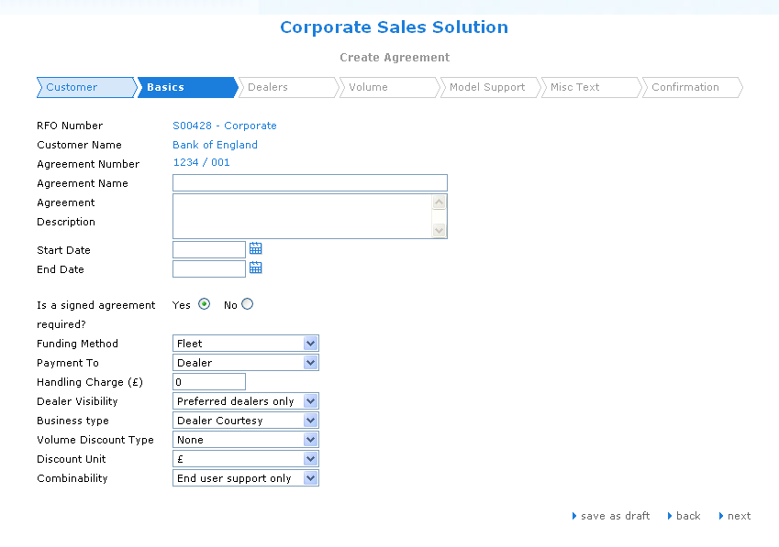

Case 2: Display the Volume information of the Agreement

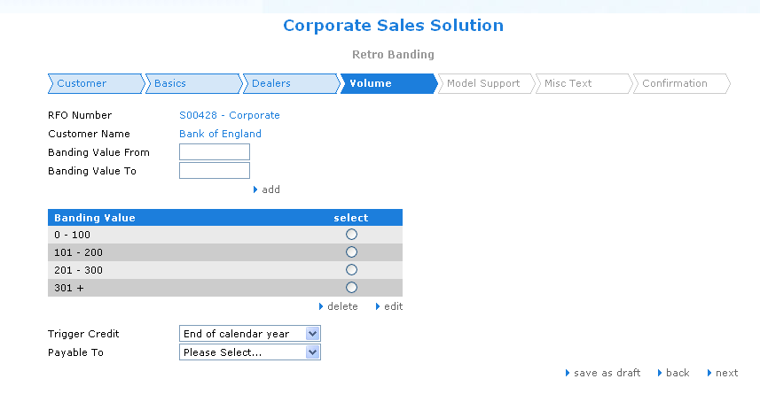

Case 3: Display the Model Support information of the Agreement

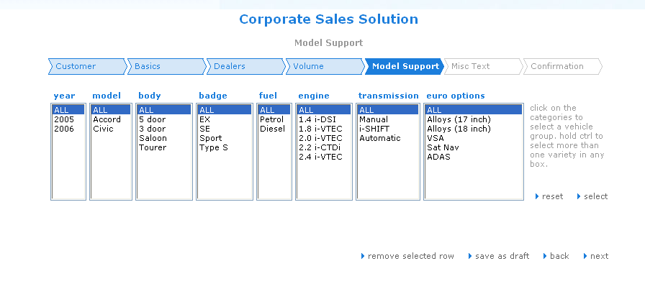

Case 4: Display the Misc Text information of the Agreement

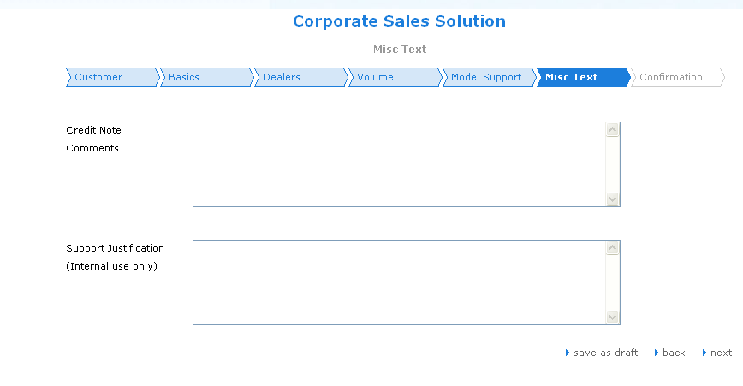

Case 5: Display the Confirmation of the Agreement

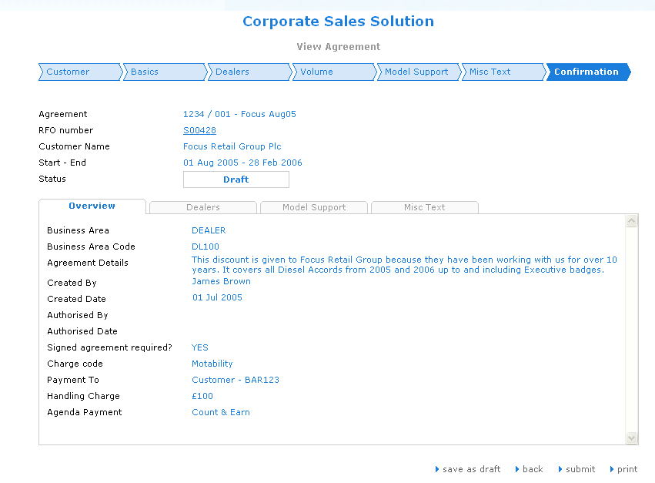

## Data requirements

|  |  |  |  |  |  |
| --- | --- | --- | --- | --- | --- |
| Field Name | Mandatory | Control Type | Data Type | Rules | Screen |
| **Input** | | | | | |
| Agreement name | Yes | Label | Text | 100 characters | Create Agreement |
| Agreement Description | Yes | Text area | Text | 1000 characters | Create Agreement |
| Start date | Yes | Textbox | Date | Current Date | Create Agreement |
| End date | Yes | Textbox | Date | Range: 90 – 3650 days from Start Date | Create Agreement |
| Is a signed Agreement | Yes | Option | Boolean | Default: “Yes” | Create Agreement |
| Funding method | Yes | Combo box | Text |  | Create Agreement |
| Payment to | Yes | Combo box | Text | Include 2 values: “Dealer”, “Customer” | Create Agreement |
| Agenda Payment | Yes | Combo box | Text | Include 3 values: "Count and Earn", "Count and not Earn", "Neither Count nor Earn" | Create Agreement |
| Handling Charge | Yes | Text box | Number | Range: 0 –  1 000 000 000  unit: USD | Create Agreement |
| Dealer visibility | Yes | Combo box | Text | Include 3 values: “Selected dealers only”, “Selected dealers only”, “'Preferred dealers only” | Create Agreement |
| Volume Discount type | Yes | Combo box | Text | Include 3 values: “None”, “Banding”, “Retrospective Banding” | Create Agreement |
| Discount Unit | Yes | Combo box | Text | Use “%” discount | Create Agreement |
| Combinability | Yes | Combo box | Text | Include three values: "End user support only", "Leasing support only", "End user and Leasing" | Create Agreement |
| **Output** | | | | | |
| RFO number | Yes | Label | Text |  | Create Agreement |
| Customer name | Yes | Yes | Text |  | Create Agreement |
| Agreement Number | Yes | Yes | Text |  | Create Agreement |