Requirement

### UC9: Reject an agreement

This function allows user to reject an agreement after reviewing the details information of that.

#### Actors in UC9

* Dealer Proposer
* CSM/ LSM
* System Administrator

#### Pre-condition

* After executing UC search agreement with “Awaiting” status then user selects an agreement to view it.

#### Functional description

|  |  |  |
| --- | --- | --- |
| ID | Description | Comments |
| UC9_001 | Perform searching Agreement with awaiting status |  |
| UC9_002 | Choose an Agreement and clicks on ‘View Agreement’ button. |  |
| UC9_003 | Clicks on ‘reject’ button to show confirmation screen |  |
| UC9_004 | Click on ‘cancel’ button to exit confirmation screen | Back to ‘View Agreement’ screen |
| UC9_005 | Input reasons reject and clicks on ‘reject’ button on reject approval screen |  |
| UC9_006 | if action success then show message and Change Agreement status to ‘Reject’ status  else show message and back to ‘View Agreement’ screen |  |

#### UML Activity diagram



#### Screen flow

View Agreement details screen:

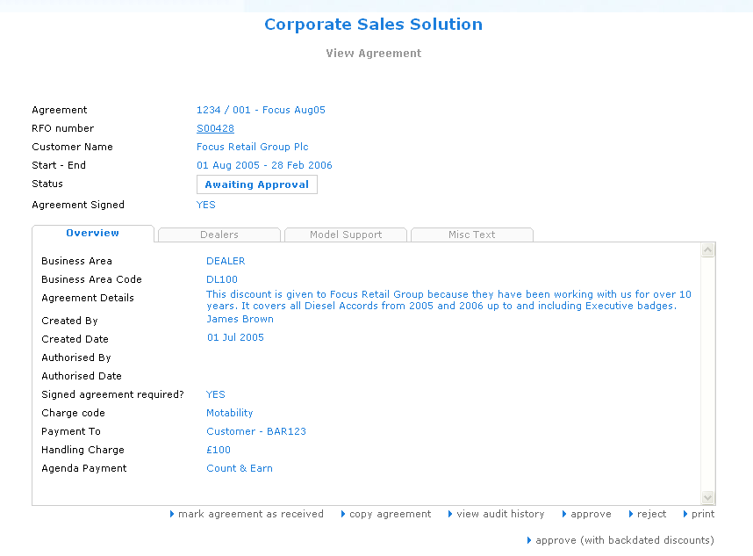

Confirmation reject screen:

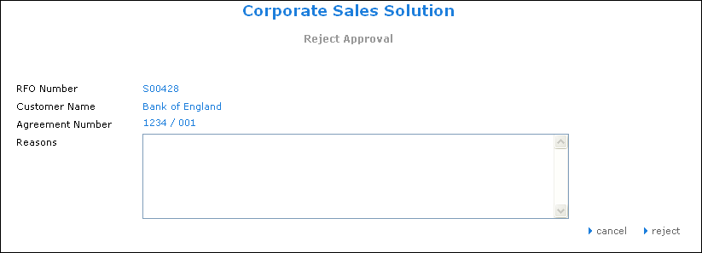

#### Data requirements

|  |  |  |  |  |  |
| --- | --- | --- | --- | --- | --- |
| Field Name | Mandatory | Control Type | Data Type | Rules | Screen |
| **Input** | | | | | |
| Reasons | Yes | Text area | Text | Not Null  Length<=200 | Reject Approval |
| **Output** | | | | | |
| RFO number | Yes | Label | Text |  | Reject Approval |
| Customer Name | Yes | Label | Text |  | Reject Approval |
| Agreement number | Yes | Label | Text |  | Reject Approval |

### UC13: View an agreement

This function displays all the information of an agreement details such as Customer, Basics, Volume, Model Support, Misc Text.

* If the status is “draft”, all the tabs in add agreement wizard will be displayed to allow user check and update information
* If the status is not “draft”, the “View agreement” screen will be displayed and user can only view the information.

#### Actors in UC13

* Dealer
* Dealer Proposer
* CSM/ LSM
* Corporate Management Team
* Corporate Sales Admin
* Read-Only User
* System Administrators

#### Pre-condition

* After executing UC search agreement with “Awaiting” status then user selects an agreement to view it.

#### Functional description

|  |  |  |
| --- | --- | --- |
| ID | Description | Comments |
| UC13_001 | Selects an Agreement which user wants to view the detailed information by choosing it from search result. |  |
| UC13_002 | The Confirmation information of Agreement will be displayed as default. Other information can be viewed by click on next tabs such as Dealer, … i |  |
| UC13_003 | When User clicks on Dealers tab, the detailed information of Dealer is displayed such as: Code, Name, Town, Country |  |
| UC13_004 | The user clicks on Misc Text tab, the screen will display the rejection reason of the Agreement and the support type if the Agreement is rejected |  |
| UC13_005 | Clicks on ‘back’ button, the previous page will display |  |

#### UML Activity diagram



#### Screen flow

Case 1: Display the customer information

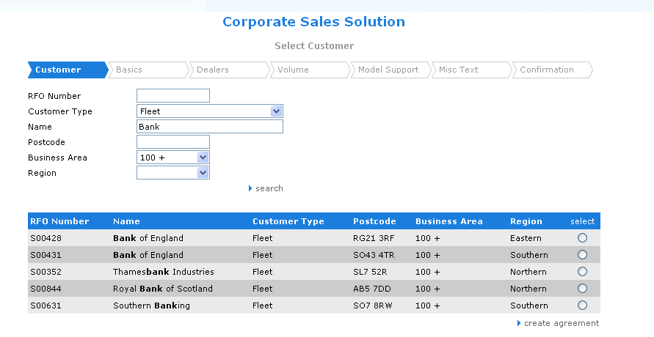

Case 2: Display the Basics information of an agreement

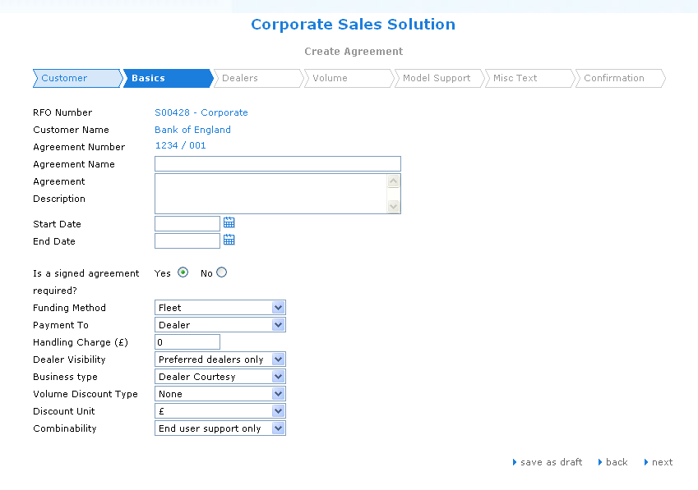

Case 3: Display the Volume information of the Agreement

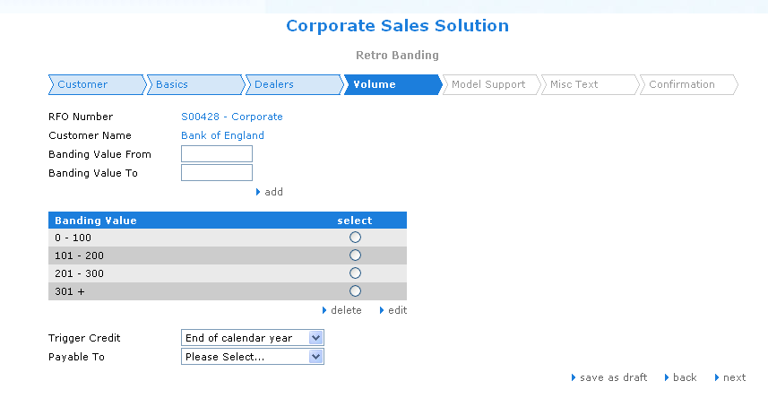

Case 4: Display the Model Support information of the Agreement

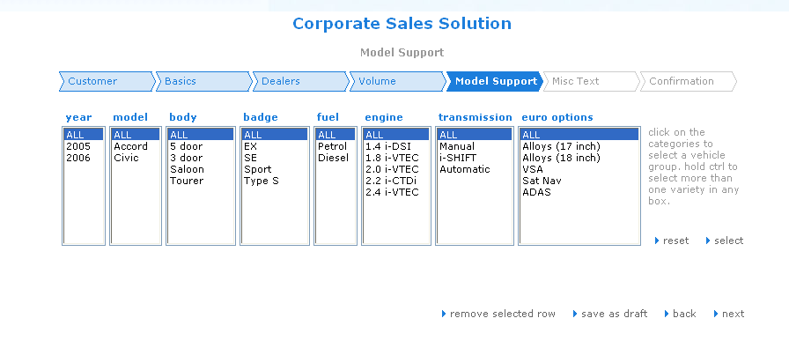

Case 5: Display the Misc Text information of the Agreement

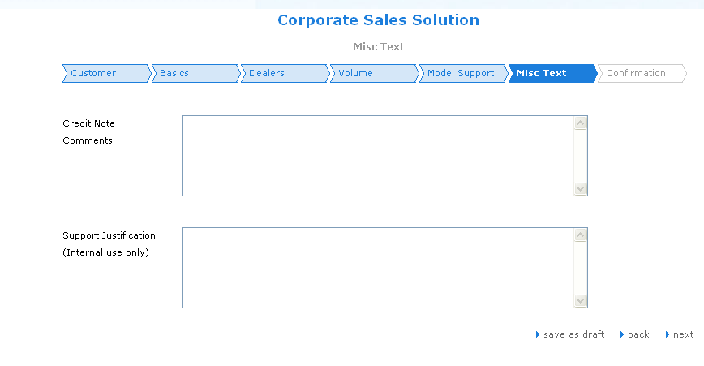

Case 6: Display the Confirmation of the Agreement

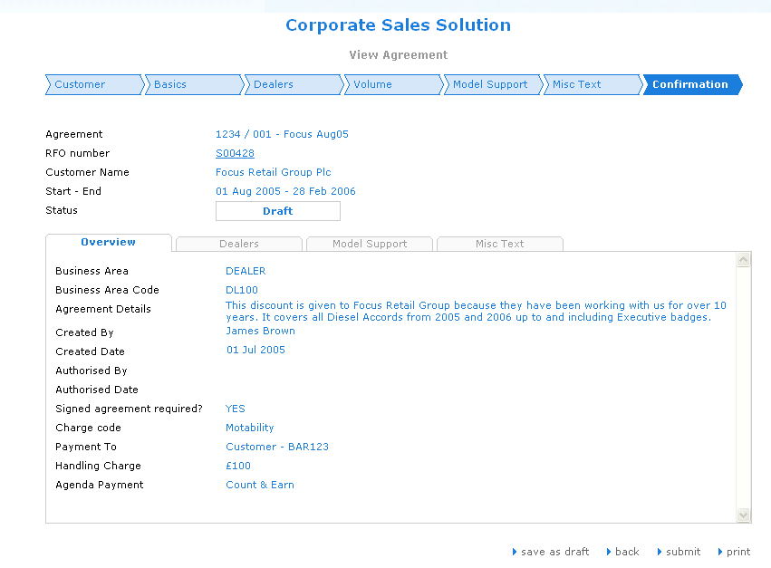

#### Data requirements

|  |  |  |  |  |  |
| --- | --- | --- | --- | --- | --- |
| Field Name | Mandatory | Control Type | Data Type | Rules | Screen |
| **Output** | | | | | |
| Agreement | Yes | Label | Text | Read only | View Agreement |
| RFO number | Yes | Link | Text |  | View Agreement |
| Customer Name | Yes | Label | Text | Read only | View Agreement |
| Start - End | Yes | Label | Text | Read only | View Agreement |
| Status | Yes | Label | Text | Read only | View Agreement |
| Agreement Signed | Yes | Label | Text | Read only | View Agreement |
| Business Area | Yes | Label | Text | Read only | View Agreement |
| Business Area Code | Yes | Label | Text | Read only | View Agreement |
| Agreement Details | Yes | Label | Text | Read only | View Agreement |
| Created By | Yes | Label | Text | Read only | View Agreement |
| Created Date | Yes | Label | Text | Read only | View Agreement |
| Authorised By | Yes | Label | Text | Read only | View Agreement |
| Authorised Date | Yes | Label | Text | Read only | View Agreement |
| Signed agreement required? | Yes | Label | Text | Read only | View Agreement |
| Charge code | Yes | Label | Text | Read only | View Agreement |
| Payment To | Yes | Label | Text | Read only | View Agreement |
| Handling Charge | Yes | Label | Text | Read only | View Agreement |
| Agenda Payment | Yes | Label | Text | Read only | View Agreement |
| Code | Yes | Label | Text | Read only | View Agreement |
| Name | Yes | Label | Text | Read only | View Agreement |
| Town | Yes | Label | Text | Read only | View Agreement |
| County | Yes | Label | Text | Read only | View Agreement |
| Year | Yes | Label | Text | Read only | View Agreement |
| Model | Yes | Label | Text | Read only | View Agreement |
| Body | Yes | Label | Text | Read only | View Agreement |
| Badge | Yes | Label | Text | Read only | View Agreement |
| Fuel | Yes | Label | Text | Read only | View Agreement |
| Engine | Yes | Label | Text | Read only | View Agreement |
| Transmission | Yes | Label | Text | Read only | View Agreement |
| Euro options | Yes | Label | Text | Read only | View Agreement |
| Num Models | Yes | Label | Text | Read only | View Agreement |
| Banding value 1 | Yes | Label | Text | Read only | View Agreement |
| Banding value n | Yes | Label | Text | Read only | View Agreement |
| Ant. Vol. | Yes | Label | Text | Read only | View Agreement |
| MP FOC | Yes | Label | Text | Read only | View Agreement |
| Credit Note Comments | Yes | Text area | Text | Read only | View Agreement |
| Support Justification | Yes | Text area | Text | Read only | View Agreement |

### UC15: Search agreement

This function allows the user search an agreement by a search criteria or combined criteria.

#### Actors in UC15

* All users

#### Pre-condition

* N/A

#### System Administrator Functional description

|  |  |  |
| --- | --- | --- |
| ID | Description | Comments |
| UC15_001 | Clicks on ‘Search’ link on the sub menu, the ‘search agreement’ page is displayed with search criteria |  |
| UC15_002 | Input search criteria in the free text and clicks on ‘search’ button, if exist information database The results are displayed on the screen else the system show message ( Unicode support  date format is ddMMyyyy) | It should be to sort within the returned results. |
| UC15_003 | User select only one agreement |  |
| UC15_004 | Clicks on the CSM name then Use UC ’CSM’ |  |
| UC15_005 | Clicks on the ‘copy agreement’ button , the ‘Copy agreement’ page is displayed to copy existing agreement details to create a new agreement/ variant or mark it as received. User use UC ‘ Copy Agreement’ |  |
| UC15_006 | Clicks on the ‘Agreement audit history’ button Use UC ‘View Audit history’ |  |
| UC18_007 | Clicks on the ‘view agreement’, the ‘View agreement’ page is displayed with information of this agreement |  |

#### UML Activity diagram



#### Screen flow

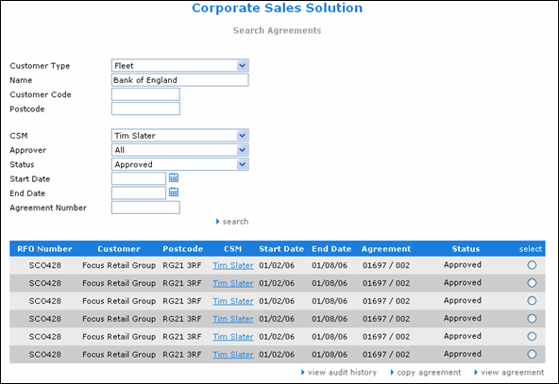

#### Data requirements

|  |  |  |  |  |  |
| --- | --- | --- | --- | --- | --- |
| Field Name | Mandatory | Control Type | Data Type | Rules | Screen |
| **Input** | | | | | |
| Customer Type | Yes | Combo box | Text |  | Search Agreement |
| Name | Yes | Combo box | Text |  | Search Agreement |
| Customer Code | Yes | Text box | Text |  | Search Agreement |
| Postcode | Yes | Text box | Text |  | Search Agreement |
| CSM | Yes | Combo box | Text |  | Search Agreement |
| Approver | Yes | Combo box | Text |  | Search Agreement |
| Status | Yes | Combo box | Text |  | Search Agreement |
| Start date | Yes | Text box | Date/ Time | Format : ddMMyyyy | Search Agreement |
| End date | Yes | Text box | Date/ Time | End date > start date  Format : ddMMyyyy | Search Agreement |
| Agreement Number | Yes | Text box | Text |  | Search Agreement |
| **Output** | | | | | |
| RFO Number | Yes | Label | Text | Read only | Search Agreement |
| Customer | Yes | Label | Text | Read only | Search Agreement |
| Postcode | Yes | Label | Text | Read only | Search Agreement |
| CSM | Yes | Link | Text |  | Search Agreement |
| Start date | Yes | Label | Date/time | Read only | Search Agreement |
| End date | Yes | Label | Date/time | Read only | Search Agreement |
| Agreement | Yes | Label | Text | Read only | Search Agreement |
| Status | Yes | Label | Text | Read only | Search Agreement |