1. **Organisation**
2. **Class Diagram**

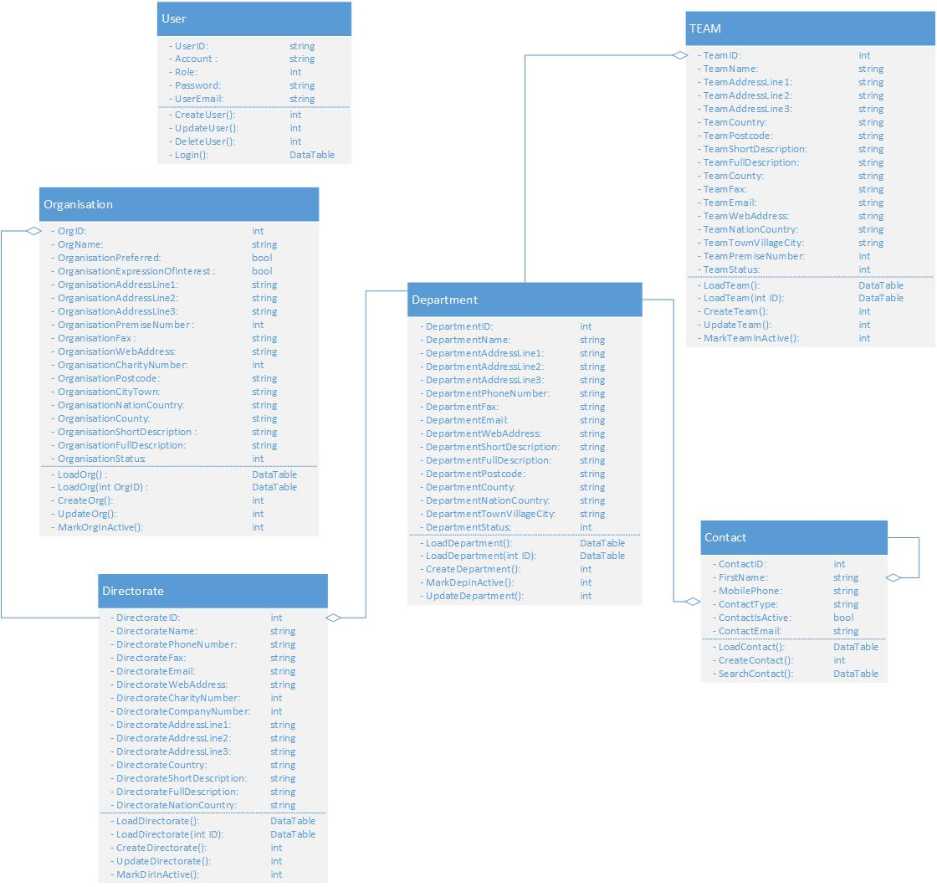

1. **Sequence Diagram**
2. **List Organisation Information**



1. **Add Organisation**



1. **Amend Organisation**



1. **Mark In-active Organisation**



1. **Screen**
2. **List Screen**
3. **Main Flow**

|  |  |
| --- | --- |
| **Screen** | Organisation Information Maintenance – List |
| **Description** | Display all Organisation information. |
| **Screen Access** | Users click on **Organisations** from the menu, ‘Organisation List’ screen is displayed. By selecting an active Organisation from the list to Amend, Organisation tab will be displayed. User select an active Directorate to Amend, after that Organisation tab displaying with Directorate Details. |

1. **User Interface**

* Filter section :
* List data section

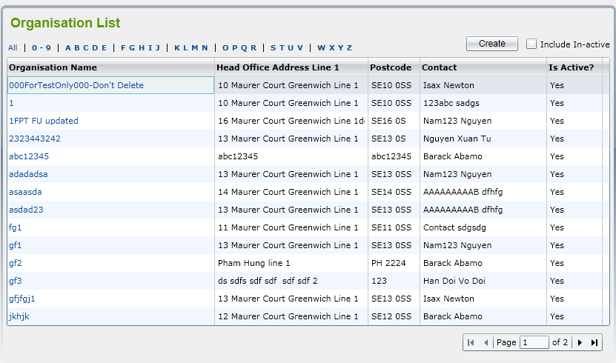

1. **Validation Rule / Data mapping**

|  |  |  |
| --- | --- | --- |
| **Field** | **Type** | **Description** |
| Filter | Dropdown list | * List item option for filter * Click an item to display Organisation Name (such as by All, by 0-9, … |
| Create | HtmlActionLink | * Allow user move to Organisation Detail and input Organisation information to save in Database |
| Include In-active | HtmlCheckbox | Load All Organisation List both Active and In-active. |
| Grid Data | jqGrid | * Display some Organisation information as a grid |
|  |  |  |
| Paging | jqGrid Pager | Easily jump to the page where user want |

1. **Add Screen**
2. **Main Flow**

|  |  |
| --- | --- |
| **Screen** | Organisation Details – Organisation Tab – **Create** button |
| **Description** | Allow Administrator to **add** new Departments. |
| **Screen Access** | Users click on the button **Save** on list Organisation screen |

1. **User Interface**

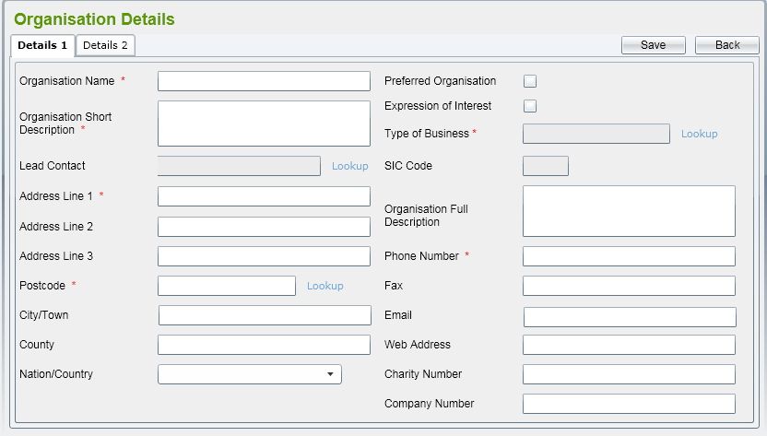

1. **Validation Rule / Data mapping**

|  |  |  |
| --- | --- | --- |
| **Field** | **Type** | **Description** |
| Organisation Name | HtmlTextbox | * Organisation Name * Must be String (100), is mandatory * Insert to field in DB: Organisation Name |
| Organisation Short Description | HtmlTextarea | * Short description of Organisation * Must be String (max), is mandatory * Insert into field in DB: Organisation ShortDescription |
| Lead Contact | HtmlTextbox | * Manager of Organisation * Must be number ID (lookup from Contact list) * Insert into field in DB: ContactID |
| Copy Address from:  - Organisation  - Parent | HtmlRadiobuton |  |
| Address Line 1 | HtmlTextbox | * Address Line 1 of Organisation * Must be String (max) with email format eg.vietnv@gmail.com * Insert into field in DB: Organisation AddressLine1 |
| Address Line 2 | HtmlTextbox | * Address Line 2 of Organisation * Clear all inputted data * Insert into field in DB: Organisation AddressLine2 |
| Address Line 3 | HtmlTextbox | * Address Line 3 of Department * Insert new record in database * Insert into field in DB: DepartmentAddressLine3 |
| Postcode | HtmlTextbox | * Postcode of Organisation * Cancel to add new and back to list screen * Insert into field in DB: Organisation Postcode |
| Lookup | HtmlActionLink | * Lookup reference data such as Contact of Organisation * Return Id of data ref |
| Town/Village/City | HtmlTextbox | * Organisation in Town/Village/City * Must be String (max) * Insert into field in DB: Organisation Town/Village/City |
| County | HtmlTextbox | * Organisation in County * Must be String (max) * Insert into field in DB: Organisation County |
| Nation/Country | HtmlDropdown list | * Country Name – Country Code * Value default is ‘All’ * Display both name and code but name first, value is code * Mapping to field in DB: CountryID, CoutryName |
| Type of Business | HtmlTextbox | * Type Business of Organisation * Defaulted values retrieved from Organisation that it belongs to |
| SIC Code | HtmlTextbox | * SIC code of Organisation * Defaulted values retrieved from Organisation that it belongs to. |
| Organisation Full Description | HtmlTextarea | * Full Description of Organisation * Must be String (max) * Insert into field in DB: Organisation FullDescription |
| Phone Number | HtmlTextbox | * Phone Number of Organisation * Must be numeric (20) with phone format only number * Insert into field in DB: Organisation PhoneNumber |
| Fax | HtmlTextbox | * Fax of Department * Must be numeric (20) with fax format only number * Insert into field in DB: Organisation Fax |
| Email | HtmlTextbox | * Email of Department * Must be String (max) with email format example@gmail.com * Insert into field in DB: Organisation Email |
| Web Address | HtmlTextbox | * Web Address of Organisation * Defaulted values retrieved from Organisation that it belongs to |
| “Save” button | Button | * Allow user save Organisation information to Database |
| “Back” HtmlActionLink | HtmlActionLink | * Allow user return to Organisation List Screen |

1. **Amend Screen**
2. **Main Flow**

|  |  |
| --- | --- |
| **Screen** | Organisation Details – Organisation Tab – Selecting an Organisation item from List Organisation |
| **Description** | Allow Administrator to **amend** new Organisation. |
| **Screen Access** | Users click on the button **Save** on list Organisation screen |

1. **User Interface**

* All fields in ‘Details’ tab can be editable.
* Besides, there should be ‘Teams’ tab displaying. Refer to List Teams (detail in List Teams Detailed Design)for more details.

1. **Validation Rule / Data mapping**

* Validation rules are the same as adding Organisation.

1. **Mark In-active a** Organisation
2. **Main Flow**

|  |  |
| --- | --- |
| **Screen** | Organisation Details – Organisation Tab – Selecting an Organisation item from List Organisation |
| **Description** | Allow Administrator to **amend** new Organisation. |
| **Screen Access** | by clicking on **‘In-active’** button on amend Organisation screen |

1. **User Interface**

* Screen as amend Organisation

1. **Validation Rule / Data mapping**

* Id for Change status will not be null.