1. **Department Maintenance**
2. **Class Diagram**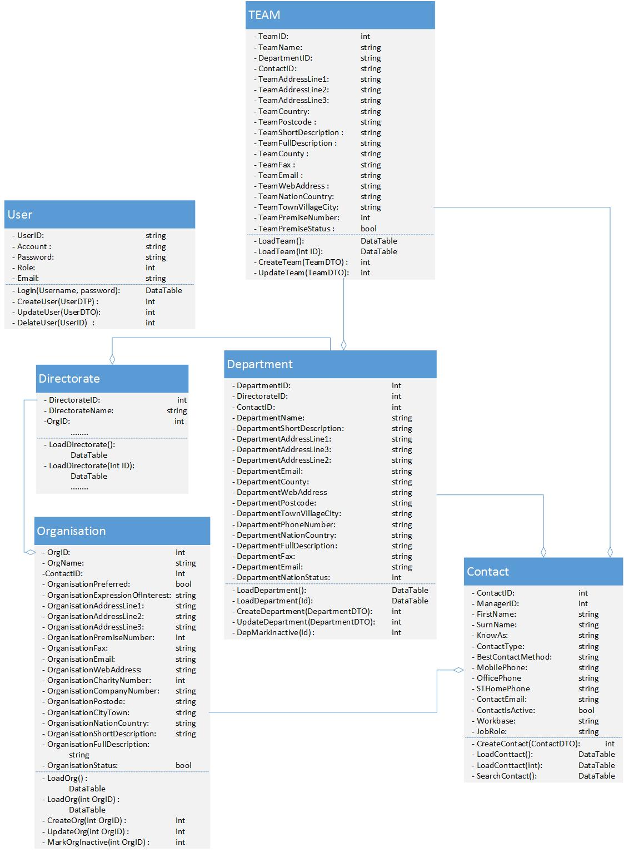
3. **Sequence Diagram**
4. **List Department Information**

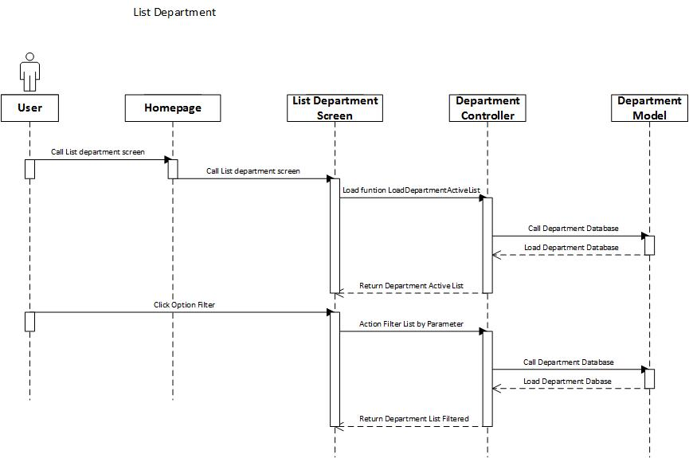

1. **Add Department**

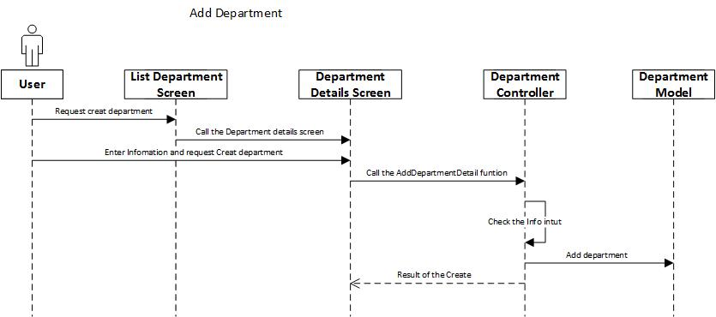

1. **Amend Department**

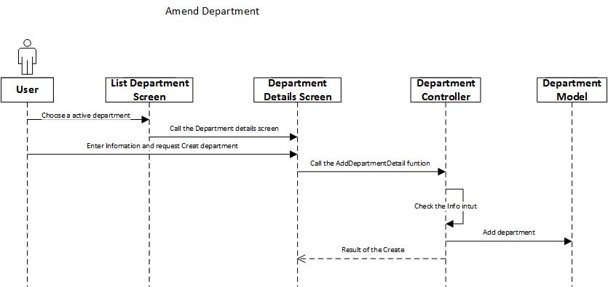

1. **Mark In-active Department**

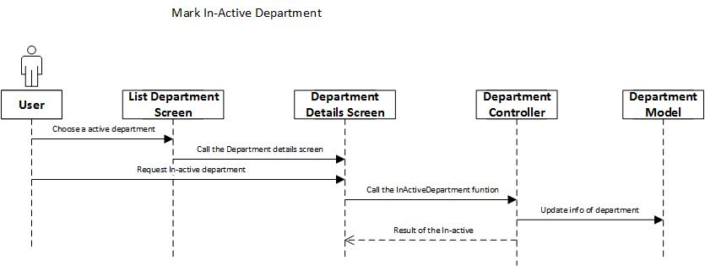

1. **Screen**
2. **List Screen**
3. **Main Flow**

|  |  |
| --- | --- |
| **Screen** | Department Information Maintenance – List |
| **Description** | Display all departments information. |
| **Screen Access** | Users click on **Organisations** from the menu, ‘Organisation List’ screen is displayed. By selecting an active Organisation from the list to Amend, **BU/Directorates** tab will be displayed. User select an active Directorate to Amend, after that **Departments** tab displaying with Directorate Details. |

1. **User Interface**

* Filter section :

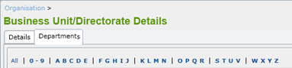

* List data section

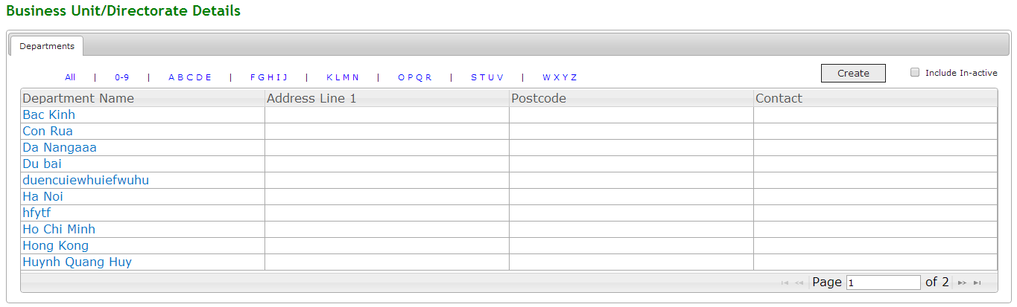

1. **Validation Rule / Data mapping**

|  |  |  |
| --- | --- | --- |
| **Field** | **Type** | **Description** |
| Filter | Dropdown list | * List item option for filter * Click an item to display Department Name (such as by All, by 0-9, … |
| Create | HtmlActionLink | * Allow user move to Department Detail and input Department information to save in Database |
| Include In-active | HtmlCheckbox | Load All Department List both Active and In-active. |
| Grid Data | jqGrid | * Display some Department information as a grid |
|  |  |  |
| Paging | jqGrid Pager | Easily jump to the page where user want |

1. **Add Screen**
2. **Main Flow**

|  |  |
| --- | --- |
| **Screen** | Business Unit/Directorate Details – Departments Tab – **Create** button |
| **Description** | Allow Administrator to **add** new Departments. |
| **Screen Access** | Users click on the button **Save** on list Department screen |

1. **User Interface**

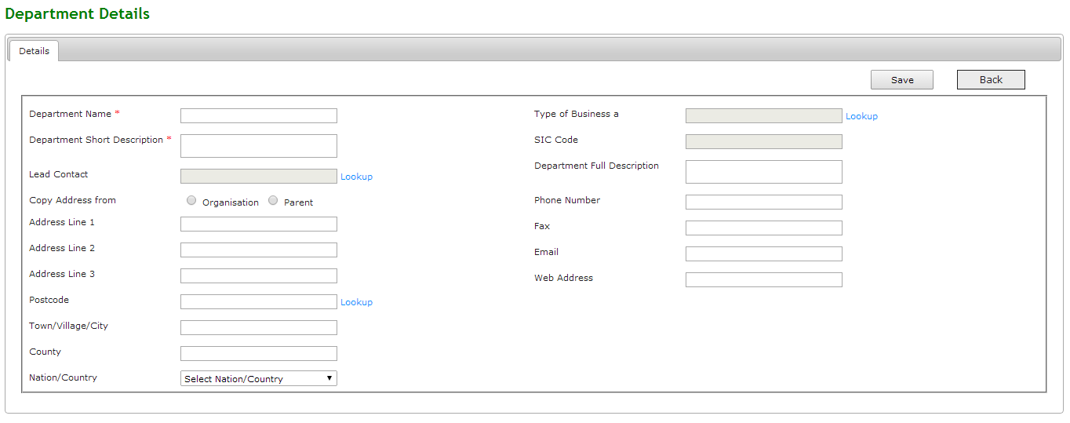

1. **Validation Rule / Data mapping**

|  |  |  |
| --- | --- | --- |
| **Field** | **Type** | **Description** |
| Department Name | HtmlTextbox | * Department Name * Must be String (100), is mandatory * Insert to field in DB: DepartmentName |
| Department Short Description | HtmlTextarea | * Short description of Department * Must be String (max), is mandatory * Insert into field in DB: DepartmentShortDescription |
| Lead Contact | HtmlTextbox | * Manager of Department * Must be number ID (lookup from Contact list) * Insert into field in DB: ContactID |
| Copy Address from:  - Organisation  - Parent | HtmlRadiobuton |  |
| Address Line 1 | HtmlTextbox | * Address Line 1 of Department * Must be String (max) with email format eg.vietnv@gmail.com * Insert into field in DB: DepartmentAddressLine1 |
| Address Line 2 | HtmlTextbox | * Address Line 2 of Department * Clear all inputted data * Insert into field in DB: DepartmentAddressLine2 |
| Address Line 3 | HtmlTextbox | * Address Line 3 of Department * Insert new record in database * Insert into field in DB: DepartmentAddressLine3 |
| Postcode | HtmlTextbox | * Postcode of Department * Cancel to add new and back to list screen * Insert into field in DB: DepartmentPostcode |
| Lookup | HtmlActionLink | * Lookup reference data such as Contact of Department * Return Id of data ref |
| Town/Village/City | HtmlTextbox | * Department in Town/Village/City * Must be String (max) * Insert into field in DB: Department Town/Village/City |
| County | HtmlTextbox | * Department in County * Must be String (max) * Insert into field in DB: DepartmentCounty |
| Nation/Country | HtmlDropdown list | * Country Name – Country Code * Value default is ‘All’ * Display both name and code but name first, value is code * Mapping to field in DB: CountryID, CoutryName |
| Type of Business | HtmlTextbox | * Type Business of Department * Defaulted values retrieved from Organisation that it belongs to |
| SIC Code | HtmlTextbox | * SIC code of Department * Defaulted values retrieved from Organisation that it belongs to. |
| Department Full Description | HtmlTextarea | * Full Description of Department * Must be String (max) * Insert into field in DB: DepartmentFullDescription |
| Phone Number | HtmlTextbox | * Phone Number of Department * Must be numeric (20) with phone format only number * Insert into field in DB: DepartmentPhoneNumber |
| Fax | HtmlTextbox | * Fax of Department * Must be numeric (20) with fax format only number * Insert into field in DB: DepartmentFax |
| Email | HtmlTextbox | * Email of Department * Must be String (max) with email format example@gmail.com * Insert into field in DB: DepartmentEmail |
| Web Address | HtmlTextbox | * Web Address of Department * Defaulted values retrieved from Organisation that it belongs to |
| “Save” button | Button | * Allow user save Department information to Database |
| “Back” HtmlActionLink | HtmlActionLink | * Allow user return to Department List Screen |

1. **Amend Screen**
2. **Main Flow**

|  |  |
| --- | --- |
| **Screen** | Business Unit/Directorate Details – Departments Tab – Selecting an Department item from List Department |
| **Description** | Allow Administrator to **amend** new Department. |
| **Screen Access** | Users click on the button **Save** on list Department screen |

1. **User Interface**

* All fields in ‘Details’ tab can be editable.
* Besides, there should be ‘Teams’ tab displaying. Refer to List Teams (detail in List Teams Detailed Design)for more details.

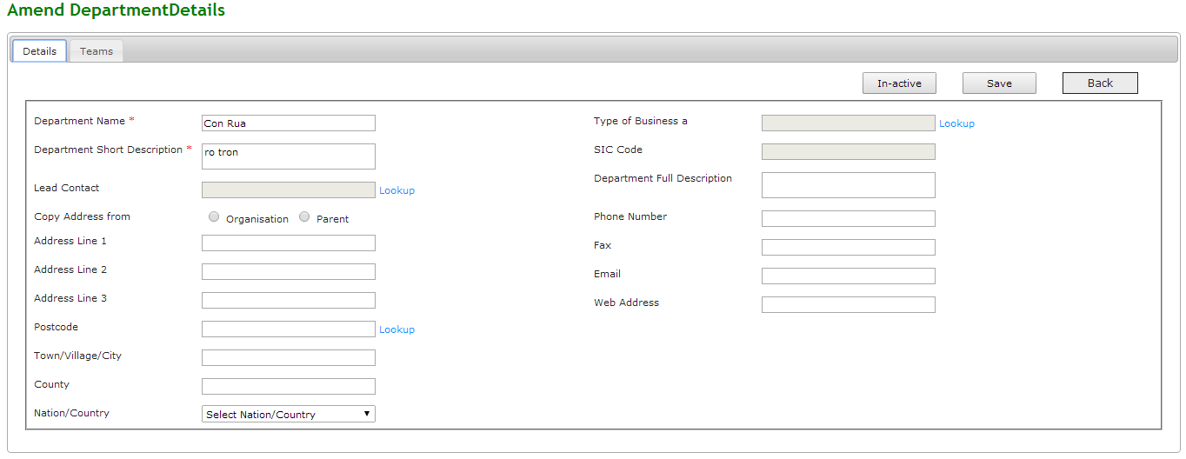

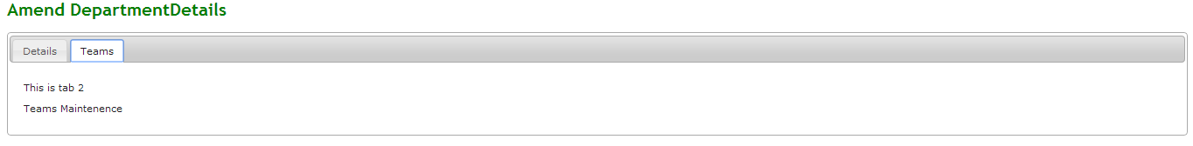

1. **Validation Rule / Data mapping**

* Validation rules are the same as adding Department.

1. **Mark In-active a Department**
2. **Main Flow**

|  |  |
| --- | --- |
| **Screen** | Business Unit/Directorate Details – Departments Tab – Selecting an Department item from List Department |
| **Description** | Allow Administrator to **amend** new Department. |
| **Screen Access** | by clicking on **‘In-active’** button on amend Department screen |

1. **User Interface**

* Screen as amend Department

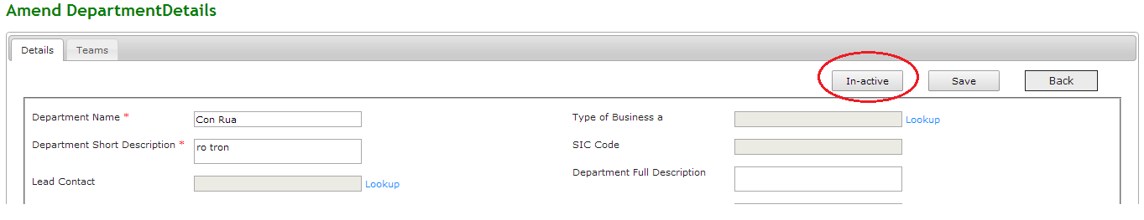

1. **Validation Rule / Data mapping**

* Id for Change status will not be null.