1. **Supporting Materials Maintenance**
2. **Class Diagram**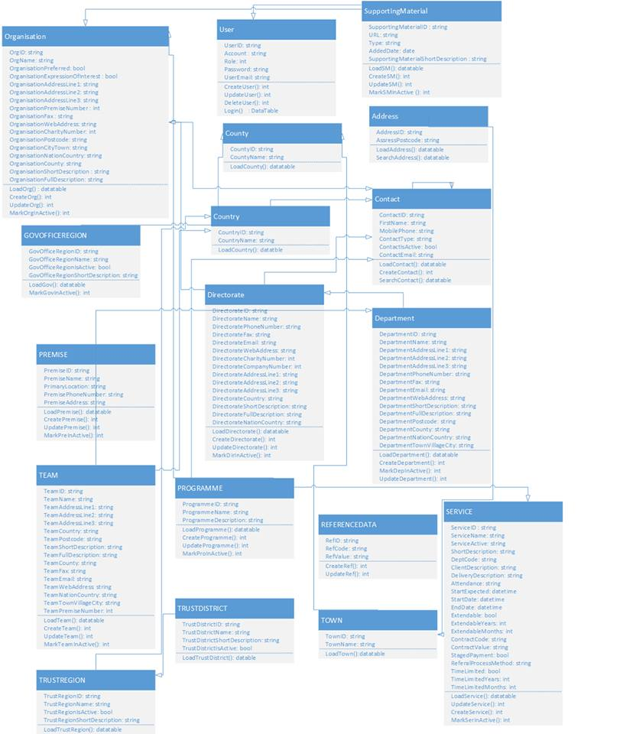
3. **Sequence Diagram**
4. **List Supporting Materials Information**

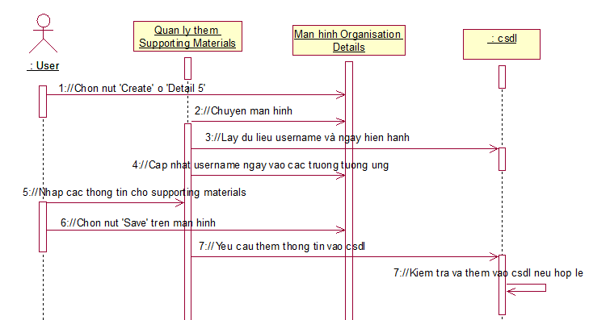

1. **Add Supporting Materials** 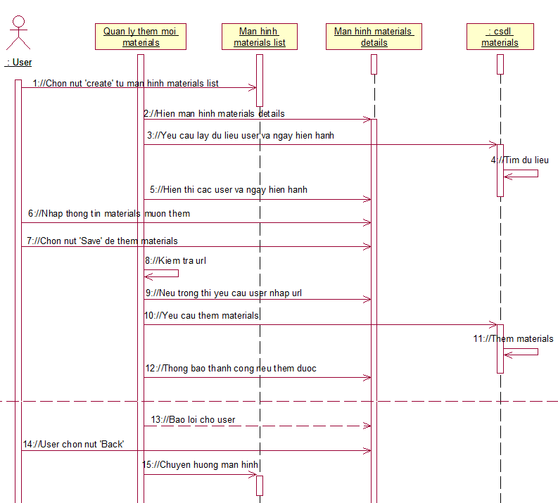
2. **Amend Supporting Materials, In- active Supporting Materials** 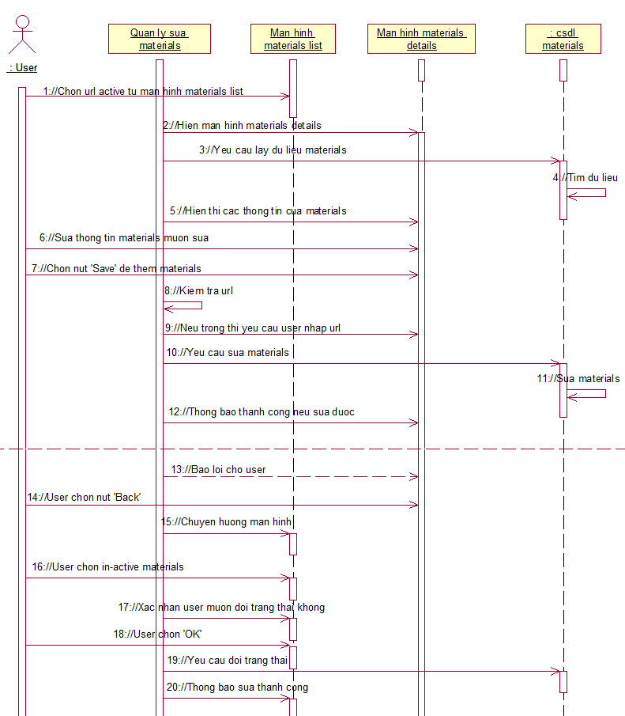
3. **Screen**
4. **List Screen**
5. **Main Flow**

|  |  |
| --- | --- |
| **Screen** | Supporting Materials Information Maintenance – List |
| **Description** | Display all Supporting Materials information except ID. |
| **Screen Access** | Users click on **Organisations** from the menu, ‘Organisation List’ screen is displayed. By selecting an active Organisation from the list to Amend, **Details 5** tab will be displayed. User select an active Directorate to Amend, after that **Supporting Materials** tab displaying with Supporting Materials **Details**. |

1. **User Interface**

* List data section

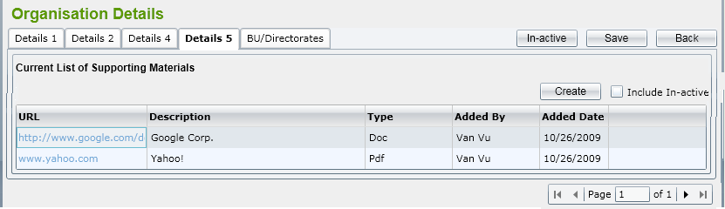

1. **Validation Rule / Data mapping**

|  |  |  |
| --- | --- | --- |
| **Field** | **Type** | **Description** |
| Create | HtmlActionLink | * Allow user move to Department Detail and input Department information to save in Database |
| Include In-active | HtmlCheckbox | * Load All Department List both Active and In-active. |
| Grid Data | jqGrid | * Display some Department information as a grid |
|  |  |  |
| Paging | jqGrid Pager | Easily jump to the page where user want |

1. **Add Screen**
2. **Main Flow**

|  |  |
| --- | --- |
| **Screen** | Details 5 – **Create** button |
| **Description** | Allow Administrator to **add** new Supporting Materials. |
| **Screen Access** | Users click on the button **Save** on Details screen |

1. **User Interface**

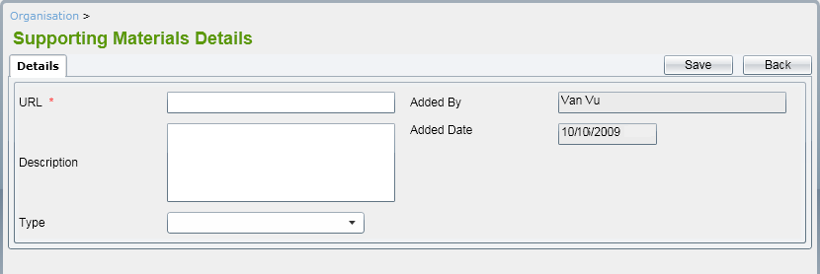

1. **Validation Rule / Data mapping**

|  |  |  |
| --- | --- | --- |
| **Field** | **Type** | **Description** |
| URL | HtmlTextbox | * URL |
| Description | HtmlTextarea | * Description of materials |
| Type | HtmlDropdown list | * Type content: Doc, Pdf, Excel |
| Added By | HtmlTextbox | * User realize create * Defaulted values retrieved when login |
| Added Date | HtmlTextbox | * Date realize create * Defaulted values retrieved from system |
| “Save” button | Button | * Allow user save Materials information to Database |
| “Back” | HtmlActionLink | * Allow user return to Materials List Screen |

1. **Amend Screen**
2. **Main Flow**

|  |  |
| --- | --- |
| **Screen** | Details Tab – Selecting an Materials item from List Materials |
| **Description** | Allow Administrator to **amend** Materials |
| **Screen Access** | Users click on the button **Save** on list Materials screen |

1. **User Interface**

* All fields in ‘Details’ tab can be editable. 



1. **Validation Rule / Data mapping**

* Validation rules are the same as adding Materials

1. **Mark In-active a Materials**
2. **Main Flow**

|  |  |
| --- | --- |
| **Screen** | Tab Details 5– Selecting an active Materials item from List Department |
| **Description** | Allow Administrator to **amend** status of Materials |
| **Screen Access** | by clicking on **‘In-active’** button on amend status of Materials screen |

1. **User Interface**

* Screen as Details 5

1. **Validation Rule / Data mapping**

* Id for Change status will not be null.