AB-SD Software Requirements Specification

MỤC LỤC

Reference 1

Overview 1

Priority 1

**1.** **Business Unit/Directorate Detail Screen => Department tab – List** **Department** 1

**1.1** **Use Case Detail** 2

**1.2** **Path of Event** 2

**2.** **Create Department and save to Database** 3

**2.1** **Use Case Detail** 3

**2.2** **Path of Event** 3

**3.** **Selecting an Department item and Amend, and save to Database** 5

**3.1** **Use Case Detail** 5

**3.2** **Path of Event** 5

**4.** **Selecting an active Department item an change status** 6

**4.1** **Use Case Detail** 6

**4.2** **Path of Event** 6

# Reference

| Title/File name | Author | Version | Effective Date |
| --- | --- | --- | --- |
| AB_SD_Software Requirements Specification [Compatibility Mode] | Customer | V 1.0 | 20/08/2015 |

# Overview

AB currently does not have a central repository for the services that they (and associated) organisation provide. This system requirements specification is part of the project to deliver a central repository called the Services Directory.

This document details the functional (within Use Case documents) requirements and non-functional requirements for the Organisation maintenance of Services Directory.

The scope of this document is for the Organisation maintenance of Services Directory, this will include any interfaces that are required.

The key features for Organisation maintenance include:

* Load Organisation list item to Organisation tab on Organisation List
* Allow user click “Create” button to add new Organisation item and save it to Database
* Select an active Organisation from the list, edit information for this Organisation and save to Database
* Change status of Organisation item.(in-Active to Active and otherwise)

All this features will be implement by user on Internet.

# Priority

| # | Functions | Priority |
| --- | --- | --- |
| 1 | Organisation Screen => Organisation tab. List Organisation | Medium |
| 2 | Create Organisation and save to Database | High |
| 3 | Selecting an Organisation item and Amend, and save to Database | High |
| 4 | Selecting an active Organisation item an change status | Medium |

1. **Organisation List Screen**

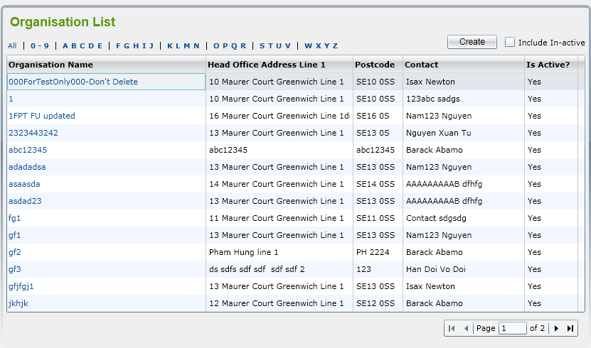

1. **Use Case Detail**

|  |  |
| --- | --- |
| Use Case Name | Organisation tab |
| Description | ‘Organisation List’ screen is displayed showing all active Organisation by default. The list is paging with 10 records showing in one page. |
| Actors | Normal User |
| Trigger(s) | User select an Directorate item to amend |
| Pre-conditions | User accesses amend Directorate item after selecting an Organisation item for amend. |
| Successful end state | The grid on screen displays active Organisation list |

1. **Path of Event**

|  |  |  |
| --- | --- | --- |
| No | Action | Response |
| 1 | User select an active Organisation item from the list on Organisation List screen for amend. | Organisation tab will displayed in Organisation Details screen. List of active Directorates will showed in this tab. |
| 2 | User select an active Directorate item from the list on Organisation tab. | Organisation Details screen will be displayed. This screen include Details tab and Organisation tab. Organisation tab show all list active Organisation on grid. |
| 3 | User select an active Organisation from list on Organisation tab. | Organisation Detail screen will be displayed. This screen include Details tab for load all and display information of Organisation with id has selected before |
| 4 | User check Include In-active checkbox | All of active and in-active Organisation will be displayed in the list. |
| 5 | User click “Create” button | Displaying Details tab within Organisation Details screen. This tab allow user input some data information for add new Organisation item to Database. |
| 6 | User click an active Organisation item from list | Organisation Detail screen display Details tab. |

1. **Create Department and save to Database**

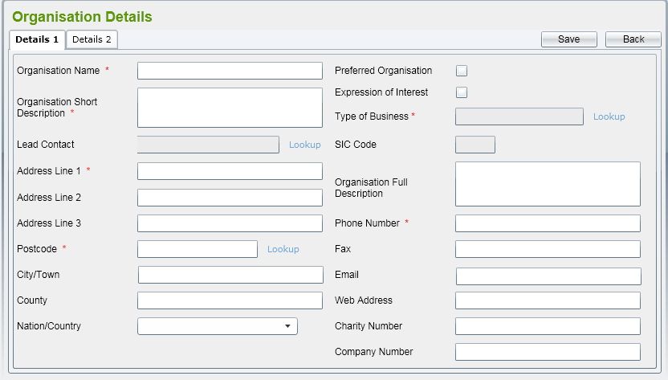

1. **Use Case Detail**

|  |  |
| --- | --- |
| Use Case Name | Details tab in Organisation Details screen |
| Description | Details tab is displayed showing all input control for user input Organisation data . |
| Actors | Normal User |
| Trigger(s) | User select must input Organisation Name and Organisation Short Description field. |
| Pre-conditions | User click “Create” button on Organisation tab in Organisation List screen. |
| Successful end state | Organisation item will save to Database and show Details tab again for User input next Organisation item. |

1. **Path of Event**

|  |  |  |
| --- | --- | --- |
| No | Action | Response |
| 1 | User click “Create” button on Organisation List screen. | ‘Organisation Details’ screen is displayed and Details to allow user to enter Organisation fields for new one.  By default, all of fields should be blank, all radio button should be un-ticked.  Type of Business, SIC Code and Web Address fields should have defaulted values retrieved from Organisation that it belongs to. |
| 2 | User enter Organisation fields on Details tab | User must enter Organisation Name and Short Description.  User can enter a new Address for Organisation (that postcode should be verified) or click on Copy from Organisation or Parent (Directorate) that Dept. belongs to.  Lead Contact lookup will display all contacts in the system in a pop-up window. Refer to Contacts for more details.  Postcode lookup will display all addresses retrieved from database in a pop-up window. Refer to Address for more details  Type of Business lookup will display all SIC Code data that already listed in reference data. Refer to Type of Business for more details. After selecting a Type of Business from pop-up window, related SIC Code will be populated to the text box under Type of Business automatically.  Nation/Country will list all of Country get from reference data. |
| 3 | User click “Save” button to Organisation record. | The system will validate mandatory fields (Organisation Name and Organisation Short Description) are already input or not and check if Organisation Name is existed in the system.  If some mandatory fields are not input, error message(s) should be displayed and adding is aborted.  If the validation is passed, Organisation record will be saved and Organisation details screen is kept to allow user to add Organisation for this Organisation. Message to inform the successful saving should be displayed as well. |
| 4 | User click “Back” button | it will come back to the Organisation List screen. |

1. **Selecting an Department item and Amend, and save to Database**

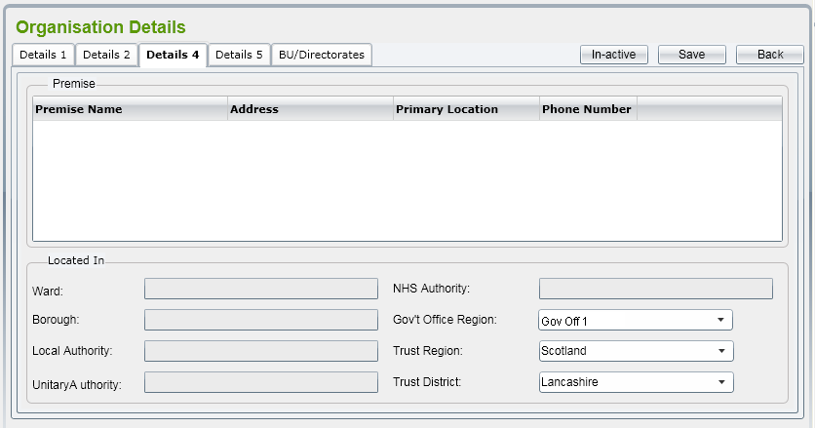

1. **Use Case Detail**

|  |  |
| --- | --- |
| Use Case Name | Details tab in Organisation Details screen |
| Description | By selecting an active Organisation from the list, ‘Organisation Details’ screen is displayed including five tabs: Details 1, 2, 4, 5 and BU/Directorate to allow user to enter Organisation fields for amend with an OrganisationID has selected before . User can amend all of fields showing in tabs. |
| Actors | Normal User |
| Trigger(s) | Organisation Id not be null.  User select must input Organisation Name and Organisation Short Description field. |
| Pre-conditions | User click “Save” button on Organisation Details screen. |
| Successful end state | Organisation item will update to Database and show Organisation Details screen. |

1. **Path of Event**

* User select an active Organisation item form list in Organisation tab within Organisation Details.
* All fields in “Details” tab can be editable. Validation rules are the same as adding Organisation.

1. **Selecting an active Department item an change status**
2. **Use Case Detail**

|  |  |
| --- | --- |
| Use Case Name | Details tab in Department Details screen |
| Description | By selecting an active Organisation from the list, ‘Organisation Details’ screen is displayed including five tabs: Details 1, 2, 4, 5 and BU/Directorate to allow user to enter Organisation fields for amend with an OrganisationID has selected before  In this screen, ‘In-active’ will be displaying with “Save” button and “Back” button |
| Actors | Normal User |
| Trigger(s) | Organisation Id not be null. |
| Pre-conditions | User select an active Organisation item from list. |
| Successful end state | Organisation item will update to Database and show Organisation Details screen. |

1. **Path of Event**

* Like as Amend Organisation
* “In-active” button will be displaying.
* If user click this button, , the prompt message “This Organisation is already in use, do you want to make this in-active?” should be displayed with two buttons “OK” and “Cancel”.
* If user clicks on ‘OK’ button, the Organisation will be changed status to ‘In-active’. Otherwise, it still keeps being ‘Active’.
* After an Organisation has been changed to ‘In-active’.