AB-SD Software Requirements Specification

MỤC LỤC

Reference 1

Overview 1

Priority 1

**1.** **Business Unit/Directorate Detail Screen => Directorate tab – List** **Directorate** 1

**1.1** **Use Case Detail** 2

**1.2** **Path of Event** 2

**2.** **Create Directorate and save to Database** 3

**2.1** **Use Case Detail** 3

**2.2** **Path of Event** 3

**3.** **Selecting an Directorate item and Amend, and save to Database** 5

**3.1** **Use Case Detail** 5

**3.2** **Path of Event** 5

**4.** **Selecting an active Directorate item an change status** 6

**4.1** **Use Case Detail** 6

**4.2** **Path of Event** 6

# Reference

| Title/File name | Author | Version | Effective Date |
| --- | --- | --- | --- |
| AB_SD_Software Requirements Specification [Compatibility Mode] | Customer | V 1.0 | 23/08/2015 |

# Overview

AB currently does not have a central repository for the services that they (and associated) organisations provide. This system requirements specification is part of the project to deliver a central repository called the Services Directory.

This document details the functional (within Use Case documents) requirements and non-functional requirements for the Directorate maintenance of Services Directory.

The scope of this document is for the Directorate maintenance of Services Directory, this will include any interfaces that are required.

The key features for Directorate maintenance include:

* Load Directorates list item to Directorates tab on Business Unit/Directorate Details
* Allow user click “Create” button to add new Directorate item and save it to Database
* Select an active Directorate from the list, edit information for this Directorate and save to Database
* Change status of Directorate item.

All this features will be implement by user on Internet.

# Priority

| # | Functions | Priority |
| --- | --- | --- |
| 1 | Business Unit/Directorate Detail Screen => Directorate tab. List Directorate | Medium |
| 2 | Create Directorate and save to Database | High |
| 3 | Selecting an Directorate item and Amend, and save to Database | High |
| 4 | Selecting an active Directorate item an change status | Medium |

1. **Business Unit/Directorate Detail Screen => Directorate tab – List** **Directorate**

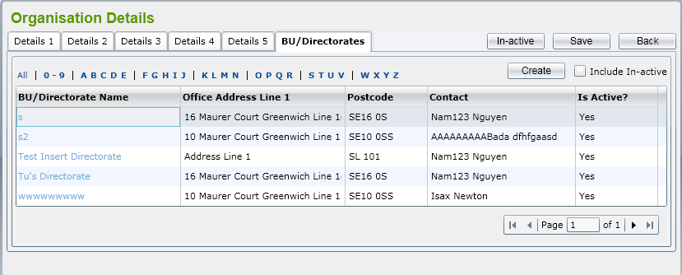

1. **Use Case Detail**

|  |  |
| --- | --- |
| Use Case Name | Directorates tab |
| Description | ‘Directorate List’ screen is displayed showing all active Directorate by default. The list is paging with 10 records showing in one page. |
| Actors | Normal User |
| Trigger(s) | User select an Directorate item to amend |
| Pre-conditions | User accesses amend Directorate item after selecting an Organisation item for amend. |
| Successful end state | The grid on screen displays active Directorate list |

1. **Path of Event**

|  |  |  |
| --- | --- | --- |
| No | Action | Response |
| 1 | User select an active Organisation item from the list on Organisation List screen for amend. | BU/Directorates tab will displayed in Organisation Details screen. List of active Directorates will showed in this tab. |
| 2 | User select an active Directorate item from the list on BU/Directorates tab. | Business Unit/Directorate Details screen will be displayed. This screen include Details tab and Directorates tab. Directorate tab show all list active Directorates on grid. |
| 3 | User select an active Directorate from list on Directorate tab. | Directorate Detail screen will be displayed. This screen include Details tab for load all and display information of Directorate with id has selected before, Teams tab also displayed for Team maintenance. |
| 4 | User check Include In-active checkbox | All of active and in-active Directorate will be displayed in the list. |
| 5 | User click “Create” button | Displaying Details tab within Directorate Details screen. This tab allow user input some data information for add new Directorate item to Database. |
| 6 | User click an active Directorate item from list | Directorate Detail screen display Details tab and Teams tab for user amend data. |

1. **Create Directorate and save to Database**

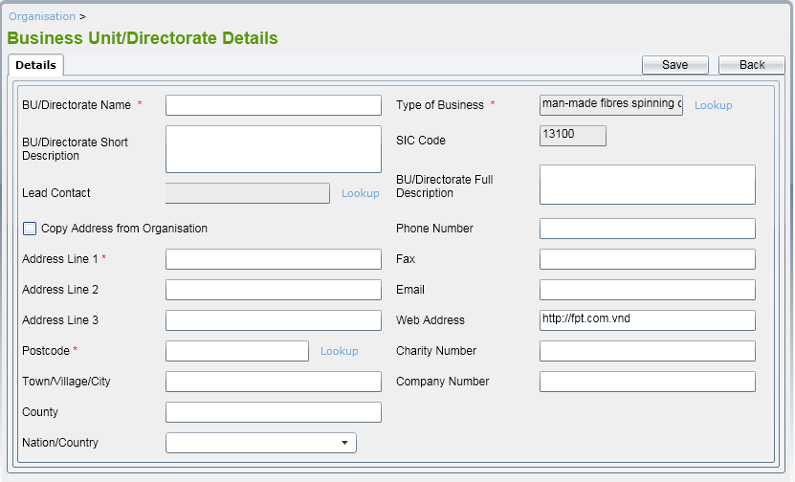

1. **Use Case Detail**

|  |  |
| --- | --- |
| Use Case Name | Details tab in Directorate Details screen |
| Description | Details tab is displayed showing all input control for user input Directorate data . |
| Actors | Normal User |
| Trigger(s) | User select must input Directorate Name and Directorate Short Description field. |
| Pre-conditions | User click “Create” button on Directorates tab in Business Unit/Directorate Details screen. |
| Successful end state | Directorate item will save to Database and show Details tab again for User input next Directorate item. |

1. **Path of Event**

|  |  |  |
| --- | --- | --- |
| No | Action | Response |
| 1 | User click “Create” button on Directorates tab in Business Unit/Directorate Details screen. | ‘Directorate Details’ screen is displayed and Details to allow user to enter Directorate fields for new one.  By default, all of fields should be blank, all radio button should be un-ticked.  Type of Business, SIC Code and Web Address fields should have defaulted values retrieved from Organisation that it belongs to. |
| 2 | User enter Directorate fields on Details tab | User must enter Directorate Name and Short Description.  User can enter a new Address for Directorate (that postcode should be verified) or click on Copy from Organisation or Parent (Directorate) that Dept. belongs to.  Lead Contact lookup will display all contacts in the system in a pop-up window. Refer to Contacts for more details.  Postcode lookup will display all addresses retrieved from database in a pop-up window. Refer to Address for more details  Type of Business lookup will display all SIC Code data that already listed in reference data. Refer to Type of Business for more details. After selecting a Type of Business from pop-up window, related SIC Code will be populated to the text box under Type of Business automatically.  Nation/Country will list all of Country get from reference data. |
| 3 | User click “Save” button to Directorate record. | The system will validate mandatory fields (Directorate Name and Directorate Short Description) are already input or not and check if Directorate Name is existed in the system.  If some mandatory fields are not input, error message(s) should be displayed and adding is aborted.  If the validation is passed, Directorate record will be saved and Directorate details screen is kept to allow user to add Directorate for this Directorate. Message to inform the successful saving should be displayed as well. |
| 4 | User click “Back” button | it will come back to the Directorate List screen. |

1. **Selecting an Directorate item and Amend, and save to Database**

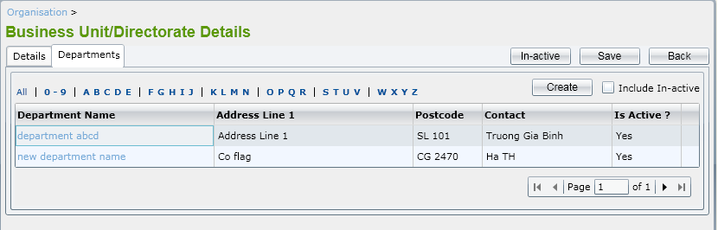

1. **Use Case Detail**

|  |  |
| --- | --- |
| Use Case Name | Details tab in Directorate Details screen |
| Description | By selecting an active Directorate from the list, ‘Directorate Details’ screen is displayed including two tabs: Details and Teams to allow user to enter Directorate fields for amend with an DirectorateID has selected before . User can amend all of fields showing in tabs. |
| Actors | Normal User |
| Trigger(s) | Directorate Id not be null.  User select must input Directorate Name and Directorate Short Description field. |
| Pre-conditions | User click “Save” button on Business Unit/Directorate Details screen. |
| Successful end state | Directorate item will update to Database and show Directorate Details screen. |

1. **Path of Event**

* User select an active Directorate item form list in Directorate tab within Business Unit/Directorate Details.
* All fields in “Details” tab can be editable. Validation rules are the same as adding Directorate.

1. **Selecting an active Directorate item an change status**
2. **Use Case Detail**

|  |  |
| --- | --- |
| Use Case Name | Details tab in Directorate Details screen |
| Description | By selecting an active Directorate from the list, ‘Directorate Details’ screen is displayed including two tabs: Details and Teams to allow user to enter Directorate fields for amend with an DirectorateID has selected before .  In this screen, ‘In-active’ will be displaying with “Save” button and “Back” button |
| Actors | Normal User |
| Trigger(s) | Directorate Id not be null. |
| Pre-conditions | User select an active Directorate item from list. |
| Successful end state | Directorate item will update to Database and show Directorate Details screen. |

1. **Path of Event**

* Like as Amend Directorate
* “In-active” button will be displaying.
* If user click this button, , the prompt message “This Directorate is already in use, do you want to make this in-active?” should be displayed with two buttons “OK” and “Cancel”.
* If user clicks on ‘OK’ button, the Directorate will be changed status to ‘In-active’. Otherwise, it still keeps being ‘Active’.
* After an Directorate has been changed to ‘In-active’, Teams still keep their status. The in-active process is not cascade.