### UC3: Copy an agreement

This function is to make a copy of an existing agreement; the status of copied agreement will be “draft”. There are three ways to create an agreement by copying:

* Create a new agreement with a new variant
* Create a new agreement with the same customer
* Create a new agreement with a new customer

#### Actors in UC3

* Dealer Proposer (Restricted to discounts proposed by the dealership)
* CSM/ LSM (Restricted to discounts proposed by the CSM / LSM)
* System Administrator
* Corporate Mgmt Team
* Corporate Sales Admin

#### Pre-condition

- After executing UC search agreement.

#### Functional description

|  |  |  |
| --- | --- | --- |
| ID | Description | Comments |
| UC3_001 | User selects an agreement from the search result then click on “copy agreement” button |  |
| UC3_002 | User chooses to create new agreement from the selected agreement by:  + Clicks on “new agreement with…” button to create new agreement for the customer information in the selected agreement.  + Clicks on “duplicate this agreement for a new customer” button to create new agreement using the same details of the selected agreement for a new customer.  + Clicks on “duplicate this agreement with a new variant” to create a new variant of the selected agreement. System will create new agreement (with new agreement number or new variant number) using the same details as the selected agreement then add an entry to audit trail. |  |
| UC3_003 | All the fields of new agreement should be populated but editable. If different customer some fields should not be populated e.g. AMIS account code. User proceeds with the wizard with all the steps to create a new agreement, user can update any information and save the new agreement at anytime |  |
| UC3_004 | User clicks on “submit” or “save as draft” button to finish |  |

#### UML Activity diagram



#### Screen flow

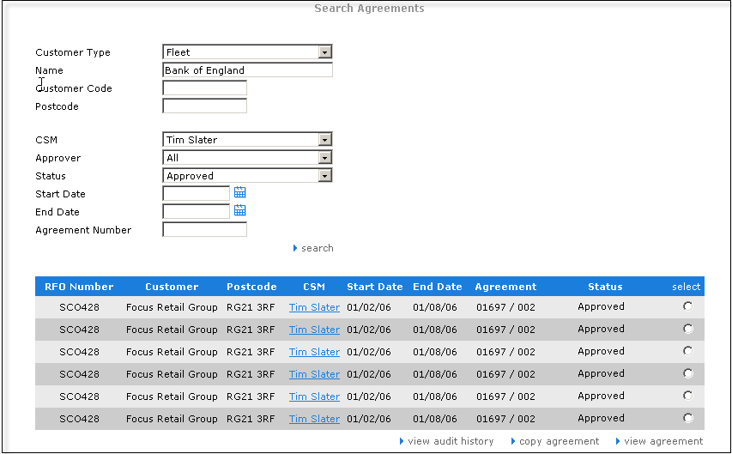

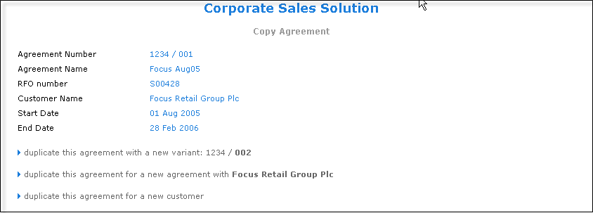

#### Data requirements

|  |  |  |  |  |  |
| --- | --- | --- | --- | --- | --- |
| Field name | Mandatory | Control Type | Data Type | Rules | Screen |
| **Output** | | | | | |
| Agreement number | Yes | Label | Text |  | Copy agreement |
| Agreement name | Yes | Label | Text |  | Copy agreement |
| RFO number | Yes | Label | Text |  | Copy agreement |
| Customer name | Yes | Label | Text |  | Copy agreement |
| Start date | Yes | Label | Date/Time | Format date: day/month/year | Copy agreement |
| End date | Yes | Label | Date/Time | Format date: day/month/year | Copy agreement |