# Exercise 1: ERD

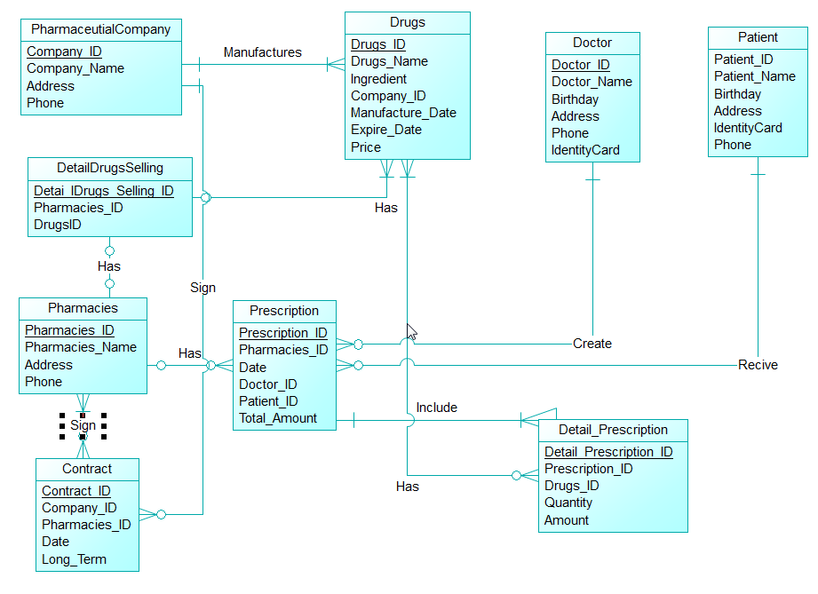

# Exercise 2: Database

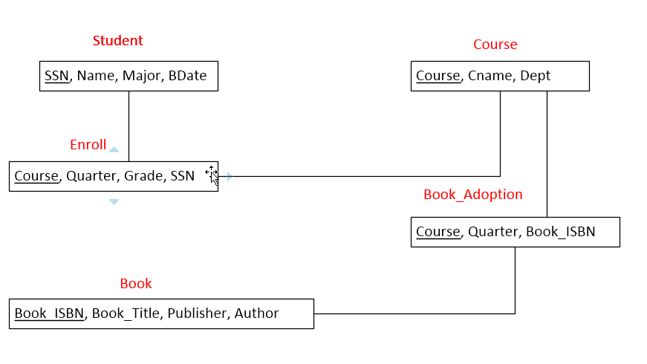

# Exercise 3: Data Types

|  |  |  |
| --- | --- | --- |
| Column | Data Type | Description |
| ID | int | Primary Key of the table, each time a record is inserted into the table this column is incresed by 1. |
| Name | Varchar | A string in English |
| Code | Char[5] | An alphanumeric code that has five characters |
| ModifiedDate | Date | The datetime of the last modification. |

# Exercise 4: Data Types (2)

|  |  |  |
| --- | --- | --- |
| Column | Data type | Description |
| ID | int | Primary Key of the table, each time a record is inserted into the table this column is incresed by 1. |
| Name | Nvarchar | A string in any language. |
| BirthDate | Date | Date of birth |
| Gender | Char | Integer, 0: Male, 1: Female, NULL: Unknown |
| IsDeletedFlag | Boolean | 0 means active, 1 means deleted. |