**ASSIGNMENT01**

**ASSIGNMENT01-OPT1**

## Assignment 1: Stack

**Objective**:

**Problem Description**:

Create the MyStack class with following info:

* Properties
  + stackValues, contain value of the stack
* Methods
  + push(): Push a value to the stack
  + pop(): Pop a value out from the stack
  + get(): Get a value from the stack

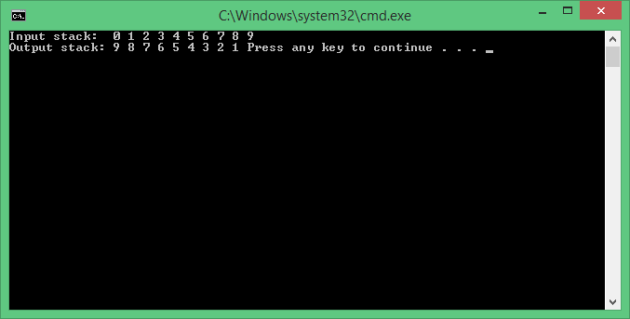

## Assignment 2: Playing cards

**Objective**:

**Problem Description**:

Write code:

* Write a class whose instances represent a single playing card from a deck of cards. Playing cards have two distinguishing properties: **rank** and **suit**.
* Write a class whose instances represent a **full deck** of cards.
* Write a small program to test your deck and card classes. The program can be as simple as creating a deck of cards and displaying its cards.

