**ASSIGNMENTS 01-OPT2**

**QUESTION 1:**

Relational schema diagram:

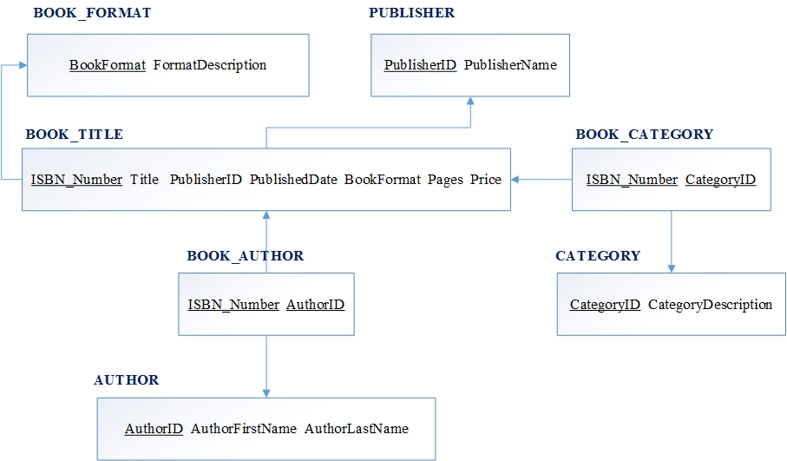

**QUESTION 2:**

Given the project table with following initial structure

|  |  |  |  |  |  |  |  |  |
| --- | --- | --- | --- | --- | --- | --- | --- | --- |
| **Project Code** | **Project Title** | **Project Manager** | **Project Budget** | **Employee No.** | **Employee Name** | **Department No.** | **Department Name** | **Hourly Rate** |
| PC010 | Pensions System | M Phillips | 24500 | S10001 | A Smith | L004 | IT ) | 22.00 |
| PC010 | Pensions System | M Phillips | 24500 | S10030 | L Jones | L023 | Pensions | 18.50 |
| PC010 | Pensions System | M Phillips | 24500 | S21010 | P Lewis | L004 | IT | 21.00 |
| PC045 | Salaries System | H Martin | 17400 | S10010 | B Jones | L004 | IT | 21.75 |
| PC045 | Salaries System | H Martin | 17400 | S10001 | A Smith | L004 | IT | 18.00 |
| PC045 | Salaries System | H Martin | 17400 | S31002 | T Gilbert | L028 | Database | 25.50 |
| PC045 | Salaries System | H Martin | 17400 | S13210 | W Richards | L008 | Salary | 17.00 |
| PC064 | HR System | K Lewis | 12250 | S31002 | T Gilbert | L028 | Database | 23.25 |
| PC064 | HR System | K Lewis | 12250 | S21010 | P Lewis | L004 | IT | 17.50 |
| PC064 | HR System | K Lewis | 12250 | S10034 | B James | L009 | HR | 16.50 |

1. Table structure to the **first**, **second** and **third** normalization forms

* NF1:
* PROJECT _JOIN(PROJECT_ID, PROJECT_TITLE, PROJECT_MANAGER , PROJECT_BUDGET, EMPLOYEE_NO, HOURLY_RATE**)**
* EMPLOYEE (EMPLOYEE_ID , DEPARTMENT_ID , DEPARTMENT_NAME**)**
* NF2:
* PROJECT_JOIN(**)**PROJECT_ID, PROJECT_TITLE, PROJECT_MANAGER , PROJECT_BUDGET, EMPLOYEE_ID, DEPARTMENT_ID)
* DEPARTMENT(DEPARTMENT_ID, DEPARTMENT_NAME, HOURLY_RATE**)**
* EMPLOYEE(EMPLOYEE_ID, EMPLOYEE_NAME**)**
* NF3:
* PROJECT_JOIN(PROJECT_ID, PROJECT_TITLE, PROJECT_MANAGER , PROJECT_BUDGET, EMPLOYEE_ID)
* PROJECT_ DEPARTMENT (EMPLOYEE_ID, DEPARTMENT_ID)
* DEPARTMENT(DEPARTMENT_ID, DEPARTMENT_NAME, HOURLY_RATE)
* EMPLOYEE(EMPLOYEE_ID, EMPLOYEE_NAME)

1. Relational schema diagram for the tables defined in the third normalization form:

