**ASSIGNMENTS 02-OPT01**

**Q1**: Create the tables (with the most appropriate/economic field/column constraints & types) and add at least 10 records into each created table.

create database Fsoft

GO

USE Fsoft

GO

CREATE TABLE TRAINEE

(

ID CHAR(7) PRIMARY KEY,

FULL_NAME varchar(40) NULL,

BIRTH_DATE SMALLDATETIME NULL,

GENDER VARCHAR(20) NULL,

ET_IQ INT NULL,

ET_GMATH INT NULL,

ET_ENGLISH INT NULL,

TRAINING_CLASS CHAR(7),

EVALUATION_NOTES varchar(100) NULL,

)

ALTER TABLE TRAINEE ADD CONSTRAINT CHECK_G CHECK(GENDER = 'Nam' Or GENDER = 'Nu')

ALTER TABLE TRAINEE ADD CONSTRAINT CHECK_IQ CHECK(ET_IQ >= 0 Or ET_IQ <= 20)

ALTER TABLE TRAINEE ADD CONSTRAINT CHECK_GMATH CHECK(ET_GMATH >= 0 Or ET_GMATH <= 20)

ALTER TABLE TRAINEE ADD CONSTRAINT CHECK_ENG CHECK(ET_ENGLISH >= 0 Or ET_ENGLISH <= 50)

insert into TRAINEE values ('1','Nguyen Van A','1960/10/22','Nam',10,16,20, '01','')

insert into TRAINEE values ('2','Nguyen Van B','1990/10/22','Nu',20,20,50, '02','')

insert into TRAINEE values ('3','Nguyen Van C','1980/10/22','Nam',10,16,20, '03','')

insert into TRAINEE values ('4','Nguyen Van D','1983/10/22','Nam',10,10,20, '04','')

insert into TRAINEE values ('5','Nguyen Van E','1985/10/22','Nam',20,20,30, '05','')

insert into TRAINEE values ('6','Nguyen Van F','1963/10/22','Nu',10,4,20, '06','')

insert into TRAINEE values ('7','Nguyen Van G','1980/10/22','Nam',10,16,20, '07','')

insert into TRAINEE values ('8','Nguyen Van H','1990/10/22','Nam',5,6,20, '01','')

insert into TRAINEE values ('9','Nguyen Van I','1984/10/22','Nu',10,16,30, '04','')

insert into TRAINEE values ('10','Nguyen Van J','1980/10/22','Nam',20,16,20, '08','')

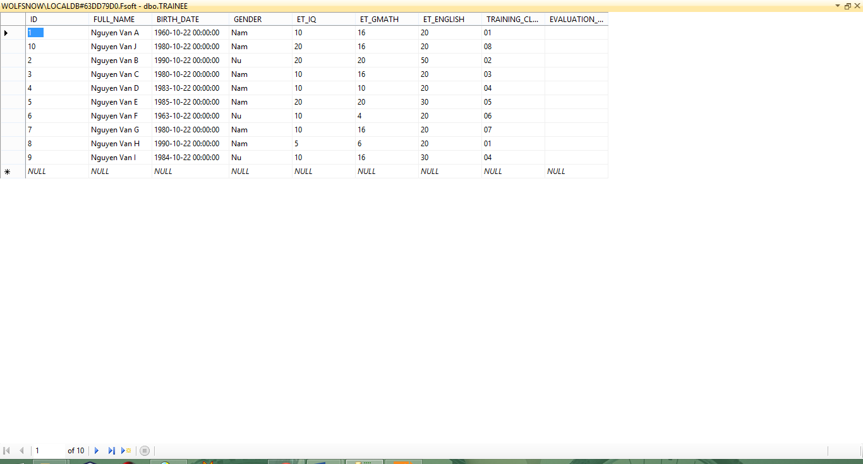

**Q2**: Change the table TRAINEE to add one more field named Fsoft_Account which is a not-null & unique field.

ALTER TABLE TRAINEE ADD Fsoft_Account CHAR(12)

ALTER Table TRAINEE alter column Fsoft_Account nchar(50) not null

ALTER TABLE TRAINEE ADD CONSTRAINT PK_f UNIQUE(Fsoft_Account)

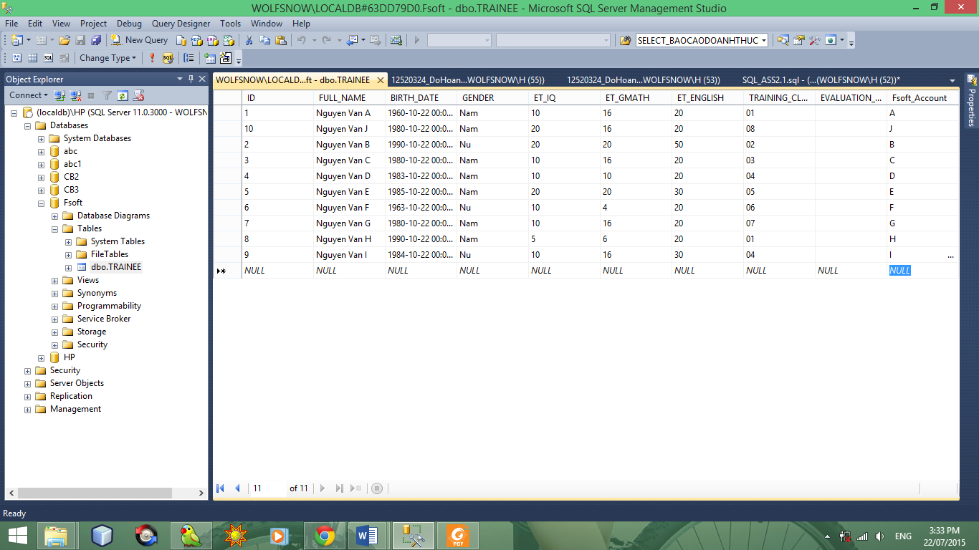

**Q3**: Create a VIEW which includes all the ET-passed trainees. One trainee is considered as ET-passed when he/she has the entry test points satisfied below criteria:

GO

SELECT ID, FULL_NAME, ET_IQ,ET_GMATH,ET_ENGLISH

FROM TRAINEE

WHERE TRAINEE.ET_IQ + TRAINEE.ET_GMATH >=20 AND

TRAINEE.ET_IQ >=8 AND TRAINEE.ET_GMATH >= 8 AND

TRAINEE.ET_ENGLISH >=18

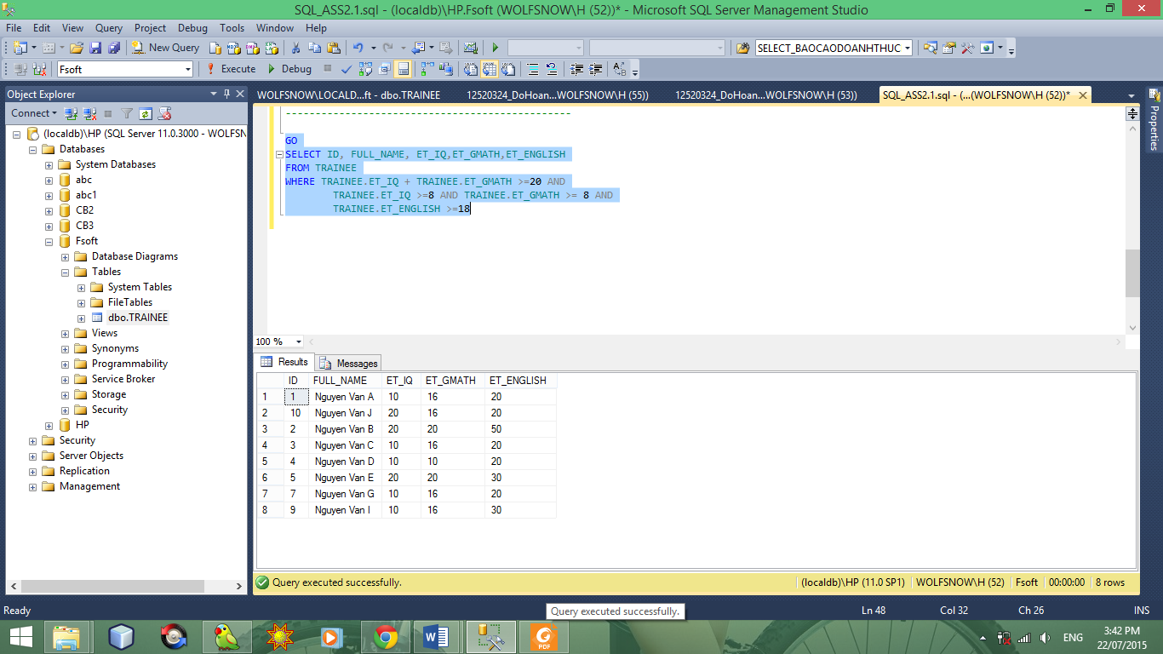

**Q4**: Query all the trainees who is passed the entry test, group them into different birth months.

GO

SELECT MONTH(BIRTH_DATE) [THÁNG]

FROM TRAINEE

WHERE TRAINEE.ET_IQ + TRAINEE.ET_GMATH >=20 AND

TRAINEE.ET_IQ >=8 AND TRAINEE.ET_GMATH >= 8 AND

TRAINEE.ET_ENGLISH >=18

GROUP BY MONTH(BIRTH_DATE)

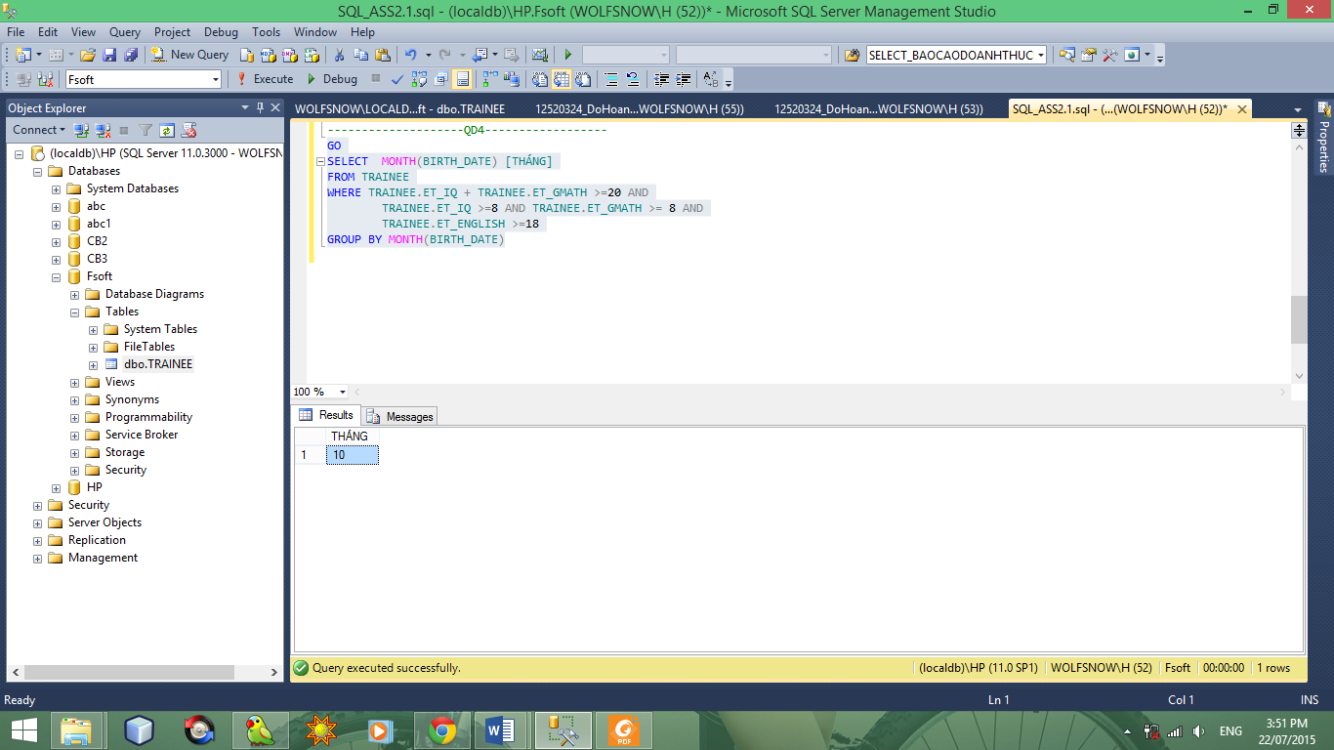

**Q5**: Query the trainee who has the longest name, showing his/her age along with his/her basic information (as defined in the table)

GO

SELECT LEN(FULL_NAME),ID ,FULL_NAME, BIRTH_DATE,GENDER,ET_IQ ,ET_GMATH ,ET_ENGLISH ,TRAINING_CLASS, DateDiff( YEAR, BIRTH_DATE , GetDate())[AGE]

FROM TRAINEE

GROUP BY LEN(FULL_NAME),ID ,FULL_NAME, BIRTH_DATE,GENDER,ET_IQ ,ET_GMATH ,ET_ENGLISH ,TRAINING_CLASS

HAVING LEN(TRAINEE.FULL_NAME) =

(

SELECT TOP 1 LEN(TRAINEE.FULL_NAME)

FROM TRAINEE

ORDER BY LEN(TRAINEE.FULL_NAME) DESC

)

