**ASSIGNMENTS 02-OPT3**

-------------------------------------------------------------------------------------------------------------

---------------------------------------------Exercise 2------------------------------------------------------

-------------------------------------------------------------------------------------------------------------

**Query 1:** Write a query that retrieves the columns ProductID, Name, Color and ListPrice from the Production.Product table, with no filter. Your result set should look something like the following.

---------------------QUERY 1----------------------

SELECT A.PRODUCTID, A.NAME, A.COLOR, A.LISTPRICE

FROM PRODUCTION.PRODUCT A

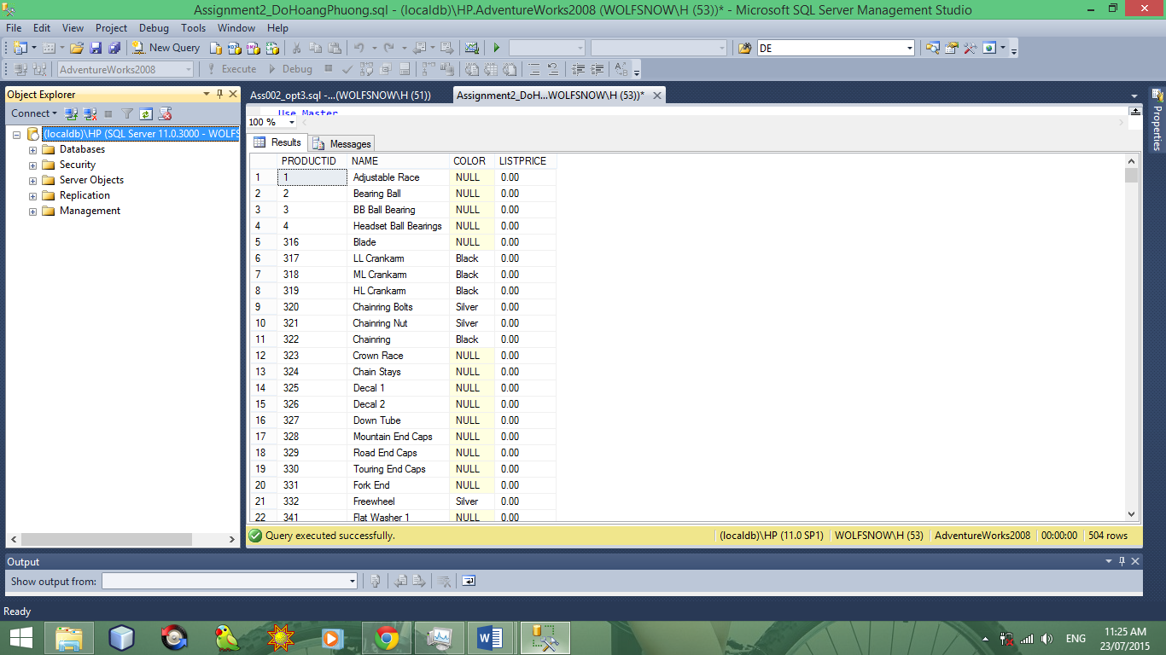

**Query 2:** Continue to work with the previous query and exclude those rows that are 0 for the column ListPrice. Your result set should look something like the following.

SELECT A.PRODUCTID, A.NAME, A.COLOR, A.LISTPRICE

FROM PRODUCTION.PRODUCT A

WHERE A.ListPrice <> 0

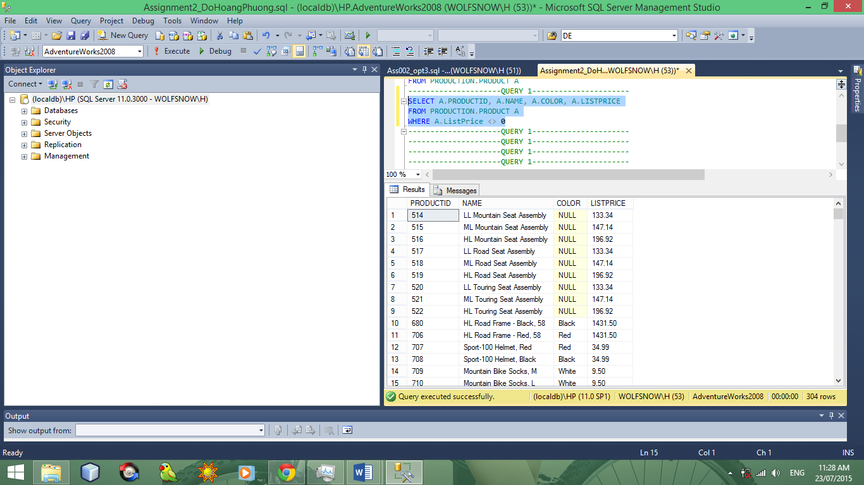

**Query 3:** Use the same query, but this time you just want to see the rows that are NULL for the Color column. Your result set should look something like the following.

SELECT A.PRODUCTID, A.NAME, A.COLOR, A.LISTPRICE

FROM PRODUCTION.PRODUCT A

WHERE A.COLOR IS NULL

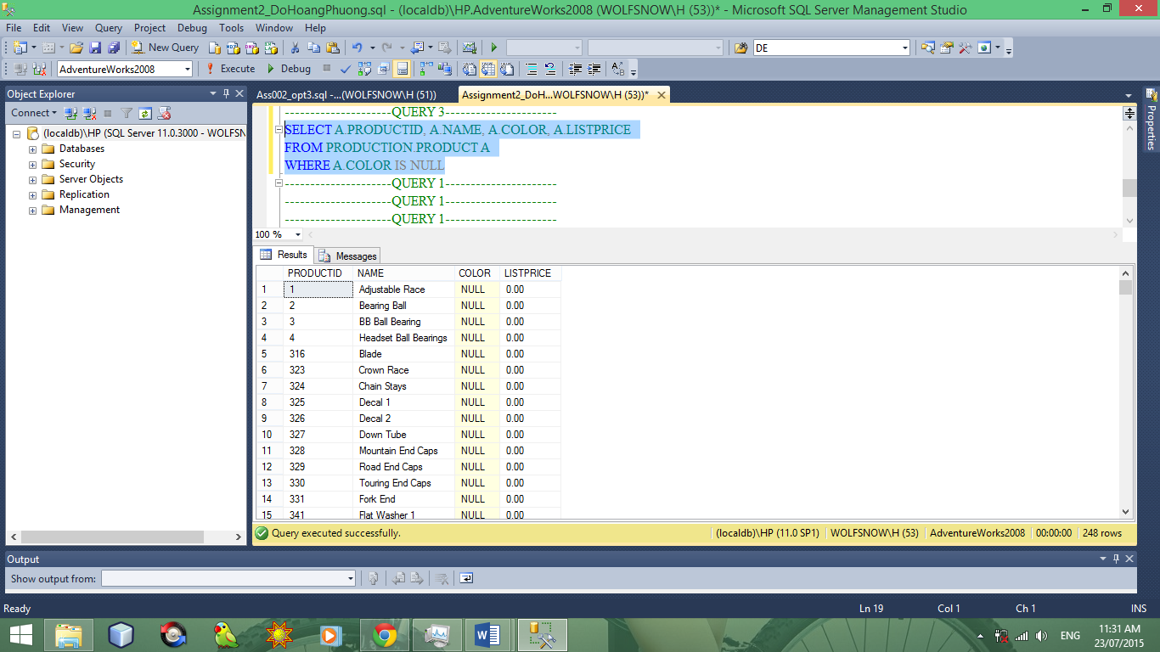

**Query 4:**Use the same query, but this time you just want to see the rows that *are not* NULL for the Color column. Your result set should look something like the following.

SELECT A.PRODUCTID, A.NAME, A.COLOR, A.LISTPRICE

FROM PRODUCTION.PRODUCT A

WHERE A.COLOR IS NOT NULL

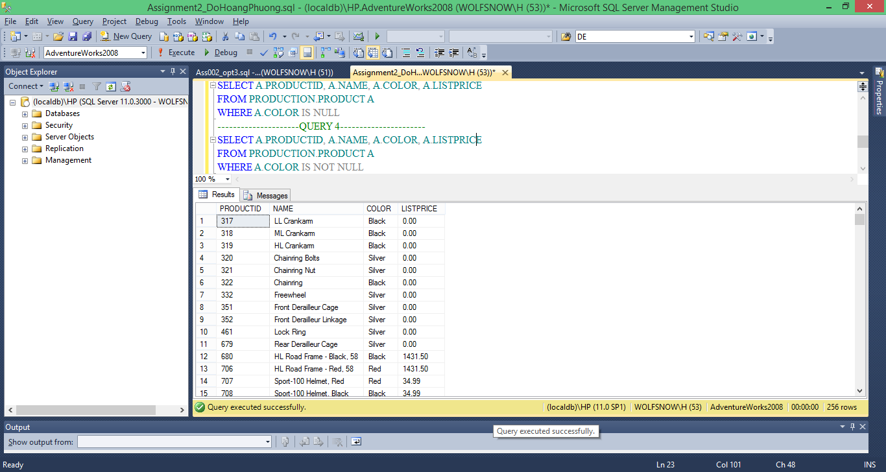

**Query 5:**Now, combine two search arguments in the query you have been working with. You just want to see the rows that *are not* NULL for the column Color, and the column ListPricehas a value greater than zero. Your result set should look something like the following.

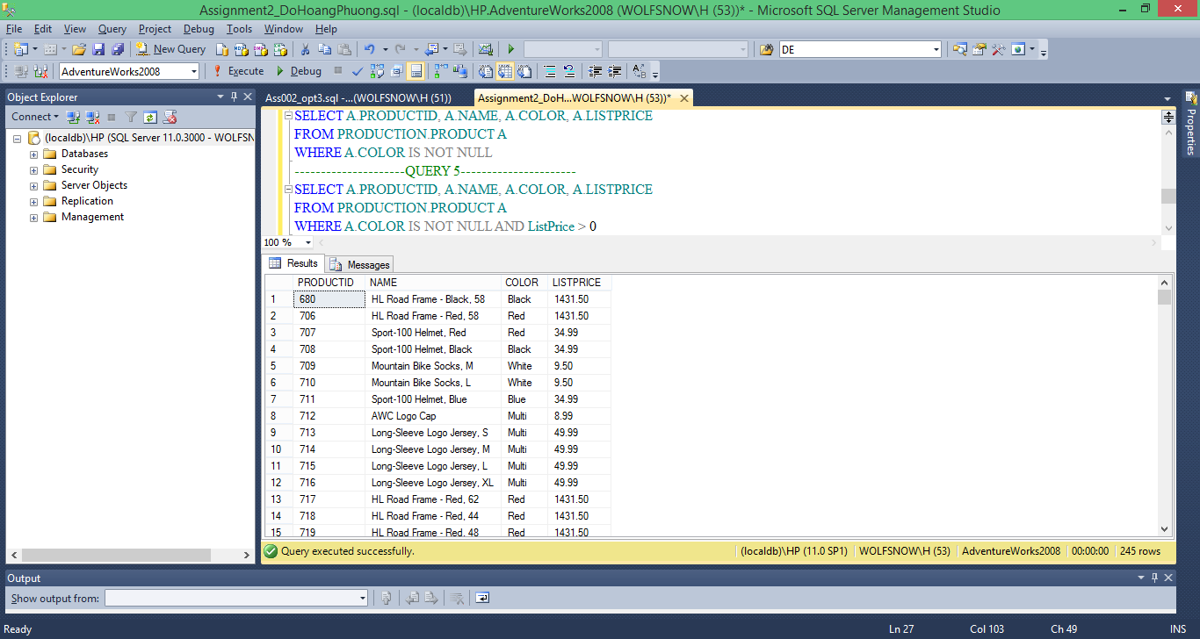

**Query 6:**

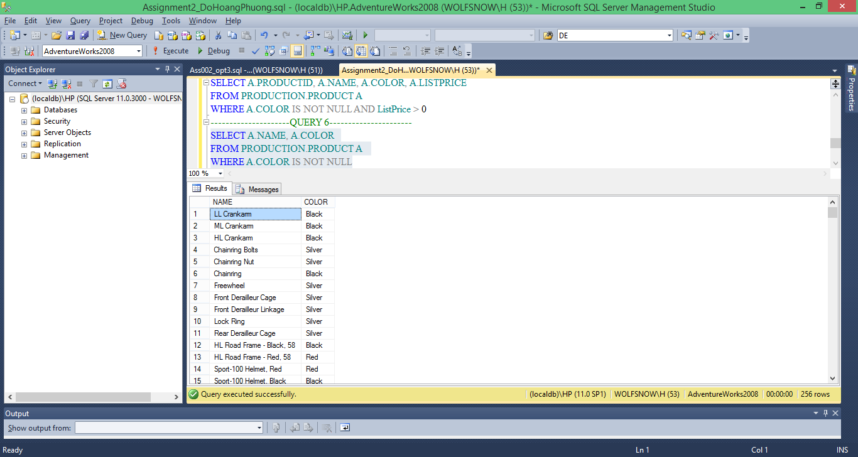

**Query 7:**

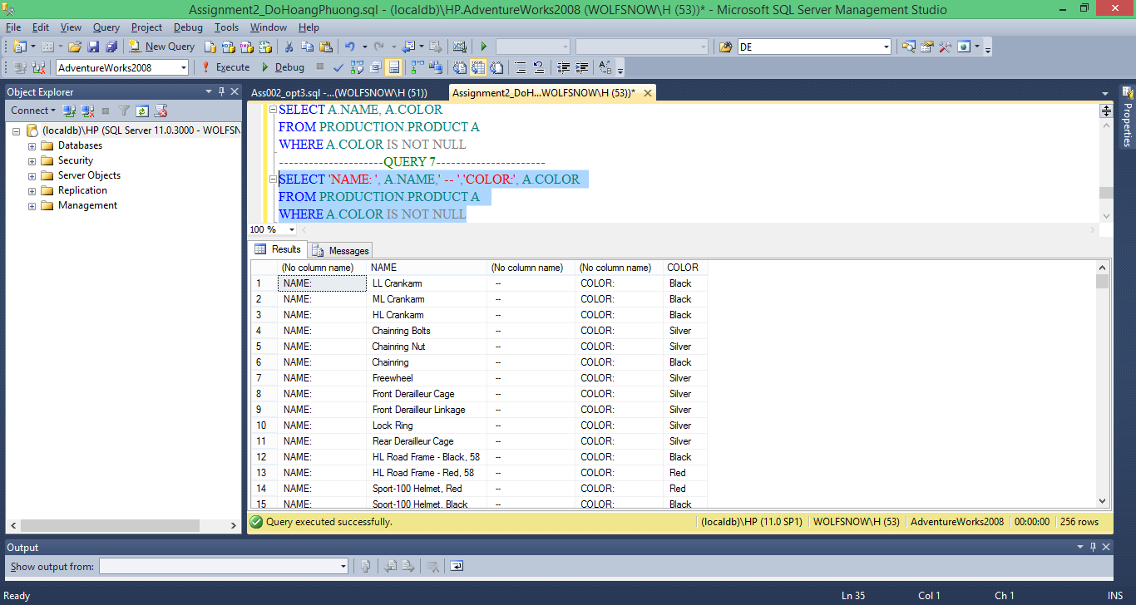

**Query 8:**

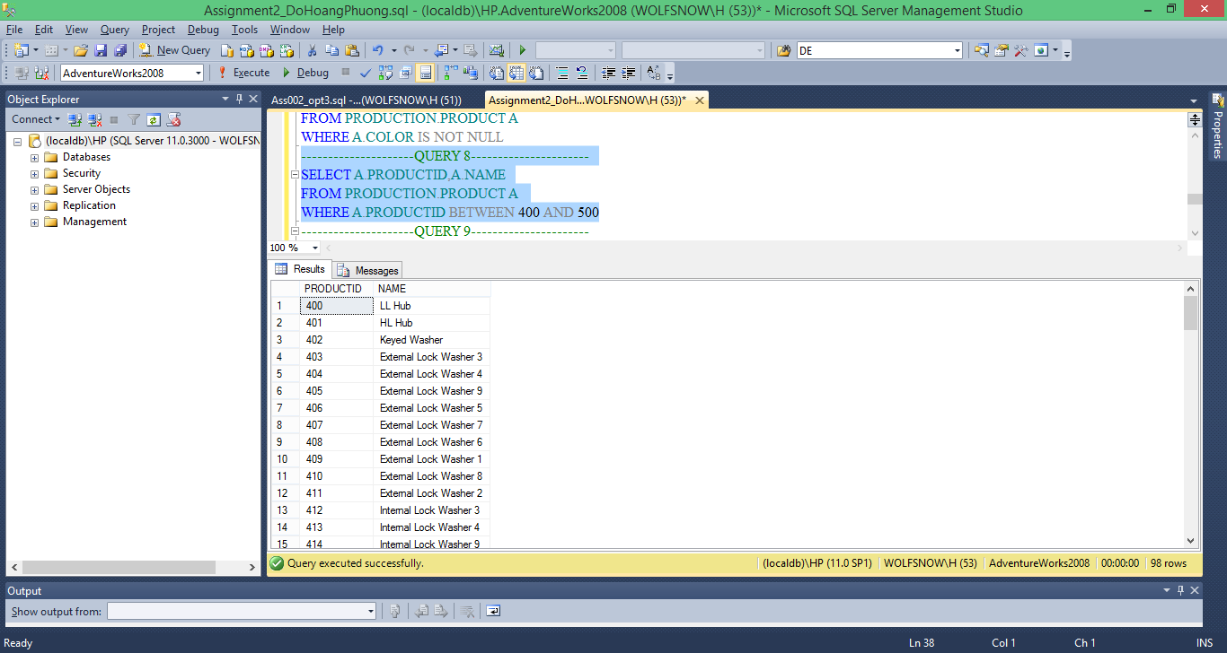

**Query 9:**

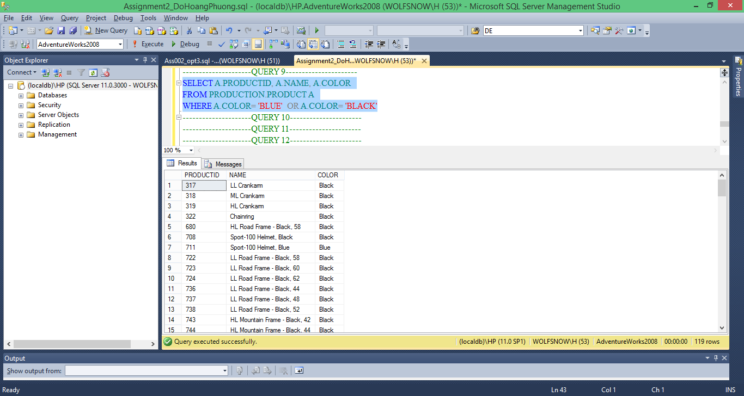

**Query 10:**

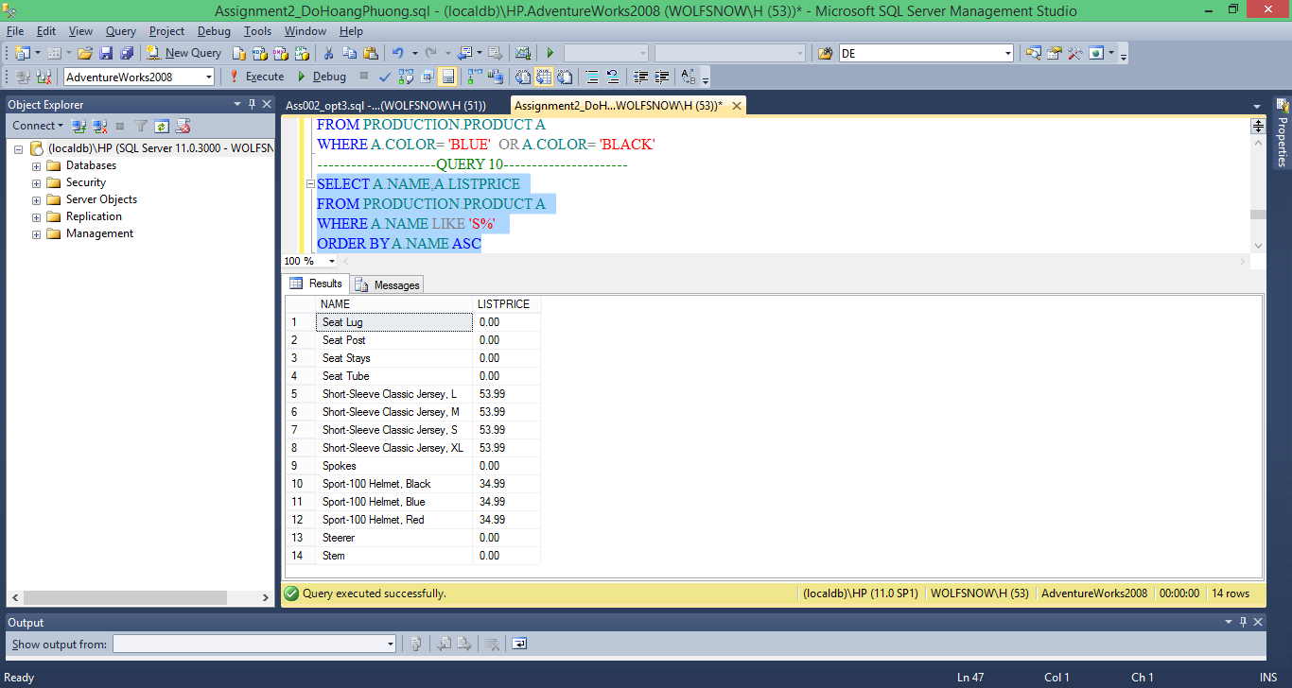

**Query 11:**

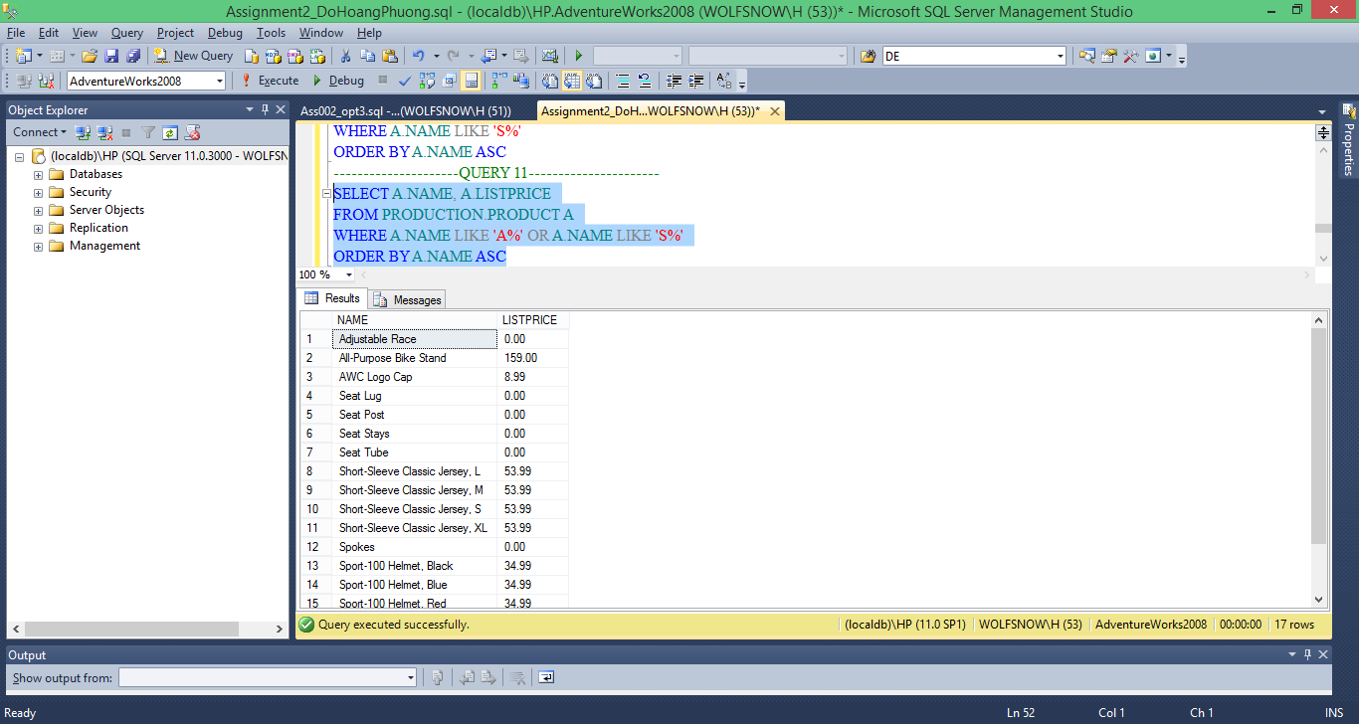

**Query 12:**

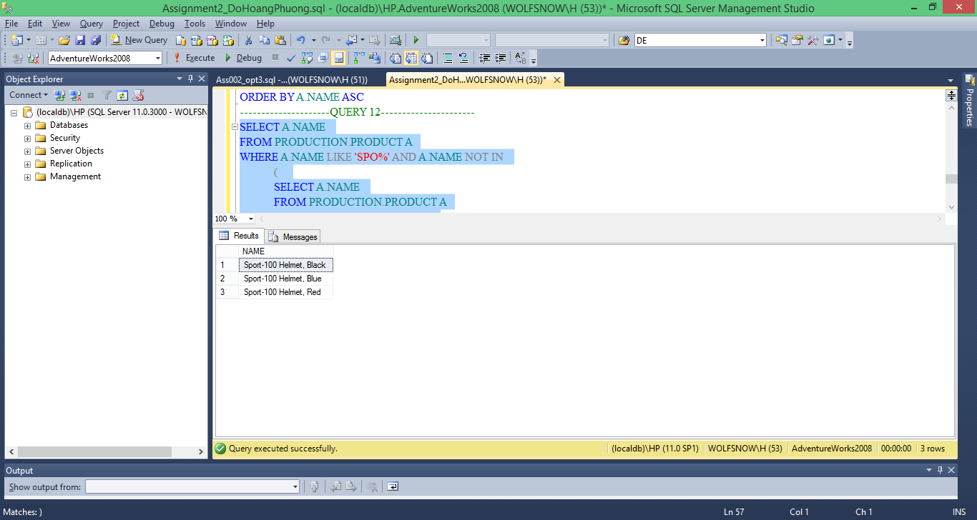

**Query 13:**

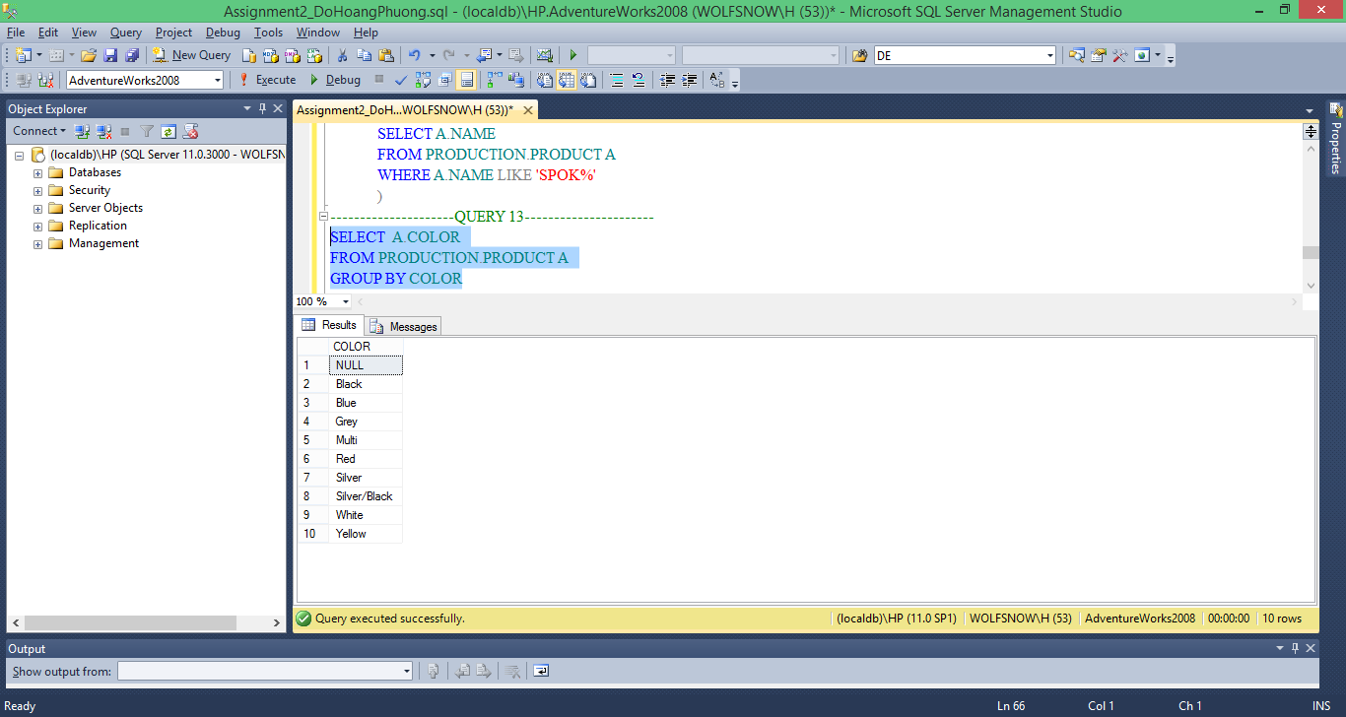

**Query 14:**

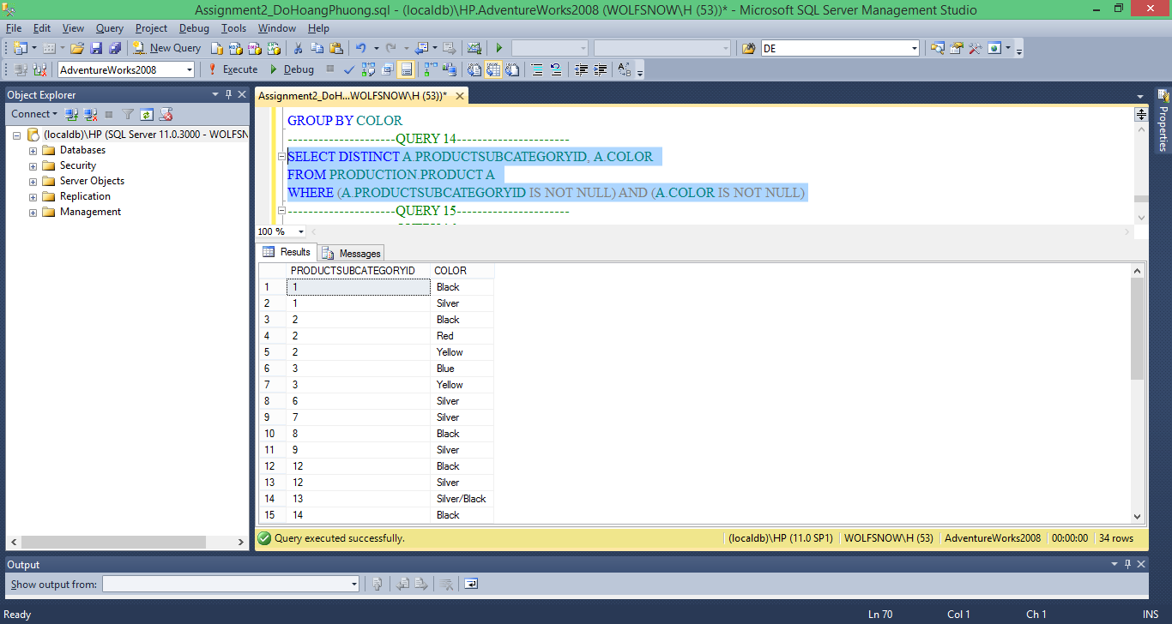

**Query 15:**

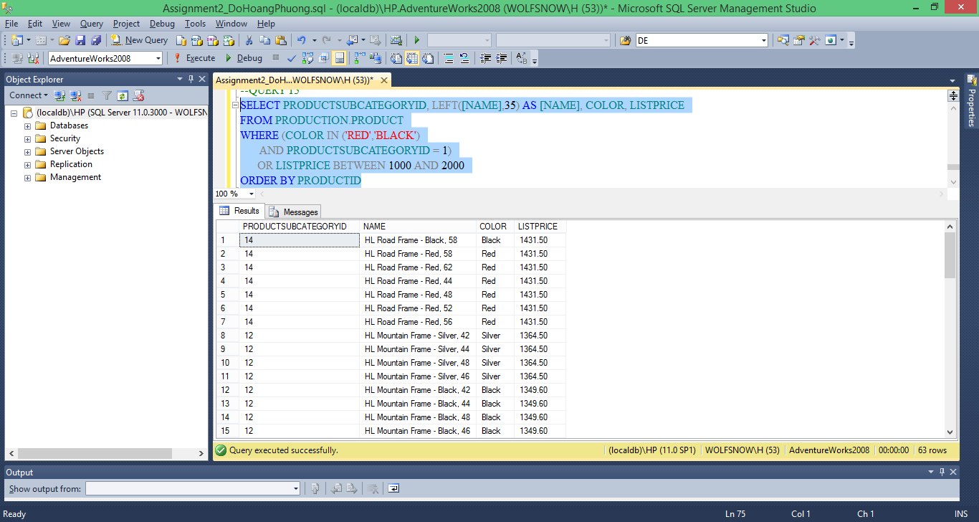

**Query 16:**

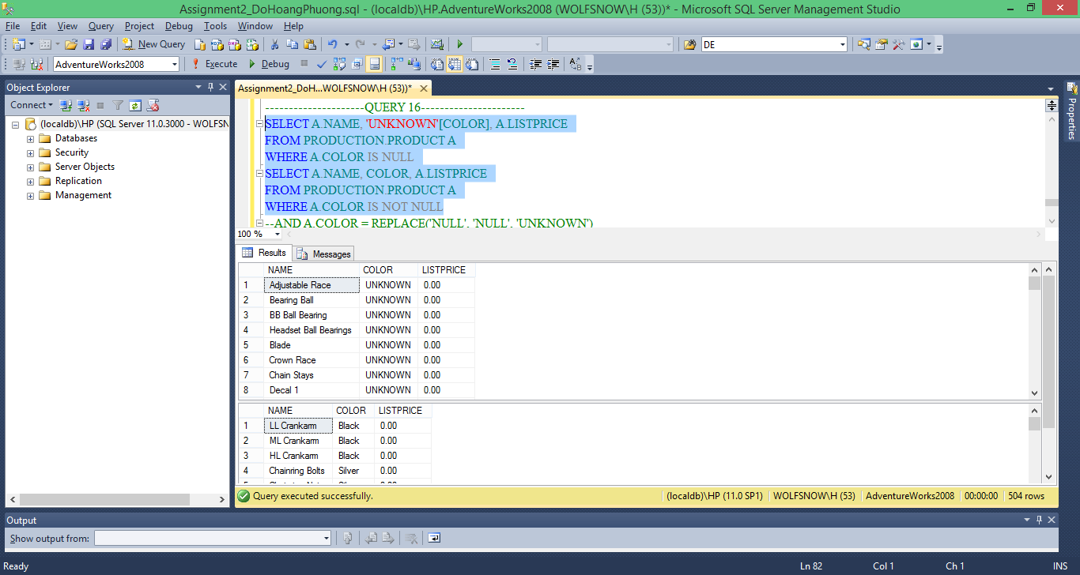

-------------------------------------------------------------------------------------------------------------

---------------------------------------------Exercise 3------------------------------------------------------

-------------------------------------------------------------------------------------------------------------

**Query 1:**

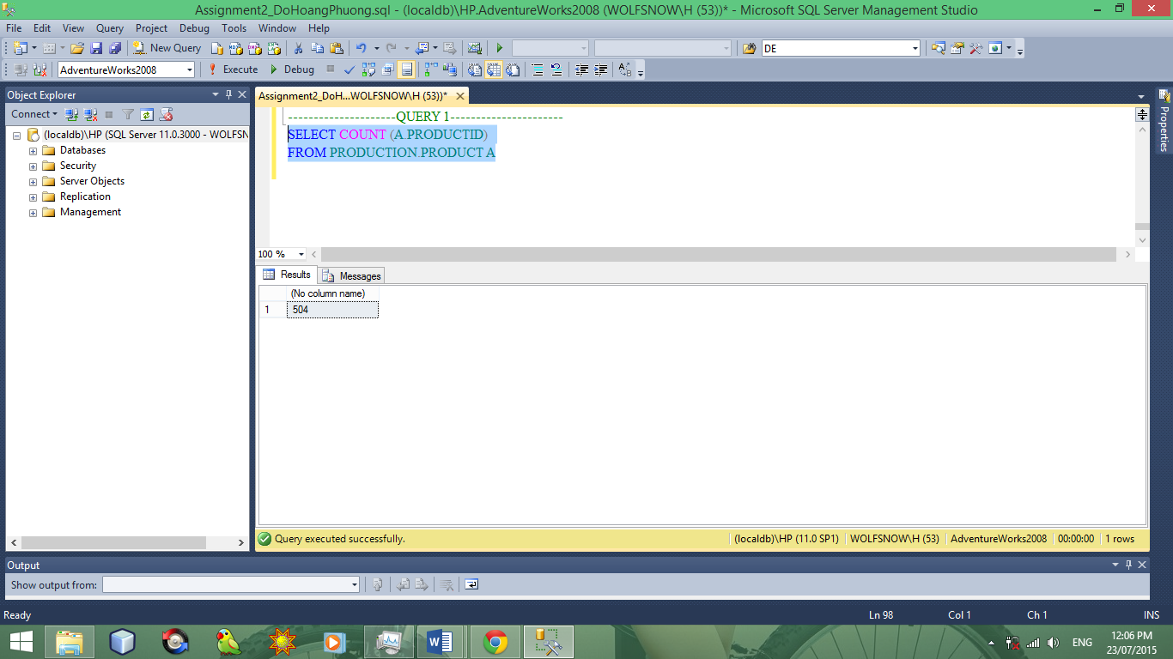

**Query 2**

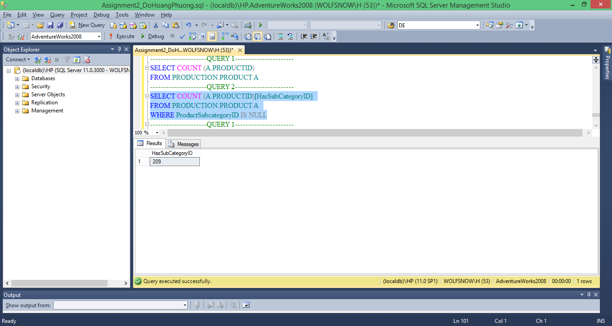

**Query 3**

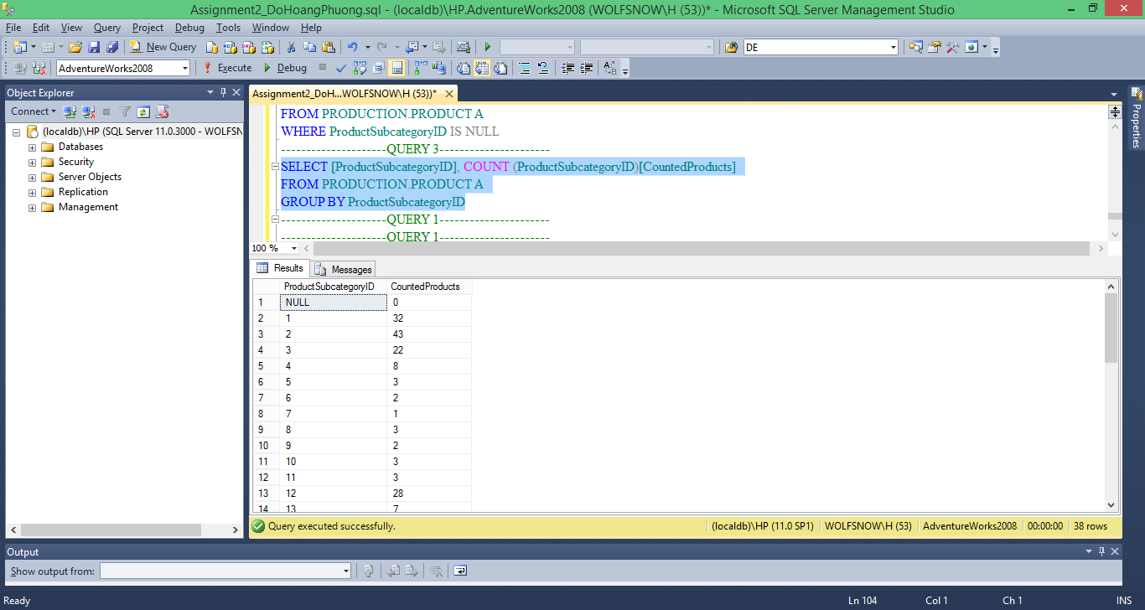

**Query 4**

**NOT WHERE**

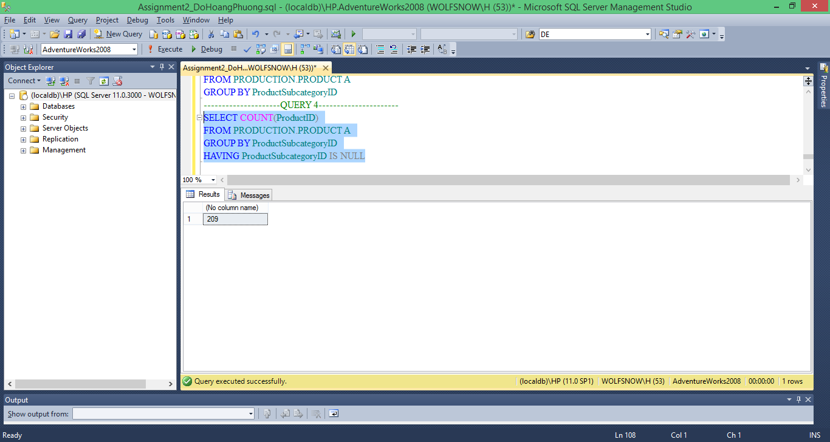

**USING A WHERE**

