Câu 01:

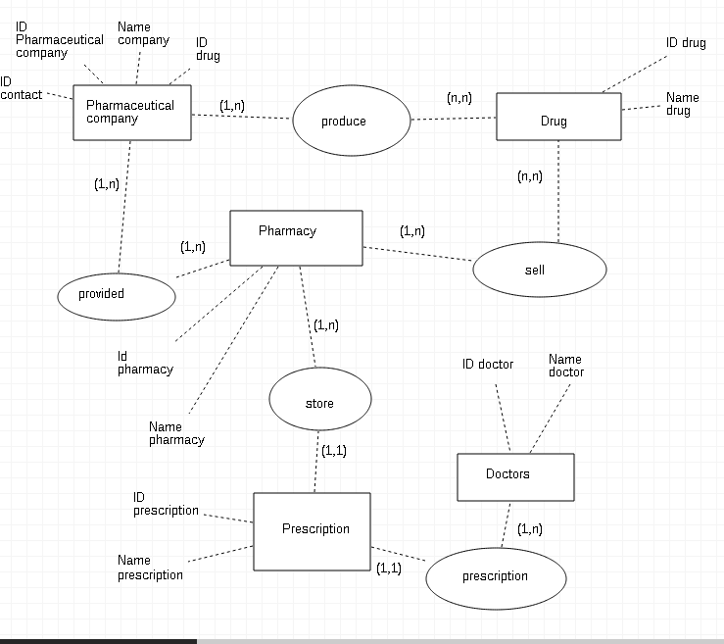

Câu 02:

|  |  |  |  |
| --- | --- | --- | --- |
| **STUDENT** | | | |
| #SSN | Name | Major | Bdate |

|  |  |  |
| --- | --- | --- |
| **COURSE** | | |
| #Course | Cname | Dept |

|  |  |
| --- | --- |
| **BOOK_ADOPTION** | |
| #(Course, Book_ISBN) | Quarter |

|  |  |  |
| --- | --- | --- |
| ENROLL | | |
| #(SSN, Course) | Quarter | Grade |

|  |  |  |  |
| --- | --- | --- | --- |
| **BOOK** | | | |
| #Book_ISBN | Book_Title | Publisher | Author |

Câu 03 :

|  |  |
| --- | --- |
| Column | Data types |
| ID | Int |
| Name | char(30) |
| Code | char(5) |
| ModifiedDate | smalldatetime |

-ID: do chứa ít hơn một triệu record nên ta chọn chon kiểu int (2^-31 đến 2^31-1).

-Name: Tên người dùng 30 kí tự => char(30).

-Code: yêu cầu không quá 5 kí tự => char(5).

-ModifiedDate : dùng smalldatetime.

Câu 04 :

|  |  |
| --- | --- |
| Column | Data types |
| ID | integer |
| Name | varchar(20) |
| BirthDate | smalldatetime |
| Gender | bit |
| IsDeletedFlag | bit |