In the design for the Fresher Training Management, given the Trainee table with below initial attributes / fields:

* TraineeID: trainee identifier, auto increment field
* Full_Name: full name of the trainee
* Birth_Date: trainee birth date
* Gender: only have one of two value male, female
* ET_IQ: entry test point (IQ) of trainee, integer, value range FROM 0 to 20
* ET_Gmath: entry test point (GMath) of trainee, integer, value range FROM 0 to 20
* ET_English: entry test point (English) of trainee, integer, value range FROM 0 to 50
* Training_Class: the class code that trainee is joining
* Evaluation_Notes: trainee evaluation notes, free text.

For the following requests, print out respectively the screenshots to show test data (the table data that you create to test each query), the query results, and pack them into the zip file Assignment2_AccountName.zip along with your answers, then handle to the evaluator via email ([XYZ@fsoft.com.vn](mailto:XYZ@fsoft.com.vn))

**Q1**: Create the tables (with the most appropriate/economic field/column constraints & types) and add at least 10 records into each created table.

***Answer:***

CREATE TABLE Trainee

(

TraineeID int IDENTITY(1,1) primary key ,

Full_Name nvarchar(50),

Birth_Date datetime,

Gender bit,

ET_IQ int,

ET_Gmath int,

ET_English int,

Training_Class nvarchar(10),

Evaluation_Notes nvarchar(100),

CONSTRAINT chk_ETIQ CHECK (ET_IQ >= 0 AND ET_IQ <= 20),

CONSTRAINT chk_ETGmath CHECK (ET_IQ >= 0 AND ET_IQ <= 20),

CONSTRAINT chk_ETEnglish CHECK (ET_IQ >= 0 AND ET_IQ <= 50)

)

INSERT INTO Trainee(Full_Name, Birth_Date, Gender, ET_IQ, ET_Gmath, ET_English, Training_Class, Evaluation_Notes) VALUES ('Mike Ambinder', '8/21/1984', 0, 15, 10, 41, 'C112', 'Lazy')

INSERT INTO Trainee(Full_Name, Birth_Date, Gender, ET_IQ, ET_Gmath, ET_English, Training_Class, Evaluation_Notes) VALUES ('Jeep Barnett', '7/15/1982', 0, 17, 6, 35, 'C121', 'Excelent')

INSERT INTO Trainee(Full_Name, Birth_Date, Gender, ET_IQ, ET_Gmath, ET_English, Training_Class, Evaluation_Notes) VALUES ('Kaci Aitchison', '2/21/1987', 1, 7, 15, 44, 'C142', 'Good')

INSERT INTO Trainee(Full_Name, Birth_Date, Gender, ET_IQ, ET_Gmath, ET_English, Training_Class, Evaluation_Notes) VALUES ('Andrea Wendel', '7/15/1988', 1, 7, 18, 35, 'C212', 'Okay')

INSERT INTO Trainee(Full_Name, Birth_Date, Gender, ET_IQ, ET_Gmath, ET_English, Training_Class, Evaluation_Notes) VALUES ('Greg Coomer', '3/21/1978', 0, 15, 17, 32, 'C152', 'Employer of the month')

INSERT INTO Trainee(Full_Name, Birth_Date, Gender, ET_IQ, ET_Gmath, ET_English, Training_Class, Evaluation_Notes) VALUES ('Mike Dunkle', '1/25/1982', 0, 17, 8, 17, 'C147', 'Good')

INSERT INTO Trainee(Full_Name, Birth_Date, Gender, ET_IQ, ET_Gmath, ET_English, Training_Class, Evaluation_Notes) VALUES ('Emilia Clarke', '2/21/1990', 1, 13, 15, 35, 'C169', 'Okay')

INSERT INTO Trainee(Full_Name, Birth_Date, Gender, ET_IQ, ET_Gmath, ET_English, Training_Class, Evaluation_Notes) VALUES ('Dave Feise', '4/15/1984', 0, 17, 18, 18, 'C192', 'Excelent')

INSERT INTO Trainee(Full_Name, Birth_Date, Gender, ET_IQ, ET_Gmath, ET_English, Training_Class, Evaluation_Notes) VALUES ('Alicia Vikander', '11/25/1987', 1, 13, 15, 24, 'C319', 'Good')

INSERT INTO Trainee(Full_Name, Birth_Date, Gender, ET_IQ, ET_Gmath, ET_English, Training_Class, Evaluation_Notes) VALUES ('John Guthrie', '4/15/1984', 0, 17, 18, 18, 'C141', 'Good')

***Result:***

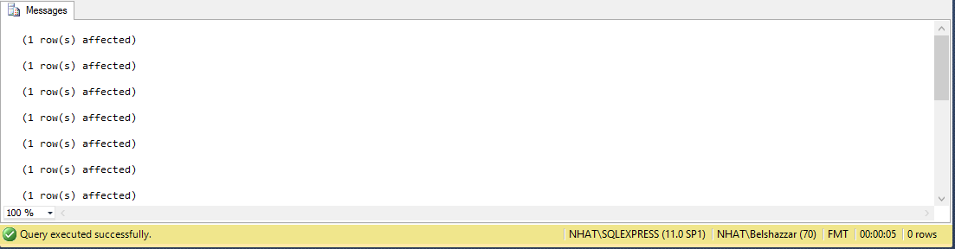

* **Test data for question 2,3,4,5**

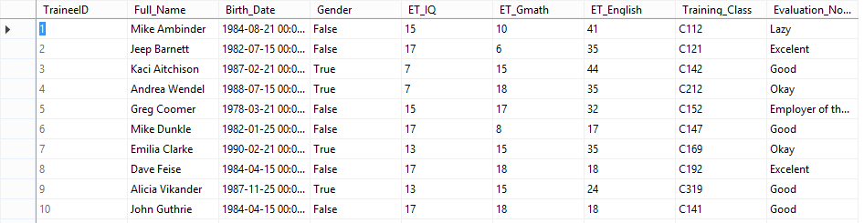

**Q2**: Change the table TRAINEE to add one more field named Fsoft_Account which is a not-null & unique field.

***Answer:***

ALTER TABLE dbo.Trainee

ADD Fsoft_Account varchar(50) NOT NULL DEFAULT ('new account')

UPDATE Trainee SET [Fsoft_Account] = [Fsoft_Account] + CONVERT(nvarchar(10),[TraineeID])

ALTER TABLE Trainee

ADD UNIQUE (Fsoft_Account)

***Result:***

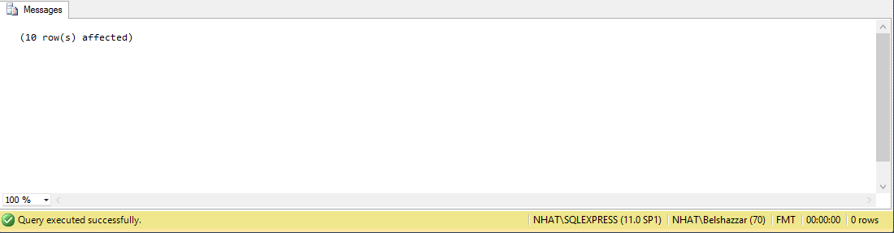

**Q3**: Create a VIEW which includes all the ET-passed trainees. One trainee is considered as ET-passed when he/she has the entry test points satisfied below criteria:

* ET_IQ + ET_Gmath >=20
* ET_IQ>=8
* ET_Gmath>=8
* ET_English>=18

***Answer:***

CREATE VIEW PassedTrainee AS

SELECT *

FROM dbo.Trainee

WHERE ([ET_IQ] + [ET_Gmath]) >= 20 AND

[ET_IQ] >= 8 AND

[ET_Gmath] >=8 AND

[ET_English] >= 18

***Result:***

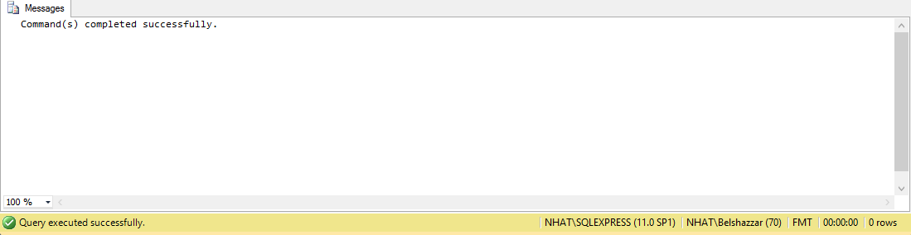

View

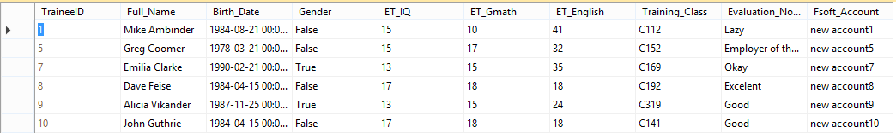

**Q4**: Query all the trainees who is passed the entry test, group them into different birth months.

***Answer:***

SELECT *

FROM dbo.PassedTrainee

ORDER BY Month([Birth_Date])

***Result:***

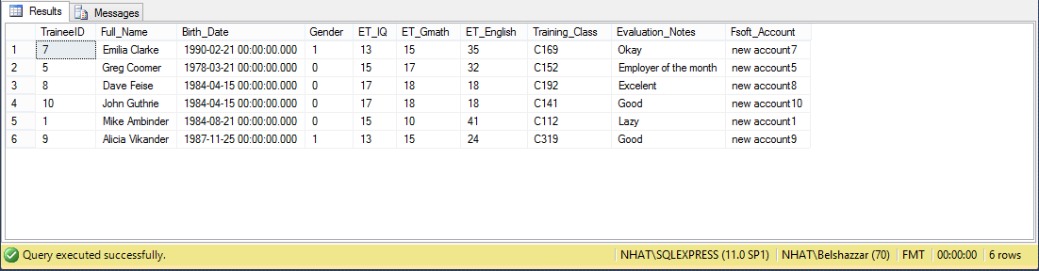

**Q5**: Query the trainee who has the longest name, showing his/her age along with his/her basic information (as defined in the table)

***Answer:***

SELECT TOP 1 *

FROM dbo.Trainee

ORDER BY Len([Full_Name]) DESC

***Result:***

