**Assignment 05 – Opt 1**

# 1. Write an application to allow the user to add or update his/her profile data to the trainees list of the application, details as described below:

* On entering the application, the user is asked to input his/her account, first-name, last-name, email. Those must not be empty.
* When valid data are inputted,
* The user’s profile information would be added or updated into the database. The update occurs only in the case his/her account exists already.
* The user would be redirected to the trainees list page which would show the guests who are accessed the application.
* Any input data validation or application exception must be handled. Warning and error messages must be shown to the user.

## User login

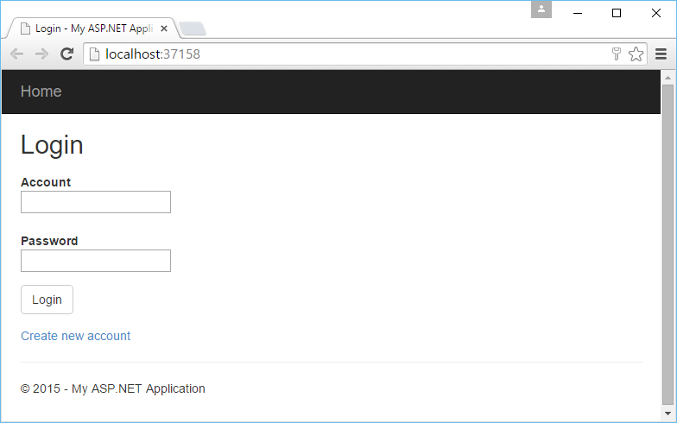

## User create new account

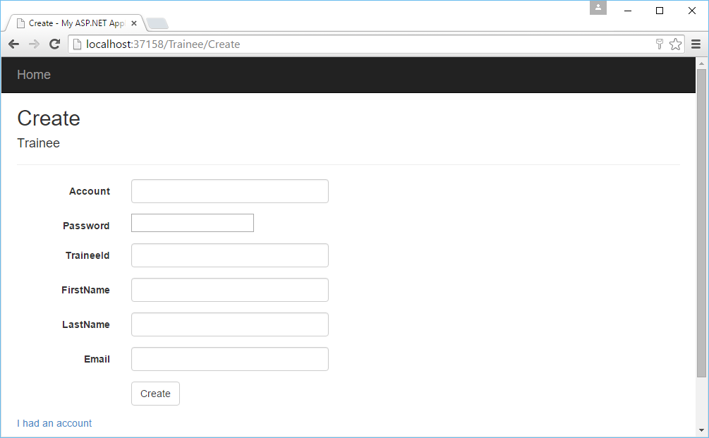

## User view his/her information

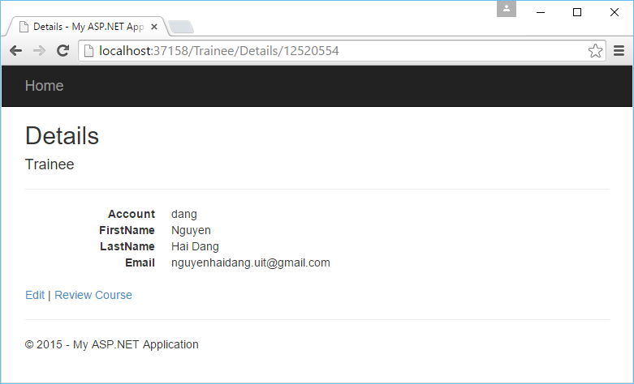

## User update his/her information

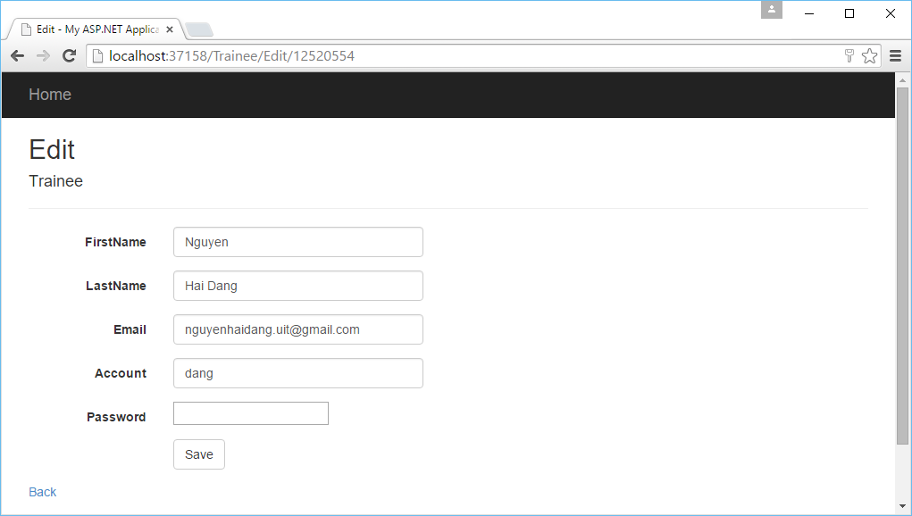

# 2. From the trainees list page, the user can add one or more feedbacks related to his/her training course (selected from the list). The feedback information includes:

* Feedback type, choose from one of following types:
* The course objectives were met (Mục tiêu khóa học đã đạt được)
* The level of the course is appropriate (Khóa học phù hợp với trình độ của học viên)
* This course will be useful for my work (Khóa học bổ ích cho công việc của bạn)
* The training materials were good (Tài liệu giảng dạy chuẩn bị tốt)
* The organization of the course (facility) was good (Cơ sở vật chất và công tác tổ chức tốt)
* Subject coverage is good with respect to courseware (Đảm bảo đủ nội dung c/t học)
* Your questions/doubts were answered satisfactorily and teacher support is good (Giảng viên hỗ trợ và giải đáp thắc mắc tốt cho học viên)
* The quality of trainer instruction and communication was good. (Kỹ năng sư phạm của GV tốt)
* Feedback rate, rate of of below 5 value (this is required data)
* Strongly disagree (1)
* Disagree (2)
* Neutral (3)
* Agree (4)
* Strongly agree (5)
* Feedback notes, for each feedback item (this is optional data)

For each course, when giving feedbacks on all feedback types, the user can store those to the database.

## User conduct review

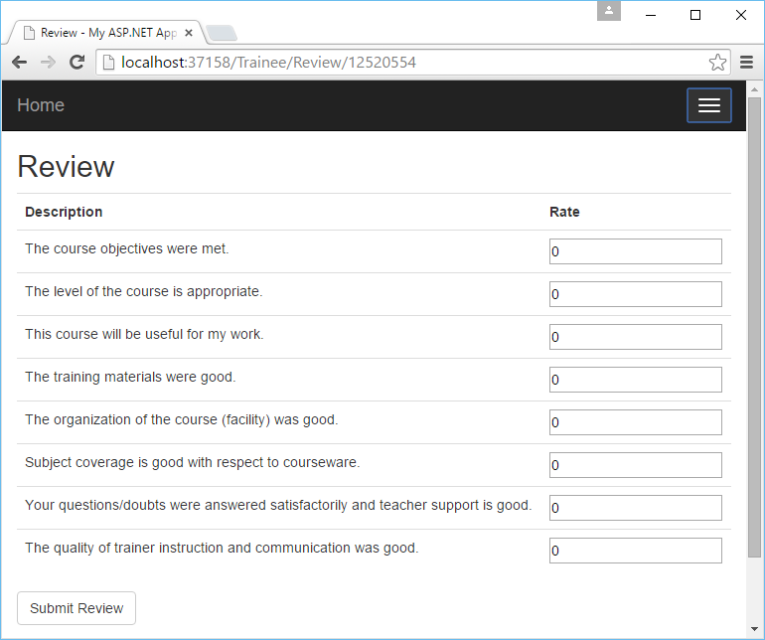

# Notes:

Test accounts:

|  |  |
| --- | --- |
| **account** | **password** |
| dang | 1234 |
| Phuong | 1234 |

Database:

