# Question 1

1. Create the tables (with the most appropriate field/column constraints & types) and add at least 3 records into each created table.

CREATE TABLE KHACHHANG

(

Ma_KH varchar(5) primary key,

Ten_KH nvarchar(50) not null,

Phone_No varchar(20) not null,

Ghi_Chu nvarchar(100)

)

GO

CREATE TABLE SANPHAM

(

Ma_SP varchar(5) primary key,

Ten_SP nvarchar(50),

Don_Gia money not null,

Ma_KH varchar(5) foreign key (Ma_KH) references KHACHHANG(Ma_KH)

)

GO

CREATE TABLE DONHANG

(

Ma_DH varchar(5) primary key,

Ngay_DH datetime not null,

Ma_SP varchar(5) foreign key (Ma_SP) references SANPHAM(Ma_SP),

SoLuong int

)

INSERT INTO KHACHHANG VALUES('KH001', N'Nguyễn Thanh Thanh','01234567890','VIP')

INSERT INTO KHACHHANG VALUES('KH002', N'Trần Đình Phong','01664567890','VIP')

INSERT INTO KHACHHANG VALUES('KH003', N'Nguyễn Thanh Lam','01245567890','Thuong')

INSERT INTO KHACHHANG VALUES('KH004', N'Phan Dương Dương','0973456789','Thuong')

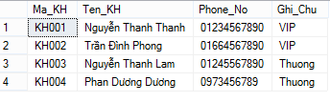

INSERT INTO SANPHAM VALUES('SP001',N'Laptop',10000000,'KH001')

INSERT INTO SANPHAM VALUES('SP002',N'Tai nghe in-ear ',500000,'KH003')

INSERT INTO SANPHAM VALUES('SP003',N'Iphone 6',150000000,'KH002')

INSERT INTO SANPHAM VALUES('SP004',N'Lumia 930',120000000,'KH004')

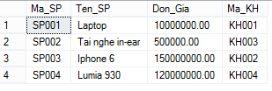

INSERT INTO DONHANG VALUES('DH001',22/06/2015,'SP001',2)

INSERT INTO DONHANG VALUES('DH002',15/03/2015,'SP004',1)

INSERT INTO DONHANG VALUES('DH003',16/06/2015,'SP002',2)

INSERT INTO DONHANG VALUES('DH004',22/06/2015,'SP004',1)

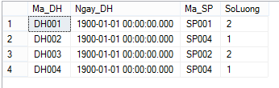

1. Create an order slip VIEW which has the same number of lines as the Don_Hang, with the following information: Ten_KH, Ngay_DH, Ten_SP, So_Luong, Thanh_Tien

CREATE VIEW Don_Hang

AS

SELECT A.Ten_KH, C.Ngay_DH, B.Ten_SP, C.SoLuong, B.Don_Gia * C.SoLuong AS Thanh_Tien

FROM KHACHHANG A, SANPHAM B, DONHANG C

WHERE A.Ma_KH= B.Ma_KH AND B.Ma_SP= C.Ma_SP

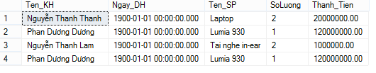

Question 2

1. Create the tables (with the most appropriate field/column constraints & types) and add at least 3 records into each created table.

CREATE TABLE EMPLOYEE

(

Employee_Number int primary key,

Employee_Name nvarchar(50),

Department_Number int foreign key (Department_Number) references DEPARTMENT(Department_Number)

)

GO

CREATE TABLE EMP_SKILL

(

Employee_Number int foreign key (Employee_Number) references EMPLOYEE(Employee_Number),

Skill_Code char(4),

Regis_Date datetime,

constraint PK_ES primary key (Employee_number, Skill_Code)

)

GO

CREATE TABLE DEPARTMENT

(

Department_number int primary key,

Department_Name nvarchar(50)

)

----insert

INSERT INTO DEPARTMENT VALUES(1,N'Web develop department')

INSERT INTO DEPARTMENT VALUES(2,N'Software develop department')

INSERT INTO DEPARTMENT VALUES(3,N'Game develop department')

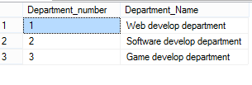

INSERT INTO EMPLOYEE VALUES(1,N'Trần Dương Dương',1)

INSERT INTO EMPLOYEE VALUES(2,N'Trần Đình Hạo',2)

INSERT INTO EMPLOYEE VALUES(3,N'Nguyễn Thanh Thảo',3)

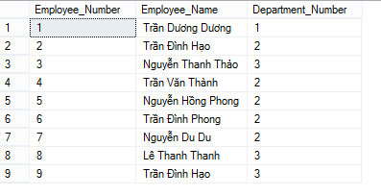

INSERT INTO EMP_SKILL VALUES(1,'PHP',12/8/2012)

INSERT INTO EMP_SKILL VALUES(2,'.Net',12/8/2012)

INSERT INTO EMP_SKILL VALUES(3,'Java',12/8/2012)

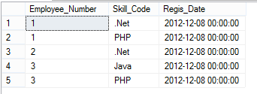

1. Specify the names of the employees whore have skill of ‘Java’

SELECT A.Employee_Number, Employee_Name, Department_Name, Skill_Code

FROM EMPLOYEE A, EMP_SKILL B, DEPARTMENT C

WHERE Skill_Code = 'Java' AND

A.Employee_Number = B.Employee_Number AND

A.Department_Number = C.Department_number

1. Specify the departments which have >=3 employees, print out the list of departments’ employees right after each department.

SELECT A.Department_Number, COUNT(A.Department_number) AS [Số Nhân Viên]

FROM DEPARTMENT A, EMPLOYEE B

WHERE A.Department_Number= B.Department_Number

GROUP BY A.Department_Number

HAVING COUNT(B.Employee_Number)>=3

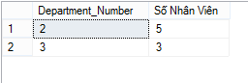

1. Use SUB-QUERY technique to list out the different employees (include employee number and employee names) who have multiple skills.

SELECT DISTINCT Employee_Number,Employee_Name

FROM EMPLOYEE

WHERE Employee_Number IN (SELECT C.Employee_Number

FROM EMPLOYEE C, EMP_SKILL D

WHERE C.Employee_Number = D.Employee_Number

GROUP BY C.Employee_Number

HAVING COUNT(D.Employee_Number)>=2)

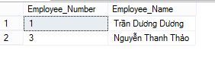

1. Create a view to show different employees (with following information: employee number and employee name, department name) who have multiple skills.

CREATE VIEW MUL_SKILL_EMPLOYEE

AS

SELECT Employee_Number, Employee_Name, Department_Name

FROM EMPLOYEE A , DEPARTMENT B

WHERE A.Department_Number = B.Department_number AND

Employee_Number IN (SELECT C.Employee_Number

FROM EMPLOYEE C, EMP_SKILL D

WHERE C.Employee_Number = D.Employee_Number

GROUP BY C.Employee_Number

HAVING COUNT(D.Employee_Number)>=2)

