Assignment 2_Opt1

Question 1:

CREATE TABLE TRAINEE

(

ID CHAR(7) PRIMARY KEY,

FULL_NAME nvarchar(40) NULL,

BIRTH_DATE SMALLDATETIME NULL,

GENDER VARCHAR(20) NULL,

ET_IQ INT NULL,

ET_GMATH INT NULL,

ET_ENGLISH INT NULL,

TRAINING_CLASS CHAR(7),

EVALUATION_NOTES varchar(100) NULL,

)

ALTER TABLE TRAINEE ADD CONSTRAINT CK_Gender CHECK(GENDER = 'Nam' Or GENDER = 'Nu')

ALTER TABLE TRAINEE ADD CONSTRAINT CK_IQ CHECK(ET_IQ >= 0 Or ET_IQ <= 20)

ALTER TABLE TRAINEE ADD CONSTRAINT CK_GMATH CHECK(ET_GMATH >= 0 Or ET_GMATH <= 20)

ALTER TABLE TRAINEE ADD CONSTRAINT CK_ENG CHECK(ET_ENGLISH >= 0 Or ET_ENGLISH <= 50)

insert into TRAINEE values ('1',N'Trần Dương Dương','1961/1/21','Nam',10,16,20, '01','')

insert into TRAINEE values ('2',N'Trần Đình Hạo','1990/11/22','Nu',20,20,50, '02','')

insert into TRAINEE values ('3',N'Trần Đình Phong','1980/7/27','Nam',10,16,20, '03','')

insert into TRAINEE values ('4',N'Nguyễn Bách Thảo','1983/10/22','Nu',10,10,20, '04','')

insert into TRAINEE values ('5',N'Bùi Xuyến Hằng','1985/5/7','Nu',20,20,30, '05','')

insert into TRAINEE values ('6',N'Phan Nhược Bạch','1964/4/22','Nam',10,4,20, '06','')

insert into TRAINEE values ('7',N'Minh Hiểu Khê','1980/10/15','Nu',10,16,20, '07','')

insert into TRAINEE values ('8',N'Phạm Quang Nhã','1990/6/22','Nu',5,6,20, '01','')

insert into TRAINEE values ('9',N'Nguyễn Thanh Thanh','1984/10/22','Nu',10,16,30, '04','')

insert into TRAINEE values ('10',N'Trần Trác Hy','1981/11/2','Nam',20,16,20, '08','')

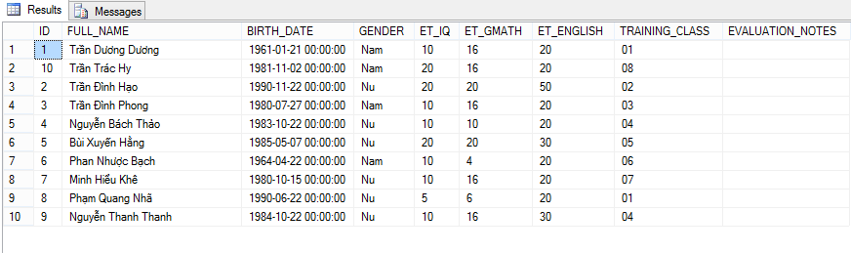

Question 2:

ALTER TABLE TRAINEE ADD Fsoft_Account CHAR(12)

ALTER table TRAINEE alter column Fsoft_Account nvarchar(50) not null

ALTER TABLE TRAINEE ADD CONSTRAINT PK_f UNIQUE(Fsoft_Account)

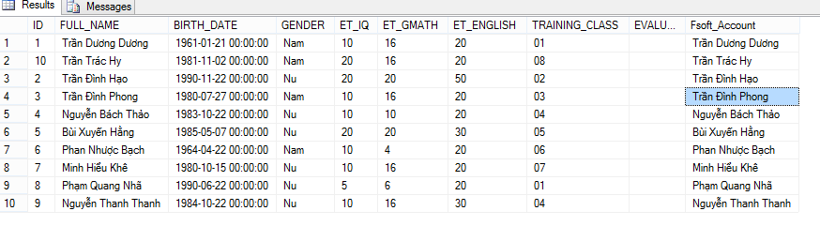

Question 3:

CREATE VIEW ET_PASS_TRAINEE

AS

SELECT ID, FULL_NAME, ET_IQ,ET_GMATH,ET_ENGLISH

FROM TRAINEE

WHERE TRAINEE.ET_IQ + TRAINEE.ET_GMATH >=20 AND

TRAINEE.ET_IQ >=8 AND TRAINEE.ET_GMATH >= 8 AND

TRAINEE.ET_ENGLISH >=18

SELECT *FROM ET_PASS_TRAINEE

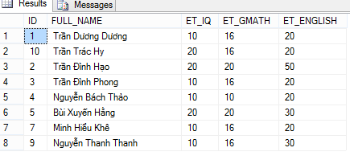

Question 4:

SELECT MONTH(BIRTH_DATE) [THÁNG]

FROM TRAINEE

WHERE TRAINEE.ET_IQ + TRAINEE.ET_GMATH >=20 AND

TRAINEE.ET_IQ >=8 AND TRAINEE.ET_GMATH >= 8 AND

TRAINEE.ET_ENGLISH >=18

GROUP BY MONTH(BIRTH_DATE)

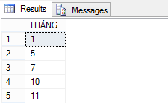

Question 5:

SELECT LEN(FULL_NAME),ID ,FULL_NAME, BIRTH_DATE,GENDER,ET_IQ ,ET_GMATH ,ET_ENGLISH ,TRAINING_CLASS, DateDiff( YEAR, BIRTH_DATE , GetDate())[AGE]

FROM TRAINEE

GROUP BY LEN(FULL_NAME),ID ,FULL_NAME, BIRTH_DATE,GENDER,ET_IQ ,ET_GMATH ,ET_ENGLISH ,TRAINING_CLASS

HAVING LEN(TRAINEE.FULL_NAME) =

(

SELECT TOP 1 LEN(TRAINEE.FULL_NAME)

FROM TRAINEE

ORDER BY LEN(TRAINEE.FULL_NAME) DESC

)

