BSQL

Assignment 01

Account: [quanlm.271@gmail.com](mailto:quanlm.271@gmail.com)

**EX1. ERD of a chain of pharmacies system.**

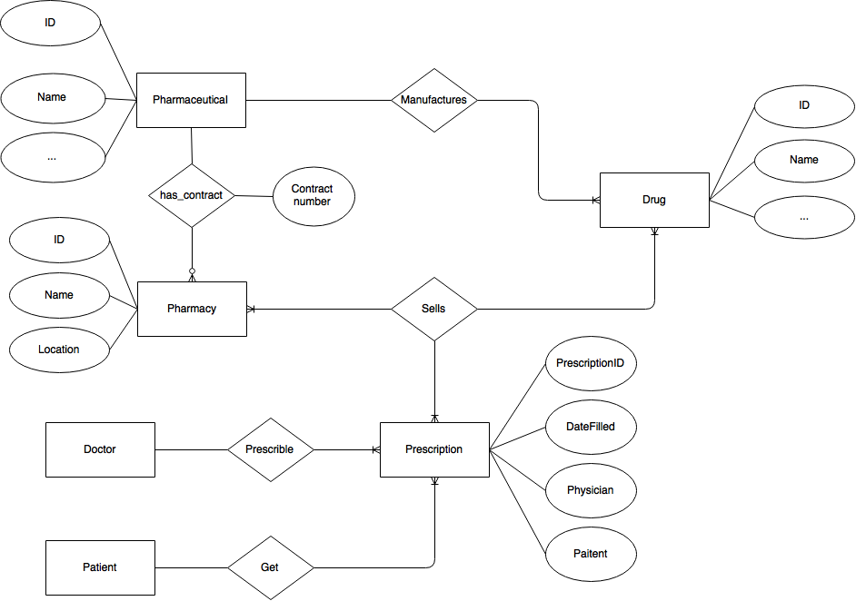

**EX2. Relational schema diagram**

- Trong một kỳ (Quarter), với mỗi khóa học (Course) sẽ có nhiều học viên (Student) tham gia. (1)

- Trong một kỳ (Quarter), với mỗi khóa học (Course) sẽ có sách (BOOK) được sử dụng. (2)

- Thêm thuộc tính **Enroll_No** làm khóa chính cho thực thể **ENROLL** để đảm bảo (1) đúng.

- Thêm thuộc tính **BookAdoption_No** làm khóa chính cho bảng **BOOK_ADOPTION** để đảm bảo (2) đúng.

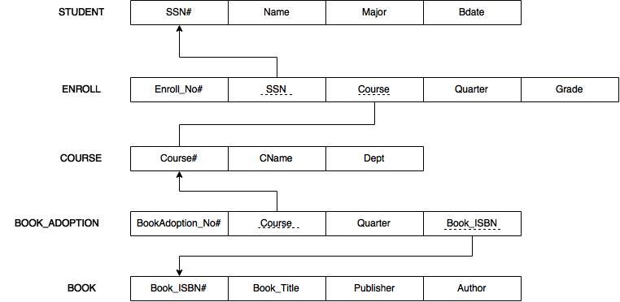

**EX3. Data Type**

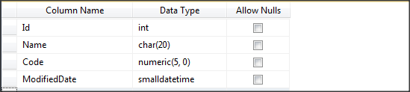

- Int : **Integer data from -2^31 through 2^31 – 1. 2^31 is a little bigger than 1 million.**

**- Char(20): Contain a string with max length 20 characters.**

**- Numeric(5,0):** An alphanumeric code that has five characters.

- SmallDateTime: **Date and time data from January 1, 1900, through June 6, 2079,  
with an accuracy of one minute.**

**EX4. Data Type (2)**

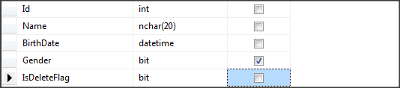

- Int : **Integer data from -2^31 through 2^31 – 1. 2^31 is a little bigger than 1 million.**

**- Nchar(20): Contain a string with max length 20 characters, unicode.**

**- Datetime: Date and time data from January 1, 1753, through December 31, 9999,  
with an accuracy of 3.33 milliseconds**

- Bit**: Integer data with either a 1 or 0 value.**