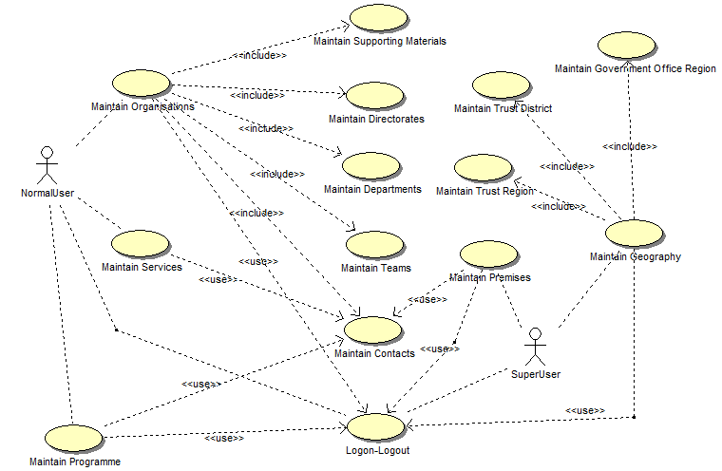

Maintain Organisations:

Write pseudocode for:

### List Organisations

### Add Organisation:

* + Deltails 1, 2 ,3 ,4 and BU/ Directorates

**BEGIN MAINPROGRAM** Organisations

Display displayed showing all active Organisations by default

**IF** users clicks on ‘Include In-active’ checkbox **THEN**

Display all of active and in-active organisations in the list.

**ENDIF**

**IF** users selecting ‘All’ or ‘0-9’ or ‘ABCDE’ or ‘FGHIK’, etc. in a row above the list **THEN**

Display all organisations that begin with the selected letter will be shown

**ENDIF**

**IF** user clicking on column name **THEN**

Display all organisations with sort

**ENDIF**

**IF** user selects an Inactive Organisation in the list to view **THEN**

Display message ‘Do you want to make this Organization active?’

**ENDIF**

**IF** user clicks on ‘Create’ button on the ‘Organisation List’ screen **THEN**

Display ‘Organisation Details’ screen;

Call solveActionOrganisationDetails();

**ENDIF**

**END** **MAINPROGRAM** Organisations()

**BEGIN SUBPROGRAM** solveActionOrganisationDetails()

**IF** user clicks on ‘Back’ button **THEN**

Come back to the ‘Organisation List’ screen;

**ENDIF**

**IF** user click tab ‘Details 1’ **THEN**

Nation/Country will list all of Country get from reference data;

**IF** user click “Lookup” of Lead Contact **THEN**

Display all contacts in the system in a pop-up window;

**ENDIF**

**IF** user click “Lookup” of Postcode **THEN**

Display all addresses retrieved from database in a pop-up window;

**ENDIF**

**IF** user click “Lookup” of Type of Business **THEN**

display all SIC Code data that already listed in reference data**;**

**ENDIF**

**IF** user manually enters Postcode value **THEN**

Get all addresses from database;

**IF** postcodevalue not exist **THEN**

Display message ‘Address Details cannot be confirmed - Do you wish to enter Unconfirmed Address Data (Y/N?)’;

**IF** user click ’No’ **THEN**

postcode should be focused again and the previous value should be cleared out;

**ENDIF**

**ENDIF**

**ENDIF**

**IF** user clicks on ‘Expression of Interest’ **THEN**

Display ‘Details 3’ tab and navigated automatically;

In ‘Details 3’ tab, it will list all of active Programmes and Services in the system to link;

**ENDIF**

**ENDIF**

**IF** user click tab ’Details 2’ **THEN**

All of list boxes in this tab get from reference data;

**ENDIF**

**IF** user should click on ‘Save’ button on the screen **THEN**

**IF** Call checkValueInputExist() = 0 **THEN**

**IF** Organisation Name isn’t existed in the system **THEN**

Organisation record will be saved;

Organisation details screen is kept to allow user to add Directorates for this Organisation;

Display message ’Save successfully’;

**ENDIF**

**ENDIF**

**ENDIF**

**IF** user click tab ‘Details 4’ **THEN**

The Government Office Region (GOR) dropdown list will contain all of GOR already link to organisation’s county (input in Details 1 tab). The screen also displays Trust Region and Trust District to allow user to select for organisation;

**IF** user click ‘Create’ button **THEN**

Display ‘Add Supporting Materials’ screen;

Get Name from database to fill ‘Added By’ field;

‘Type’ could be Doc / PDF / Excel;

**IF** user click ‘Save’ button **THEN**

Store data input on fields to database;

**ELSE IF** user click ‘Cancel’ button **THEN**

Back to previous screen;

**ENDIF**

**ENDIF**

**ENDIF**

**IF** user click tab ’BU/Directorates’ **THEN**

**IF** user’s clicking column name **THEN**

Sorting rows follow column selected;

**IF** users selecting ‘All’ or ‘0-9’ or ‘ABCDE’ or ‘FGHIK’, etc. in a row above the list **THEN**

Display all organisations that begin with the selected letter will be shown;

**ELSE IF** user’s checking ‘Include In-active’ checkbox **THEN**

Display records with active and in-active;

**ELSE IF** user selecting an inactive record **THEN**

Display ‘Do you want to make this BU/Directorate active?’;

**ELSE** **IF** user click ‘Create’ button **THEN**

Display ‘Add Directorate’ screen;

**IF** user click “Lookup” of Lead Contact **THEN**

Display all contacts in the system in a pop-up window;

**ELSE** **IF** user click “Lookup” of Postcode **THEN**

Display all addresses retrieved from database in a pop-up window;

**ELSE IF** user click “Lookup” of Type of Business **THEN**

Display all SIC Code data that already listed in reference data**;**

**ELSE IF** user tick on ‘Copy Address from Organisation’ check box **THEN**

All address fields will be populated value from Organisation’s address fields

**ENDIF**

**ENDIF**

**IF** user click ‘In-active’ button **THEN**

Display ’ This Organization is already in use, do you want to make this in-active? (Y, N)’;

**IF** user click ‘Ok’ button **THEN**

Changed status to ‘In-active’;

**ELSE**

it still keeps being ‘Active’;

**ENDIF**

**ENDIF**

**END SUBPROGRAM** solveActionOrganisationDetails()

**BEGIN SUBPROGRAM** checkValueInputExist()

isError = 0;

**IF** ‘Organisation Name’ field isn’t filled **THEN**

Display ‘Please input the organisation name’;

isError = 1;

**ENDIF**

**IF** ‘Organisation Short Description’ field isn’t filled **THEN**

Display ‘Please input the short description’;

isError = 1;

**ENDIF**

**IF** ‘Adress Line 1’ field isn’t filled **THEN**

Display ‘Please input the adress line 1’;

isError = 1;

**ENDIF**

**IF** ‘Postcode’ field isn’t filled **THEN**

Display ‘Please input the postcode’;

isError = 1;

**ENDIF**

**IF** ‘Type Of Business’ field isn’t filled **THEN**

Display ‘Please input the type of business’;

isError = 1;

**ENDIF**

**IF** ‘Phone Number’ field isn’t filled **THEN**

Display ‘Please input the phone number’;

isError = 1;

**ENDIF**

**Return** isError;

**END SUBPROGRAM** checkValueInputExist()