Assignment 1: Stack
Objective:
Problem Description:
Create the MyStack class with following info:
- Properties
  - stackValues, contain value of the stack
- Methods
  - push(): Push a value to the stack
  - pop(): Pop a value out from the stack
  - get(): Get a value from the stack
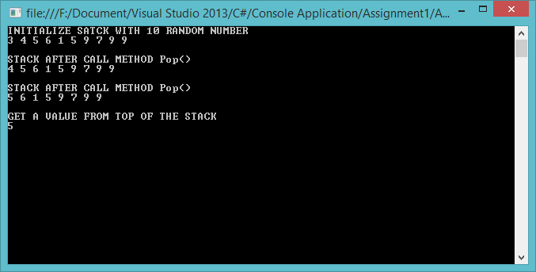

Assignment 2: Playing cards
Objective:
Problem Description:
Write code:
- Write a class whose instances represent a single playing card from a deck of cards. Playing cards have two distinguishing properties: rank and suit.
- Write a class whose instances represent a full deck of cards.
- Write a small program to test your deck and card classes. The program can be as simple as creating a deck of cards and displaying its cards.
