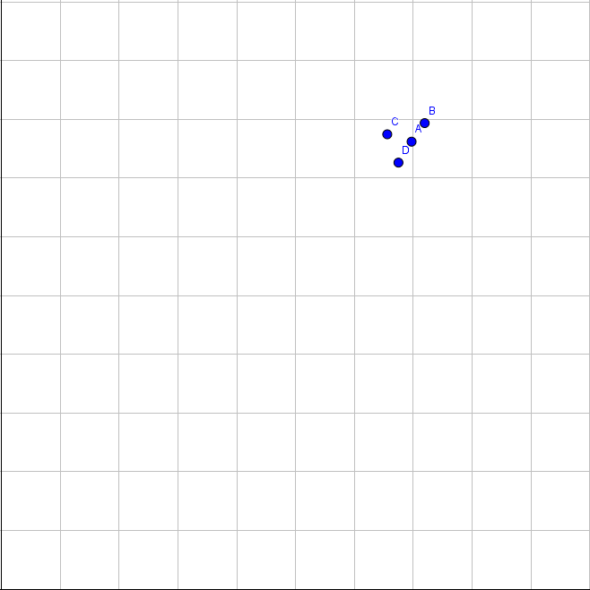AAVAVAVAVAVAVAVAVAVAVAVA\A 
"AVAVAVAVAVAVAVAVAVAVAVAVAVA\A 
XVAVAVAVAVAVAVAASVAUVAVAVAVAV>" 
VAVAVAVAVAVAVAVAVAVAVAVAVAV'" 
VAVAVAVAVAVAVAVAVAVAVAV'" 
XVAVAVAVAVAVAVAVAV4V" 

