James Le

Santa Ana, CA, 92704 Email: [dohuul@gmail.com](mailto:dohuul@gmail.com) Phone: 626 944 0933 U.S.Citizen

**PROFESSIONAL SUMMARY**

Proactive Software Engineer in Test (SDET) with 12 years of experience in Application Development, Manual and Automated, Web Services, Database testing for Cloud (AWS), Microservices, and Client/Server based applications. Eager to learn new things and implement ideas into working test automation solutions. A great team player dedicated to collaborating with Product Owners, Developers, and others to jointly produce the highest quality final products.

* Excellence knowledge and implementation skills in complete Software Development Life Cycle, and Software Testing Life Cycle.
* Experience in Agile Projects; worked closely with Product Owners and Developers in Agile and attended different meetings like Sprint Planning, Scrum, Sprint Review, Retrospective.
* Experience in ensuring software readiness through regression testing, load testing and error checking.
* Experience in implementing software test automation framework, executing test cases, writing complex test plans, and leading a team of 2 QAs for multi-tier system.
* Experience in establishing CICD pipeline for different testing stages, including sanity, and regression tests.
* Expertise in analyzing BRD, Functional Specifications, and Architecture documents. Experience in preparing Test plans, Test cases, Test summary reports for both automated and manual testing.
* Experience in working with multiple projects in parallel and taking on additional challenges outside of regular responsibilities (application development tasks, and data researching tasks for product team).
* Experience in performing Integration testing, Regression Testing, Database testing, Data verification testing, Load testing, and Stress testing.
* Experience in functional and load testing for Data Migration (50 million records), Active-Active (AWS multi region), API Blue Green pattern (for deployment), AP third party integration.
* Experience in designing configurable automation tests for multi environment application (QA, RC, Production).
* Experience in using mock data to streamline testing and development for complex vendor data.
* Experience in building multi-layer automation framework from scratch on top of Selenium and .NET.
* Experience in categorizing and prioritizing tests to be executing during software release.
* Experience in setting up test environment for web services allowing fast turnaround time when troubleshooting Production issue and producing more accurate test result.
* Experience in optimizing test script execution time, reusability, and reliability.

**SKILLS & TOOLS**

* Testing tools: Selenium Web Driver, Playwright, Visual Studio MS Test, Node JS, Postman, Fiddler, Browser Developer Tools, .NET Console App
* Load Testing tools: K6, JMETER, SOAP UI, .NET Console App
* Test Automation design: Layered Architecture, Page Object Model
* Version Control Tools: GIT (Azure DevOps), TFS (Visual Studio)
* Database: Microsoft SQL, PostgreSQL, NoSQL (AWS Dynamo)
* CICD Tools: Azure Pipeline, Jenkin
* Deployment: Terraform
* Programming Language: C#, JavaScript, Python
* Other languages/technologies: HTML, CSS, XML, JSON, XPath, JSON Path, XSLT, YML

**WORK EXPERIENCE**

**First American Mortgage Solution**

**Senior Software Engineer In Test 2014 – Present**

**FraudGuard is a mortgage fraud detection and prevention solution delivered as a Software as a Service (SaaS), built on a Service Oriented Architecture (SOA).**

Responsible for leading the testing aspect for flagship product FraudGuard and Digital Gateway services involved in cloud migration, data migration, data quality comparison, and analytic in Mortgage industry.

• Developed test plan, test cases, and automation scripts to verify the migration of over 50 millions records from MongoDB to AWS S3 using C# console app.

* Developed test strategy for the effort of setting up Active-Active (Cloud Multi Region) for flagship FraudGuard in AWS Cloud using K6 Load Test, Selenium Web Driver and C#
* Designed, implemented and executed load test to measure application performance for flagship FraudGuard during cloud migration and Active-Active (Cloud Multi Region) set up using K6 Load Test.
* Designed and implemented data quality comparison automation tests producing statistic values to provide a deep insight into the effect of invasive modification such as Business Logic and Vendor changes.
* Provided application support in Production environment as needed using SPLUNK, SQL, AWS Cloud Watch.
* Led release testing and application health readiness using Regression Tests baseline, Load Test baseline, and SPLUNK (for scanning new error)
* Analyzed vendor data model, documents, and sample responses to create a portfolio of mock data for application development, Production troubleshooting, and Test Automation for all Vendor sources. Increase the mock data coverage to 100%.
* Worked closely with various roles in tech organization such as Product, DBA, DevOps, Project Managers.
* Provided support, coordinate testing effort, and conduct regular QA code review with other SDET engineers.
* Improved automation reusability by applying Page Object Model pattern in turn increasing UI automation coverage by 260%
* Decrease automation execution time by 80% by applying Thread Safe, Smart Wait, DB Calls Reduction, Loop Break, Caching, API Call instead of UI interaction, and Efficient Web Page Element Search.
* Improved automation reliability by breaking large test in to smaller one, applying retry when need, avoiding duplication, and emphasizing reusable code.
* Integrated automation tests into Azure pipeline for CICD integration using yml, K6, and .NET.
* Provided the validation of data through SQL queries.
* Implemented UI automation for Iframe navigation, PDF validation, file download verication, and new tab/window using Selenium.
* Implemented a daily report scheduled to run daily to monitor application heath using Selenium and C#.
* Used Fiddler, PostMan, in house application, and Web Browser Developer Tools for daily testing activities.
* Used Selenium, Playwright, JavaScript, and .NET for functional test automation.
* Used JMETER, SoapUI, K6, and .NET for load test automation.

**Digital Gateway is an API platform for data and services allowed seamless access to Property, Identity, and Verification data. The platform is built on a Microservices Architecture on AWS Cloud. Some of the technologies are being leveraged include 3Scale, AWS S3, AWS Lambda, AWS Dynamo.**

* Worked closely with developers to define logic to allow the testing of unexpected data such as hard failure, time out, and intermittent error from vendor services.
* Designed and collaborated with other SDET engineers to produce testing guideline serving as core test cases for Web Service test.
* Analyzed application volume and behavior to create various load tests scenarios.
* Conducted various load test scenarios during daytime, nighttime, weekends, and from different locations in the East or West region.
* Collaborated with other SDET engineers to create a configurable multi environment test.
* Analyzed vendor raw data and application logic to gain deep insight into mapping rules, increasing the accuracy of the testing of the mapping of vendor raw data to internal model using XPath, and Json Path.
* Categorized and prioritized tests to be executing during software release.
* Participated in application development, migrate on premise services to AWS Cloud using C#, AWS Lambda, AWS S3, AWS dynamo, and automate the deployment using Terraform.
* Used K6, JMeter, SOAP UI, and C# for functional and load testing.

**Interthinx**

**Software Engineer in Test 2012 – 2014**

* Developed automated tests suites for testing web applications using RFT, PhantomJS, CasperJS, and CodeUI Test.
* Conducted load test using SOAP UI, and MS Test.
* Assisted Senior Developers with development taasks such as web service unit test, update store procedure, technical design document, and create deployment packages.
* Created test plan and test cases for functional, load test, and stress testing.
* Designed an automated C# app scheduled to run hourly to check the health of major services.
* Integrated C# MS Test into in house regression test tool.
* Assisted QA Manager during release by volunteering to run regression to verify application health.

**EDUCATION**

• Computer Engineer - Bachelor of Science, University of California Irvine   December 2011

• Udacity online learning platform – Front End Web Developer November 2016

**AWARD**

• Award of Excellence – First American September 2018

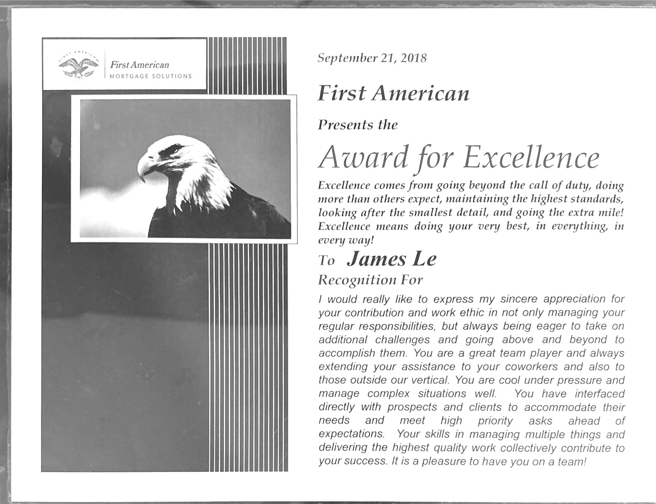

**AWARD**

• Expect Excellence Certificate of Appreciation - Interthinx April 2013

