James Le

Sana Ana, CA

[dohuul@gmail.com](mailto:jamesle01051986@gmail.com)

626 944 0933

To Disney Hiring Department,

I am writing to express my interest in the Software Engineer in Test (SDET) position currently available at your firm. I am a hard-working individual, very punctual and responsible. I have expertise in managing multiple complex tasks simultaneously, experience delivering high-quality work under tight timelines, and I am eager to take on additional challenges beyond regular responsibilities. Additionally, I am a great team player, always ready to assist coworkers and those outside my department.

I have been with my current employer for 12 years, primarily responsible for testing a multi-tier application in financial services. This application is built on a Software as a Service architecture, backed by a set of RESTful web services on a Microservices architecture. My daily responsibilities include creating new test scripts, maintaining an in-house automation framework built on .NET and Selenium, validating release tickets, assisting in troubleshooting production issues, answering client questions, and providing guidance to two Junior SDETs. Additionally, once a month, I ensure application readiness in the monthly code release by executing regression tests (both functional and performance), reviewing application logs for new errors, and publishing test results to product owners and managers.

Beyond my regular responsibilities, I also participate in application development. For example, I have helped troubleshoot the root cause of bugs by debugging application code, migrated on-premise services to AWS Cloud, set up automated deployment, and integrated test scripts into Azure Pipeline for CI/CD.

During my tenure as an SDET with my current employer, I have been recognized twice for my contributions (Award section pages 4 & 5).

After 12 years with my current employer, I am seeking a new opportunity and am particularly excited about the opportunity at your firm. A new opportunity brings new challenges, and I am excited to conquer these challenges and gain recognition with a new team. I believe that with my current skill set and experience, I will be able to tackle new challenges and be a great addition to your team.

Please feel free to contact me at any time to schedule an interview. Thank you for considering my application.

Sincerely,  
James Le

James Le

Santa Ana, CA, 92704 Email: [dohuul@gmail.com](mailto:dohuul@gmail.com) Phone: 626 944 0933 U.S.Citizen

**PROFESSIONAL SUMMARY**

Proactive Software Engineer in Test (SDET) with 12 years of experience in Application Development, Manual and Automated, Web Services, Database testing for Cloud (AWS), Microservices, and Client/Server based applications. Eager to learn new things and implement ideas into working test automation solutions. A great team player dedicated to collaborating with Product Owners, Developers, and others to jointly produce the highest quality final products.

* Excellence knowledge and implementation skills in complete Software Development Life Cycle, and Software Testing Life Cycle.
* Experience in Agile Projects; worked closely with Product Owners and Developers in Agile and attended different meetings like Sprint Planning, Scrum, Sprint Review, Retrospective.
* Experience in implementing software test automation framework, executing test cases, writing complex test plans. managing CICD test pipelines, and leading a team of 2 QAs for multi-tier system.
* Expertise in analyzing BRD, Functional Specifications, and Architecture documents. Experience in preparing Test plans, Test cases, Test summary reports for both automated and manual testing.
* Experience in working with multiple projects in parallel and taking on additional challenges outside of regular responsibilities (application development tasks, and data researching tasks for product team).
* Experience in performing Integration testing, Regression Testing, Database testing, Data verification testing, Load testing, and Stress testing.
* Experience in functional and load testing for Data Migration (50 million records), Active-Active (AWS multi region), API Blue Green pattern (for deployment), API Vendor changes (vendor sources, and secondary vendor).
* Experience in designing configurable automation tests for multi environment application DEV, QA, RC, and Production.
* Experience in using mock data to streamline testing and development for complex vendor data.
* Experience in building multi-layer automation framework from scratch on top of Selenium and .NET.
* Experience in categorizing and prioritizing tests to be executing during software release.
* Experience in setting up test environment for web services allowing fast turnaround time when troubleshooting Production issue and producing more accurate test result.
* Experience in optimizing test script execution time, and reliability (script log review, threading, smart wait, Database/API calls reduction)
* Experience in improving test script reusability (standardization, and modularization).

**SKILLS & TOOLS**

* Testing tools: Selenium Web Driver, Playwright, Visual Studio MS Test, Node JS, Postman, Fiddler, Browser Developer Tools, .NET Console App
* Load Testing tools: K6, JMETER, SOAP UI, .NET Console App
* Test Automation design: Layered Architecture, Page Object Model
* Version Control Tools: GIT (Azure DevOps), TFS (Visual Studio)
* Database: Microsoft SQL, PostgreSQL, NoSQL (AWS Dynamo)
* CICD Tools: Azure Pipeline, Jenkin
* Deployment: Terraform
* Programming Language: C#, JavaScript, Python
* Other languages/technologies: HTML, CSS, XML, JSON, XPath, JSON Path, XSLT, YML

**WORK EXPERIENCE**

**First American Mortgage Solution**

**Senior Software Engineer In Test 2014 – Present**

**FraudGuard is a mortgage fraud detection and prevention solution delivered as a Software as a Service (SaaS), built on a**

**Service Oriented Architecture (SOA).**

Responsible for leading the testing aspect for flagship product FraudGuard and Digital Gateway services involved in cloud migration, data migration, data quality comparison, and analytic in Mortgage industry.

• Developed test plan, test cases, and automation scripts to verify the migration of over 50 millions records from MongoDB to AWS S3 using C# console app.

* Developed test strategy for the effort of setting up Active-Active (Cloud Multi Region) for flagship FraudGuard in AWS Cloud using K6 Load Test, Selenium Web Driver and C#
* Designed, implemented and executed load test to measure application performance for flagship FraudGuard during cloud migration and Active-Active (Cloud Multi Region) set up using K6 Load Test.
* Designed and implemented data quality comparison automation tests producing statistic values to provide a deep insight into the effect of invasive modification such as Business Logic and Vendor changes.
* Provided application support in Production environment as needed using SPLUNK, SQL, AWS Cloud Watch.
* Led release testing and application health readiness using Regression Tests baseline, Load Test baseline, and SPLUNK (for scanning new error)
* Analyzed vendor data model, documents, and sample responses to create a portfolio of mock data for application development, Production troubleshooting, and Test Automation for all Vendor sources. Increase the mock data coverage to 100%.
* Worked closely with various roles in tech organization such as Product, DBA, DevOps, Project Managers.
* Provided support, coordinate testing effort, and conduct regular QA code review with other SDET engineers.
* Improved automation reusability by applying Page Object Model pattern in turn increasing UI automation coverage by 260%
* Decrease automation execution time by 80% by applying Thread Safe, Smart Wait, DB Calls Reduction, Loop Break, Caching, API Call instead of UI interaction, and Efficient Web Page Element Search.
* Improved automation reliability by breaking large test in to smaller one, applying retry when need, avoiding duplication, and emphasizing reusable code.
* Integrated automation tests into Azure pipeline for CICD integration using yml, K6, and .NET.
* Provided the validation of data through SQL queries.
* Implemented UI automation for Iframe navigation, PDF validation, file download verication, and new tab/window using Selenium.
* Implementd a daily report scheduled to run daily to monitor application heath using Selenium and C#.
* Used Fiddler, PostMan, in house application, and Web Browser Developer Tools for daily testing activities.
* Used Selenium, Playwright, JavaScript, and .NET for functional test automation.
* Used JMETER, SoapUI, K6, and .NET for load test automation.

**Digital Gateway is an API platform for data and services allowed seamless access to Property, Identity, and Verification data. The platform is built on a Microservices Architecture on AWS Cloud. Some of the technologies are being leveraged include 3Scale, AWS S3, AWS Lambda, AWS Dynamo.**

* Worked closely with developers to define logic to allow the testing of unexpected data such as hard failure, time out, and intermittent error from vendor services.
* Designed and collaborated with other SDET engineers to produce testing guideline serving as core test cases for Web Service test.
* Analyzed application volume and behavior to create various load tests scenarios.
* Conducted various load test scenarios during daytime, nighttime, weekends, and from different locations in the East or West region.
* Collaborated with other SDET engineers to create a configurable multi environment test.
* Analyzed vendor raw data and application logic to gain deep insight into mapping rules, increasing the accuracy of the testing of the mapping of vendor raw data to internal model using XPath, and Json Path.
* Categorized and prioritized tests to be executing during software release.
* Participated in application development, migrate on premise services to AWS Cloud using C#, AWS Lambda, AWS S3, AWS dynamo, and automate the deployment using Terraform.
* Used K6, JMeter, SOAP UI, and C# for functional and load testing.

**Interthinx**

**Software Engineer in Test 2012 – 2014**

* Developed automated tests suites for testing web applications using IBM RFT, JS Phantom, Casper JS, and Code UI Test.
* Conducted load test using SOAP UI, and MS Test.
* Assisted Senior Developers with development taasks such as web service unit test, update store procedure, technical design document, and create deployment packages.
* Created test plan and test cases for functional, load test, and stress testing.
* Designed an automated C# app scheduled to run hourly to check the health of major services.
* Integrated C# MS Test into in house regression test tool.
* Assisted QA Manager during release by volunteering to run regression to verify application health.

**EDUCATION**

• Computer Engineer - Bachelor of Science, University of California Irvine   December 2011

• Udacity online learning platform – Front End Web Developer November 2016

**AWARD**

• Award of Excellence – First American September 2018

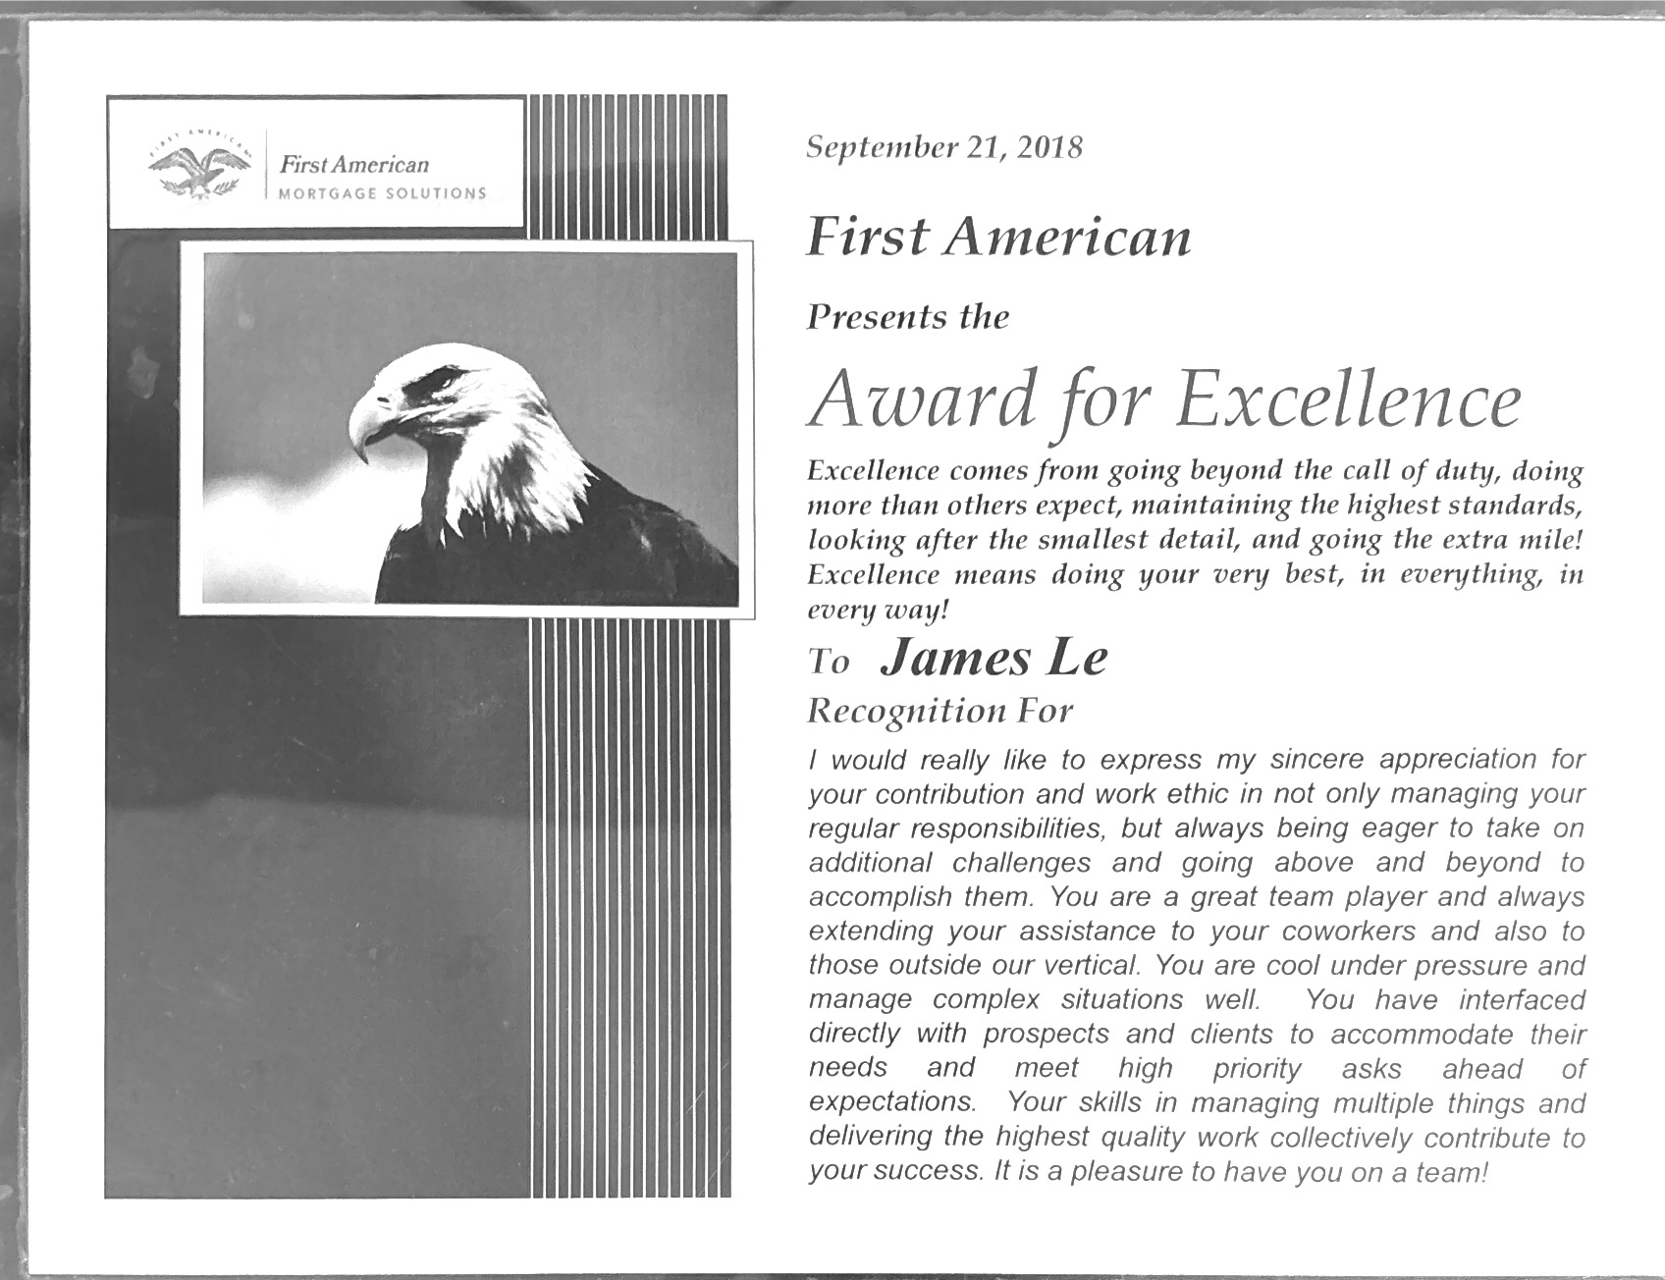

**AWARD**

• Expect Excellence Certificate of Appreciation - Interthinx April 2013

