CSYE7220-Devops

Amogh Doijode Harish

Homework5

**Running Docker container on AWS:**

1. Create an AMI with docker installed using HashiCorp Packer.

* Install Packer <https://packer.io/downloads.html>. And create a ubuntu.json file

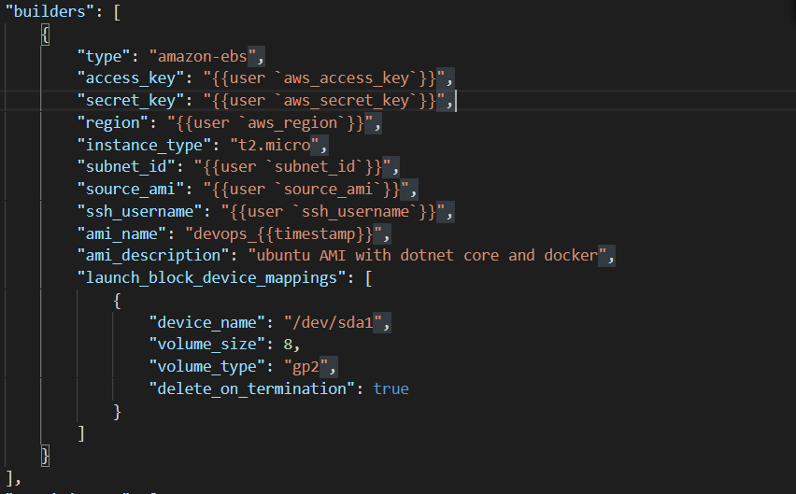

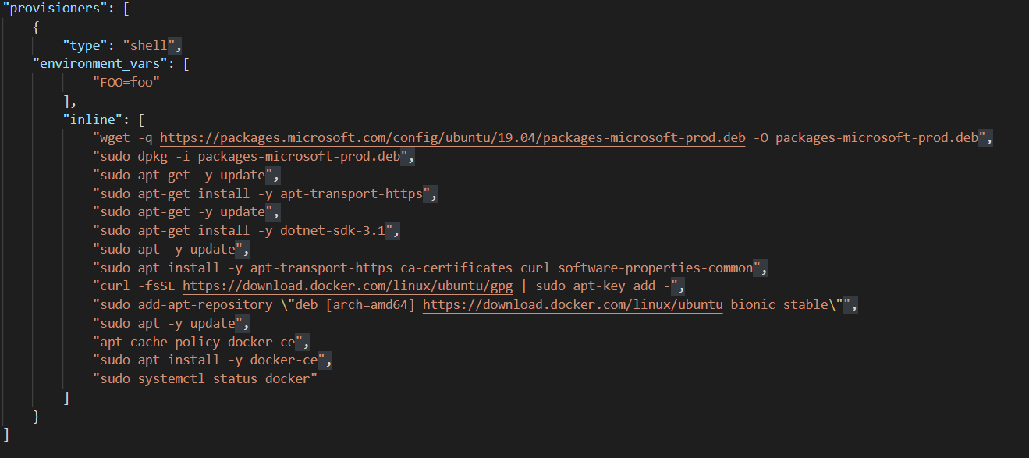

1. Run the commands packer validate < ubuntu.json >.json



1. Run packer build < ubuntu.json >.json

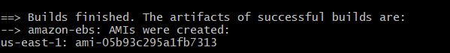

1. Copy the AMI ID after creation
2. In the aws_instance resource. Insert the AMI ID and insert user_data to pull docker image and run.

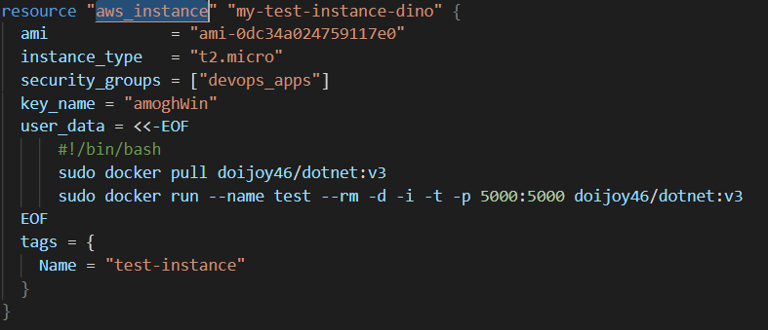

1. Run Terraform init.
2. Run command Terraform plan -out=test
3. Run Terraform apply test

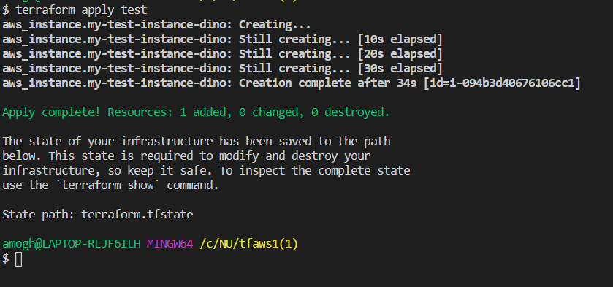

1. Open a browser and open <public_ip of your ec2 instance>:5000

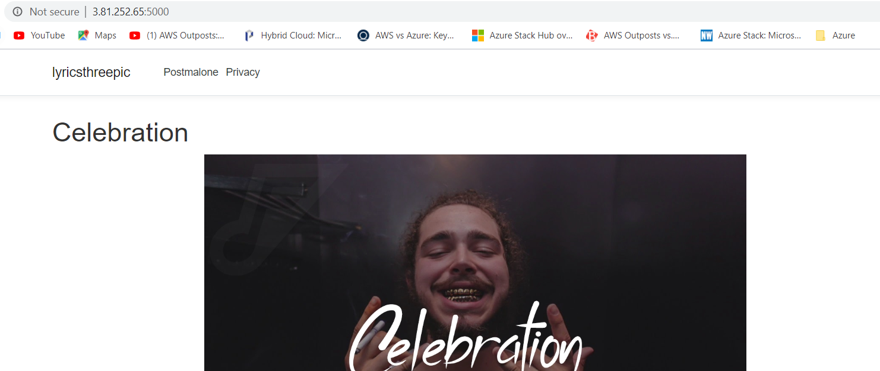

1. After testing run “Terraform Destroy”

**Deploying Docker container on AZURE:**

1. Insert the azurerm_virtual_machine_extension resource and enter your commands that you need to install docker and pull the image.

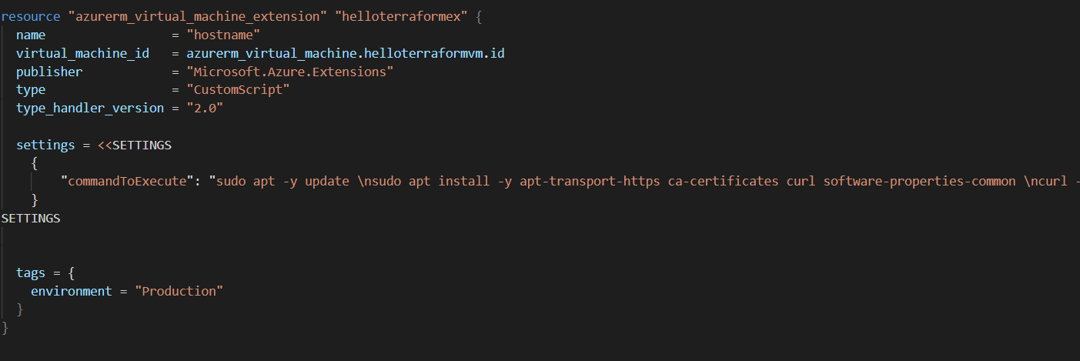

1. Run “Terraform init”
2. Run command “Terraform plan -out=test”
3. Run command “Terraform apply test”

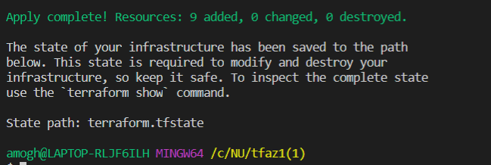

1. Open your browser and navigate to <your_VM_PUBLIC_IP>:5000 and you will see the app.

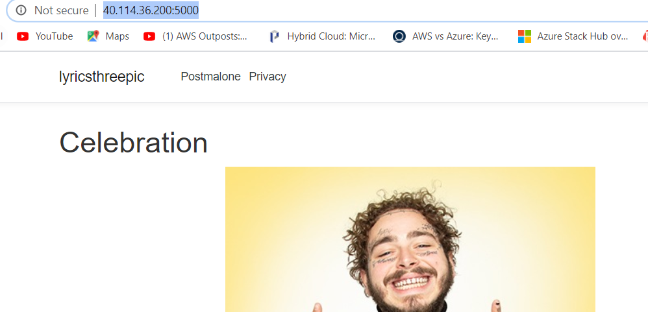

1. Run “Terraform destroy” to destroy your resources.