Lane Detection using U-Net with Spatiotemporal Feature Extraction for Improved Road Segmentation

Robert-Marian Damoc¹, Dan Marius Dobrea^{1,2}
¹ Faculty of Electronics, Telecommunications and Information Technology, Technical University „Gh. Asachi“, Iasi, Romania
r_damoc@yahoo.com, mdobrea@etti.tuiasi.ro
² Institute of Computer Science, Romanian Academy Iasi Branch, Iasi, Romania

Abstract— The aim of this paper is to develop and evaluate a robust lane detection system for Advanced Driver Assistance Systems (ADAS) using deep learning techniques. While advanced deep learning models offer excellent detection accuracy, their overwhelming requests on computational resources, energy, and memory often ruin their deployment on embedded platforms. In our work, a unique approach was utilized to generate a comprehensive dataset that not only captures ideal conditions but also incorporates challenging scenarios with wrong detections. The network was trained on this diverse dataset, improving its robustness and resulting in high accuracy for lane marking detection. The outcomes of this study offer a promising path toward more dependable and effective lane detection systems that can be integrated into real-time automotive and smart infrastructure applications, ultimately contributing to improved road safety in autonomous driving technologies.

Introduction
Lane detection is crucial for various autonomous driving functionalities, such as lane keeping, lane departure warning, and trajectory planning. However, lane detection remains challenging due to complex and variable realistic road conditions (bad weather, poor lighting), occlusions, motion blur, the curvature of the lane, and time-consuming operations [1].
In segmentation-based approaches, the primary goal is to create a segmentation mask based on specific classes. The system transforms the lane detection problem into a multi-class segmentation problem in this mode. The system has several classes, such as the left and right lanes (each lane has its own class). Based on this idea, LaneNet [2] comprises an encoder (E-Net), followed by a Hydra network with two heads: a lane segmentation branch and a lane embedding branch. The lane segmentation branch performs binary line segmentation, producing two output classes: background and lane. The lane embedding branch assigns a lane ID to each pixel from the lane segmentation branch while ignoring the background. In the end, each pixel is converted into a parametric description, and the image is transformed into a “bird's-eye view” using a perspective transformation; the fitting is then performed in this new space.
One of the popular models for semantic segmentation is the U-Net architecture. Initially developed for biomedical image segmentation, it is recognized by its encoder-decoder structure, skipping connections (enhancing the resolution of segmentation outputs), and its capacity to precisely locate and categorize pixels [3]. This architecture is perfect for detailed segmentation results, poor recording conditions for the images, and it is an effective solution for limited datasets. One significant downside is its sensitivity to noise, and high-quality labeled data is necessary for better performance. In this paper, various techniques are explored to surpass these issues.
Enhancing the advantages of U-Net, a backbone network such as ResNet [4] or DLA[5] is often used for feature extraction in deep learning segmentation systems. These networks effectively capture spatial and semantic features combined with specific metrics [6] to improve confidence in particular assignments. Despite the potential offered by these methods, disadvantages persist. Filtering irrelevant data, which can be time-consuming, requires significant hardware resources for both training and deployment, which can be unreasonable for real-time applications.
The main contributions of this paper lie in threefold:
- First, for the problem that lane cannot be accurately detected under challenging conditions, the method suggested is a comprehensive data generation strategy that involves advanced image processing techniques. With this, the dataset will include both ideal and imperfect lane detections.
- Second, the network architecture is based on U-Net with specific optimization to make it resistant to awful training images (adaptive filter scaling, progressive dropout, and batch normalization to accelerate convergence and improve stability).
- Third, incorporating a memory component (ConvLSTM layer) to integrate temporal information from consecutive frames. This addition improves accuracy and assures a smooth transit for spatiotemporal information that can filter noisy images.
Experiments demonstrate that our method achieves state-of-the-art performance, especially in complex scenarios such as occlusion, curved lanes, and low-light environments. One big achievement is the good accuracy attained on previously unseen images, which shows the model’s generalization capabilities.

Generating a labeled dataset

TuSimple Dataset
To better understand the behavior and process for good accuracy in lane segmentation, the labels of the dataset were generated using advanced image processing. This involves obtaining the correct labels associated with the input images, which indicate the proper position and size of the bands in the image and other elementary features such as the orientation angle.
The image set used is TuSimple [7], which is one of the most well-known and widely used datasets for lane detection and segmentation. It consists of 6,408 road images, each taken from a short sequence of 20 consecutive frames captured on US highways, organized into short video clips of 20 consecutive frames each. The resolution of the images is 1280 x 720. TuSimple comprises 3,626 images for training, 358 for validation, and 2,782 for the testing set. These images are acquired under different weather conditions. This database is widely used in research and in the development community in the field of autonomous vehicles and driver assistance systems.

Image Segmentation
Creating the data sets required by the DNN training process, with line detections, for the images from the TuSimple database, is a crucial stage for a successful image segmentation. First, specific filters are applied to clear away unnecessary information. The US highway consists of white and yellow lanes. To isolate the white lanes, a combination of grayscale and threshold filters is used to extract only the white regions, which are crucial for segmentation. For yellow lanes, an HSV (Hue, Saturation, Value) filter is applied. The outputs from these filters are then combined using a logical ‘OR’ operation, which combines the white and yellow lane markings. To eliminate unwanted objects from the resulting filters, the image is cropped using four specific points representing the region where the road lanes are expected to be located (Figure 1). The selections of those four points result from imperfect detections, caused by the position of the car and the angle from which these photos are taken, which differ from some pictures. A “bird-eye view” filter processes the selected region to generate a histogram representing a white pixel map. Finally, a sliding window is used to classify whether a specific zone from the histogram represents the right or left lane. This algorithm aims to identify clusters of white pixels representing potential lane lines [7].
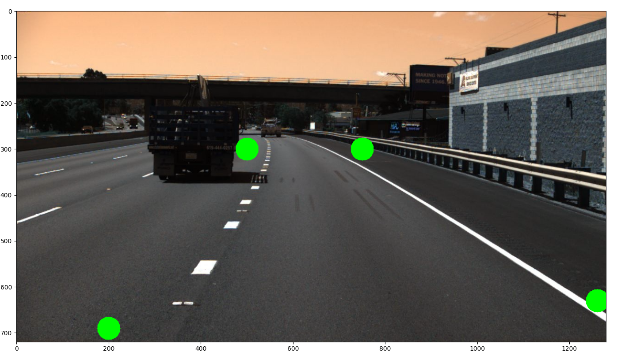
- Example of selecting a road lane region

Image Segmentation Results
In many cases, the segmentation was correctly done (Figure 2). However, from all 6,408 images in the TuSimple dataset, approximately 20% result in inaccurate detection (Figure 3). Although these results could potentially impact the model performance, the advanced image processing techniques and sturdy data generation ensure that the model is exposed to various conditions during training. One of the main causes of inaccurate detections is the use of static parameters for cropping the road region. The main deficiency of using static cropping points is their lack of adaptability to different perspectives and road scenarios.

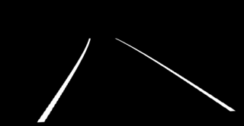
- Good lane detection
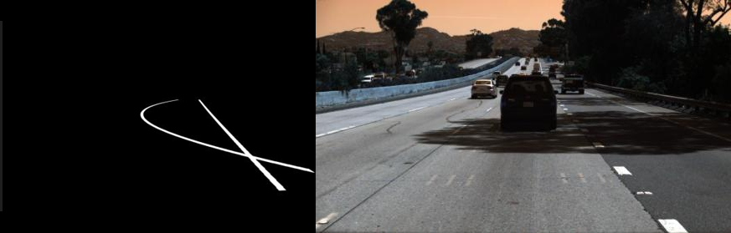
- Imperfect lane detection

U-Net optimizations
The U-Net architecture is a type of convolutional neural network (CNN) originally developed for biomedical image segmentation. It includes a symmetric architecture consisting of a contracting path (encoder) and an expansive path (decoder), allowing for precise localization and segmentation of objects [3].
Components of U-Net:
- The encoder is responsible for extracting features from the input image. Based on this information, a progressive convolution layer is used to assemble a more precise output.
- The bottleneck connects the encoder and the decoder, acting as the most profound layer. It allows capturing complex patterns, textures, and contextual relationships without worrying about redundant spatial information.
- The decoder reconstructs the segmented image using up-sampling procedures. It reverses the compression process, ensuring that key details are preserved.
- Skip connections are a key feature of U-Net that help preserve important details during segmentation.
Compared to classic network architecture, we made the following changes:

Adaptive Filter Scaling
On this DNN, the number of filters determines how many features are extracted at different stages of the network. A higher number of filters allows for more features to be extracted, but it also increases computational costs, requiring powerful hardware. For example, in the original U-Net paper, the filter count starts at 64 and doubles at each level, reaching a maximum of 1024 filters. However, this setup is not optimal for real-time applications. To improve efficiency, it is essential to reduce the number of filters. As a direct result, in this research, the network started with 16 and stopped at a number of filters of 256. This approach ensured better performance on embedded systems.
In the original paper, the U-Net architecture processed 32x32 input images; however, for the lane segmentation task, it needed to process more complex and bigger images. For this reason, in the case of this research, we used a 512x256 input image dimension.

Progressive Dropout at Encoder
The progressive use of dropout in the U-Net encoder (at the end of the convolutional layer and increasing values at each level), helps generalization and reduces overfitting. The network was used in early layers with a lower dropout rate (0.1). As the network gets deeper (the dropout was increased by 0.1 at each level), filters capture more complex features, and for that a higher dropout rate forces the model to be more robust. This method eliminates unwanted correlations and enables the model to learn diverse features.

Batch normalization at Decoder
In this research, batch normalization is used in the decoder to improve training efficiency and model performance. During up-sampling, the network has high variance, making optimization more challenging. The benefits of this method are smoothing gradient flow and eliminating artifacts in the final segmentation map.

Binary Focal Loss
Lane segmentation is essentially a pixel classification task that involves two classes: representing or not representing the component of a lane. The Binary Focal loss function [8] is designed to focus more on hard-to-classify examples, ensuring that the model does not focus on easily classified pixels.
After addressing class imbalance and emphasizing hard-to-classify pixels with Binary Focal loss, it is crucial to evaluate the segmentation performance using robust metrics. In lane segmentation, Intersection over Union (IoU) [9] provides a comprehensive understanding of how well the model delineates lane regions. The results obtained using the Binary Focal Loss function (Figure 4) are a helpful starting point to understand the model and identify adjustments (0.1174 accuracy value and 0.0117 loss value). However, the model’s output (Figure 5) presents an imprecise image interpretation.

IoU Loss Function
After a thorough analysis, improving prediction requires a strong correlation between the loss and accuracy functions. The
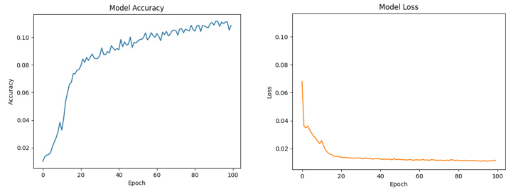
- Binary Focal loss training plots using TuSimple database
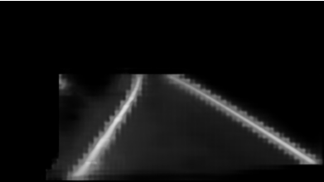
- Binary Focal loss model result
loss value in the Binary Focal Loss model doesn’t offer a realistic number (Figure 4). However, it provides a good opportunity to test the model’s performance. The IoU loss function represents the value required for the model to be 100% accurate, comparable with the IoU accuracy function, which reflects the actual capabilities of the model. The results obtained after changing the loss function are remarkable (0.5604 accuracy value and 0.4396 loss value) (Figure 6). Moreover, the detection is identical to the ground truth label (Figure 7).
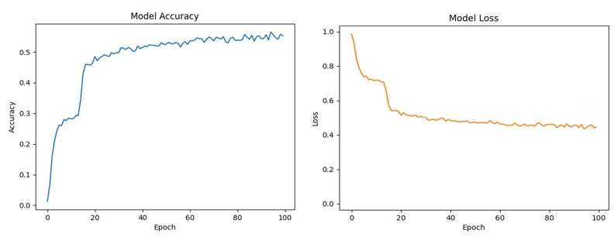
- IoU loss training plots using TuSimple database
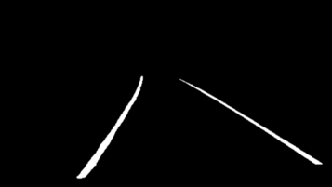
- IoU loss model result

Integrating short-term memory
The ConvLSTM layer plays a crucial role in preserving information from previous frames. The main objective is to combine data with spatial-temporal memory to make the model more robust to unseen images.
The optimal placement to apply a long-short-term memory convolution is the bottleneck, where the most complex information is processed. Additionally, this modification filters the zone with correlations of spatial-temporal space.
Since ConvLSTM operates in four-dimensional tensors (channel, width, height, time), we expand the output of the bottleneck convolution with one dimension, representing the time axis, and assign with one value, representing the present time step. That information is processed into a progressive ConvLSTM, making a more profound spatial-temporal correlation. The time space is removed for the output, leaving only a three-dimensional tensor (channel, width, height), and the result is passed into the decoder for reconstruction.
The training plots (Figure 8) and the numerical evaluation (0.5666 accuracy value and 0.4334 loss value) are approximately identical to the model without short-term memory. However, on execution, it exceeds the model without ConvLSTM. (Figure 9, Figure 10)
- Performance Comparison of original architecture (original u-net)
Model |  | Model Characteristics
Model | Number of parameters |  | Time on Raspberry Pi 4 | Time on Intel i5-9th | Accuracy
Original U-Net | 31,049,409 (118.44MB) |  | 6.5s | 672ms | 60.5%
U-Net Binary Focal Loss | 1,941,105(7,40MB) |  | 552.28ms | 65.9ms | 11.74%
U-Net IoU Loss | 1,941,105(7.40MB) |  | 555.54ms | 63.6ms | 56.04%
U-Net ConvLSTM | 20,545,969(78.38MB) |  | 975.6ms | 148ms | 56.66%

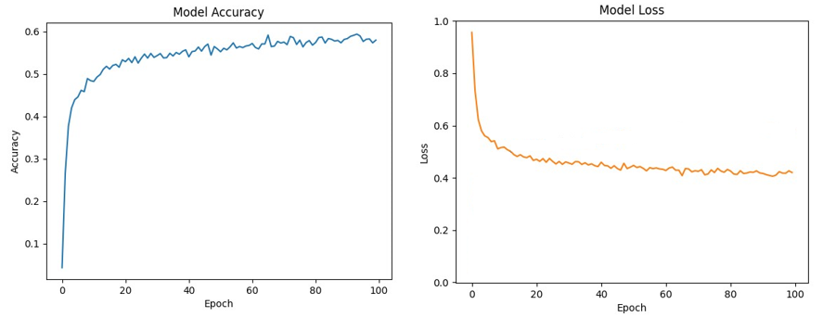
- ConvLSTM plots results using TuSimple database
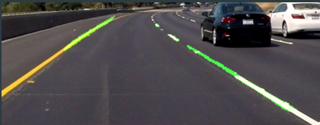
- Non-ConvLSTM model result
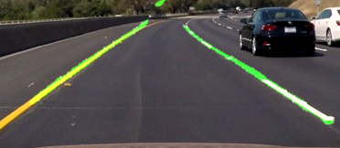
- ConvLSTM model result

Conclusions
The optimizations used in the U-Net architecture exceed any expectations in performance and accuracy, making it perfect for real-time embedded projects and giving good accuracy on the UE highway. One limitation is the model’s dependency on maintaining the same camera angle and position as the training dataset to make strong predictions. Another notable limitation is the model’s reduced ability to make accurate predictions at long distances, but the detection is nearly perfect for close-range bands. The proposed models in this research achieve accuracy like the original U-Net, but are more optimized regarding parameter count and prediction time (see Table I). The Raspberry Pi 4 measurements were assumed in a worst-case scenario: no active cooling and the CPU locked at 1 GHz.

References
- Q. Zou, H. Jiang, Q. Dai, Y. Yue, L. Chen, and Q. Wang, “Robustlane detection from continuous driving scenes using deep neuralnetworks,” IEEE Trans. Veh. Technol., vol. 69, no. 1, pp. 41–54, 2020,doi: 10.1109/TVT.2019.2949603.
- D. Neven, B. De Brabandere, S. Georgoulis, M. Proesmans, L. Van Gool, Towards End-to-End Lane Detection: an Instance Segmentation Approach, IEEE Intelligent Vehicles Symposium (IV), pp. 286-291, 26 June 2018, DOI: doi.org/10.1109/IVS.2018.8500547
- O. Ronneberger, P. Fischer and T. Brox, "U-Net: Convolutional Networks for Biomedical Image Segmentation," în Medical Image Computing and Computer-Assisted Intervention (MICCAI), vol. 9351, Lecture Notes in Computer Science, Springer, 2015, pp. 234–241
- Kaiming He, Xiangyu Zhang, Shaoqing Ren, and Jian Sun.Deep residual learning for image recognition. In Proceed-ings of the IEEE Conference on Computer Vision and PatternRecognition (CVPR), June 2016
- Fisher Yu, Dequan Wang, Evan Shelhamer, and Trevor Dar-rell. Deep layer aggregation. In Proceedings of the IEEEConference on Computer Vision and Pattern Recognition(CVPR), June 2018.
- H. Honda and Y. Uchida, "CLRerNet: Improving Confidence of Lane Detection with LaneIoU," arXiv preprint arXiv:2305.08366, 2023.
- Neven Udiljak, Shai Zeevi, Hongjian Wang, Tomer Michaeli, Yosef Mendelovich, “TuSimple: A Benchmark for Lane Detection,” Proc. IEEE Intelligent Vehicles Symposium (IV), 2017.
- E. Forson, "Teaching Cars to See: Advanced Lane Detection Using Computer Vision," Towards Data Science, 2017.
- T.-Y. Lin, P. Goyal, R. Girshick, K. He and P. Dollár, "Focal Loss for Dense Object Detection," IEEE Transactions on Pattern Analysis and Machine Intelligence, vol. 42, nr. 2, pp. 318–327, 2020, doi: 10.1109/TPAMI.2018.2858826.
- H. Rezatofighi, N. Tsoi, J. Gwak, A. Sadeghian, I. Reid and S. Savarese, "Generalized Intersection over Union: A Metric and A Loss for Bounding Box Regression," Proceedings of the IEEE/CVF Conference on Computer Vision and Pattern Recognition (CVPR), 2019, pp. 658–666, doi: 10.1109/CVPR.2019.00075.

