Revision Data Book for IoT-67808-2026
This document collects all data and tables that were added or revised in the present major revision. Section 1 lists the final values of the tables that can be inserted directly into the manuscript. Section 2 provides the complete raw data that support those tables. Section 3 lists the new figures. Prepared on 7 October 2026.

Section 0. Data sources and statistical conventions
Experiment | Content | Replications
exp1 | Online matching time per epoch and module level decomposition | Five independent repetitions for each of the nine scenarios, pooled over 14 355 matched epochs
exp2 | Comparison with mainstream geomagnetic matching algorithms | Eight methods and nine scenarios, one run for each entry
exp3 | Mechanism ablation and empirical coverage of the statistical envelope | Single run for the Professional grade at 1 nT. Coverage statistics are counts of true trajectory points
exp4 | Extended accuracy statistics of Table IV and constructive worst case | Ten independent Monte Carlo runs for each scenario. The worst case additionally compresses the magnetic anomaly amplitude
exp5 | Candidate grid counts and engineering implementation parameters | Geometric counts at three mission times. Parameters are taken from the configuration
The inertial grades follow the bias specifications of Table I, namely 0.005, 0.01 and 0.03 degrees per hour together with 20, 50 and 100 micro g. The geomagnetic noise levels are 1, 2 and 5 nT. The matching update runs at 1 Hz while the inertial system outputs at 100 Hz. The matching segment is the part of the flight for which the true trajectory lies inside the coverage of the geomagnetic map. That segment is 322 s long and contains 319 matched epochs. The matching sequence length is five samples of 1 Hz. The error envelope is generated offline from 10 000 Monte Carlo samples of the sensor biases. The random seeds are incremented from the base value 20261008.

Section 1. Tables added or revised in the manuscript, final values

Table III, revised with a new row of measured probability
Table III. Comparison of distributed probabilities.
Quantity | 1σ | 2σ | 3σ
Coverage probability | 68.27% | 95.45% | 99.73%
Ideal probability | 68.27% | 27.14% | 4.28%
Real count | 686 | 273 | 39
Real probability | 68.60% | 27.30% | 3.90%
Probability measured in this work | 68.23% | 27.06% | 4.45%
The last row reports the probability measured in this work. The sample is the true trajectory over the matching segment for the three inertial grades. It reproduces the ideal Gaussian partition within 0.17 percentage points, with 0.26 per cent of the samples outside the three sigma region and a cumulative coverage of 99.74 per cent. The row of real probability is obtained from the Monte Carlo sample set whereas the last row is obtained from the true trajectory over the matching segment.

Table IV, revised and recomputed from ten Monte Carlo runs
Table IV. Matching accuracy, Convergence Steps and RMSE.
Grade | Metric | 1 nT | 2 nT | 5 nT
0.005 °/h, 20 μg | Average Error (m) | 105 | 125 | 170
 | Convergence Steps | 1 | 47 | 141
 | RMSE (m) | 130 | 153 | 203
0.01 °/h, 50 μg | Average Error (m) | 132 | 176 | 263
 | Convergence Steps | 76 | 113 | 231
 | RMSE (m) | 167 | 221 | 329
0.03 °/h, 100 μg | Average Error (m) | 201 | 268 | 406
 | Convergence Steps | 96 | 139 | 218
 | RMSE (m) | 283 | 367 | 525
Each entry is obtained from ten independent Monte Carlo runs. The average error and the root mean square error are evaluated over the matching segment. The convergence steps are the number of matched epochs after which the error remains below 500 m.

Table V, recomputed with a single error model and expressed in the three sigma scale
Table V. Quantitative Normal Scales of the Matching Area Across Different Flight Durations.
Grade | 200 s | 400 s | 600 s | 800 s | 1000 s | 1200 s
0.005 °/h, 20 μg | 11.8 | 47.4 | 109.6 | 204.7 | 345.4 | 533.8
0.01 °/h, 50 μg | 29.4 | 120.0 | 271.8 | 503.8 | 830.7 | 1291.2
0.03 °/h, 100 μg | 58.9 | 236.1 | 554.9 | 1057.3 | 1772.9 | 2771.7
The tabulated quantities are three sigma scales. The corresponding one sigma scales are 3.9, 15.8, 36.5, 68.2, 115.1 and 177.9 m for the Professional grade, 9.8, 40.0, 90.6, 167.9, 276.9 and 430.4 m for the relay node grade, and 19.6, 78.7, 185.0, 352.4, 591.0 and 923.9 m for the conventional grade. All values are obtained from 10 000 Monte Carlo samples of the gyro and accelerometer biases defined in Table I, propagated through the fifteen state error transition matrix, and the quantiles are taken from the central 99.73 per cent interval. Figure 20 of the manuscript shows this group of three sigma curves.

Table VI, worst case and stability statistics
Table VI. Worst-case and stability statistics of the proposed method.
Scenario | Std (m) | Worst-case Max (m) | Worst p95 (m) | Fix acceptance (%)
Professional, 1 nT | 22 | 494 | 364 | 8.8
Professional, 2 nT | 31 | 670 | 542 | 8.8
Professional, 5 nT | 26 | 692 | 518 | 12.1
Relay node, 1 nT | 28 | 784 | 624 | 7.4
Relay node, 2 nT | 45 | 835 | 824 | 5.7
Relay node, 5 nT | 47 | 1516 | 924 | 7.5
Conventional, 1 nT | 61 | 1206 | 837 | 5.8
Conventional, 2 nT | 111 | 1589 | 1147 | 4.2
Conventional, 5 nT | 79 | 2256 | 1363 | 4.1
Each scenario was executed ten times with independent Monte Carlo runs. Std is the standard deviation of the average position error among runs. Worst case max is the largest peak error among the ten runs and worst p95 is the worst 95th percentile of the per run error series. Fix acceptance is the fraction of matched epochs whose correction satisfied the trajectory consistency criterion and it is not the 99.73 per cent envelope coverage. No fallback search was triggered in any of the ninety runs and no run diverged.

Table VII, online matching time of one epoch
Table VII. The time consumption for a single match.
Scenario | Mean (ms) | p95 (ms) | p99 (ms) | Worst (ms) | Worst over 10 ms budget (%)
Professional, 1 nT | 0.243 | 0.553 | 0.821 | 6.137 | 61.4
Professional, 2 nT | 0.178 | 0.424 | 0.788 | 1.15 | 11.5
Professional, 5 nT | 0.207 | 0.509 | 0.834 | 1.24 | 12.4
Relay node, 1 nT | 0.241 | 0.603 | 0.865 | 1.166 | 11.7
Relay node, 2 nT | 0.237 | 0.641 | 0.901 | 1.283 | 12.8
Relay node, 5 nT | 0.232 | 0.570 | 0.832 | 1.544 | 15.4
Conventional, 1 nT | 0.305 | 0.650 | 0.946 | 1.714 | 17.1
Conventional, 2 nT | 0.298 | 0.645 | 0.930 | 1.369 | 13.7
Conventional, 5 nT | 0.315 | 0.666 | 0.937 | 1.248 | 12.5
Each scenario was executed five times with different random seeds and all matched epochs were pooled, giving 14 355 epochs. A warm up run precedes the timing and is excluded. Pooled over the nine scenarios the mean is 0.251 ms, the median is 0.180 ms, the 95th percentile is 0.601 ms, the 99th percentile is 0.876 ms, the worst epoch is 6.137 ms, the standard deviation is 0.180 ms and the minimum is 0.083 ms. The mean corresponds to 0.025 per cent of the 1 s matching interval and to 2.5 per cent of the 10 ms inertial step. The worst epoch of 6.137 ms occurs in the first scenario executed and retains a residual cold start effect of the run time environment, whereas the worst steady state epoch is 1.714 ms.

Table VIII, module level decomposition of the online matching time
Table VIII. Decomposition of time consumption for each module.
Module | Per-epoch (ms) | Share (%)
Candidate construction and map look up | 0.0396 | 15.8
MAD coarse screening and MSD fine localization | 0.021 | 8.4
Covariance consistency criterion | 0.0112 | 4.5
Fallback search | 0 | 0
Other fixed per-epoch overhead | 0.1789 | 71.4
Total | 0.2506 | 100
Values are normalized over 14 355 matched epochs obtained from 45 runs. The four functional modules that form the complete on line matching branch amount to 0.0717 ms per epoch. The fallback branch was never entered in these scenarios and its worst case behaviour is characterized in Table XI. The tabulated entries are rounded to four decimal places whereas the subtotal and the total are accumulated from the unrounded per epoch times, so they can differ from the sum of the tabulated entries by one unit in the last digit.

Table IX, comparison with reference algorithms
Table IX. Average horizontal position error at 1 nT for the proposed method and for reference algorithms.
Method | Professional | Relay node | Conventional
Proposed three-tier strip | 93 | 106 | 184
ICCP | 173 | 227 | 279
Particle filter | 201 | 107 | 340
Traditional fixed-width search | 156 | 209 | 347
Global traversal | 271 | 159 | 505
Global traversal over a fixed area | 113 | 130 | 288
Stand-alone INS | 201 | 472 | 1050
The values correspond to a single run per scenario at 1 nT measurement noise. All methods share the same candidate expansion kernel, the same similarity measures, the same observation sequence, the same map look up, the same envelope protection and the same trajectory consistency criterion. ICCP is used with a constrained registration, that is a normal search band of one sigma and translation only. The difference with respect to Table IV should be noted. Table IV reports the average of ten Monte Carlo runs, namely 105, 132 and 201 m at 1 nT, whereas the present table reports the single run values of 93, 106 and 184 m.

Table X, mechanism ablation
Table X. Ablation of the proposed mechanism for the Professional grade at 1 nT measurement noise.
Configuration | Average error | RMSE
Proposed three-tier strip | 93 m | 119 m
Without the covariance criterion | 235 m | 304 m
First tier only | 114 m | 144 m
Second tier only | 218 m | 248 m
Third tier only | 217 m | 246 m
Single union strip over three sigma | 296 m | 325 m
The scenario is the Professional grade at 1 nT with a single seed. All configurations share the same candidate kernel, the same envelope protection and the same trajectory consistency criterion, and they differ only in the tier structure and in the covariance criterion. Removing the covariance criterion makes the average error 2.5 times larger and makes every matched epoch admissible. Replacing the tiered search by a single union strip over three sigma makes the average error 3.2 times larger.

Table XI, constructive worst case
Table XI. Constructive worst case.
Anomaly amplitude | Average error | Maximum error | Maximum candidate points | Worst single-epoch time
100% | 406 m | 2256 m | 432 | 1.52 ms
60% | 509 m | 3713 m | 270 | 1.33 ms
40% | 586 m | 3199 m | 252 | 1.48 ms
30% | 670 m | 3235 m | 247 | 8.19 ms
20% | 768 m | 3131 m | 144 | 1.50 ms
The lowest grade inertial system is combined with 5 nT noise and with a magnetic anomaly amplitude compressed by the indicated factor, and ten Monte Carlo runs are performed for each setting. The search scale remains bounded between 144 and 432 candidate points and no global search occurs. The worst single epoch time over all settings is 8.19 ms and it is observed at an anomaly amplitude of 30 per cent, whereas at an anomaly amplitude of 20 per cent the worst single epoch time is 1.50 ms. Both values are inside the 10 ms budget. The average error increases from 406 m to 768 m as the field weakens, which means that the system degrades to inertial coasting rather than diverging.

Table XII, search space and efficiency
Table XII. Search space and efficiency at 1 nT measurement noise.
Grade | Candidate points of the proposed method | Candidate points of the global traversal | Reduction
Professional | 22 | 373 | 94.2%
Relay node | 51 | 2108 | 97.6%
Conventional | 111 | 9834 | 98.9%
The tabulated quantities are the average number of candidate grid points evaluated per matching epoch at 1 nT. The global traversal uses the same grid step as the proposed method, so that the ratio of the two counts equals the ratio of the two search areas. The ratios are 17, 41 and 89. The computation time is reduced by 60 per cent in the relay node grade and by 87 per cent in the conventional grade. For the Professional grade the global traversal spans only 373 points, so the benefit of the proposed method there is the reduction of the search space rather than the computation time.

Table XIII, engineering implementation parameters
Table XIII. Engineering implementation parameters of the online system.
Item | Value
Computing platform and software | MATLAB R2024a on PCWIN64, vectorized code without MEX functions
Map resolution | as given in Table II
Candidate grid step | equal to the spacing of the online reference map
Matching sequence length | 5 samples at 1 Hz
Matching update period | 1 s while the inertial system outputs at 100 Hz
Candidate grid points per epoch | 22, 51 and 111 for the three grades
Memory footprint | 127.7 MB for the online map and 19.2 MB for the inertial buffer
Online computation time per epoch | 0.251 ms on average and 6.137 ms in the worst case, see Table VII
The online map has 3992 by 4000 grid points. All time and memory values are measured. The envelope tables are precomputed offline from 10 000 Monte Carlo samples in 2.2 to 2.7 s and they add no online sampling or propagation cost.

Section 2. Complete raw data supporting the tables
The tables below are generated directly from the CSV files in the results directory, without rounding and without removing any row, so that every entry can be compared with the corresponding table of the manuscript. The mapping between the experiments and the files is given in Section 0.

Table S1. Online matching time per epoch from exp1, nine scenarios
grade | noise_nT | mean_ms | median_ms | p95_ms | p99_ms | max_ms | cand_mean
Professional | 1 | 0.243 | 0.1699 | 0.5529 | 0.8205 | 6.137 | 21.85
Professional | 2 | 0.1782 | 0.1262 | 0.4237 | 0.788 | 1.15 | 21.78
Professional | 5 | 0.2065 | 0.1329 | 0.5086 | 0.834 | 1.24 | 21.78
Relay node | 1 | 0.2406 | 0.1737 | 0.6025 | 0.8652 | 1.166 | 50.57
Relay node | 2 | 0.2369 | 0.1583 | 0.641 | 0.9008 | 1.283 | 50.68
Relay node | 5 | 0.2324 | 0.1599 | 0.5698 | 0.8321 | 1.544 | 50.94
Conventional | 1 | 0.3046 | 0.2914 | 0.6501 | 0.9455 | 1.714 | 113
Conventional | 2 | 0.2982 | 0.2866 | 0.6454 | 0.9303 | 1.369 | 110.2
Conventional | 5 | 0.3152 | 0.3093 | 0.666 | 0.9369 | 1.248 | 108.9

Table S2. Complete comparison matrix from exp2, eight methods and nine scenarios, 72 rows
grade | noise_nT | method | errMean_m | RMSE_m | errMax_m | p95_m | convSteps | tMean_ms | tMax_ms | candMean | acceptRate
Professional | 1 | pure | 201.1 | 202.6 | 245.2 | 240.6 | 1 | NA | NA | NA | 0
Professional | 1 | proposed | 92.53 | 119.3 | 409.5 | 251.8 | 1 | 0.4185 | 39.07 | 21.78 | 0.1066
Professional | 1 | fixedU | 295.8 | 325 | 497.4 | 493 | 1 | 0.3109 | 18.52 | 410.7 | 0.03135
Professional | 1 | trad | 155.9 | 175.9 | 276.2 | 272.5 | 1 | 0.2068 | 3.622 | 139.6 | 0.01881
Professional | 1 | global | 271.4 | 340.1 | 682.9 | 679.4 | 196 | 0.2284 | 3.132 | 373.4 | 0.03135
Professional | 1 | globalfix | 113 | 116.8 | 171 | 166.9 | 1 | 1.85 | 5.032 | 1.21e+04 | 0.00627
Professional | 1 | iccp | 73.32 | 107.7 | 379.2 | 267.5 | 1 | 0.3548 | 17.72 | 579.1 | 0.1003
Professional | 1 | pf | 201.1 | 202.6 | 245.2 | 240.6 | 1 | 1.769 | 29.82 | 2.5e+04 | 0
Professional | 2 | pure | 201.1 | 202.6 | 245.2 | 240.6 | 1 | NA | NA | NA | 0
Professional | 2 | proposed | 130.6 | 174.5 | 524.7 | 377.9 | 315 | 0.1623 | 1.947 | 21.78 | 0.09718
Professional | 2 | fixedU | 325.6 | 344.9 | 652.6 | 648.1 | NA | 0.2219 | 0.616 | 410.7 | 0.009404
Professional | 2 | trad | 156.3 | 188.7 | 475.8 | 428.1 | 1 | 0.143 | 0.8295 | 136.6 | 0.03762
Professional | 2 | global | 58.56 | 73.32 | 167.9 | 163.9 | 1 | 0.1862 | 0.6087 | 373.4 | 0.00627
Professional | 2 | globalfix | 180.5 | 210.1 | 330.9 | 328.6 | 1 | 1.889 | 2.865 | 1.21e+04 | 0.00627
Professional | 2 | iccp | 102 | 138.2 | 301.9 | 289.7 | 1 | 0.2546 | 1.052 | 582.9 | 0.08777
Professional | 2 | pf | 201.1 | 202.6 | 245.2 | 240.6 | 1 | 1.335 | 2.227 | 2.5e+04 | 0
Professional | 5 | pure | 201.1 | 202.6 | 245.2 | 240.6 | 1 | NA | NA | NA | 0
Professional | 5 | proposed | 205.2 | 253.5 | 691.5 | 517.8 | 319 | 0.1527 | 0.7518 | 21.78 | 0.1317
Professional | 5 | fixedU | 201.1 | 202.6 | 245.2 | 240.6 | 1 | 0.2133 | 0.6002 | 410.7 | 0
Professional | 5 | trad | 201.1 | 202.6 | 245.2 | 240.6 | 1 | 0.2006 | 0.6019 | 242 | 0
Professional | 5 | global | 201.1 | 202.6 | 245.2 | 240.6 | 1 | 0.1824 | 0.6253 | 373.4 | 0
Professional | 5 | globalfix | 201.1 | 202.6 | 245.2 | 240.6 | 1 | 1.792 | 2.524 | 1.21e+04 | 0
Professional | 5 | iccp | 253.2 | 301.1 | 696.1 | 567.1 | 313 | 0.2447 | 0.7369 | 604.8 | 0.116
Professional | 5 | pf | 201.1 | 202.6 | 245.2 | 240.6 | 1 | 1.355 | 4.055 | 2.5e+04 | 0
Relay node | 1 | pure | 471.7 | 475 | 571.4 | 561 | NA | NA | NA | NA | 0
Relay node | 1 | proposed | 106.1 | 134.1 | 376.4 | 343.1 | 1 | 0.2045 | 4.889 | 50.62 | 0.06583
Relay node | 1 | fixedU | 116.2 | 161.4 | 432.1 | 421.9 | 1 | 0.5734 | 1.382 | 2237 | 0.01254
Relay node | 1 | trad | 209.3 | 240.5 | 576.7 | 390.4 | 310 | 0.1411 | 0.675 | 135.4 | 0.03762
Relay node | 1 | global | 158.5 | 186.1 | 397.3 | 388 | 1 | 0.5168 | 1.146 | 2108 | 0.009404
Relay node | 1 | globalfix | 129.8 | 162.7 | 396.7 | 387.5 | 1 | 1.746 | 2.696 | 1.21e+04 | 0.01567
Relay node | 1 | iccp | 126.9 | 155.6 | 404.2 | 268 | 1 | 0.2705 | 0.9881 | 1254 | 0.05956
Relay node | 1 | pf | 107.4 | 151.6 | 396.2 | 386.9 | 1 | 1.547 | 2.774 | 2.5e+04 | 0.01254
Relay node | 2 | pure | 471.7 | 475 | 571.4 | 561 | NA | NA | NA | NA | 0
Relay node | 2 | proposed | 134.7 | 176.2 | 551.7 | 352.8 | 17 | 0.1714 | 0.8768 | 51.02 | 0.06583
Relay node | 2 | fixedU | 692.9 | 799.1 | 1281 | 1276 | NA | 0.5393 | 1.215 | 2237 | 0.009404
Relay node | 2 | trad | 271.1 | 298.7 | 602.5 | 590.6 | 316 | 0.1417 | 0.9009 | 136.2 | 0.04702
Relay node | 2 | global | 246.1 | 256.4 | 398.5 | 389.2 | 1 | 0.5123 | 1.325 | 2108 | 0.003135
Relay node | 2 | globalfix | 194.7 | 222.9 | 398.5 | 389.2 | 1 | 1.755 | 3.059 | 1.21e+04 | 0.009404
Relay node | 2 | iccp | 337.9 | 370.9 | 792.8 | 780.9 | 319 | 0.279 | 0.8037 | 1301 | 0.05329
Relay node | 2 | pf | 471.7 | 475 | 571.4 | 561 | NA | 1.357 | 2.346 | 2.5e+04 | 0
Relay node | 5 | pure | 471.7 | 475 | 571.4 | 561 | NA | NA | NA | NA | 0
Relay node | 5 | proposed | 227.4 | 312.5 | 793.8 | 782.9 | 319 | 0.1653 | 1.262 | 50.76 | 0.0627
Relay node | 5 | fixedU | 667.7 | 774.1 | 1370 | 1366 | NA | 0.5429 | 1.682 | 2237 | 0.003135
Relay node | 5 | trad | 471.7 | 475 | 571.4 | 561 | NA | 0.2085 | 0.7369 | 242 | 0
Relay node | 5 | global | 642.7 | 730.8 | 1267 | 1263 | NA | 0.5186 | 1.035 | 2108 | 0.003135
Relay node | 5 | globalfix | 471.7 | 475 | 571.4 | 561 | NA | 1.827 | 3.039 | 1.21e+04 | 0
Relay node | 5 | iccp | 269 | 405 | 1455 | 921.3 | NA | 0.274 | 0.8167 | 1321 | 0.08777
Relay node | 5 | pf | 471.7 | 475 | 571.4 | 561 | NA | 1.312 | 2.095 | 2.5e+04 | 0
Conventional | 1 | pure | 1050 | 1060 | 1308 | 1280 | NA | NA | NA | NA | 0
Conventional | 1 | proposed | 184.4 | 261.7 | 823.9 | 565.7 | 156 | 0.1964 | 0.8169 | 111.4 | 0.06583
Conventional | 1 | fixedU | 345.2 | 406.9 | 866.5 | 844 | 41 | 1.548 | 3.279 | 1.021e+04 | 0.01567
Conventional | 1 | trad | 346.9 | 455.1 | 1129 | 1106 | 52 | 0.129 | 0.4619 | 125.2 | 0.04702
Conventional | 1 | global | 505.3 | 535.7 | 865.1 | 842.6 | NA | 1.525 | 2.658 | 9834 | 0.003135
Conventional | 1 | globalfix | 287.8 | 358.1 | 863.7 | 841.2 | 39 | 1.765 | 3.06 | 1.21e+04 | 0.01567
Conventional | 1 | iccp | 178.6 | 205.3 | 813.2 | 309.7 | 3 | 0.3145 | 0.935 | 2771 | 0.04389
Conventional | 1 | pf | 340.3 | 425.2 | 1295 | 839.8 | 47 | 1.301 | 2.236 | 2.5e+04 | 0.02194
Conventional | 2 | pure | 1050 | 1060 | 1308 | 1280 | NA | NA | NA | NA | 0
Conventional | 2 | proposed | 204.3 | 278.8 | 822.9 | 652.3 | 151 | 0.205 | 0.7102 | 109.8 | 0.03448
Conventional | 2 | fixedU | 1050 | 1060 | 1308 | 1280 | NA | 1.578 | 2.802 | 1.021e+04 | 0
Conventional | 2 | trad | 336.8 | 393.9 | 866.5 | 844 | 41 | 0.1319 | 0.6672 | 136.6 | 0.03448
Conventional | 2 | global | 1050 | 1060 | 1308 | 1280 | NA | 1.512 | 3.029 | 9834 | 0
Conventional | 2 | globalfix | 546.5 | 571.1 | 866.5 | 844 | NA | 1.745 | 2.714 | 1.21e+04 | 0.003135
Conventional | 2 | iccp | 315.6 | 438.7 | 1260 | 1232 | NA | 0.3009 | 0.9001 | 2740 | 0.03762
Conventional | 2 | pf | 479.2 | 511.4 | 865.1 | 842.6 | 291 | 1.366 | 2.613 | 2.5e+04 | 0.00627
Conventional | 5 | pure | 1050 | 1060 | 1308 | 1280 | NA | NA | NA | NA | 0
Conventional | 5 | proposed | 368.7 | 496.2 | 1366 | 1174 | NA | 0.1916 | 0.6195 | 107.8 | 0.04702
Conventional | 5 | fixedU | 1050 | 1060 | 1308 | 1280 | NA | 1.548 | 2.701 | 1.021e+04 | 0
Conventional | 5 | trad | 729.5 | 814.6 | 1522 | 1492 | 242 | 0.1485 | 0.5363 | 176 | 0.03762
Conventional | 5 | global | 1050 | 1060 | 1308 | 1280 | NA | 1.5 | 2.815 | 9834 | 0
Conventional | 5 | globalfix | 1350 | 1496 | 2519 | 2504 | NA | 1.762 | 2.966 | 1.21e+04 | 0.003135
Conventional | 5 | iccp | 610.8 | 679.7 | 1441 | 1405 | NA | 0.3137 | 0.8864 | 2762 | 0.04389
Conventional | 5 | pf | 1050 | 1060 | 1308 | 1280 | NA | 1.347 | 2.277 | 2.5e+04 | 0

Table S3. Complete mechanism ablation from exp3, nine configurations
config | errMean_m | RMSE_m | errMax_m | convSteps | tMean_ms | tMax_ms | candMean | acceptRate
proposed | 92.53 | 119.3 | 409.5 | 1 | 0.3969 | 43.69 | 21.78 | 0.1066
no-cov | 235.3 | 304.4 | 997.1 | 312 | 0.1566 | 2.952 | 21.78 | 1
only-L1 | 113.9 | 143.6 | 480.6 | 1 | 0.2931 | 46.38 | 145.2 | 0.05016
only-L2 | 218.1 | 247.7 | 534.4 | 20 | 0.1696 | 5.383 | 158 | 0.04702
only-L3 | 217.1 | 246 | 496.8 | 1 | 0.1529 | 0.6572 | 158 | 0.01881
prefix-L2 | 218.1 | 247.7 | 534.4 | 20 | 0.1445 | 1.082 | 158 | 0.04702
prefix-L3 | 256.7 | 294.6 | 500.8 | 26 | 0.1852 | 0.8615 | 290.5 | 0.03762
no-tier | 295.8 | 325 | 497.4 | 1 | 0.2193 | 0.9535 | 410.7 | 0.03135
tier-box | 113.9 | 143.6 | 480.6 | 1 | 0.2104 | 4.118 | 145.2 | 0.05016

Table S4. Empirical coverage of the envelope from exp3, three grades and two mission times
grade | t_s | p1_sigma | p2_sigma | p3_sigma | p_out
Professional | 1200 | 68.21 | 27 | 4.53 | 0.26
Professional | 1443 | 68.28 | 27.03 | 4.43 | 0.26
Relay node | 1200 | 68.18 | 27.09 | 4.47 | 0.26
Relay node | 1443 | 68.29 | 27.01 | 4.44 | 0.26
Conventional | 1200 | 68.19 | 27.14 | 4.41 | 0.26
Conventional | 1443 | 68.26 | 27.08 | 4.4 | 0.26

Table S5. Complete extended accuracy statistics from exp4, nine scenarios and fourteen columns
grade | noise_nT | AverageError_m | StdError_m | RMSE_m | MaximumError_m | WorstMaxError_m | p95_m | WorstP95_m | tMean_ms | tWorst_ms | AcceptRate | FallbackCnt | ConvSteps
Professional | 1 | 105.1 | 21.66 | 130 | 359.3 | 493.7 | 261.8 | 363.5 | 0.203 | 1.274 | 0.08809 | 0 | 1
Professional | 2 | 125.3 | 30.8 | 152.5 | 414.5 | 670 | 306.8 | 542 | 0.2388 | 1.167 | 0.08777 | 0 | 46.9
Professional | 5 | 169.5 | 25.8 | 202.6 | 536.1 | 691.5 | 407.4 | 517.8 | 0.2072 | 1.49 | 0.121 | 0 | 140.7
Relay node | 1 | 131.7 | 27.98 | 167.3 | 491.8 | 784.4 | 339.9 | 623.7 | 0.2437 | 1.318 | 0.07398 | 0 | 76.3
Relay node | 2 | 176.3 | 45.01 | 220.7 | 599.3 | 835.4 | 461.4 | 824.1 | 0.2329 | 1.254 | 0.05737 | 0 | 112.6
Relay node | 5 | 262.5 | 46.79 | 328.9 | 959.7 | 1516 | 666.1 | 924.1 | 0.2435 | 1.152 | 0.07524 | 0 | 231.4
Conventional | 1 | 200.9 | 61.31 | 282.6 | 895 | 1206 | 641.6 | 837 | 0.3328 | 1.475 | 0.05799 | 0 | 96.22
Conventional | 2 | 267.9 | 111.2 | 366.6 | 1154 | 1589 | 795.4 | 1146 | 0.2736 | 1.461 | 0.04232 | 0 | 139.4
Conventional | 5 | 406 | 79.15 | 525.5 | 1576 | 2256 | 1060 | 1363 | 0.289 | 1.594 | 0.04138 | 0 | 218.3

Table S6. Constructive worst case from exp4, five anomaly amplitudes
weakScale | errMean_m | errMax_m | p95_m | noFixRate | candMax | tWorst_ms
1 | 406 | 2256 | 1060 | 0.9586 | 432 | 1.522
0.6 | 509.1 | 3713 | 1448 | 0.9467 | 270 | 1.33
0.4 | 585.5 | 3199 | 1535 | 0.9361 | 252 | 1.479
0.3 | 669.7 | 3235 | 1846 | 0.9157 | 247 | 8.187
0.2 | 767.7 | 3131 | 1896 | 0.895 | 144 | 1.502

Table S7. Geometric candidate grid counts from exp5, three grades and three mission times
grade | t_s | sigma_m | cand_L1 | cand_full
Professional | 1121 | 150.6 | 84.69 | 220.1
Professional | 1200 | 177.9 | 108.4 | 287.2
Professional | 1443 | 284.6 | 264.3 | 730.9
Relay node | 1121 | 362.9 | 392.1 | 1102
Relay node | 1200 | 430.4 | 557.1 | 1581
Relay node | 1443 | 684.3 | 1317 | 3814
Conventional | 1121 | 778.7 | 1706 | 4959
Conventional | 1200 | 923.9 | 2365 | 6909
Conventional | 1443 | 1495 | 6040 | 1.782e+04
Table S1, pooled over all nine scenarios and 14355 matched epochs. The mean is 0.251 ms, the median is 0.180 ms, the 95th percentile is 0.601 ms, the 99th percentile is 0.876 ms, the worst epoch is 6.137 ms, the standard deviation is 0.180 ms and the minimum is 0.083 ms. The worst to mean ratio is 24.5 and the average number of candidates is 61.1. The mean corresponds to 0.0251 per cent of the 1 s matching interval and to 2.51 per cent of the 10 ms inertial step.

Table S8. Error envelope of the three grades from the offline Monte Carlo study, metres
Grade | Level | 200 s | 400 s | 600 s | 800 s | 1000 s | 1200 s
0.005 deg/h and 20 micro g | 1 sigma | 3.9 | 15.8 | 36.5 | 68.2 | 115.1 | 177.9
0.005 deg/h and 20 micro g | 2 sigma | 7.8 | 31.6 | 73.1 | 136.5 | 230.3 | 355.9
0.005 deg/h and 20 micro g | 3 sigma | 11.8 | 47.4 | 109.6 | 204.7 | 345.4 | 533.8
0.01 deg/h and 50 micro g | 1 sigma | 9.8 | 40.0 | 90.6 | 167.9 | 276.9 | 430.4
0.01 deg/h and 50 micro g | 2 sigma | 19.6 | 80.0 | 181.2 | 335.9 | 553.8 | 860.8
0.01 deg/h and 50 micro g | 3 sigma | 29.4 | 120.0 | 271.8 | 503.8 | 830.7 | 1291.2
0.03 deg/h and 100 micro g | 1 sigma | 19.6 | 78.7 | 185.0 | 352.4 | 591.0 | 923.9
0.03 deg/h and 100 micro g | 2 sigma | 39.2 | 157.4 | 370.0 | 704.9 | 1181.9 | 1847.8
0.03 deg/h and 100 micro g | 3 sigma | 58.9 | 236.1 | 554.9 | 1057.3 | 1772.9 | 2771.7
The values are obtained from 10000 Monte Carlo samples of the gyro and accelerometer biases of Table I, propagated through the fifteen state error transition matrix, with the quantiles taken from the central 99.73 per cent interval. The envelope means at 1200 s are -2.1, -3.7 and +14.4 m for the three grades and the offline generation times are 2.65, 2.64 and 2.16 s. Table V of the manuscript lists the three sigma row of this table.

Section 3. New figures
The six figures below are generated from the same runs that produced Table III, Table V, Table VII and Table XII, so that the figures and the tables are mutually consistent. They are reproduced here from the 300 dpi preview files for reference. The vector files in PDF and EPS format are stored in the figures directory.
Fig. 18. Regional geomagnetic anomaly field with the true trajectory, the stand-alone inertial solution and the matched trajectory of the proposed method.
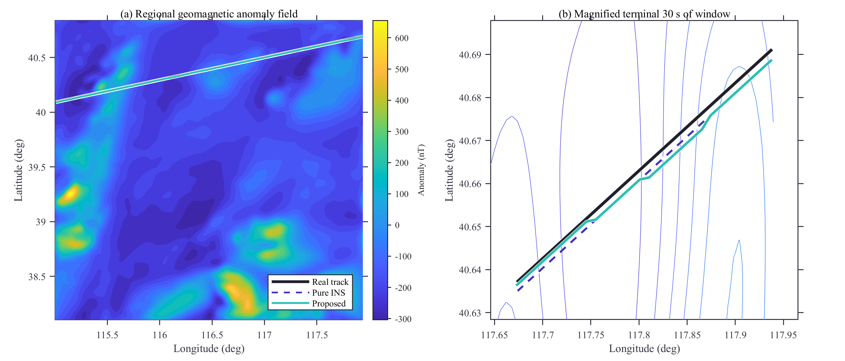
Fig. 19. Horizontal position error of the proposed method against time together with the three sigma error envelope.
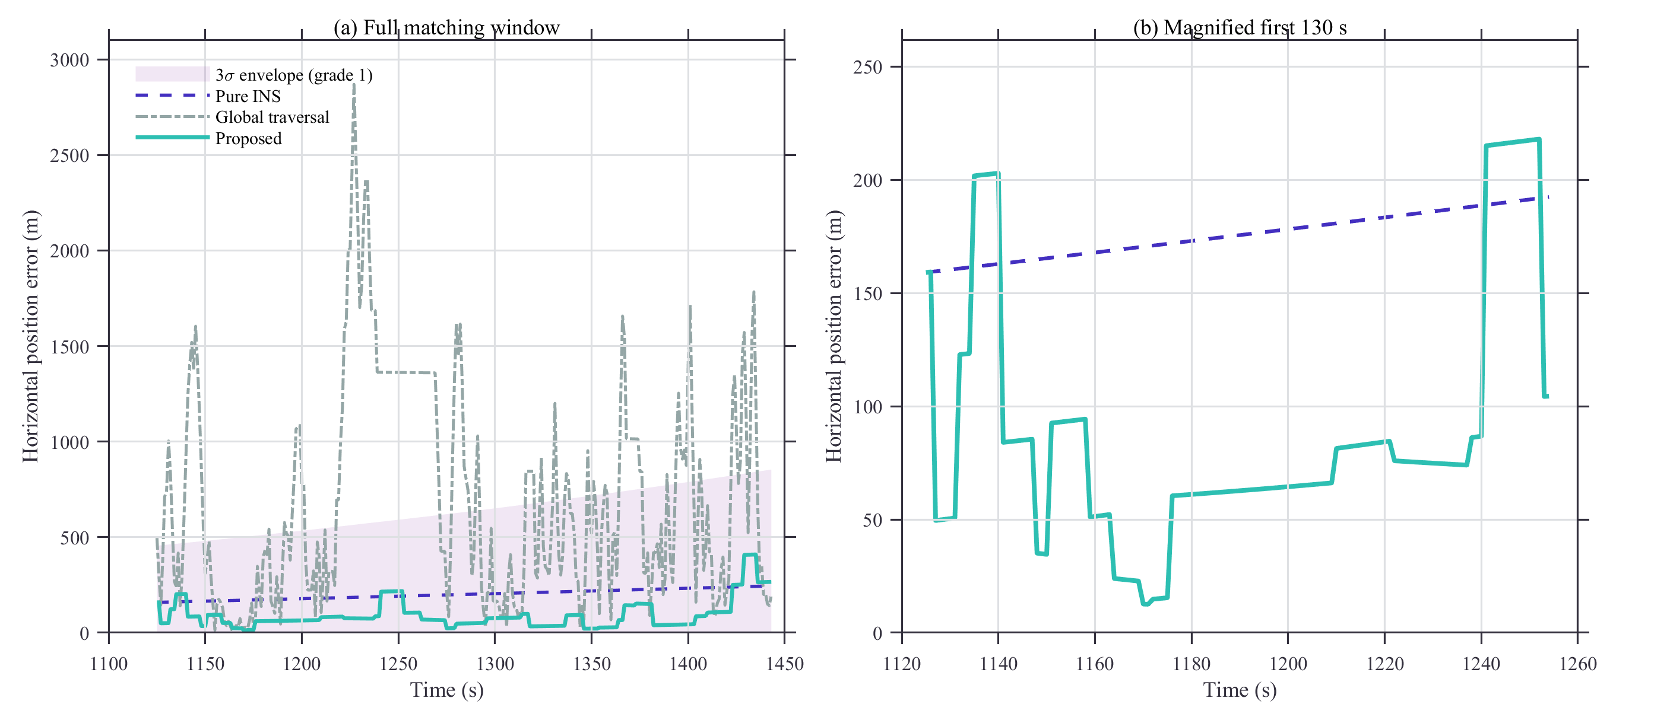
Fig. 20. Evolution of the three sigma normal scale of the matching area with the flight duration for the three inertial grades, corresponding to Table V.
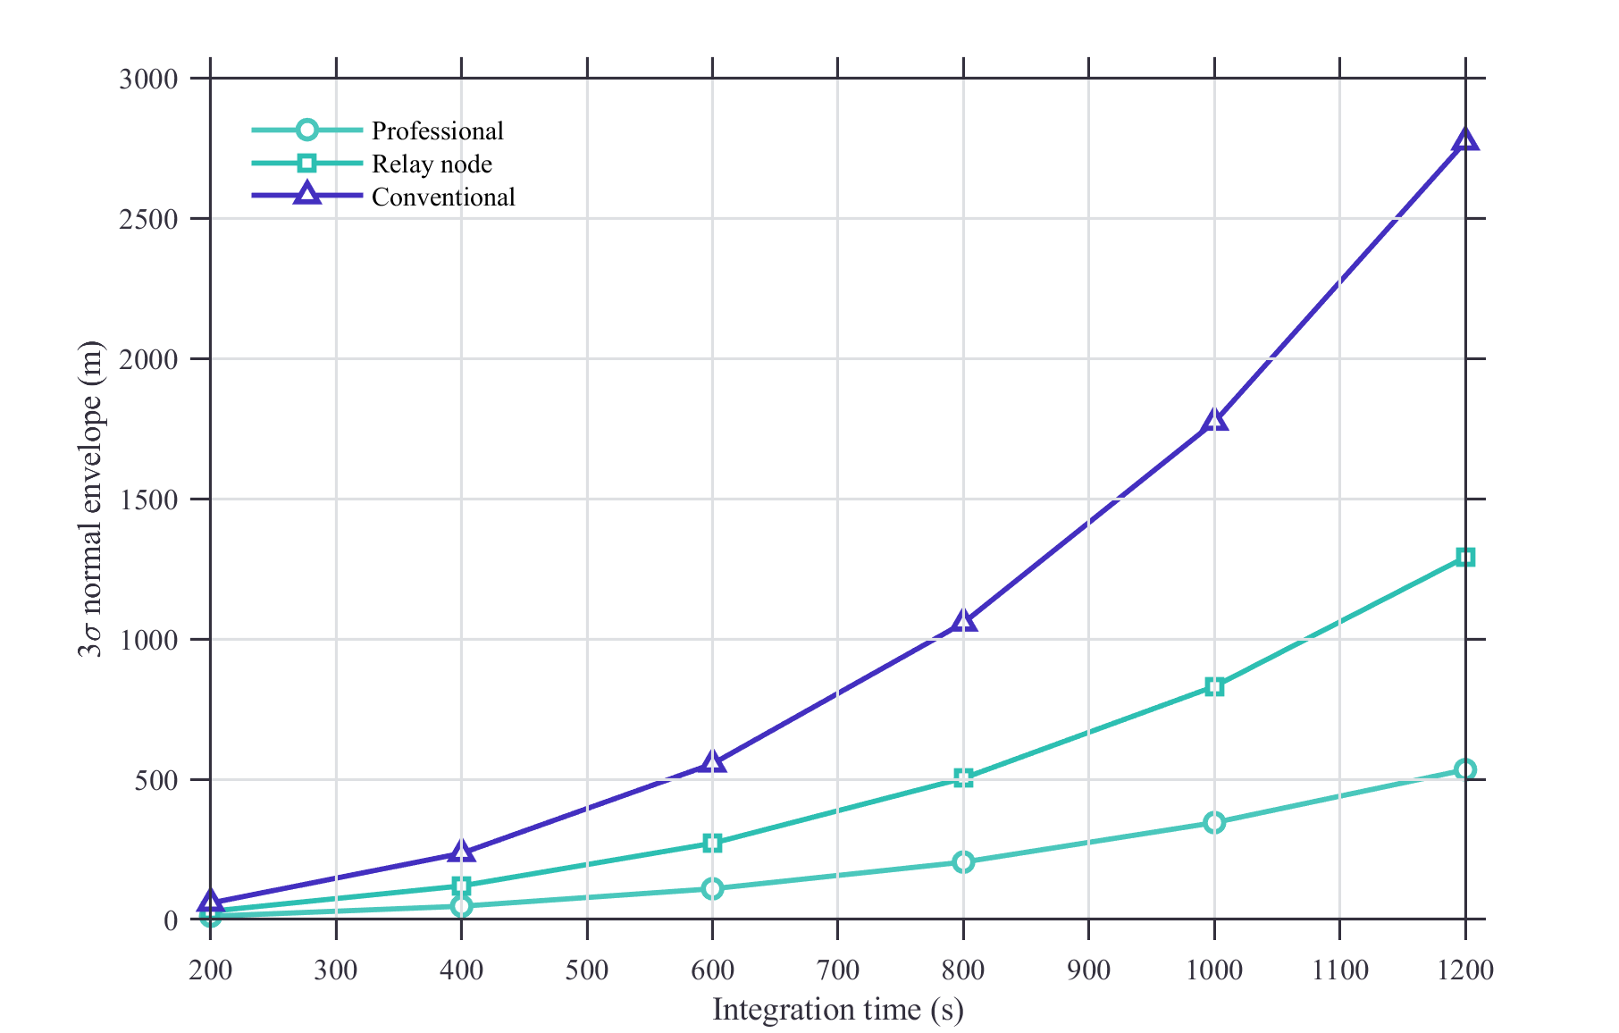
Fig. 21. Empirical coverage of the one sigma, two sigma and three sigma intervals compared with the ideal Gaussian partition, corresponding to the last row of Table III.
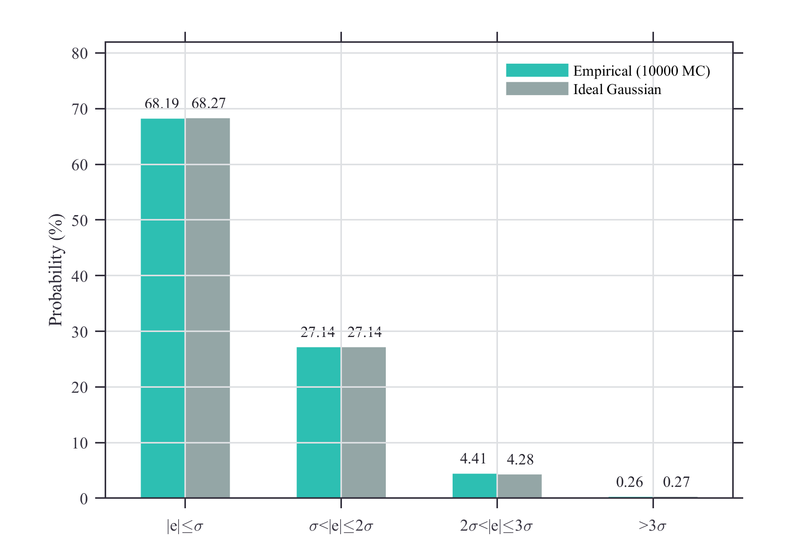
Fig. 22. Online matching time per epoch for the three inertial grades, showing the mean, the 95th percentile and the worst epoch, corresponding to Table VII.
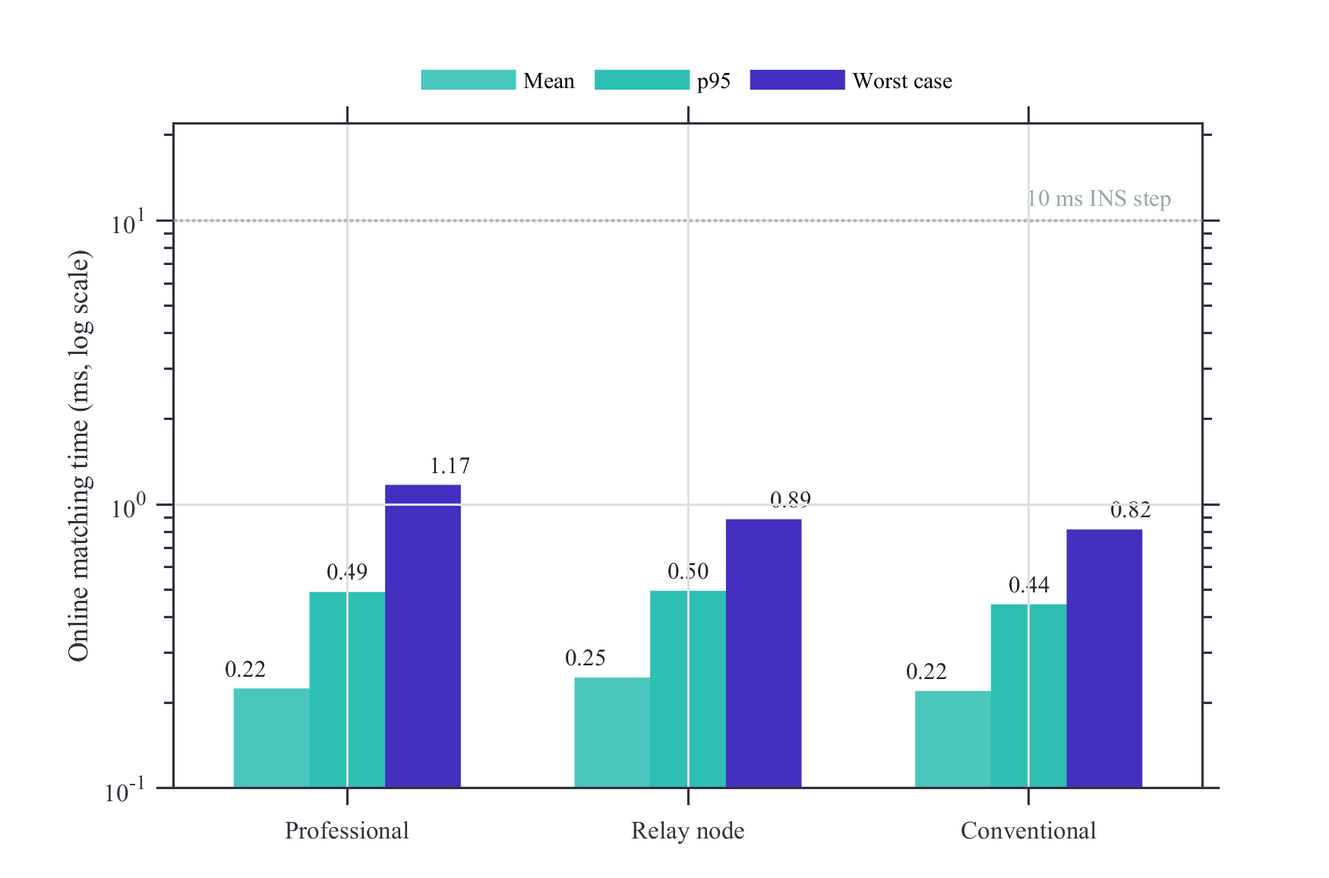
Fig. 23. Candidate grid points per matching epoch of the proposed method and of the global traversal, corresponding to Table XII.
