Julian Ramil Y. Andales BSCS-3 F2
Views.py
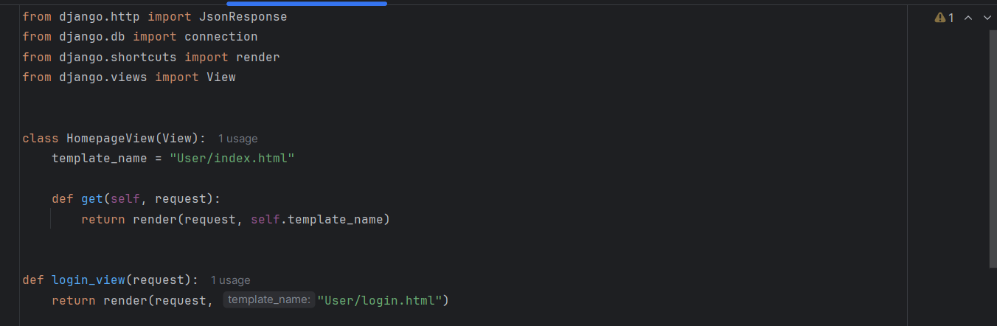
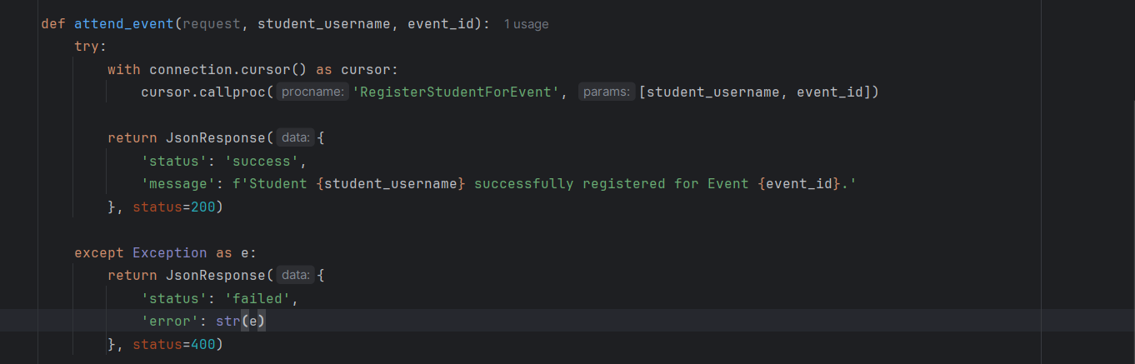
Urls.py
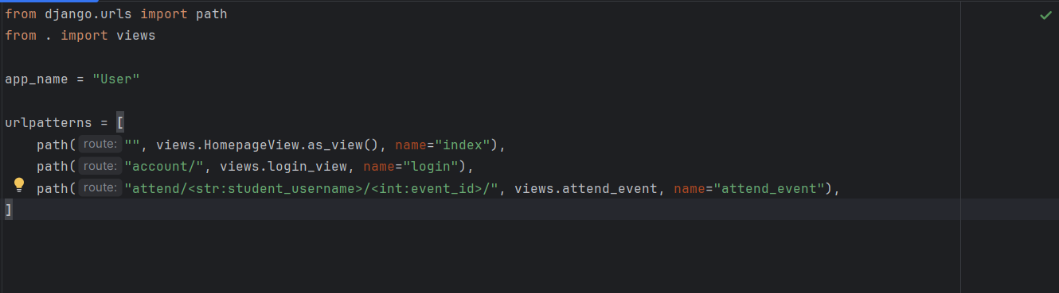
Stored Procedure:
