**COMP229 Team Project**

**Group9:** DooHee Choi,

Sophonie Gerardin Bien-Aime,

Warnassoriya Illangasinghe

**Online Toy Car Shop**

**\*First Version (Mar 22, 2016 ~ Mar 30, 2016)**

**\*Functions:**

-Category is classified

-Details of Items

-Item Add and Remove

-Item Discount

-Search Item (modifying)

**Main Page**

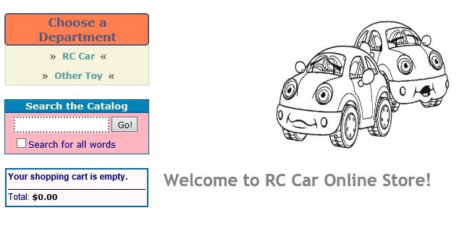

**Click RC Car Department**

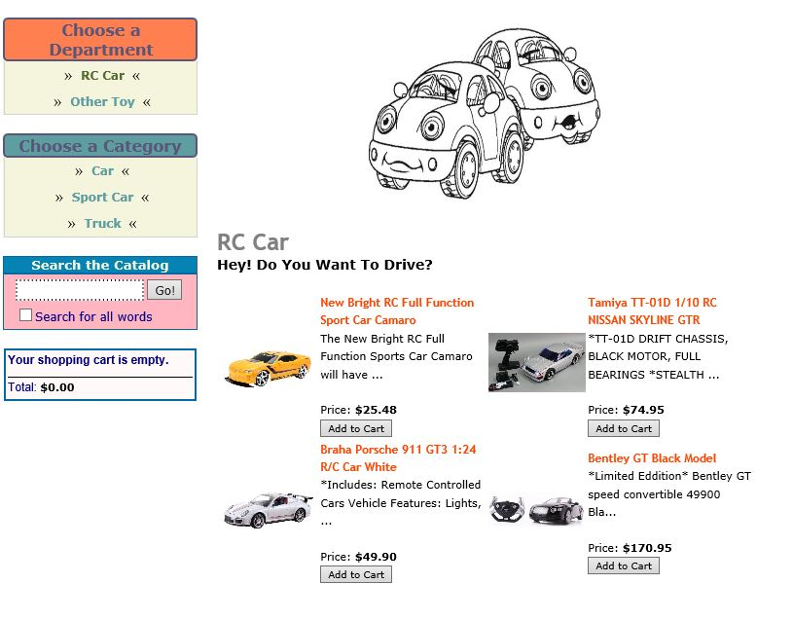

**Click Car Category**

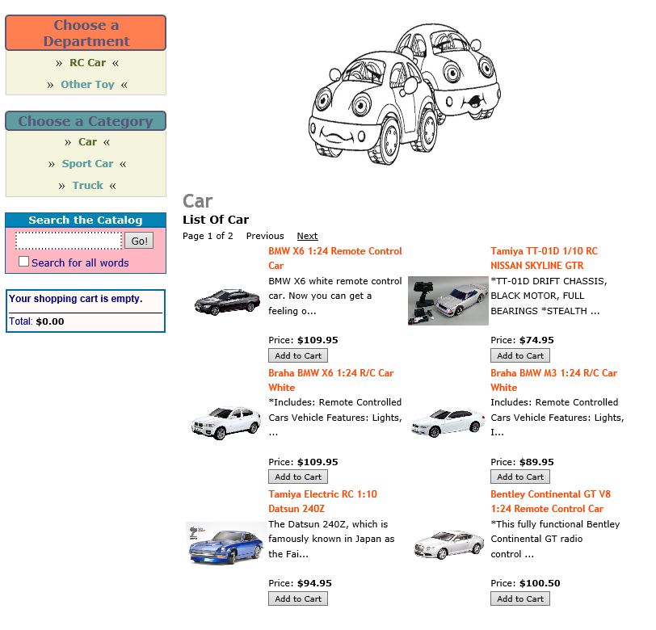

**Second Page**

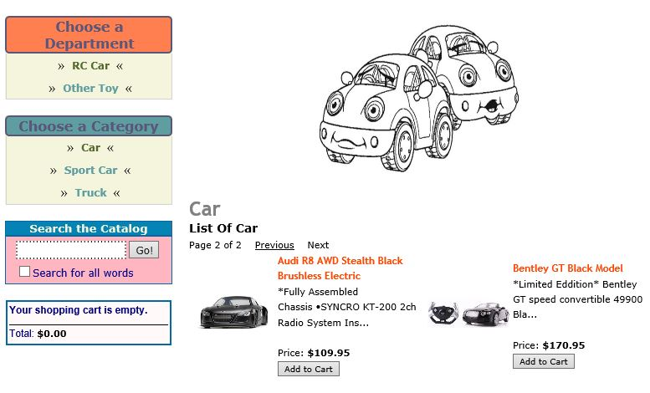

**Click Sport Car Category**

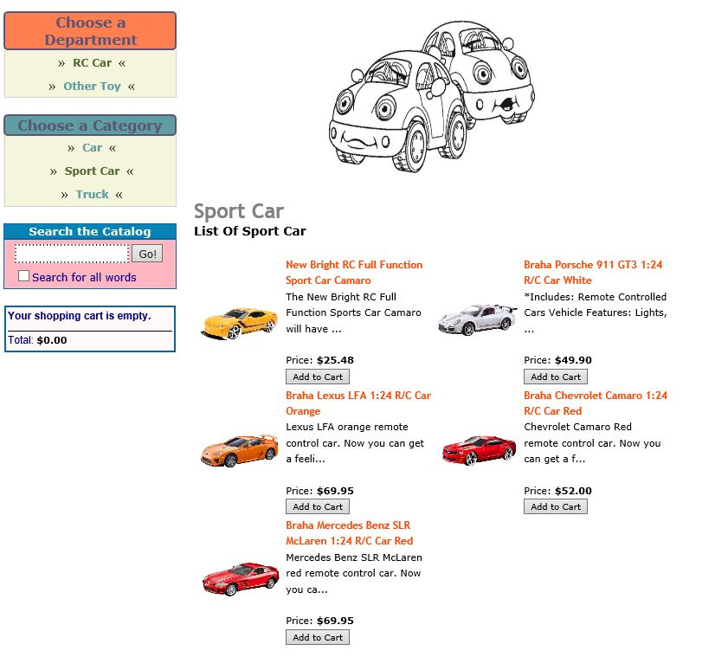

**Click Truck Category**

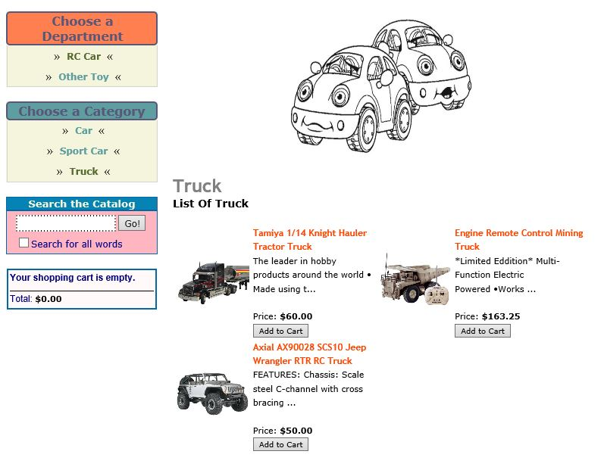

**Click Other Toy Department**

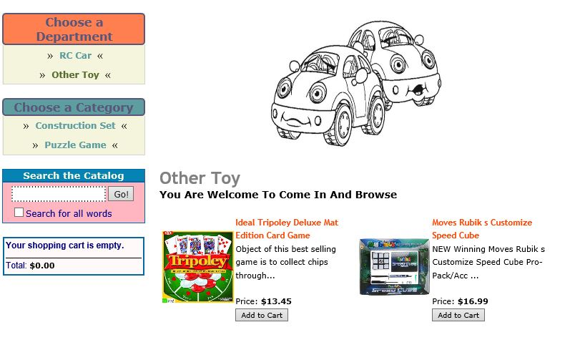

**Click Construction Set Category**

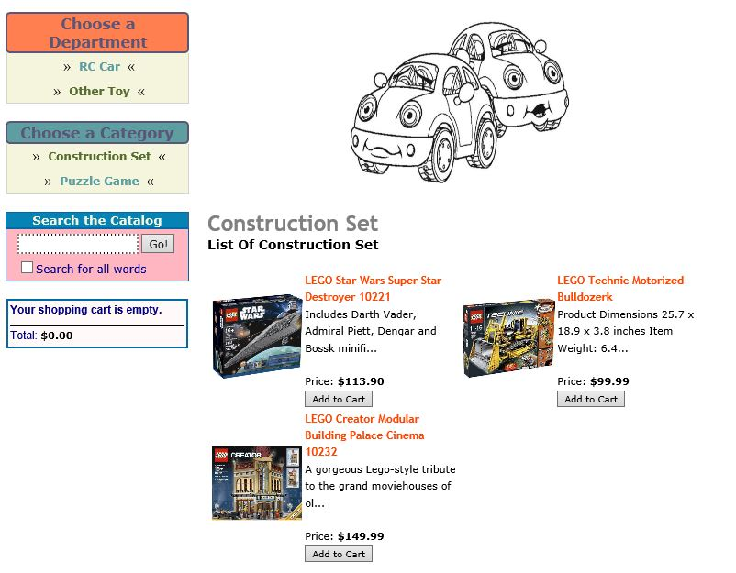

**Click Puzzle Game Category**

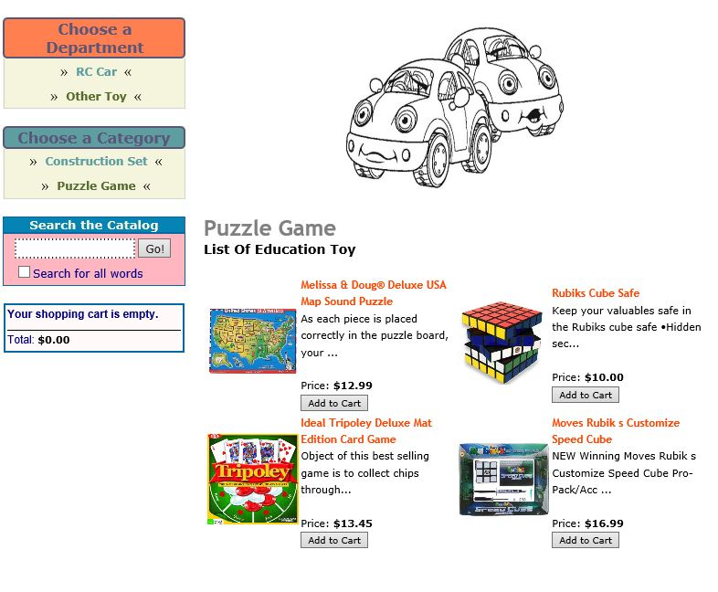

**Empty Shopping Cart**

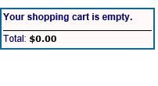

**Add Item: Change total price in the Shopping cart**

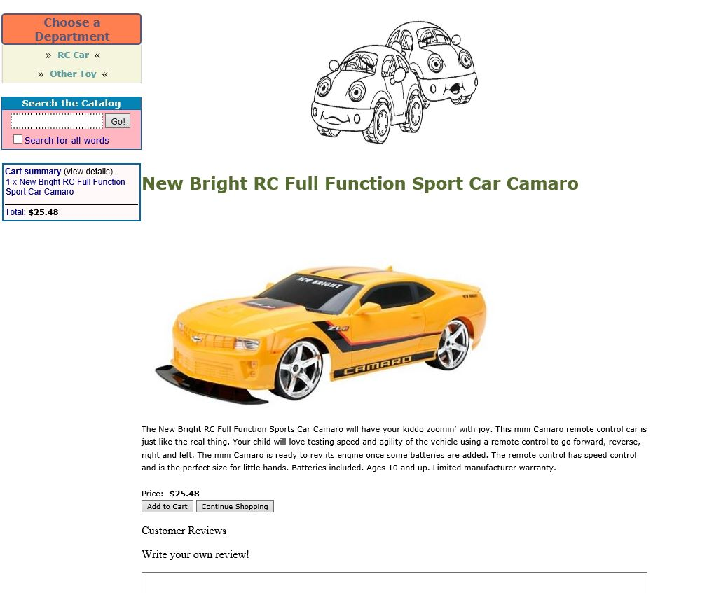

**Click View Details**

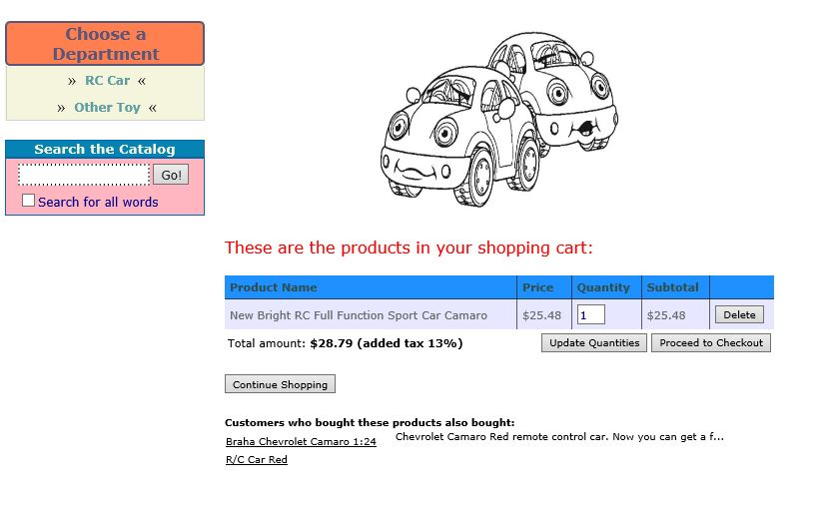

**Total price is < 100$: Added tax 13%**

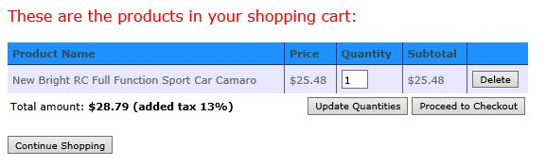

**Total price is > 100$ and < 200$: No Tax added**

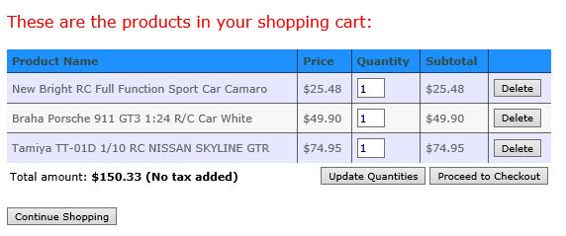

**Total price is > 200$: No tax and 10% discount**

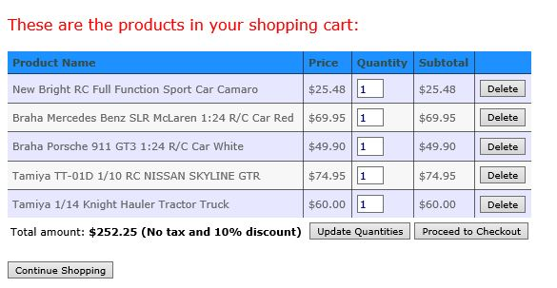

**Update Quantity**

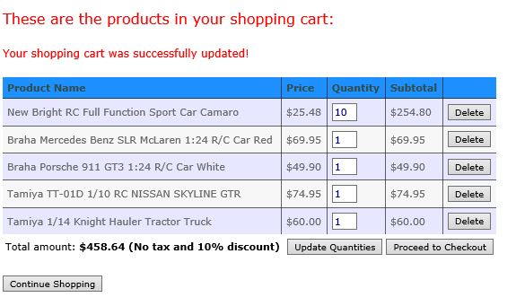

**Remove Product**

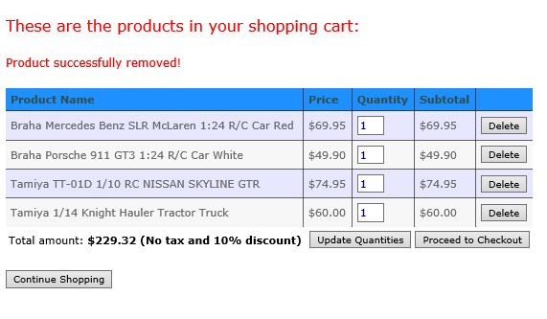

**Click Proceed to Checkout: Connect with PayPal**

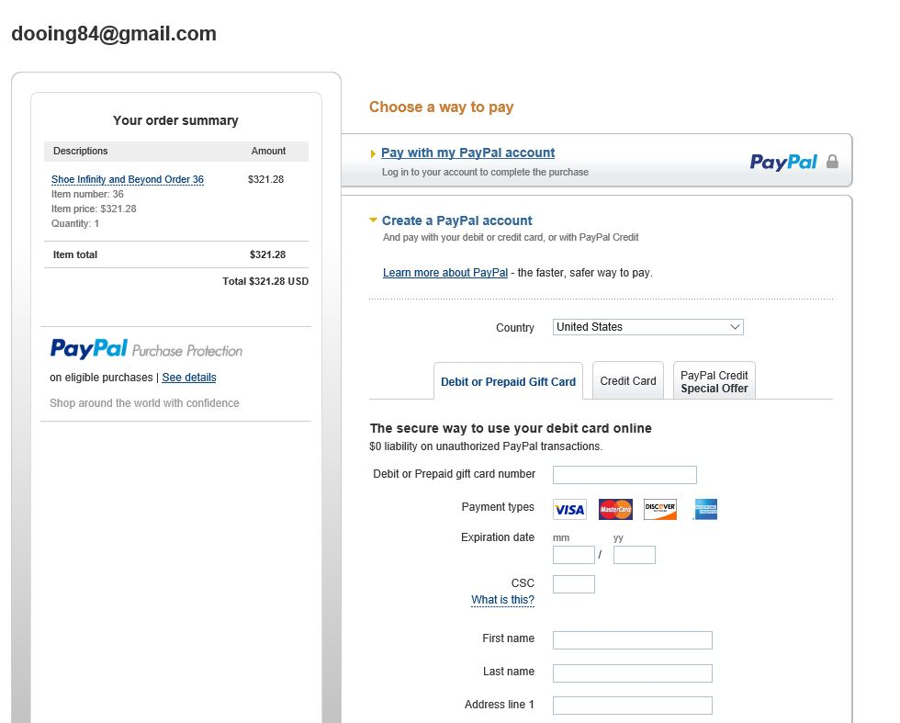

**\*Second Version (Mar 31, 2016 ~ Apr 07, 2016)**

**\*Functions:**

-Registration for users

-Login

-Review

**Click Create an Account**

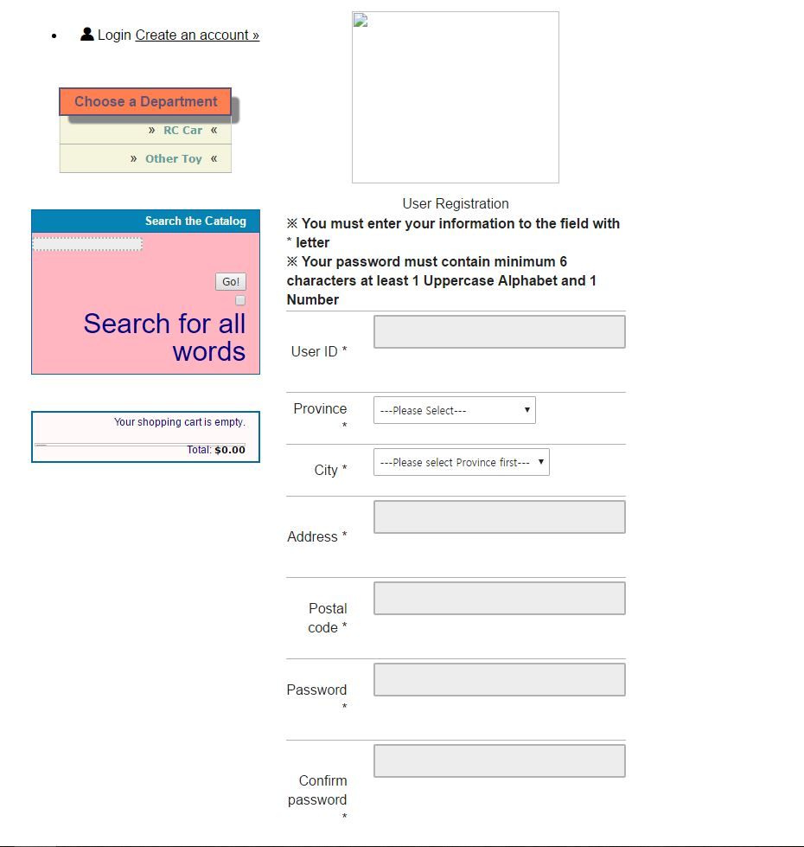

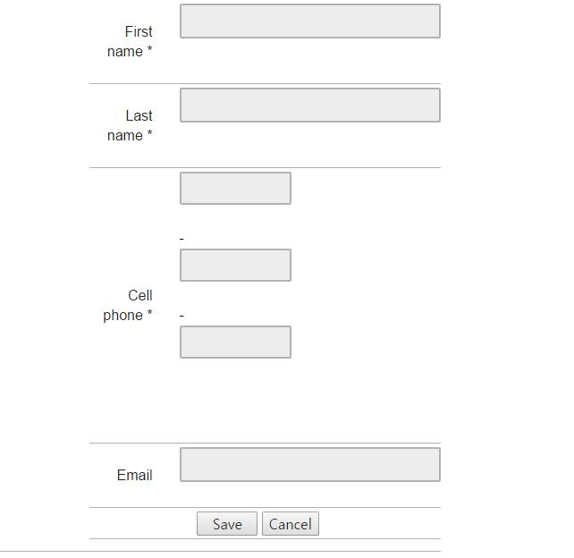

**Validations for registration**

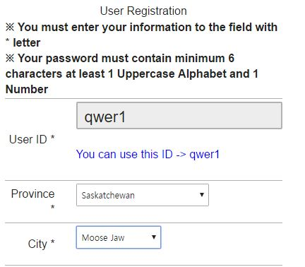

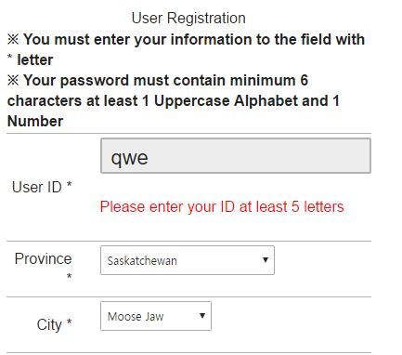

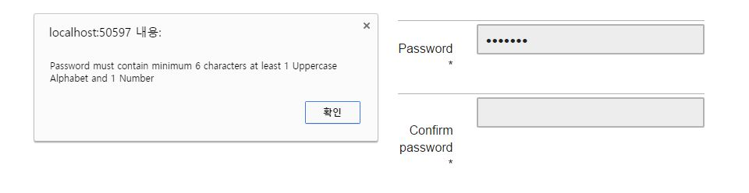

**Login Page**

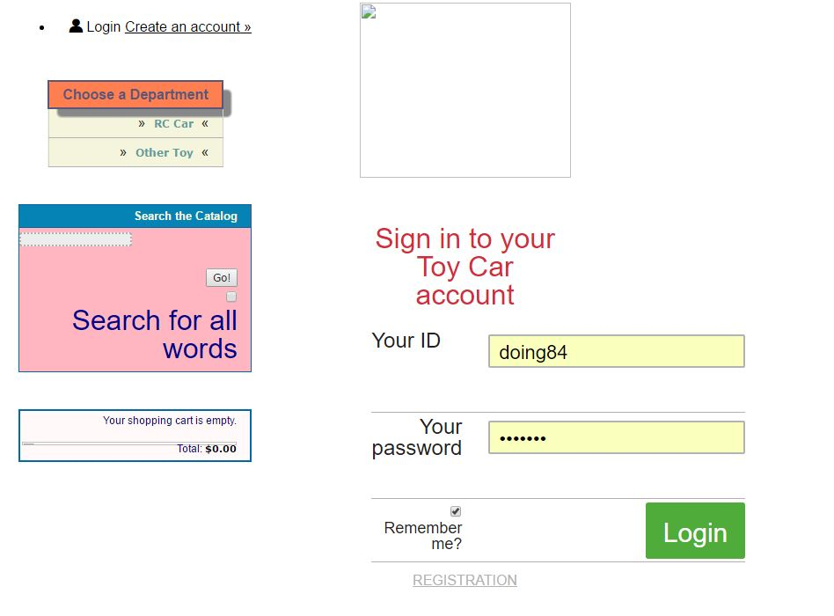

**After Login**

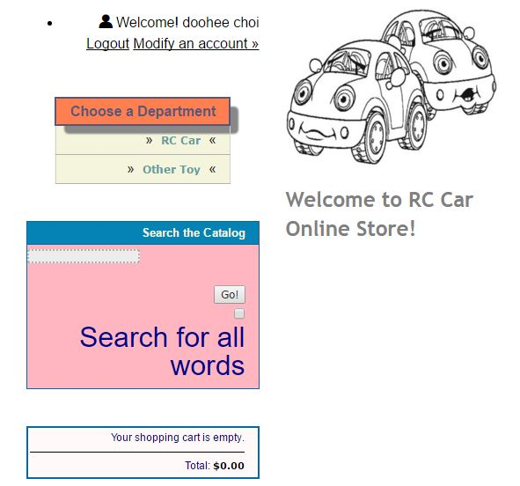

**Can Modify Account**

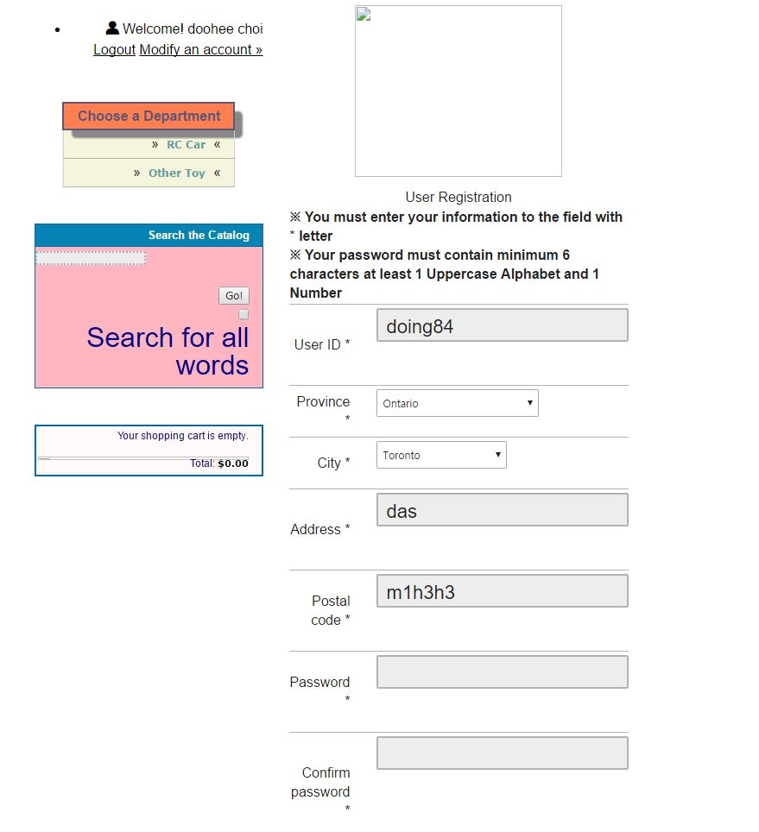

**Can write review**

