**Practical manual for Bookclip** (Made by DooHee Choi)

*I worked on the MS Windows system

*My OS system’s language is Korean

1. Before run this site, you need Microsoft® SQL Server® 2014 Express

<http://www.microsoft.com/ko-kr/download/details.aspx?id=42299>

and Visual Studio 2015 community

<https://www.visualstudio.com/en-us/downloads/download-visual-studio-vs.aspx>

and then install them.

1. Create database with MS SQL server for Bookclip. You can find query statement for creating database in \web applicaton_1\bookclip

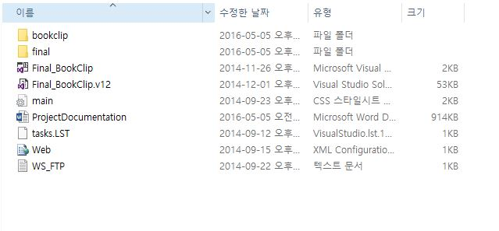

Click

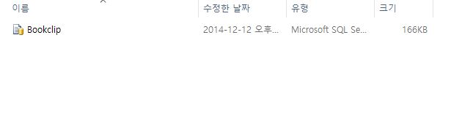

Click SQL file

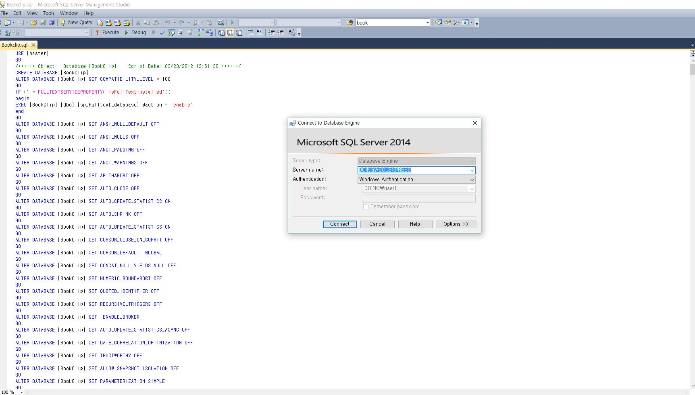

-Click Connect button

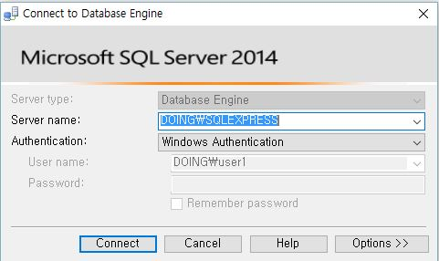

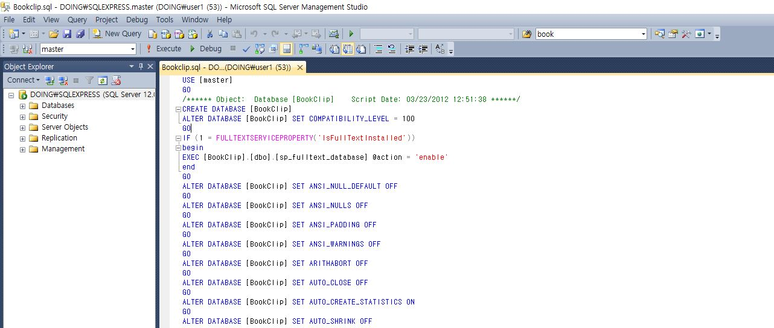

Execute query

C:\Users\user1\Desktop\exec.JPG

-You can check completed database that is bookclip

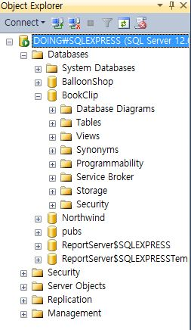

1. Check your server name (Hint: DOING is my computer’s name)

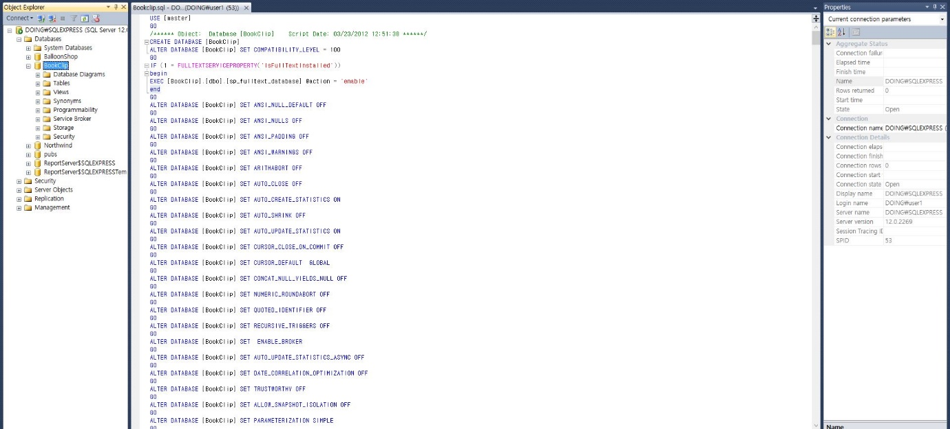

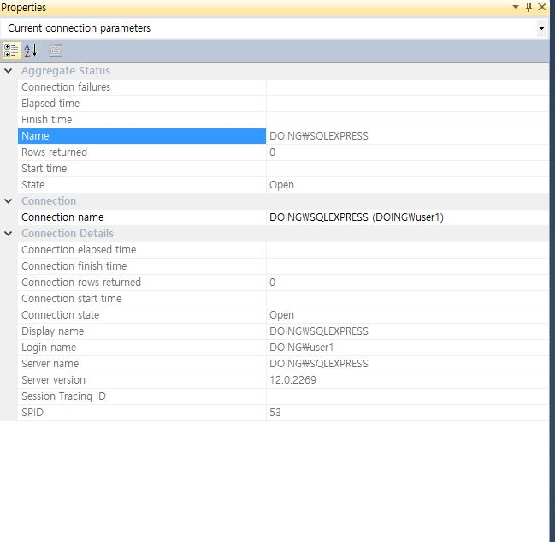

1. Open Visual Studio

-Open -> Project/Solution

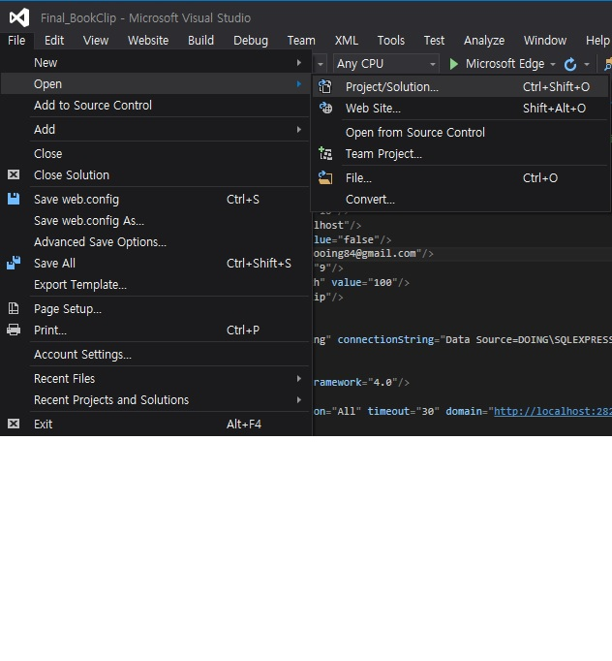

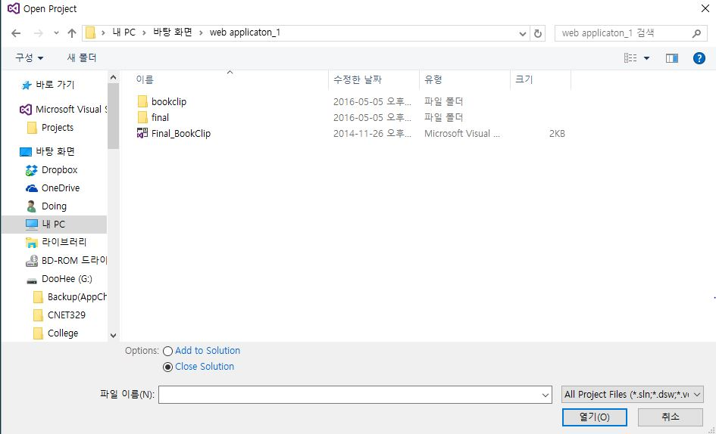

Click Here

1. Connect with database

-Right click and then select ‘Add Connection’

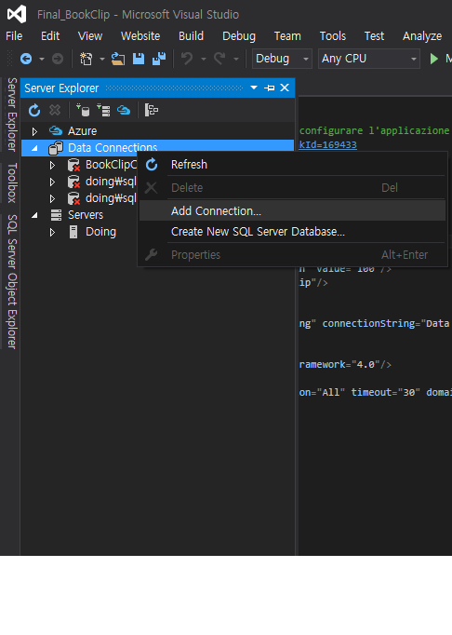

-Choose ‘Microsoft SQL Server’ and click Continue button

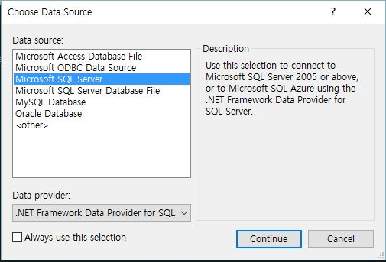

-Select your sever and select Bookclip database

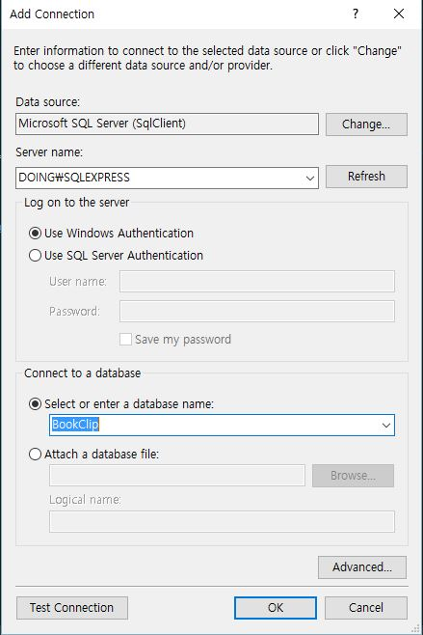

-Test connection and click OK button

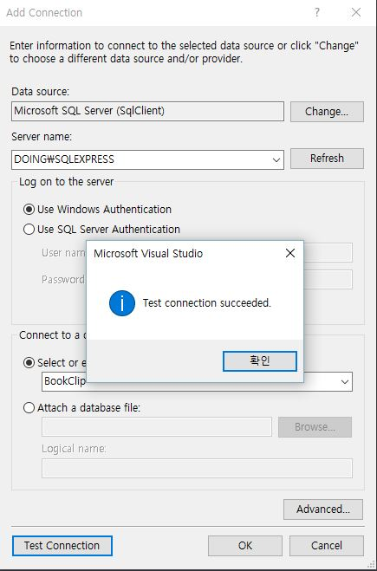

1. Should change path of data source

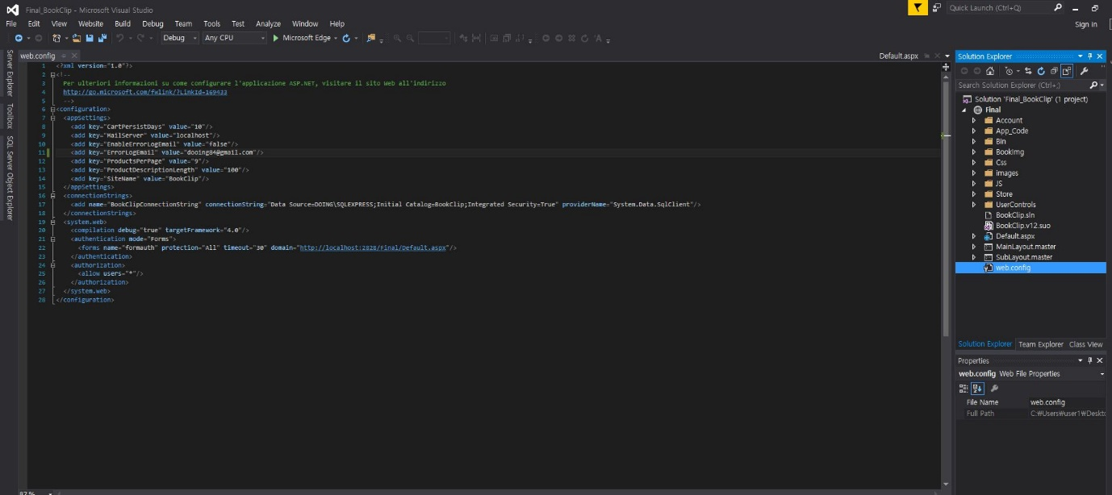

-Open web.config file

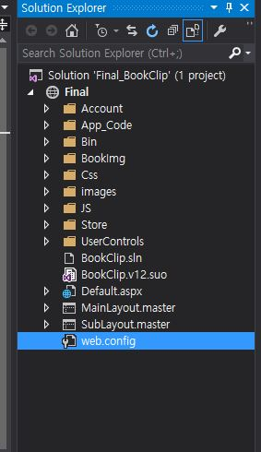

-Change current data source name into your server name

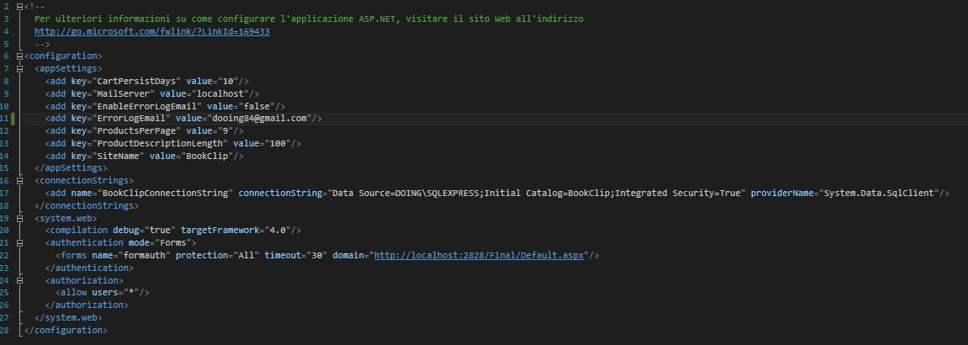

-

C:\Users\user1\Desktop\connetionstring.JPG

1. Select default page and then execute website (press ‘F5’ or click execute browser button)

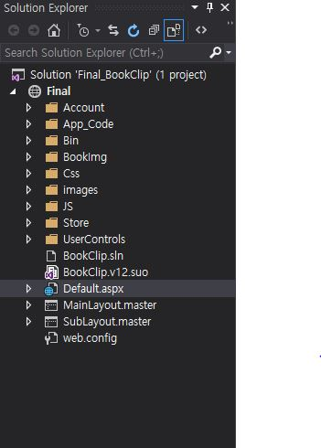

C:\Users\user1\Desktop\excutionSite.JPG

Click Here or press ‘F5’

1. Please enjoy this website!

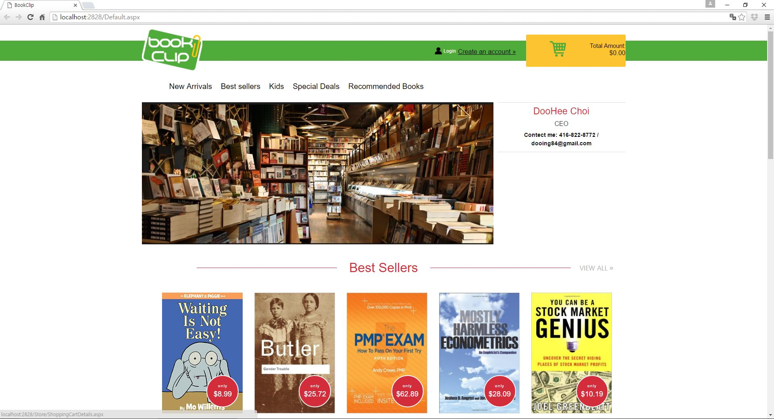

*If you have any problems, you can ask me

Email: [dooing84@gmail.com](mailto:dooing84@gmail.com)

Phone: 416 822 8772