Book Clip

DooHee Choi

Contents

Scope / target audience for the project 2

Site diagram 2

Screenshots of all the web forms 3

Database Diagram 9

Description of security features 9

A list of challenges that your group encountered while developing the project and the solutions found to surpass those difficulties 10

# Scope / target audience for the project

The main objective of the project is to create an online book store that allows users to search and purchase a book online based on title, author and subject. The selected books are displayed in a tabular format and the user can order their books online through credit card payment. Using this Website the user can purchase a book online instead of going out to a book store and wasting time. Online Book store is an online web application where the customer can purchase books online. Through a web browser the customers can search for a book by its title or author, later can add to the shopping cart and finally purchase using credit card transaction. The user can login using his account details or new customers can set up an account very quickly. They should give the details of their name, contact number and shipping address. The books are divided into many categories.

The Online Book Store Website provides customers with online shopping through a web browser. A customer can, create, sign in to his account, place items into a shopping cart and purchase using his credit card details.

# Site diagram

Our website site consists of 8 pages:

Default.aspx

Login.aspx

Registr.aspx

BookDetails.aspx

BookList.aspx

OrderDetails.aspx

ShoppingCartDetails.aspx

WishList.aspx

# Screenshots of all the web forms

When we run the Website first home page is displayed. The home page will appear as below. On main page we made additional feature to show customer Best Selling products, New Arrivals, Special Deals and Kids categories. All information are taken from database.

If you are a new user you can register using the register link or if you are already a user you can login to purchase book and pay using the checkout.

The register page will appear as below

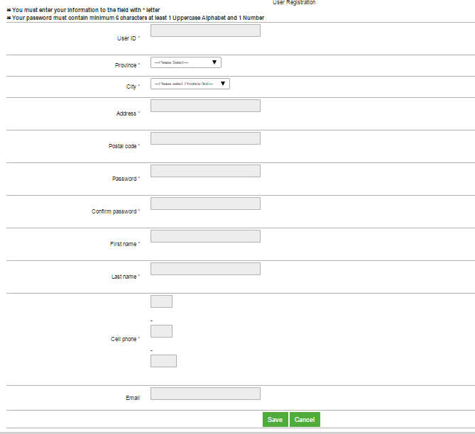

A user should enter all the required fields’ information. If he didn’t fill all the fields he cannot create an account. After entering all the required data click the submit button to register. Now you can login to the Website. Login page is used to login to the website.

Login page will appear as below.

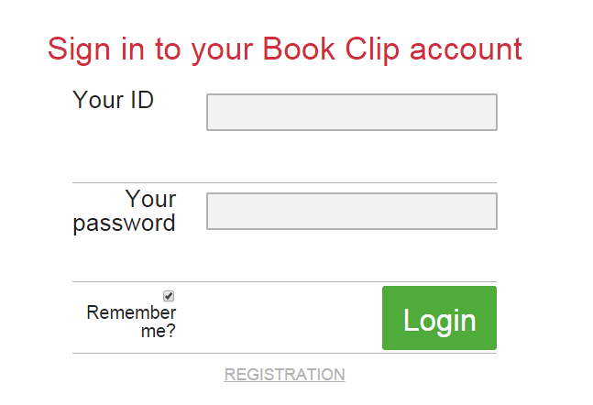

If the user is interested in any particular book category he can click the book category link to get the list of books in this category.

The book category page will appear as below.

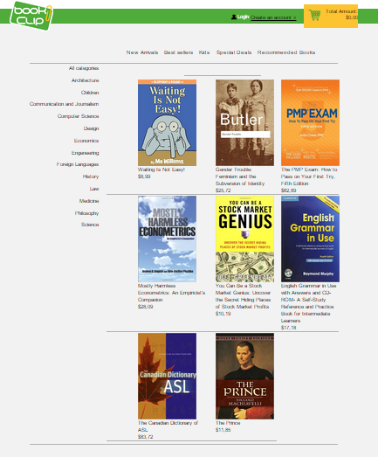

If the user is interested in any particular book he can click the book image to get the book details.

The book details page will appear as below.

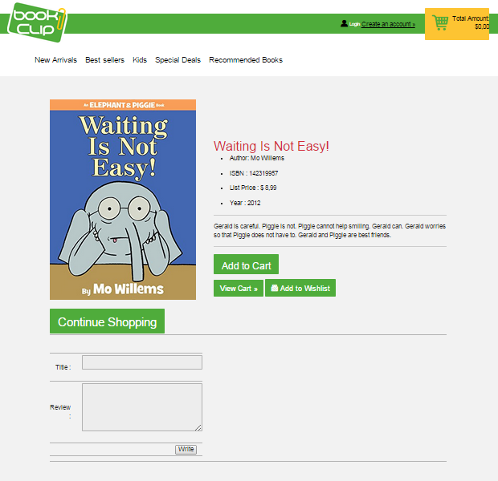

Our next feature is that the user can also provide review to a book in the form, this information will be stored in a database and will be look like on image below



The user can add the book to a shopping cart by clicking the add to shopping cart button. After adding to the shopping cart if the user wants to continue shopping he should click the continue shopping link else he can checkout using the view cart link. Our next feature is that only user who already logged on the site has access to the shopping cart.

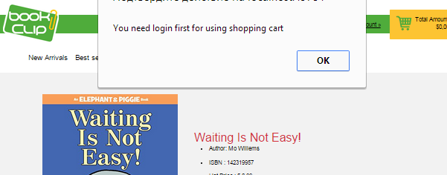

If customer logged he can see this message

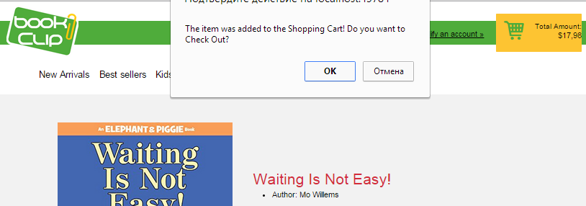

The user can also edit his shopping cart details. If he wants to change the quantity or cancel his order he can use this page.

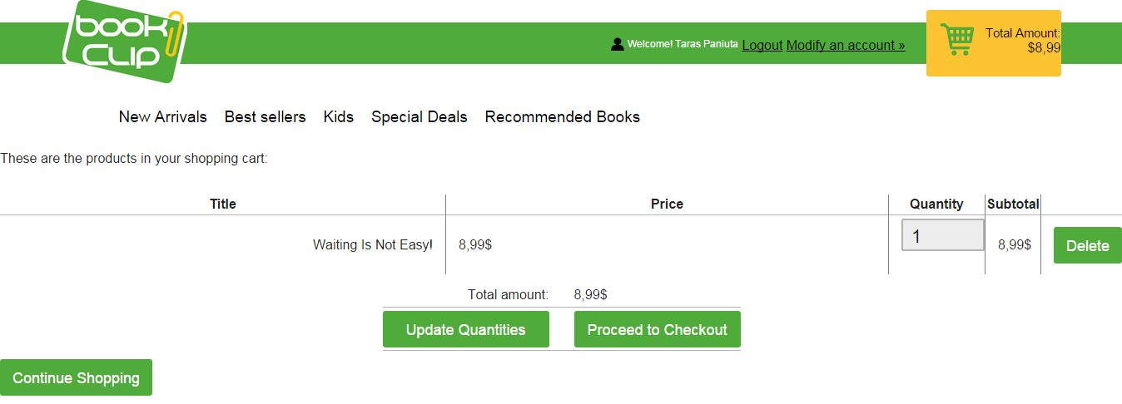

The above page shows the edit shopping cart page.

After proceeding to checkout the user redirecting to the PayPal page where user should enter the billing details to process his order request.

One more feature for costumers is a wish list, user can add books to this list to store them for the future shopping or other purposes.

The wish list page will appear as below.

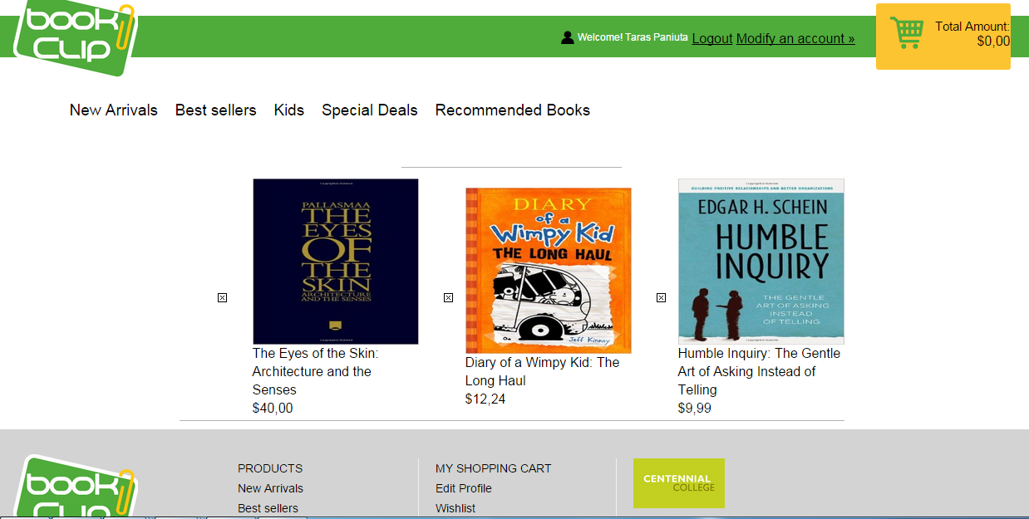

# Database Diagram



# Description of security features

Our web site has built in secured architecture since the client cannot access the database directly.



# A list of challenges that your group encountered while developing the project and the solutions found to surpass those difficulties

The most challenging part for us was: making access to the shopping cart only for already logged customer, we faced with necessity to change a lot of procedures; dealing with the shopping card was a little bit difficult, because of necessity to show information in shopping cart page and small bar in main and other pages.