Sight-Undercover Camera beta version 1:

Listed below are the steps for starting the thermal camera and video camera. Then power down the two applications down and turning off the device. This device currently supports (real-time) viewing from a computer display for thermal images and video images from the monitor or smartphone. (this device is currently in development)

Steps: 1 ) Turn power on to the device.

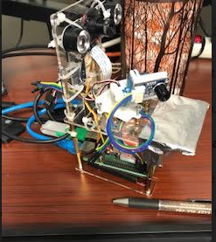

Step: 2) You should see a standard raspberry desktop.

Step: 3) Open VNC GUI (icon top right toolbar) and find the IP address on the left side in VNC GUI.

Step: 4) Open THonny Python IDE (Open Programming/ Thonny Python IDE)

Step:5) Find and Run a script called (rpi_cammera_surveilance_system.py)

Step:6 ) Run a script called (rpi_cammera_surveilance_system.py)

Step: 7) View the output of the script at the bottom of the IDE shell window. There should be no errors.

Step:8) open terminal and type history at the command line.

Step:9) In the terminal, type the following at the command line. “su root”, the password is “rootroot”

Step:10) in the terminal and type “history” at the command line.

Step: 11) start thermal camera. Run next script as root, you should be at a root command promp at this time. Type the following below.

1. cd ../..
2. cd *iPi
3. ls
4. cd C++*
5. cd *SDL2
6. ls
7. sudo ./main (this script runs the thermal camera)
8. thermal camera window should open in a new window.

Step:12) You should see the thermal camera window running.

1. In the terminal window, you should see the ./main program running as (sudo ./main)
2. You may see a time-out error displayed at the command line while the script is running.
3. If the script errors and stops. Restart the script by hitting the up arrow on the keyboard.

You should see the (sudo ./main) display at the command line. Hit the enter key.

1. You should see a new thermal camera window reopen starting a new session.

Step: 13) to view a video on your cell phone, do the following.

1. Pair your phone to the same WI-Fi setting as the raspberry is on.
2. I am using the IP address displayed in the VNC GUI.
3. Use that IP address and enter the following into your phone webbr/
4. Type: http://<your IP>:8000
5. Example: <http://10.0.0.47:8000>
6. You should see the video camera display on your cellphone.

Step:14) you should see activity in the shell output in the Thonny GUI.

Step: 15) to shut down the cameras and the device, do the following.

1. In the terminal window. Type exit. Then exit again. (dropping from root user to pi user and closing the terminal window.
2. Shutdown Thonny IDE window by stop, stopping the script. Then close the IDE window.

Step: 16) close the VNC server GUI.

Step: 17) you should see a standard desktop. At this point, cameras are off.

Step:18) the mouse over to the left of the toolbar to shut down the device.

Step:19) you should see a shutdown menu, click shutdown.

Step: 20) power down steps

Step:21) at shutdown display will go dark. Wait for the device the complete shutdown.

Step:22) device is off

Step:23) find the power switch and power off

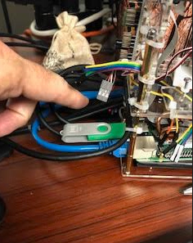

Step:24) power off

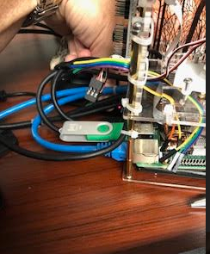

Step:25) device is off

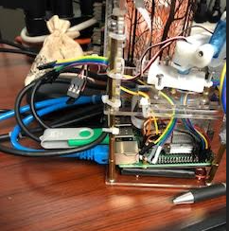

Step: 26) pack up the device carefully for the next time.

If you have any questions, please get in touch with me at the link below.

Sight-Undercover

<https://sightundercover.com/>

[admin@sightundercover.com](mailto:admin@sightundercover.com)

cell: 262-374-4373