PE_PRN212_FA25TrialTest
FALL 2025
Subject: PRN212
Duration: 90 minutes

INSTRUCTIONS
Please read the instructions carefully before doing the questions.
- You are NOT allowed to use any other materials. You are NOT allowed to use any device to share data with others.
- You must use IDE as Visual Studio 2019 or later, MSSQL Server 2016 or later database for your development tools.
IMPORTANT – Before you start doing your solution, MUST do the following steps:
- To do your program, you must use Windows Presentation Foundation (WPF), apply 3-Layer architecture. Note that you are not allowed to connect direct to database from WPF Windows/Pages, every database connection must be used with Repository and Data Access Objects. The database connection string must get from appsettings.json file. In the case your program connects directly to database from WPF Windows/Pages or you hardcode connection string, you will get 0 point.
- If there are syntax errors or compilation errors in your PE program, you will not pass the PE requirements, the point will be 0.
- Create Solution in Visual Studio 2019/2022 named PE.PRN212.FA25.StudentName. Inside the Solution, Project WPF named: AirConditionerShop.StudentName.
- Create your MS SQL database named AirConditionerShopDB by running code in script AirConditionerShopDB.sql.
- Set the default user interface for your project as Login window/page.
- Your work will be considered invalid (0 point) if your code inserts stuff that is unrelated to the test.

Create an application using Windows Presentation Foundation (WPF) with .NET5/.NET6/.NET7/.NET8, C#, and Entity Framework Core. A MS SQL Server database will be created to persist the data and it will be used for reading and managing data.
The below Figure is a part of AirConditionerShopDB database.
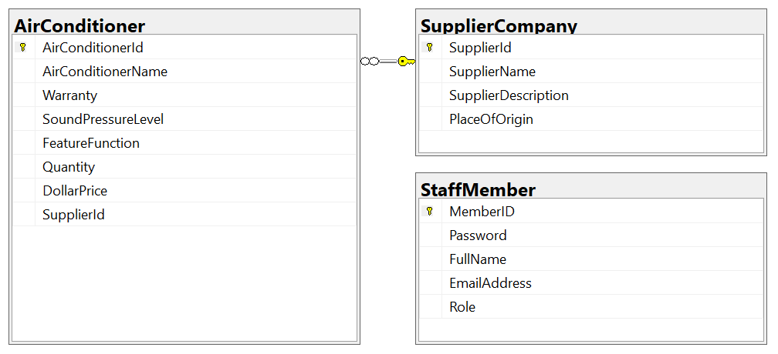
Note that: Member role: Administrator = 1; Staff = 2; Member = 3. A supplier company will have many air-conditioners, an air-conditioner will belong to only one supplier company.

Task 1. Design graphic user interface.
- (0.5 point) Design Login Window includes UI controls for login function.
Window/Page Properties
Title= MainWindow
Height= 330
Width= 600
FontFamily= Arial
FontSize= 14
Background= #FFD4F7D4
WindowStartupLocation= CenterScreen

- (1.0 point) Design AirConditioner Management form, this form includes UI controls for CRUD actions with air-conditioner information. Note: The SupplierId/SupplierName will come from the SupplierCompany table. Design a form which allows you to view the list of records, create a new item, update the existing item, and delete a specific item.
Form Properties
Title= MainWindow
Height= 330
Width= 600
FontFamily= Arial
FontSize= 14
Background= #FFD4F7D4
WindowStartupLocation= CenterScreen

All TextBoxes’ Properties
ForeColor = Blue
TextAlign = Center

All Labels Properties
ForeColor = Black
TextAlign = Left
Task 2. Implement CRUD actions with GUI.
- (1.0 point) Authentication function
If user with a Administrator and Staff role logs in successfully (using email address/password for login process), save this information to a temporary parameter. All CRUD actions are required authentication. In the case login unsuccessfully, display “You have no permission to access this function!”.
- (1.5 points) Check if login successfully with Administrator and Staff role, list all air-conditioners in AirConditioner table (the information includes AirConditionerId, AirConditionerName, Warranty, SoundPressureLevel, FeatureFunction, Quantity, DollarPrice and SupplierName – supplier company name).
- (1.0 point) Check if login successfully with Administrator and Staff role, search air-conditioner information by FeatureFunction or Quantity (using relative search).
- (1.0 point) Check if login successfully with Administrator role, delete the selected item with the confirmation then update the list of air-conditioners.
- (2.5 points) Check if login successfully with Administrator role, add new item with the requirements:
- The SupplierId/ SupplierName (supplier company Id, supplier company name) will come from the SupplierCompany table (you can use ComboBox UI control in this case)
- All fields are required.
- Value for DollarPrice and Quantity is greater than or equal to 0 and less than 4 000 000.
- Value for AirConditionerName (the name of the air-conditioner) is in the range of 5 – 90 characters. Each word of the AirConditionerName must begin with the capital letter or digits (1 – 9). AirConditionerName is also allowed with special characters.
- (1.5 points) Check if login successfully with Administrator role, update an existing item.
- You can use your different form or use the data grid view for this update function (update by AirConditionerId). With update function, the same validation requirements with Add function.

