September 6, 2022

**Registrar’s Office**

St. Anthony’s College

Brgy. San Angel, San Jose de Buenavista,

Antique, Philippines, 5700

Subject: Authorization Letter for Claiming of my Request Documents.

To Whom It May Concern:

I, Kaye A. Ordovas, Graduate of Bachelor of Science in Business Administration – Marketing Management, Batch 2022, hereby authorize Hya Cynth G. Dojillo, Student of St. Anthony’s College and relative, to act on my behalf to claim my School Credentials, specified below as part of the requirements for my work employment.

* School Diploma
* Transcript of Records (T.O.R)
* Special Order

I would not be able to claim the documents personally because of work-related matters.

Thank you and I am hoping for your smooth cooperation.

Sincerely yours,

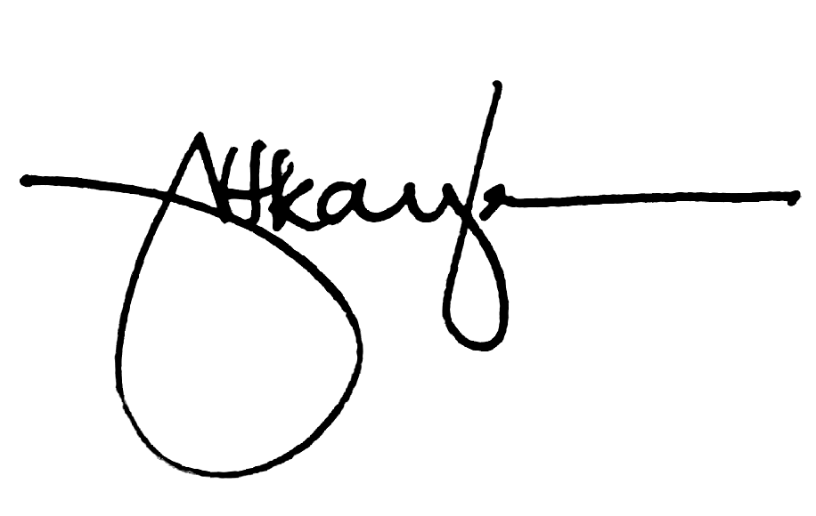

KAYE A. ORDOVAS