Concise Essay 1

Shaila Ang

30 October, 2020

# Acupuncture for headache

A study by Vickers et al., published in the British Medical Journal in 2004, investigated the use of acupuncture for chronic headache in primary care in a large, randomised trial.  
 The data from this study provides the basis for this concise essay.

This essay provides visualisations of major outcomes considered by the study at 3 and 12 months. The outcomes of interest are headache severity score and headache frequency.

# Treatments

The study measured the effectiveness of acupuncture for chronic headache in primary care using two treatments labelled ‘usual care’ and ‘acupuncture group’. The eligible patients completed a baseline headache diary for four weeks and were randomised according to “use acupuncture” or “avoid acupuncture”. During a 3 month period, patients in the “use acupuncture” group received four acupuncture treatments per month from qualified professionals, and the acupuncture point prescriptions were unique to each person. This was in addition to the standard care from their GPs, whereas the “avoid acupuncture” group only received standard care and were never referred to acupuncture specialists.

## Registered S3 method overwritten by 'pryr':  
## method from  
## print.bytes Rcpp

## For best results, restart R session and update pander using devtools:: or remotes::install_github('rapporter/pander')

##   
## Attaching package: 'dplyr'

## The following objects are masked from 'package:stats':  
##   
## filter, lag

## The following objects are masked from 'package:base':  
##   
## intersect, setdiff, setequal, union

##   
## Attaching package: 'janitor'

## The following objects are masked from 'package:stats':  
##   
## chisq.test, fisher.test

# Age of participants

The plot below shows a histogram of the age of the participants in the study.

plot1 <- ggplot(acupuncture_for_headache, aes(x = age)) +   
 geom_histogram(binwidth=5)  
plot1

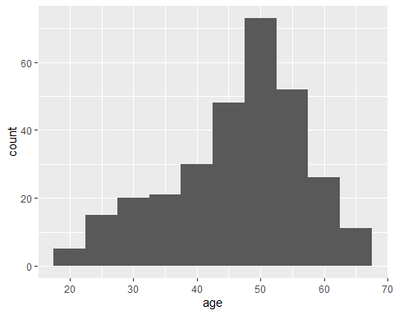

# Headache frequency at 3 months

A daily diary was completed by patients over a four week period at three different stages of the study. The frequency was linked to the severity in a six-point Likert scale, where 5 equalled the most severe headache and 0 represented no headache at all. These were recorded 4 times per day, and this total provided an overall headache score. Additional health status questionnaires were also completed across the 12 month period at quarterly intervals, and after 12 months, patients were also asked to provide an estimate of headache severity on a different scale, which further provided indications of headache frequency in the cohort.

Theme1 <- theme(axis.title.x = element_text(size=12),   
 axis.text.x = element_text(size=12),   
 axis.title.y = element_text(size=12),   
 axis.text.y = element_text(size=12),   
 plot.title = element_text(size = 16),  
 strip.text = element_text(size = 12))   
  
graph1 <- ggplot(acupuncture_for_headache,aes(x=group, y=as.numeric(f2))) +  
 geom_boxplot() +  
 labs(  
 x = "Treatment groups",  
 y = "Headache frequency at 3 months",  
 title = paste(  
 "Headache frequency for both treatment groups at 3 months"  
 )  
 ) +  
 scale_y_continuous(breaks = scales::pretty_breaks(n = 10)) +  
 Theme1  
graph1

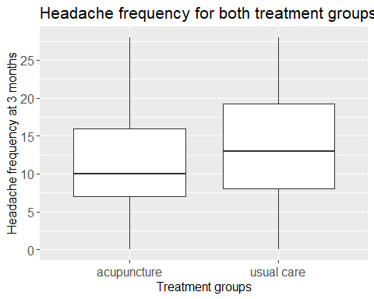

Graph1 is a boxplot that shows the difference in headache frequency at three months for acupuncture and usual care groups. Overall, the acupuncture group experienced lower headache frequency compared to the usual care group. The median for the acupuncture group was also lower compared to the usual care group (acupuncture = 10; usual care = 13), while the interquartile range (IQR) for usual care was higher than the acupuncture group (acupuncture = 9; usual care = 11.50) (Refer to Appendix 1). Both graphs are positively skewed. However, a skew of 0.21 in usual care group suggests that it is approximately symmetric, whereas a skew of 0.67 for acupuncture group suggests that it is moderately symmetric (Refer to Appendix 1).

# Headache severity at 12 months

The headache severity was linked to the frequency and was recorded four times a day across a four week period to create a baseline, then at 3 months and 12 months after randomisation. The diary used a six-point Likert scale ranging from ‘no headache’ to ‘intense incapacitating’, which summed up to give the total headache score. Patients also completed the SF36 health status questionnaire at baseline, three months, and one year. Along with additional questionnaires throughout the study period, after 12 months patients also provided an estimate of their current and baseline headache severity on a scale of 1-10.

graph2 <- ggplot(acupuncture_for_headache,aes(x=group, y=as.numeric(pk5))) +  
 geom_boxplot() +  
 labs(  
 x = "Treatment groups",  
 y = "Headache at 12 months",  
 title = paste(  
 "Headache severity for both treatment groups at 12 months"  
 )  
 ) +  
 scale_y_continuous(breaks = scales::pretty_breaks(n = 10)) +  
 Theme1  
graph2

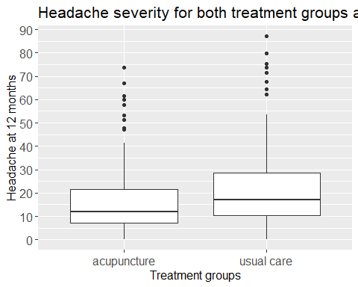

Graph2 is a boxplot that shows the difference in headache severity at 12 months for acupuncture and usual care groups. In general, the acupuncture group experienced less severe headaches compared to the usual care group. The median for the acupuncture group was lower compared to the usual care (median: acupuncture = 12; usual care = 17), and the standard deviation for the acupuncture group was 13.72, which was also lower compared to the usual care group (17.06) (Refer to Appendix 1). Both graphs are highly skewed (Skewness: acupuncture = 1.76; usual care - 1.59) and have outliers, which needs further investigation.

# The relationship between headache frequency at 12 months and baseline

Theme2 <- theme(axis.title.x = element_text(size=10),   
 axis.text.x = element_text(size=10),   
 axis.title.y = element_text(size=8),   
 axis.text.y = element_text(size=8),   
 plot.title = element_text(size = 10),  
 strip.text = element_text(size = 10))   
  
  
graph3 <- ggplot(acupuncture_for_headache, aes(x=as.numeric(f5), y = as.numeric(f1))) +  
 geom_point() +  
 geom_smooth(method = "lm", se = TRUE) +  
 facet_grid(cols=vars(group)) +  
 labs(  
 x="Headache frequency at 12 months",   
 y = "Headache frequency at baseline",   
 title = paste(  
 "Headache severity for both treatment groups at 12 months and baseline")) +  
 scale_x_continuous(breaks = scales::pretty_breaks(n = 10)) +  
 scale_y_continuous(breaks = scales::pretty_breaks(n = 10)) +  
 Theme1  
graph3

## `geom_smooth()` using formula 'y ~ x'

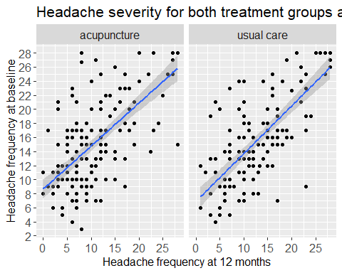

Graph3 is a scatterplot with a regression line that shows the difference in headache frequency at 12 months and baseline. Generally, there are not many big differences with the results for both groups. Both treatment groups have the same median (10), IQR (15), and are both highly skewed on the baseline (refer to Appendix3.2). At 12 months, the difference in minimum value and Q1 for both groups is 1, while the difference in IQR is 2, and maximum value is the same for both groups, which is 28 (refer to Appendix3.1).

Both graphs showed outliers, which needs further investigation to understand if acupuncture has a long-term effect on headache.

Appendix

Appendix 1

Appendix1 <- acupuncture_for_headache %>%  
 group_by(group) %>%  
 summarize(f2)

## `summarise()` regrouping output by 'group' (override with `.groups` argument)

Appendix1

## # A tibble: 301 x 2  
## # Groups: group [2]  
## group f2  
## <chr> <dbl>  
## 1 acupuncture 8  
## 2 acupuncture 24  
## 3 acupuncture 11  
## 4 acupuncture 2  
## 5 acupuncture 10  
## 6 acupuncture 8  
## 7 acupuncture 3  
## 8 acupuncture 9  
## 9 acupuncture 8  
## 10 acupuncture 23  
## # ... with 291 more rows

descr(Appendix1)

## Warning: `funs()` is deprecated as of dplyr 0.8.0.  
## Please use a list of either functions or lambdas:   
##   
## # Simple named list:   
## list(mean = mean, median = median)  
##   
## # Auto named with `tibble::lst()`:   
## tibble::lst(mean, median)  
##   
## # Using lambdas  
## list(~ mean(., trim = .2), ~ median(., na.rm = TRUE))  
## This warning is displayed once every 8 hours.  
## Call `lifecycle::last_warnings()` to see where this warning was generated.

## Descriptive Statistics   
## f2 by group   
## Data Frame: Appendix1   
## N: 161   
##   
## group = acupuncture group = usual care  
## ----------------- --------------------- --------------------  
## Mean 11.96 13.94  
## Std.Dev 7.32 7.60  
## Min 0.00 0.00  
## Q1 7.00 8.00  
## Median 10.00 13.00  
## Q3 16.00 19.50  
## Max 28.00 28.00  
## MAD 7.41 8.15  
## IQR 9.00 11.25  
## CV 0.61 0.55  
## Skewness 0.67 0.20  
## SE.Skewness 0.19 0.20  
## Kurtosis -0.43 -0.82  
## N.Valid 161.00 140.00  
## Pct.Valid 100.00 100.00

Appendix 2

Appendix2 <- acupuncture_for_headache %>%  
 group_by(group) %>%  
 summarize(pk5)

## `summarise()` regrouping output by 'group' (override with `.groups` argument)

Appendix2

## # A tibble: 301 x 2  
## # Groups: group [2]  
## group pk5  
## <chr> <dbl>  
## 1 acupuncture 6.25  
## 2 acupuncture 51.2   
## 3 acupuncture 25.2   
## 4 acupuncture 1   
## 5 acupuncture 2.5   
## 6 acupuncture 13.5   
## 7 acupuncture 2.75  
## 8 acupuncture 19.5   
## 9 acupuncture 21.5   
## 10 acupuncture 38   
## # ... with 291 more rows

descr(Appendix2)

## Descriptive Statistics   
## pk5 by group   
## Data Frame: Appendix2   
## N: 161   
##   
## group = acupuncture group = usual care  
## ----------------- --------------------- --------------------  
## Mean 16.25 22.34  
## Std.Dev 13.72 17.01  
## Min 0.00 0.25  
## Q1 7.25 10.38  
## Median 12.00 17.00  
## Q3 21.50 28.75  
## Max 73.73 87.25  
## MAD 8.52 12.97  
## IQR 14.25 18.31  
## CV 0.84 0.76  
## Skewness 1.76 1.60  
## SE.Skewness 0.19 0.20  
## Kurtosis 3.46 2.63  
## N.Valid 161.00 140.00  
## Pct.Valid 100.00 100.00

Appendix 3

Appendix3.1 <- acupuncture_for_headache %>%  
 group_by(group) %>%  
 summarize(f5)

## `summarise()` regrouping output by 'group' (override with `.groups` argument)

Appendix3.1

## # A tibble: 301 x 2  
## # Groups: group [2]  
## group f5  
## <chr> <dbl>  
## 1 acupuncture 13  
## 2 acupuncture 27  
## 3 acupuncture 13  
## 4 acupuncture 2  
## 5 acupuncture 2  
## 6 acupuncture 9  
## 7 acupuncture 1  
## 8 acupuncture 12  
## 9 acupuncture 10  
## 10 acupuncture 22  
## # ... with 291 more rows

descr(Appendix3.1)

## Descriptive Statistics   
## f5 by group   
## Data Frame: Appendix3.1   
## N: 161   
##   
## group = acupuncture group = usual care  
## ----------------- --------------------- --------------------  
## Mean 11.38 13.61  
## Std.Dev 7.47 7.46  
## Min 0.00 1.00  
## Q1 6.00 7.00  
## Median 9.00 12.00  
## Q3 15.00 18.00  
## Max 28.00 28.00  
## MAD 5.93 7.41  
## IQR 9.00 11.00  
## CV 0.66 0.55  
## Skewness 0.91 0.51  
## SE.Skewness 0.19 0.20  
## Kurtosis -0.06 -0.73  
## N.Valid 161.00 140.00  
## Pct.Valid 100.00 100.00

Appendix3.2 <- acupuncture_for_headache %>%  
 group_by(group) %>%  
 summarize(f1)

## `summarise()` regrouping output by 'group' (override with `.groups` argument)

Appendix3.2

## # A tibble: 301 x 2  
## # Groups: group [2]  
## group f1  
## <chr> <dbl>  
## 1 acupuncture 15  
## 2 acupuncture 25  
## 3 acupuncture 14  
## 4 acupuncture 11  
## 5 acupuncture 6  
## 6 acupuncture 8  
## 7 acupuncture 9  
## 8 acupuncture 25  
## 9 acupuncture 9  
## 10 acupuncture 25  
## # ... with 291 more rows

descr(Appendix3.2)

## Descriptive Statistics   
## f1 by group   
## Data Frame: Appendix3.2   
## N: 161   
##   
## group = acupuncture group = usual care  
## ----------------- --------------------- --------------------  
## Mean 15.63 16.15  
## Std.Dev 6.59 6.70  
## Min 3.00 4.00  
## Q1 10.00 11.00  
## Median 15.00 15.00  
## Q3 20.00 21.00  
## Max 28.00 28.00  
## MAD 7.41 7.41  
## IQR 10.00 10.00  
## CV 0.42 0.41  
## Skewness 0.47 0.33  
## SE.Skewness 0.19 0.20  
## Kurtosis -0.81 -0.93  
## N.Valid 161.00 140.00  
## Pct.Valid 100.00 100.00