Assignment4

Sairam Soundararajan

Montgomery College

**Image of Concordance Data Program**

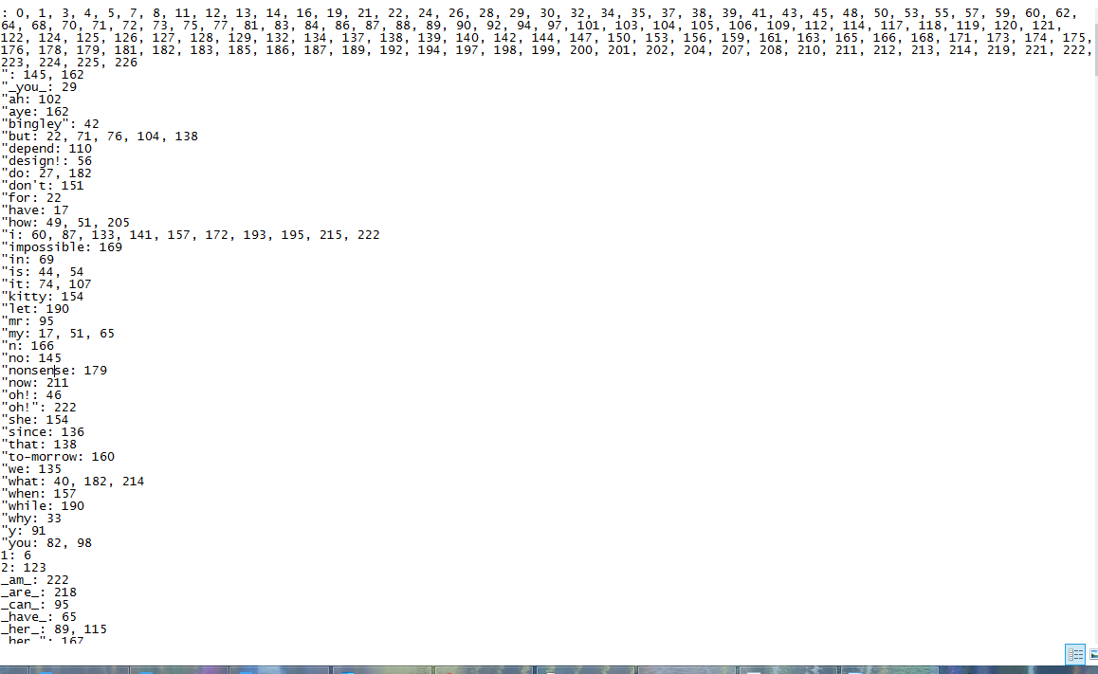

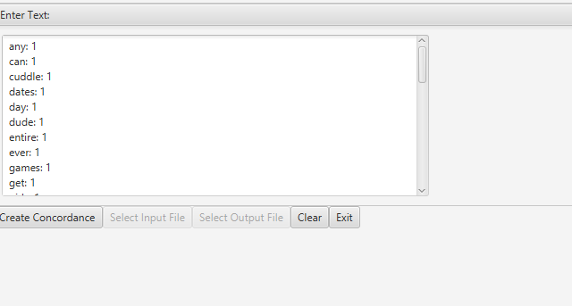

**Test Table**

|  |  |  |  |  |
| --- | --- | --- | --- | --- |
| **Test Case #** | **Input** | **Expected Output** | **Actual Output** | **Did Test Pass?** |
| 1 | Create Concordance From Text:  A freedom to express rhythmically  As well as to gesticulate physically  Is the ultimate art form of dance  One or another shall take a chance  What other way to share your deepest story  Through such a message that is heart pouring  No other can fathom the whole-hearted feeling  The unique performer is intimately revealing  The distinctive movements of a performer or society  Filled with a series of a certain variety  Are compiled as a sacred offer  To dear god as light shines at his altar  To rebel against a discriminatory act  Compelling enough to cause an impact  But one thing that really interests me  Is finding true love indeed  I have learned to appreciate dance more  From a passionate being I have never met before  She guides me in such a way  That no one else I know could portray  I have acquired to think beyond my state of mind  And image myself in the style of other human kind  Much gratitude and dedication owed to her  The feelings I have to confer | acquired: 21  act: 13  against: 13  altar: 12  anor: 4  appreciate: 17  are: 11  art: 3  before: 18  being: 18  beyond: 21  but: 15  can: 7  cause: 14  certain: 10  chance: 4  compelling: 14  compiled: 11  confer: 24  could: 20  dance: 3, 17  dear: 12  dedication: 23  deepest: 5  discriminatory: 13  distinctive: 9  else: 20  enough: 14  express: 1  fathom: 7  feeling: 7  feelings: 24  filled: 10  finding: 16  form: 3  freedom: 1  from: 18  gesticulate: 2  god: 12  gratitude: 23  guides: 19  have: 17, 18, 21, 24  heart: 6  her: 23  his: 12  human: 22  image: 22  impact: 14  indeed: 16  interests: 15  intimately: 8  kind: 22  know: 20  learned: 17  light: 12  love: 16  message: 6  met: 18  mind: 21  more: 17  movements: 9  much: 23  myself: 22  never: 18  offer: 11  one: 4, 15, 20  owed: 23  passionate: 18  performer: 8, 9  physically: 2  portray: 20  pouring: 6  really: 15  rebel: 13  revealing: 8  rhythmically: 1  sacred: 11  series: 10  shall: 4  share: 5  she: 19  shines: 12  society: 9  state: 21  story: 5  style: 22  such: 6, 19  take: 4  that: 6, 15, 20  thing: 15  think: 21  through: 6  true: 16  ultimate: 3  unique: 8  variety: 10  way: 5, 19  well: 2  what: 5  whole-hearted: 7  with: 10  your: 5 | acquired: 21  act: 13  against: 13  altar: 12  anor: 4  appreciate: 17  are: 11  art: 3  before: 18  being: 18  beyond: 21  but: 15  can: 7  cause: 14  certain: 10  chance: 4  compelling: 14  compiled: 11  confer: 24  could: 20  dance: 3, 17  dear: 12  dedication: 23  deepest: 5  discriminatory: 13  distinctive: 9  else: 20  enough: 14  express: 1  fathom: 7  feeling: 7  feelings: 24  filled: 10  finding: 16  form: 3  freedom: 1  from: 18  gesticulate: 2  god: 12  gratitude: 23  guides: 19  have: 17, 18, 21, 24  heart: 6  her: 23  his: 12  human: 22  image: 22  impact: 14  indeed: 16  interests: 15  intimately: 8  kind: 22  know: 20  learned: 17  light: 12  love: 16  message: 6  met: 18  mind: 21  more: 17  movements: 9  much: 23  myself: 22  never: 18  offer: 11  one: 4, 15, 20  owed: 23  passionate: 18  performer: 8, 9  physically: 2  portray: 20  pouring: 6  really: 15  rebel: 13  revealing: 8  rhythmically: 1  sacred: 11  series: 10  shall: 4  share: 5  she: 19  shines: 12  society: 9  state: 21  story: 5  style: 22  such: 6, 19  take: 4  that: 6, 15, 20  thing: 15  think: 21  through: 6  true: 16  ultimate: 3  unique: 8  variety: 10  way: 5, 19  well: 2  what: 5  whole-hearted: 7  with: 10  your: 5 | Yes |
| 2 | Create Concordance from Text:  Nicole, if you are reading this, it is because I have never stopped thinking about you. Ever since I met you, my heart has not reverted back to anyone else. Even to this day, the thought of not being with you makes me devastated. I can not live another day without you by my side. No matter the distance, I will walk thousands of miles in the dessert and have the sand melt in my shoes if it means I will get to your heart. You have no idea the feeling I have had for you all these years. The more I have to live another day without you, the more agony my heart will be in. Ever since I met you, I could never revert. Please come back to me. I love you so much babe. Love, Sairam | about: 1  agony: 1  all: 1  anor: 1  anyone: 1  are: 1  babe: 1  back: 1  because: 1  being: 1  can: 1  come: 1  could: 1  day: 1  dessert: 1  devastated: 1  distance: 1  else: 1  even: 1  ever: 1  feeling: 1  for: 1  get: 1  had: 1  has: 1  have: 1  heart: 1  idea: 1  live: 1  love: 1  makes: 1  matter: 1  means: 1  melt: 1  met: 1  miles: 1  more: 1  much: 1  never: 1  nicole: 1  not: 1  please: 1  reading: 1  revert: 1  reverted: 1  sairam: 1  shoes: 1  side: 1  since: 1  stopped: 1  thinking: 1  this: 1  thought: 1  thouss: 1  walk: 1  will: 1  with: 1  without: 1  years: 1  you: 1  your: 1 | back: 1  because: 1  being: 1  can: 1  come: 1  could: 1  day: 1  dessert: 1  devastated: 1  distance: 1  else: 1  even: 1  ever: 1  feeling: 1  for: 1  get: 1  had: 1  has: 1  have: 1  heart: 1  idea: 1  live: 1  love: 1  makes: 1  matter: 1  means: 1  melt: 1  met: 1  miles: 1  more: 1  much: 1  never: 1  nicole: 1  not: 1  please: 1  reading: 1  revert: 1  reverted: 1  sairam: 1  shoes: 1  side: 1  since: 1  stopped: 1  thinking: 1  this: 1  thought: 1  thouss: 1  walk: 1  will: 1  with: 1  without: 1  years: 1  you: 1  your: 1 | Yes |
| 3 | I am the most popular dude you have ever met. The MOST popular dude in the entire planet. You can never get any other dude that will rank any higher than the dude you see right now on the day of today. And most importantly, girls will want to take me on the many dates with them. we can go to the movies, play the games, go to the restuarant, and cuddle like no other. | any: 1  can: 1  cuddle: 1  dates: 1  day: 1  dude: 1  entire: 1  ever: 1  games: 1  get: 1  girls: 1  have: 1  higher: 1  importantly: 1  like: 1  many: 1  met: 1  most: 1  movies: 1  never: 1  now: 1  planet: 1  play: 1  popular: 1  rank: 1  restuarant: 1  right: 1  see: 1  take: 1  than: 1  that: 1  today: 1  want: 1  will: 1  with: 1  you: 1 | any: 1  can: 1  cuddle: 1  dates: 1  day: 1  dude: 1  entire: 1  ever: 1  games: 1  get: 1  girls: 1  have: 1  higher: 1  importantly: 1  like: 1  many: 1  met: 1  most: 1  movies: 1  never: 1  now: 1  planet: 1  play: 1  popular: 1  rank: 1  restuarant: 1  right: 1  see: 1  take: 1  than: 1  that: 1  today: 1  want: 1  will: 1  with: 1  you: 1 | Yes |

**Lessons Learned:**

What I learned: I learned how to use hashing for a concordance data program. I also used a linked list and an array list once again. The concordance data program is used to detect every word except punctuation and common words such as “the” and “and”. The only exception to punctuation is an apostrophe ‘ used in the middle of the world. Aside from detecting the word, the concordance data program also detects the page the word was on. Ultimately, it ends up being a long list of words with the indicated page numbers if it is as long as a book like Pride & Prejudice by Jane Austin.

What I struggled with: For this project, I struggled with getting my J-Unit tests to run. It seemed as though it was not detecting anything. When running both tests and one GFA tests, it displayed an arrow on the first method but did not go any further than that. No green or red color was marked. I got this looked over by a tutor and it appeared that some of the while loops utilized was causing an infinite execution of a variable, preventing it to continue to the next parts of the program. With the help of the tutor, I was able to get that problem fixed and some errors of J-Unit tests that followed after. The only thing I was not able to fix were two comparison failures on the DataManager Test. Both GFA tests as well as the DataStructure test run perfectly. Everything but two comparison failures runs perfectly on the DataManager test.

What I could do differently: I started two weeks early for this project but worked on this a little slowly. If I could do anything differently, I could work a little efficiently on the next remaining project(s) aside from starting early.