Assignment5

Sairam Soundararajan

Montgomery College

**Image of Morse Code Program**

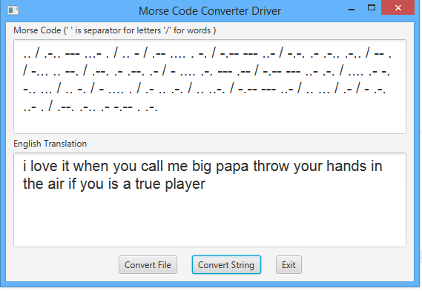

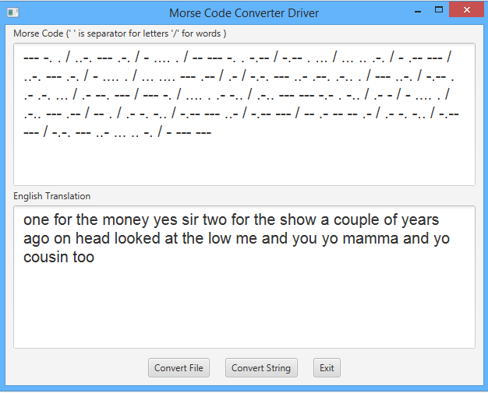

**Test Table**

|  |  |  |  |  |
| --- | --- | --- | --- | --- |
| **Test Case #** | **Input** | **Expected Output** | **Actual Output** | **Did Test Pass?** |
| 1 | .. / .-.. --- ...- . / -.-- --- ..- / -. .. -.-. --- .-.. . | i love you nicole | i love you nicole | Yes |
| 2 | -... --- --- -- / -... --- --- -- / ..-. .-.. .- -.- .- -.- .- -.- .- -.- .- -.- .- | boom boom flakakakakaka | boom boom flakakakakaka | Yes |
| 3 | .. / .-.. --- ...- . / .. - / .-- .... . -. / -.-- --- ..- / -.-. .- .-.. .-.. / -- . / ... . -. --- .-. .. - .- | i love it when you call me senorita | i love it when you call me senorita | Yes |

**Lessons Learned:**

What I learned: Through working on this project, one of the main takeaways from this was learning how to build a tree. When it came to working on the tree node, I used getters and setters to build the basic structure of the tree node.

What I struggled with: Initially, I had null pointer exceptions and comparison failures when running the J-Unit test the first time. But after looking at it with a tutor, the reason for that was due to syntax errors mostly in the Morse code tree and Morse code converter. I got help from the tutor, I was able to fix those syntax errors and run the J-Unit test successfully.

What I could do differently: The only thing I would really like to work on is my critical thinking. Being able to think critically is my Achilles heel. I am slowly but surely making progress. But it is still a challenge I face.