Assignment6

Sairam Soundararajan

Montgomery College

**Image of Town Graph Program**

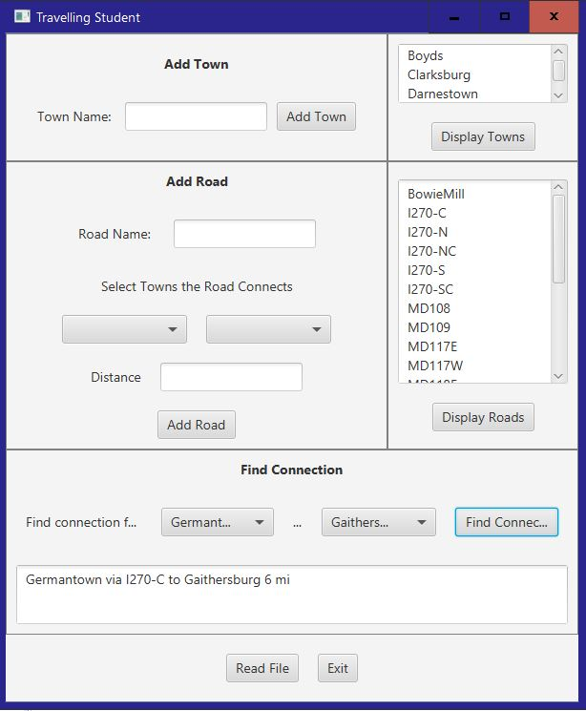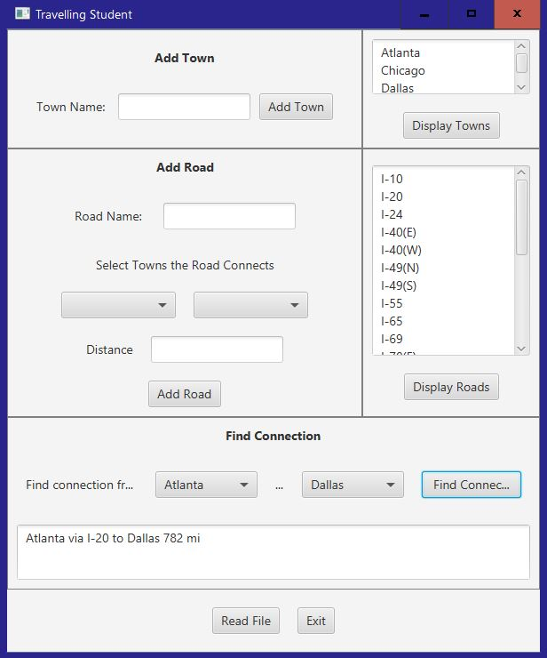

**Test Table**

|  |  |  |  |  |
| --- | --- | --- | --- | --- |
| **Test Case #** | **Input** | **Expected Output** | **Actual Output** | **Did Test Pass?** |
| 1 | Read File: MD Towns  Find Connection:  Germantown to Gaithersburg | Germantown via I270-C to Gaithersburg 6 mi | Germantown via I270-C to Gaithersburg 6 mi | Yes |
| 2 | Read File: US Towns  Find Connection:  Atlanta to Dallas | Atlanta via I-20 to Dallas 782 mi | Atlanta via I-20 to Dallas 782 mi | Yes |
| 3 | Read File: US Towns  Find Connection:  Bethesda to Boyds | Bethesda via I270-S to Rockville 7 mi  Rockville via I270-SC to Gaithersburg 7 mi  Gaithersburg via I270-C to Germantown 6 mi  Germantown via MD117E to Boyds 4 mi | Bethesda via I270-S to Rockville 7 mi  Rockville via I270-SC to Gaithersburg 7 mi  Gaithersburg via I270-C to Germantown 6 mi  Germantown via MD117E to Boyds 4 mi | Yes |

**Lessons Learned:**

What I learned: The main takeaways from this project are using edges to connect vertices, learning how many different ways one can travel from a source to a destination and figuring out which way is the most efficient way. An edge’s weight can be compared to a road that may either have more traffic than another road, or a road that is longer than another, thus taking longer to get to that particular destination. Our goal was to find the quickest way to travel to that destination. The algorithm used in this project was the Dijkstra algorithm.

What I struggled with: Aside from NullPointerExceptions and Comparison Failures, I had a big struggle with implementing Dijkstra’s shortest path method and the shortest path method of type ArrayList. Along with looking at some examples to further help me, I received help from a tutor to develop the Dijkstra’s method and shortest path method. It was a rather long process since it required a queue, set, hash map, and array list. But slowly but surely, I was able to run all the J-Unit tests successfully.

What I could do differently: As usual, critical thinking continues to be a struggle for me; hence resulting in taking longer to complete the graph project successfully. For the university that I have been accepted to, I plan to do the same routine that I have done at MC, which is starting he project at least a week early. But then again, I might even need to start earlier than that since I will be taking classes at a higher level.