Sairam Soundararajan

CMSC405: 6381 Computer Graphics (2228)

University of Maryland Global Campus

Professor: Lauren King

Date: October 11, 2022

|  |  |  |  |  |
| --- | --- | --- | --- | --- |
| Case | Input | Expected Output | Actual Output | Pass? |
| 1 | Size | minimum 640x480 | 640x500 | YES |
| 2 | Lighting | Must use multiple lighting effects on different materials | Uses multiple lighting effects on scene | YES |
| 3 | Components | Must include radio buttons, sliders or other widgets to turn on/off certain components of animation | Includes radio buttons and sliders to zoom, turn on/off animation and lighting effects. |  |
| 4 | Objects | Must include at least 10 objects | Includes at least 10 objects | YES |

**Snapshots of Test Runs:**

Starting point

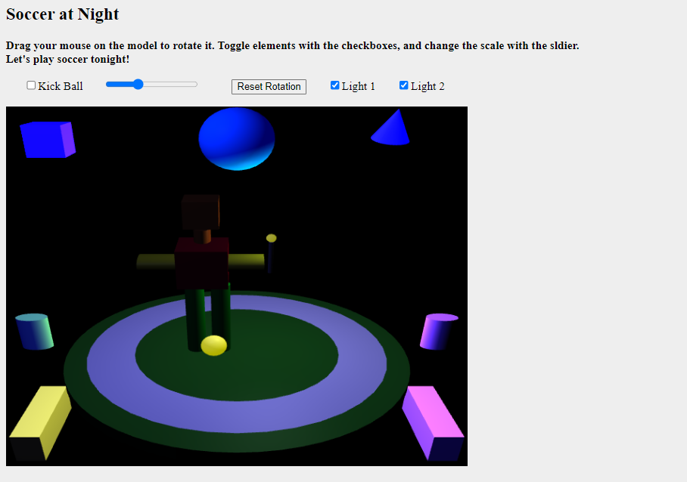

Animation on

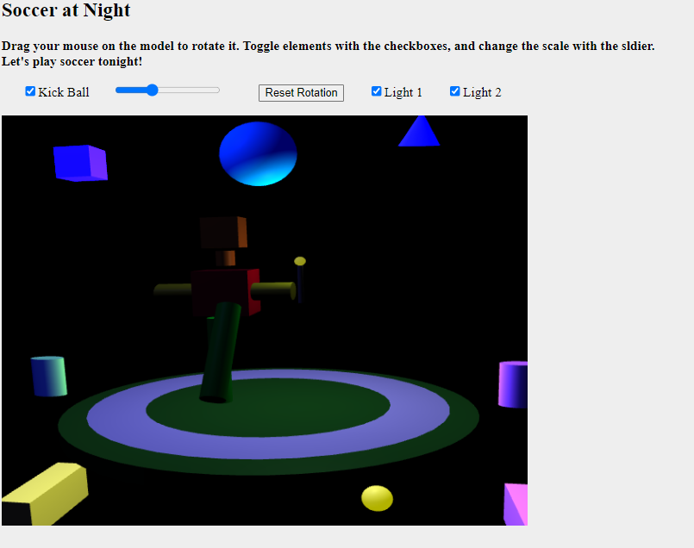

Light 1 off

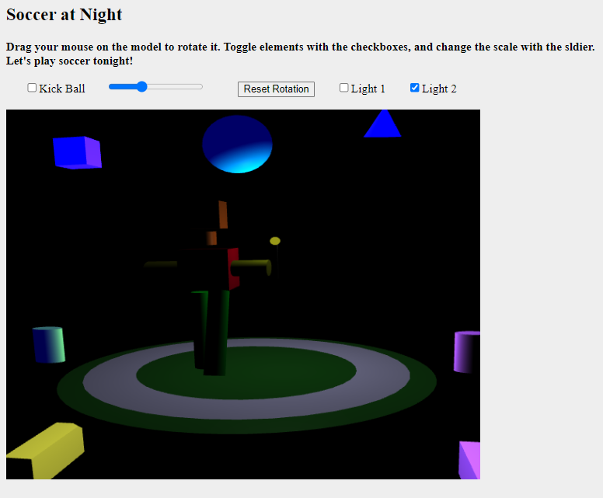

Light 2 off

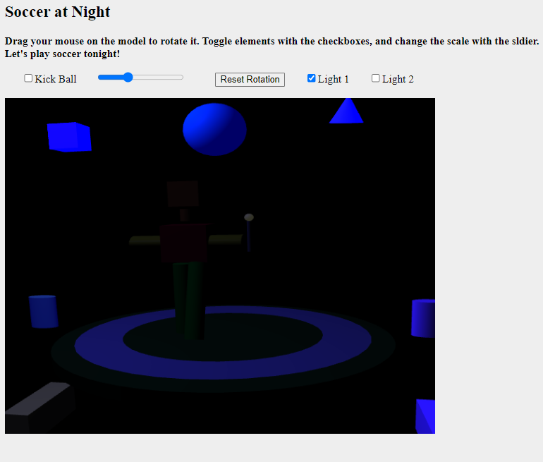

Both lights off

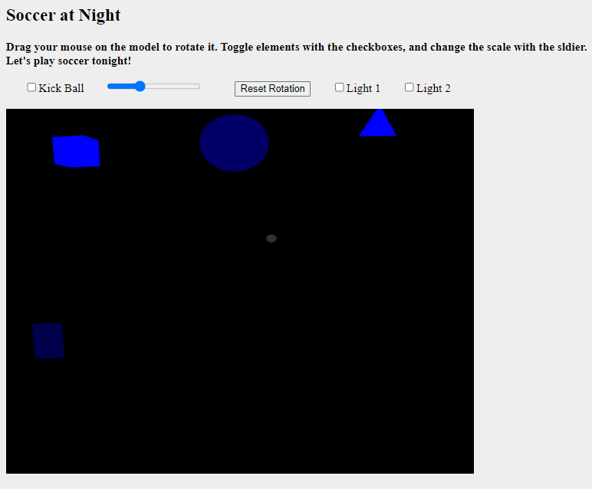

Slider zooming in

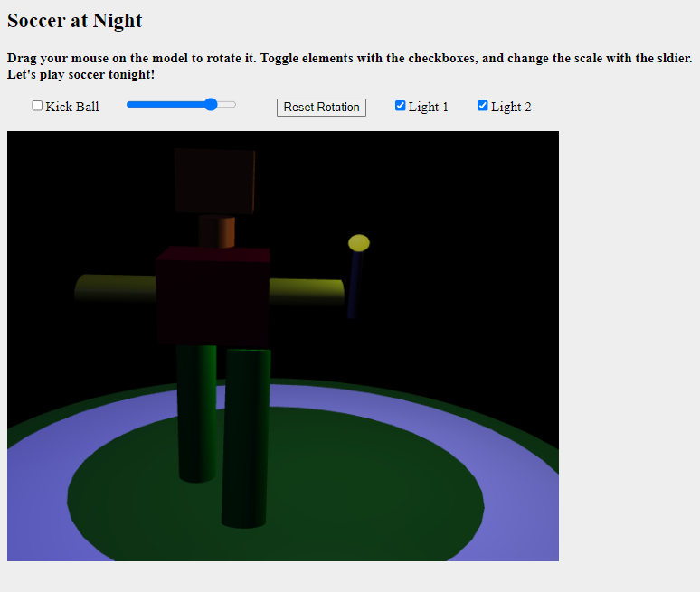

Lesson Learned:

For this project, I used notepad++ as the text editor for the html. This project involved using JavaScript and WebGL. I was able to add at least 10 objects, set the canvas size minimum, include radio buttons and sliders for certain components of the scene, and use lighting effects. The code I worked on is a modified version of the diskplay where the boxman is kicking the soccer ball. My original hope was to set an infinite rotation animation for the three shapes above the boxman, but unfortunately I was struggling to accomplish that in the particular way I wanted. I was also hoping to set an ice texture for the cube, discoball texture for the sphere, and diamond texture for the cone. Sadly, I was unable to implement texture to those objects because I need some kind of permission to be able to use textures for the objects in html or at least WebGL. I spent a lot of time trying to figure out how to get the texture to work but unfortunately did come of any success. As a result, I could not add any frame buffers to the objects as well. I felt as though some of the materials covered in this project were a little condensed. I believe I could have benefited from working on these topics a little longer. In spite of all that, I was able to make a scene where the boxman is playing soccer at a huge stadium at night, while holding a lamp torch, that is.

References

UMGC. (n.d.). *gl-matrix-min.js*. CMSC405. Retrieved from https://learn.umgc.edu/d2l/le/content/719405/viewContent/26836714/View.

UMGC. (n.d.). *trackball-rotator.js*. CMSC405. Retrieved from https://learn.umgc.edu/d2l/le/content/719405/viewContent/26836714/View.

UMGC. (n.d.). *basic-object-models-IFS.js*. CMSC405. Retrieved from https://learn.umgc.edu/d2l/le/content/719405/viewContent/26836714/View.