Sairam Soundararajan

CMSC405: 6381 Computer Graphics (2228)

University of Maryland Global Campus

Professor: Lauren King

Date: September 27, 2022

|  |  |  |  |  |
| --- | --- | --- | --- | --- |
| Case | Input | Expected Output | Actual Output | Pass? |
| 1 | Lighting | Must use multiple lighting effects | Program uses multiple lighting effects | YES |
| 2 | Animation | Animation must rotate each shape along the x, y , and z axis | Shapes rotated shape along the x, y , and z axis | Yes |
| 3 | Size | Size of scene must be at  least 640x48 | Size of scene satisfies the 640x48 minimum requirement | Yes |
| 4 | Different shapes | Must consist of at least 6 different shapes | Program is comprised of cube, sphere, tetrahedron, torus, cylinder, and circle | Yes |

**Snapshots of Test Runs:**

Program at starting point:

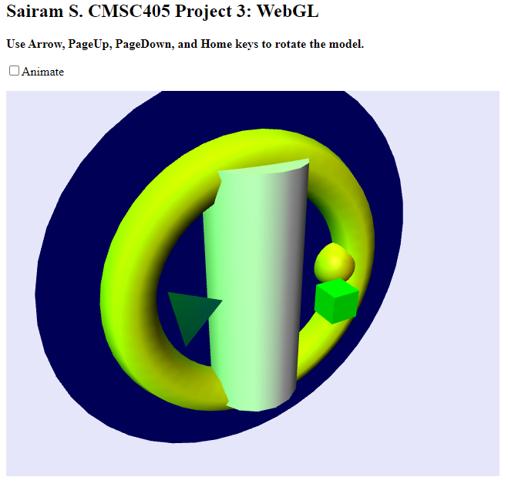

Controls:

PG UP –

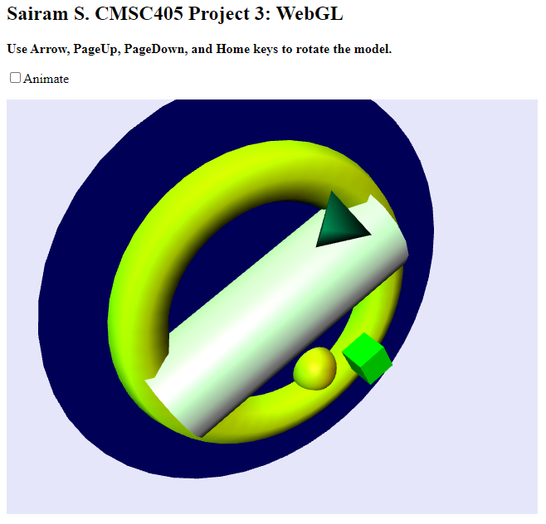

PG DOWN –

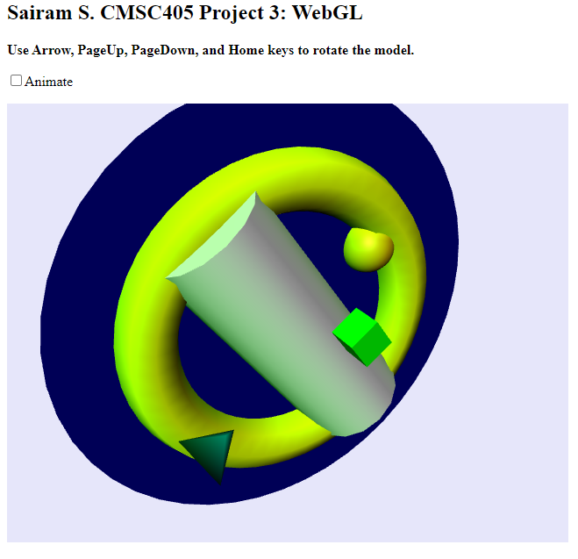

UP –

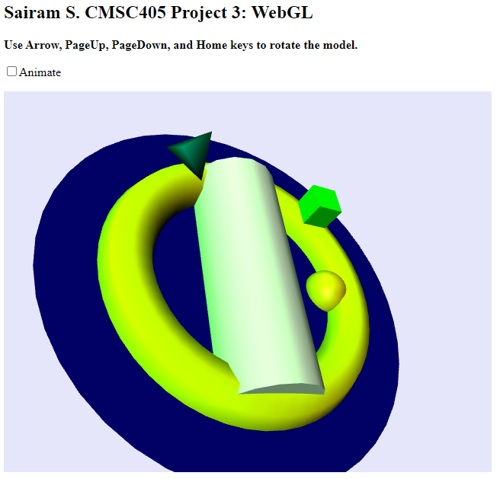

DOWN –

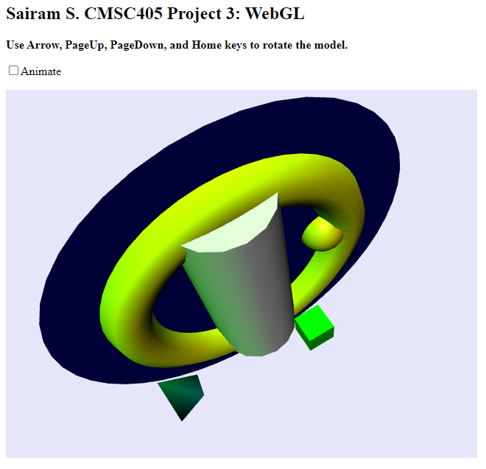

HOME –

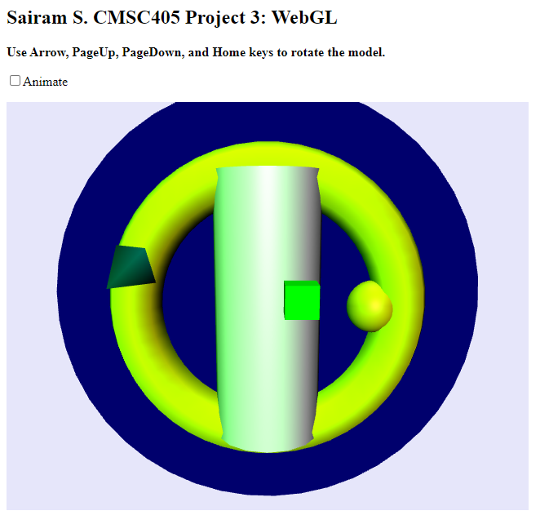

Lesson Learned:

For this project, I used both Notepad++ and Visual Studio Code back-to-back as text editors. The main objective was to use three.js to display many shapes, some of which are animated, and all have rotating key commands. At first, I struggled a lot with getting started on this project because it was my first time working with JavaScript. I tried following a few YouTube videos on how to get started with three.js and I was not able to succeed with that alone. When I first implemented the code, initially, my program wouldn’t display anything. It only dawned on me later that I could have referred to the “How to use three.js” pdf and modeling-starter.js this entire time. After following the pdf and using the modeling-starter.js as a starting point, I was able to get the code running and referred to three.js as to how to declare and initialize the tetrahedron. I also referred to threejs.org for the example codes, how to create scenes, and how to use CircleGeometry. After some adjustments to the shape material and colors. I was able to finish the program successfully. The only shapes animated in my program are the cube, sphere, and tetrahedron. If only I realized sooner that using modeling-starter.js and the pdf was the key, I’m sure I would have submitted it sooner.

References

*CircleGeometry on three.js*. Three.js docs. (n.d.). Retrieved September 27, 2022, from https://threejs.org/docs/#api/en/geometries/CircleGeometry

*Creating a scene*. Three.js docs. (n.d.). Retrieved September 27, 2022, from https://threejs.org/docs/index.html#manual/en/introduction/Creating-a-scene

Three.js – JavaScript 3D Library. (n.d.). Retrieved September 27, 2022, from https://threejs.org/

UMGC. (n.d.). *threejs.zip*. CMSC405. Retrieved from https://learn.umgc.edu/d2l/le/content/719405/viewContent/26836713/View.