Sairam Soundararajan

CMSC412: Operating Systems

University of Maryland Global Campus

Professor Schmeelk

|  |  |  |  |  |
| --- | --- | --- | --- | --- |
| Test Case | Input | Expected Output | Actual Output | Pass? |
| 1 | 1  C:\Users\saira\Desktop\CMSC412\src  2 | Select option:  Please enter a path:  Path set to C:\Users\saira\Desktop\CMSC412\src  file: C:\Users\saira\Desktop\CMSC412\src\HW6.java  -file: C:\Users\saira\Desktop\CMSC412\src\SairamSHW6.zip  -file: C:\Users\saira\Desktop\CMSC412\src\testing.txt | Select option:  Please enter a path:  Path set to C:\Users\saira\Desktop\CMSC412\src  file: C:\Users\saira\Desktop\CMSC412\src\HW6.java  -file: C:\Users\saira\Desktop\CMSC412\src\SairamSHW6.zip  -file: C:\Users\saira\Desktop\CMSC412\src\testing.txt | YES |
| 2 | 1  C:\Users\saira\Desktop\CMSC412\src  3 | Select option:  Please enter a path:  Path set to C:\Users\saira\Desktop\CMSC412\src  -file: C:\Users\saira\Desktop\CMSC412\src\HW6.java  -file: C:\Users\saira\Desktop\CMSC412\src\SairamSHW6.zip  -file: C:\Users\saira\Desktop\CMSC412\src\testing.txt | Select option:  Please enter a path:  Path set to C:\Users\saira\Desktop\CMSC412\src  -file: C:\Users\saira\Desktop\CMSC412\src\HW6.java  -file: C:\Users\saira\Desktop\CMSC412\src\SairamSHW6.zip  -file: C:\Users\saira\Desktop\CMSC412\src\testing.txt | Yes |
| 3 | 1  C:\Users\saira\Desktop\CMSC412\src  3  4  hi.txt | Select option:  Please enter a path:  Path set to C:\Users\saira\Desktop\CMSC412\src  -file: C:\Users\saira\Desktop\CMSC412\src\HW6.java  -file: C:\Users\saira\Desktop\CMSC412\src\SairamSHW6.zip  -file: C:\Users\saira\Desktop\CMSC412\src\testing.txt  Input file to delete:  hi.txt was deleted sucessfully. | Select option:  Please enter a path:  Path set to C:\Users\saira\Desktop\CMSC412\src  -file: C:\Users\saira\Desktop\CMSC412\src\HW6.java  -file: C:\Users\saira\Desktop\CMSC412\src\SairamSHW6.zip  -file: C:\Users\saira\Desktop\CMSC412\src\testing.txt  Input file to delete:  hi.txt was deleted sucessfully. | Yes |

Snapshots of Test Run:

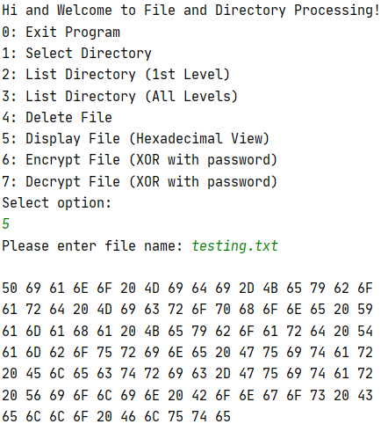

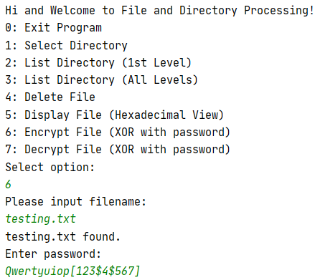 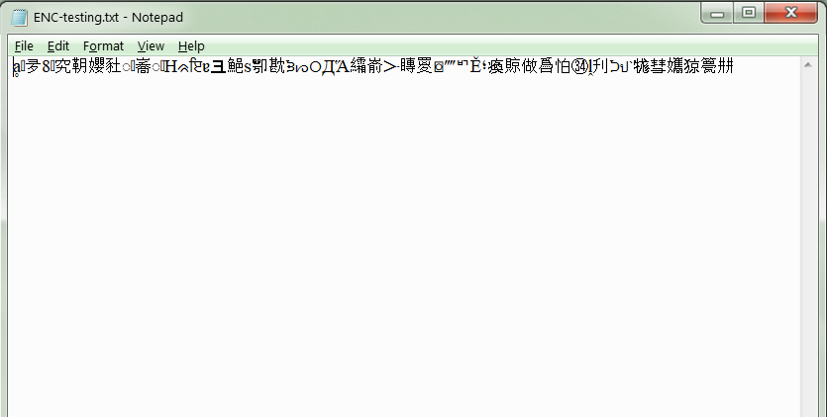

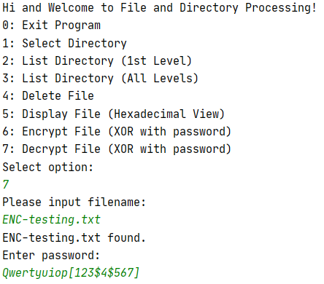 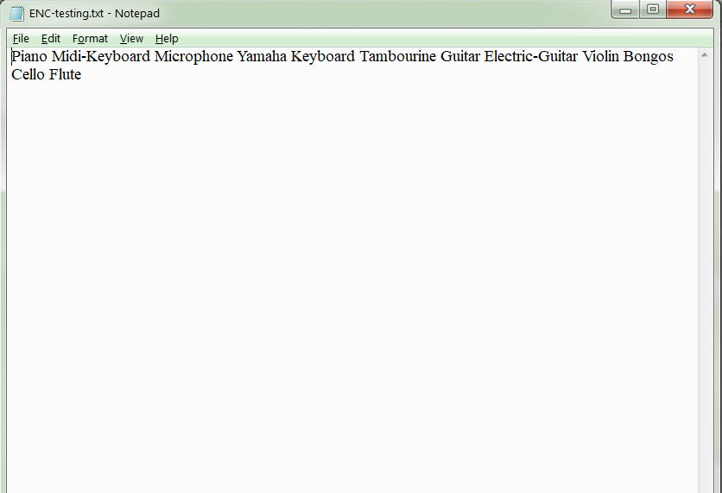

Reflection:

For this homework, I used Java (IntelliJ) to work on file and directory processing. Thanks to my professor’s guidance, I was able to get a start on how to process my desired file and directory. The functions of file/directory processing includes selecting directory, listing directory content of first level and all levels, deleting the file, displaying the file in hexadecimal view, and encrypting and decrypting the file with password. At first, I had trouble with all my inputs directing me back to the main menu during test run. My tutor made me realize that it was how I declared my scanner variable in the main method. He also gave me a few pointers on how to make the readFileAsHex() method display the hexadecimal value of the file chosen.