Sairam Soundararajan

CMSC430: Advanced Programming Languages

University of Maryland Global Campus

Professor Jarc

|  |  |  |  |  |
| --- | --- | --- | --- | --- |
| Test Case | Input | Expected Output | Actual Output | Pass? |
| 1 | ./compile < test9.txt | $./compile < test9.txt  1 -- Conditional expression  2  3 function main returns integer;  4 begin  5 if not (5 + 4 >= 9) then  6 6 + 9 * 3;  7 else  8 8 - 9 rem 7;  9 endif;  10 end;  Compiled Successfully  Result = 6 |  | YES |
| 2 | $ ./compile < test10.txt | $ ./compile < test10.txt  1 -- Multiple integer variable initialization  2  3 function main returns integer;  4 b: integer is 5 + 1 - 4;  5 c: integer is 2 + 3;  6 begin  7 b + 1 - c;  8 end;  Compiled Successfully  Result = -2 |  | Yes |
| 3 | $ ./compile < test12.txt 3.6 | $ ./compile < test12.txt 3.6  1 -- Single parameter declaration  2  3 function main a: real returns real;  4 begin  5 a + 1.5;  6 end;  Compiled Successfully  Result = 5.1 |  | Yes |

Snapshots of Test Run:

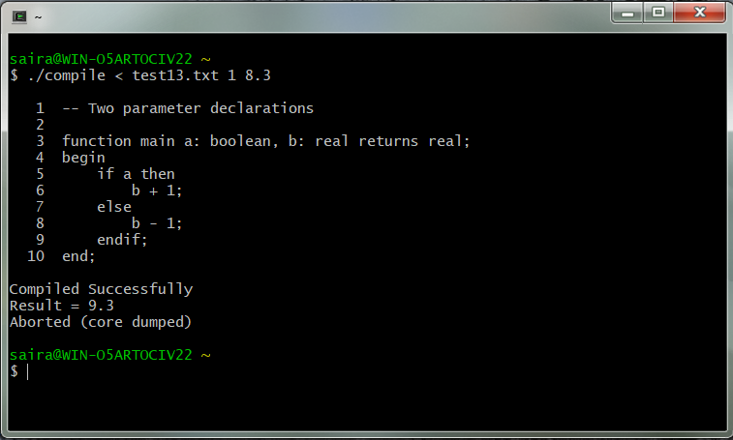

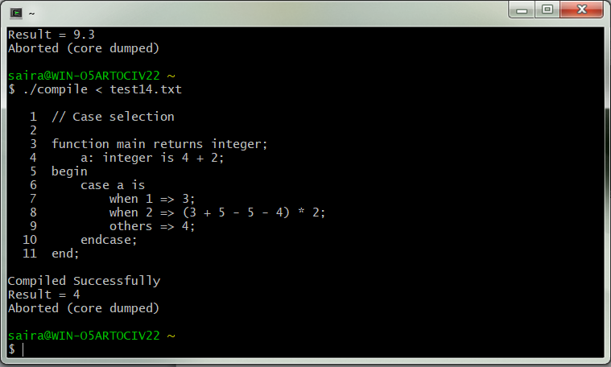

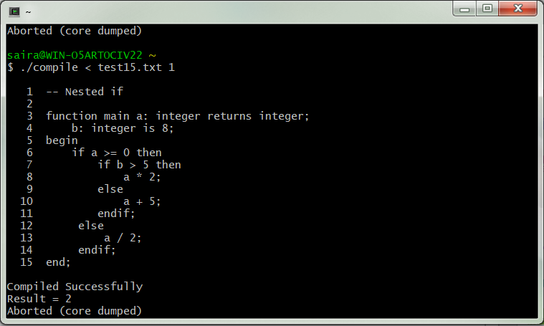

Reflection:

For this project, I used notepad for editing and Cygwin for building, compiling, and testing. This was a continuation of the last project that involved the parser. Only it involved actually computing arithmetic, relational, and logical operations. With a few additional files used for this project, I was able to make the parser calculate operations involving real and Boolean literals, all operations and variables with conditional statements functions with parameters. With help from the professor and one of my friends, I was able to successfully get all components of the project running. I think I approached this project in a better than the previous projects. Thus, I don’t think there is anything that could have went better that I’ll do next time.