Sairam Soundararajan

CMSC430: Advanced Programming Languages

University of Maryland Global Campus

Professor Jarc

|  |  |  |  |  |
| --- | --- | --- | --- | --- |
| Test Case | Input | Expected Output | Actual Output | Pass? |
| 1 | ./compile < semantic14.txt | 1 -- Narrowing Variable Initialization  2  3 function main returns integer;  4 b: integer is 5 * 2.5;  Semantic Error, Illegal Narrowing Variable Initialization  5 begin  6 b + 1;  7 end;  Lexical Errors 0  Syntax Errors 0  Semantic Errors 1 |  | YES |
| 2 | ./compile < semantic15.txt | 1 -- Narrowing Function Return  2  3 function main returns integer;  4 b: integer is 6 * 2;  5 begin  6 if 8 < 0 then  7 b + 3.0;  8 else  9 b * 4.6;  10 endif;  11 end;  Semantic Error, Illegal Narrowing Function Return  Lexical Errors 0  Syntax Errors 0  Semantic Errors 1 |  | Yes |
| 3 | ./compile < semantic16.txt | 1 -- Duplicate Identifier  2  3 function main returns integer;  4 b: integer is 4 * 2;  5 b: boolean is true;  Semantic Error, Duplicate Identifier: b  6 begin  7 if 8 <= 0 then  8 b + 3;  9 else  10 b * 4;  11 endif;  12 end;  Lexical Errors 0  Syntax Errors 0  Semantic Errors 1 |  | Yes |

Snapshots of Test Run:

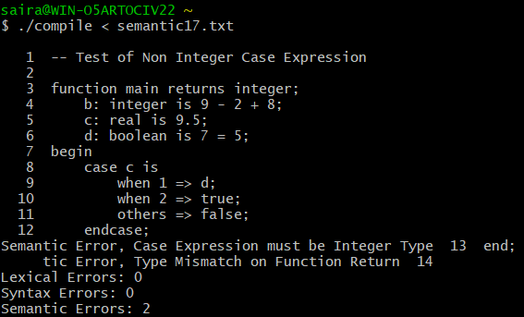

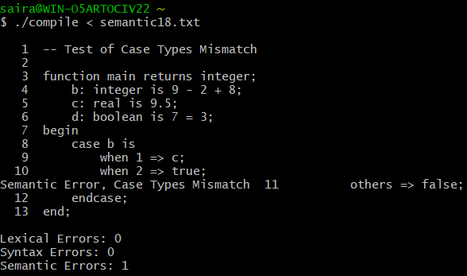

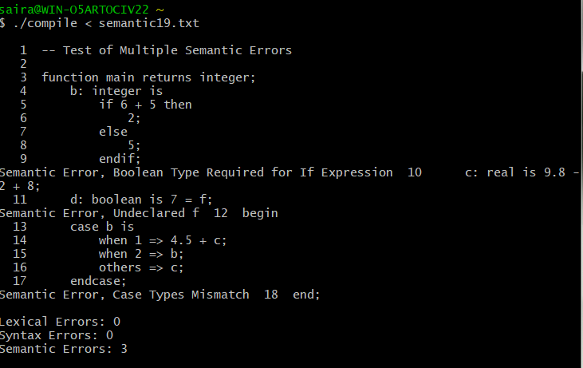

Reflection:

As with the previous projects, this project was a continuation of the parser continuity project, as involved adding semantic actions and type checking for testing semantic programs. More specifically, this project deals with detecting semantic errors of mismatch existing in the types of operations being performed. As with other projects, I did get guidance from my professor and tutored by my friend. Since this was the last project of the course, my takeaways include the following. After taking the course, I hope to have more practice with linux based-programs like Ubuntu. As a windows, I believe Cygwin was great for me to get started with regards to learning to work in a linux-based environment. With the completion of the course, I hope to carry forward what I learned with lexical, syntactic, and semantic analyzers. I would like to thank my professor for his timely responses and guidance while I was having trouble at times.