Sairam Soundararajan

SDEV300: Building Secure Python Applications

University of Maryland Global Campus

Professor Howards

|  |  |  |  |  |
| --- | --- | --- | --- | --- |
| Test Case | Input | Expected Output | Actual Output | Pass? |
| 1 | Welcome to the United States Python Program!!  ======= Menu =======  1. Display all U.S. States in Alphabetical order along with the Capital, State Population, and Flower  2. Search for a specific state and display the appropriate Capital name, State Population, and an image of the associated State Flower.  3. Provide a Bar graph of the top 5 populated States showing their overall population.  4. Update the overall state population for a specific state.  5. Exit program  ====================  Enter a choice(1-5):1 | Display Alphabetical Order  Alabama: Montgomery, Camellia, 4908620  Alaska: Juneau, Forget Me Not, 734002  Arizona: Phoenix, Saguaro Cactus Blossom, 7378490  Arkansas: Little Rock, Apple Blossom, 3039000  California: Sacramento, California Poppy, 39937500  Colorado: Denver, White and Lavender Columbine, 5845530  Connecticut: Juneau, Hartford, 3563080  Delaware: Dover, Peach Blossom, 982895  Florida: Tallahassee, Orange Blossom, 21993000  Georgia: Atlanta, Cherokee Rose, 10736100  Hawaii: Honolulu, Hibiscus, 1412690  Idaho: Boise, Syringa, 1826160  Illinois: Springfield, Purple Violet, 12659700  Indiana: Indianapolis, Peony, 6745350  Iowa: Des Moines, Wild Prairie Rose, 3179850  Kansas: Topeka, Sunflower, 2910360  Kentucky: Frankfort, Goldenrod, 4499690  Louisiana: Baton Rouge, Magnolia, 4645180  Maine: Augusta, White Pine Cone and Tassel, 1345790  Maryland: Annapolis, Black-Eyed Susan, 6083120  Massachusetts: Boston, Mayflower, 6976600  Michigan: Lansing, Apple Blossom, 10045000  Minnesota: Saint Paul, Pink and White Lady Slipper, 5700670  Mississippi: Jackson, Magnolia, 2989260  Missouri: Jefferson City, White Hawthorn Blossom, 6169270  Montana: Helena, Bitterroot, 1086760  Nebraska: Lincoln, Goldenrod, 1952570  Nevada: Cason City, Sagebrush, 3139660  New Hampshire: Concord, Purple Lilac, 1371250  New Jersey: Trenton, Violet, 8936570  New Mexico: Santa Fe, Yucca Flower, 2096640  New York: Albany, Rose, 19440500  North Carolina: Raleigh, Dogwood, 10611900  North Dakota: Bismarck, Wild Prairie Rose, 761723  Ohio: Columbus, Scarlet Carnation, 11747700  Oklahoma: Oklahoma City, Mistletoe, 3954820  Oregon: Salem, Oregon Grape, 4301090  Pennsylvania: Harrisburg, Mountain Laurel, 12820900  Rhode Island: Providence, Violet, 1056160  South Carolina: Columbia, Yellow Jessamine, 5210100  South Dakota: Pierre, Pasque Flower, 903027  Tennessee: Nashville, Iris, 6897580  Texas: Austin, Bluenonnet, 29472300  Utah: Salt Lake City, Sego Lily, 3282120  Vermont: Montpelier, Red Clover, 628061  Virginia: Richmond, Dogwood, 8626210  Washington: Olympia, Pink Rhododendron, 7797100  West Virginia: Charleston, Rhododendron, 1778070  Wisconsin: Madison, Wood Violet, 5851750  Wyoming: Cheyenne, Indian Paintbrush, 567025 | Display Alphabetical Order  Alabama: Montgomery, Camellia, 4908620  Alaska: Juneau, Forget Me Not, 734002  Arizona: Phoenix, Saguaro Cactus Blossom, 7378490  Arkansas: Little Rock, Apple Blossom, 3039000  California: Sacramento, California Poppy, 39937500  Colorado: Denver, White and Lavender Columbine, 5845530  Connecticut: Juneau, Hartford, 3563080  Delaware: Dover, Peach Blossom, 982895  Florida: Tallahassee, Orange Blossom, 21993000  Georgia: Atlanta, Cherokee Rose, 10736100  Hawaii: Honolulu, Hibiscus, 1412690  Idaho: Boise, Syringa, 1826160  Illinois: Springfield, Purple Violet, 12659700  Indiana: Indianapolis, Peony, 6745350  Iowa: Des Moines, Wild Prairie Rose, 3179850  Kansas: Topeka, Sunflower, 2910360  Kentucky: Frankfort, Goldenrod, 4499690  Louisiana: Baton Rouge, Magnolia, 4645180  Maine: Augusta, White Pine Cone and Tassel, 1345790  Maryland: Annapolis, Black-Eyed Susan, 6083120  Massachusetts: Boston, Mayflower, 6976600  Michigan: Lansing, Apple Blossom, 10045000  Minnesota: Saint Paul, Pink and White Lady Slipper, 5700670  Mississippi: Jackson, Magnolia, 2989260  Missouri: Jefferson City, White Hawthorn Blossom, 6169270  Montana: Helena, Bitterroot, 1086760  Nebraska: Lincoln, Goldenrod, 1952570  Nevada: Cason City, Sagebrush, 3139660  New Hampshire: Concord, Purple Lilac, 1371250  New Jersey: Trenton, Violet, 8936570  New Mexico: Santa Fe, Yucca Flower, 2096640  New York: Albany, Rose, 19440500  North Carolina: Raleigh, Dogwood, 10611900  North Dakota: Bismarck, Wild Prairie Rose, 761723  Ohio: Columbus, Scarlet Carnation, 11747700  Oklahoma: Oklahoma City, Mistletoe, 3954820  Oregon: Salem, Oregon Grape, 4301090  Pennsylvania: Harrisburg, Mountain Laurel, 12820900  Rhode Island: Providence, Violet, 1056160  South Carolina: Columbia, Yellow Jessamine, 5210100  South Dakota: Pierre, Pasque Flower, 903027  Tennessee: Nashville, Iris, 6897580  Texas: Austin, Bluenonnet, 29472300  Utah: Salt Lake City, Sego Lily, 3282120  Vermont: Montpelier, Red Clover, 628061  Virginia: Richmond, Dogwood, 8626210  Washington: Olympia, Pink Rhododendron, 7797100  West Virginia: Charleston, Rhododendron, 1778070  Wisconsin: Madison, Wood Violet, 5851750  Wyoming: Cheyenne, Indian Paintbrush, 567025 | Yes |
| 2 | Welcome to the United States Python Program!!  ======= Menu =======  1. Display all U.S. States in Alphabetical order along with the Capital, State Population, and Flower  2. Search for a specific state and display the appropriate Capital name, State Population, and an image of the associated State Flower.  3. Provide a Bar graph of the top 5 populated States showing their overall population.  4. Update the overall state population for a specific state.  5. Exit program  ====================  Enter a choice(1-5):4 | Choose a state to update its population: Pennsylvania  Original Population: : 12820900  Enter a new population: 5467234  Population Successfully Changed! | Choose a state to update its population: Pennsylvania  Original Population: : 12820900  Enter a new population: 5467234  Population Successfully Changed! | yes |

Snapshots of Test Run:

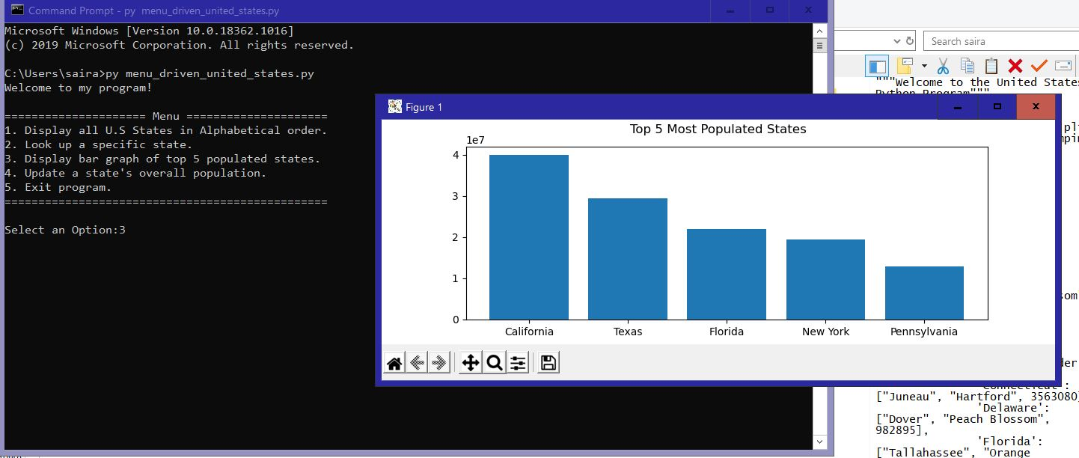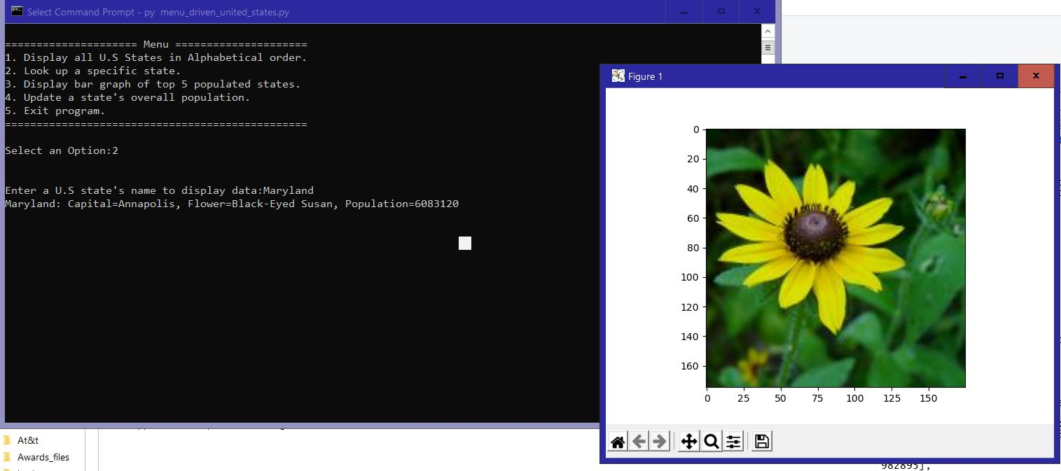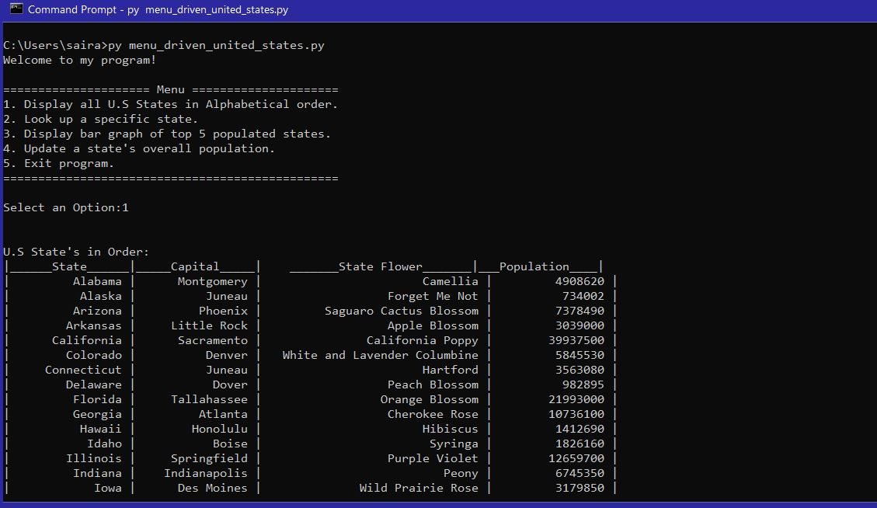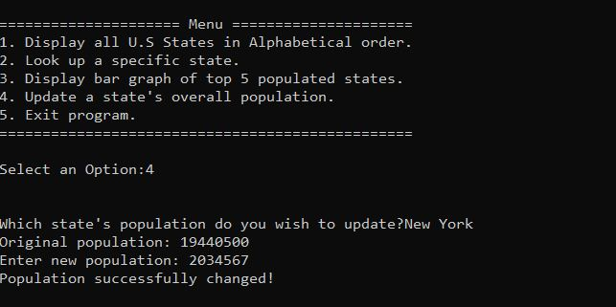

Pylint Discussion and Snapshots:

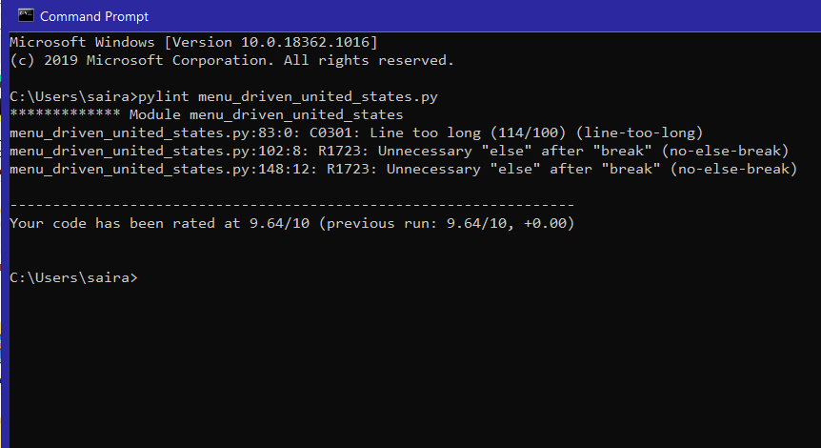

After making changes for the command prompt to be able to view the flower photos and graph, I was having difficulty with getting Pylint to run 10.00/10. Fixing the one long line was not without tremendous struggle when it came to the format of the print statement because it would still give indentation conventions even after rearranging. The unnecessary else after break could not be fixed because it was mandatory for the code to work properly.