Sairam Soundararajan

SDEV300: Building Secure Python Applications

University of Maryland Global Campus

Professor Howards

|  |  |  |  |  |
| --- | --- | --- | --- | --- |
| Test Case | Input | Expected Output | Actual Output | Pass? |
| 1 | ***************** Welcome to the Python Matrix Application***********  Do you want to play the Matrix Game?  Enter Y for Yes or N for No:Y  Enter your phone number (Don't enter any dashes):3017759588  301-775-9588  Enter your 9-digit zip code (put a dash after the first 5 digits before finishing): 20879-1415  Zip Code: 20879-1415  Enter your first 3x3 matrix:  17 15 13  12 14 10  20 23 21  Your first 3x3 matrix is:  [[17 15 13]  [12 14 10]  [20 23 21]]  Enter your second 3x3 matrix:  1 2 3  4 5 6  7 8 9  Your second 3x3 matrix is:  [[1 2 3]  [4 5 6]  [7 8 9]]  Select a Matrix Operation from the list below:  a. Addition  b. Subtraction  c. Matrix Multiplication  d. Element by element multiplication  b | You selected Subtraction. The results are:  [[16 13 10]  [ 8 9 4]  [13 15 12]]  The Transpose is:  [[16 8 13]  [13 9 15]  [10 4 12]]  The row and column mean values of the results are:  Row: 13.0, 7.0, 13.333333333333334  Column: 12.333333333333334, 12.333333333333334, 8.666666666666666 | You selected Subtraction. The results are:  [[16 13 10]  [ 8 9 4]  [13 15 12]]  The Transpose is:  [[16 8 13]  [13 9 15]  [10 4 12]]  The row and column mean values of the results are:  Row: 13.0, 7.0, 13.333333333333334  Column: 12.333333333333334, 12.333333333333334, 8.666666666666666 | Yes |
| 2 | ***************** Welcome to the Python Matrix Application***********  Do you want to play the Matrix Game?  Enter Y for Yes or N for No:Y  Enter your phone number (Don't enter any dashes):3017759588  301-775-9588  Enter your 9-digit zip code (put a dash after the first 5 digits before finishing): 20879-1415  Zip Code: 20879-1415  Enter your first 3x3 matrix:  1 2 3  4 5 6  7 8 9  Your first 3x3 matrix is:  [[1 2 3]  [4 5 6]  [7 8 9]]  Enter your second 3x3 matrix:  1 2 3  4 5 6  7 8 9  Your second 3x3 matrix is:  [[1 2 3]  [4 5 6]  [7 8 9]]  Select a Matrix Operation from the list below:  a. Addition  b. Subtraction  c. Matrix Multiplication  d. Element by element multiplication  c | You selected Matrix Multiplication. The results are:  [[ 30 36 42]  [ 66 81 96]  [102 126 150]]  The Transpose is:  [[ 30 66 102]  [ 36 81 126]  [ 42 96 150]]  The row and column mean values of the results are:  Row: 36.0, 81.0, 126.0  Column: 66.0, 81.0, 96.0 | You selected Matrix Multiplication. The results are:  [[ 30 36 42]  [ 66 81 96]  [102 126 150]]  The Transpose is:  [[ 30 66 102]  [ 36 81 126]  [ 42 96 150]]  The row and column mean values of the results are:  Row: 36.0, 81.0, 126.0  Column: 66.0, 81.0, 96.0 | yes |
| 3 | ***************** Welcome to the Python Matrix Application***********  Do you want to play the Matrix Game?  Enter Y for Yes or N for No:Y  Enter your phone number (Don't enter any dashes):3017759588  301-775-9588  Enter your 9-digit zip code (put a dash after the first 5 digits before finishing): 20879-1415  Zip Code: 20879-1415  Enter your first 3x3 matrix:  21 26 25  14 15 12  11 13 10  Your first 3x3 matrix is:  [[21 26 25]  [14 15 12]  [11 13 10]]  Enter your second 3x3 matrix:  1 2 3  4 5 6  7 8 9  Your second 3x3 matrix is:  [[1 2 3]  [4 5 6]  [7 8 9]]  Select a Matrix Operation from the list below:  a. Addition  b. Subtraction  c. Matrix Multiplication  d. Element by element multiplication  a | You selected Addition. The results are:  [[22 28 28]  [18 20 18]  [18 21 19]]  The Transpose is:  [[22 18 18]  [28 20 21]  [28 18 19]]  The row and column mean values of the results are:  Row: 26.0, 18.666666666666668, 19.333333333333332 | You selected Addition. The results are:  [[22 28 28]  [18 20 18]  [18 21 19]]  The Transpose is:  [[22 18 18]  [28 20 21]  [28 18 19]]  The row and column mean values of the results are:  Row: 26.0, 18.666666666666668, 19.333333333333332 | yes |
| 4 | ***************** Welcome to the Python Matrix Application***********  Do you want to play the Matrix Game?  Enter Y for Yes or N for No:Y  Enter your phone number (Don't enter any dashes):3017759588  301-775-9588  Enter your 9-digit zip code (put a dash after the first 5 digits before finishing): 20879-1415  Zip Code: 20879-1415  Enter your first 3x3 matrix:  1 2 3  4 5 6  7 8 9  Your first 3x3 matrix is:  [[1 2 3]  [4 5 6]  [7 8 9]]  Enter your second 3x3 matrix:  1 2 3  4 5 6  7 8 9  Your second 3x3 matrix is:  [[1 2 3]  [4 5 6]  [7 8 9]]  Select a Matrix Operation from the list below:  a. Addition  b. Subtraction  c. Matrix Multiplication  d. Element by element multiplication  d | You selected Element by Element Multiplication. The results are:  [[ 1 4 9]  [16 25 36]  [49 64 81]]  The Transpose is:  [[ 1 16 49]  [ 4 25 64]  [ 9 36 81]]  The row and column mean values of the results are:  Row: 4.666666666666667, 25.666666666666668, 64.66666666666667  Column: 22.0, 31.0, 42.0 | You selected Element by Element Multiplication. The results are:  [[ 1 4 9]  [16 25 36]  [49 64 81]]  The Transpose is:  [[ 1 16 49]  [ 4 25 64]  [ 9 36 81]]  The row and column mean values of the results are:  Row: 4.666666666666667, 25.666666666666668, 64.66666666666667  Column: 22.0, 31.0, 42.0 | yes |

Snapshots of Test Run:

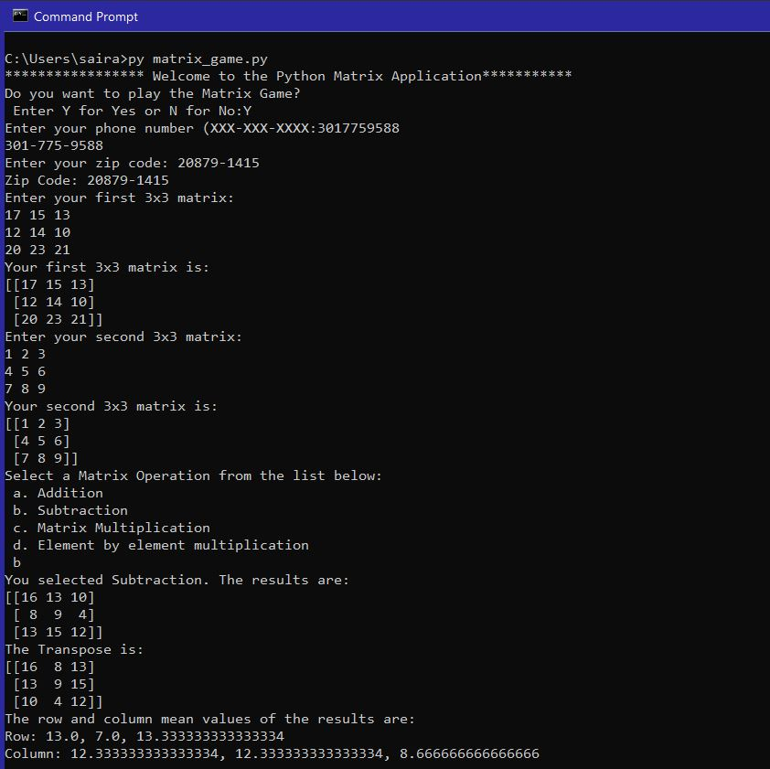

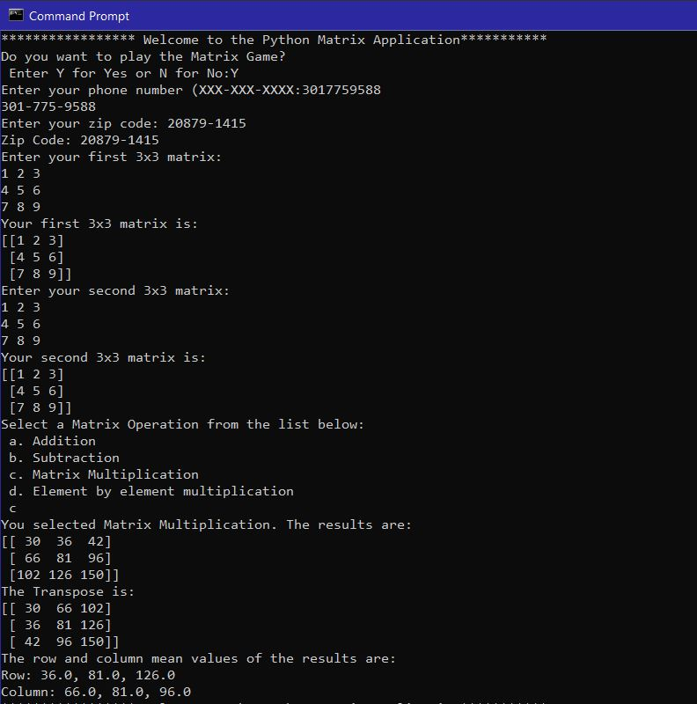

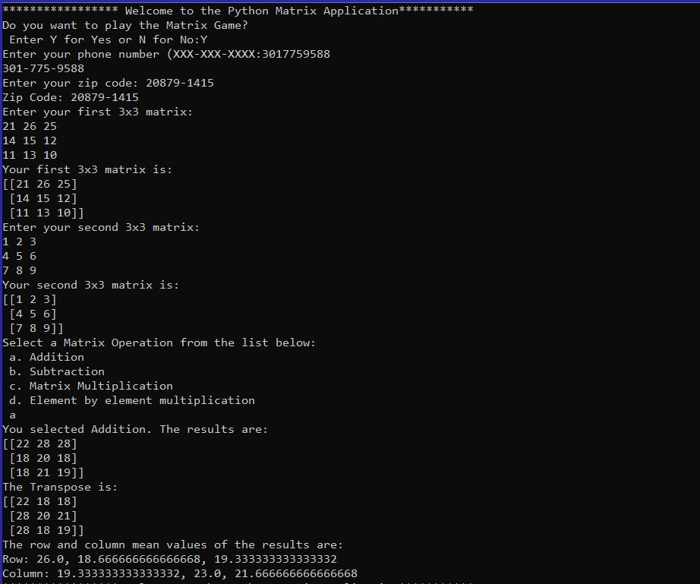

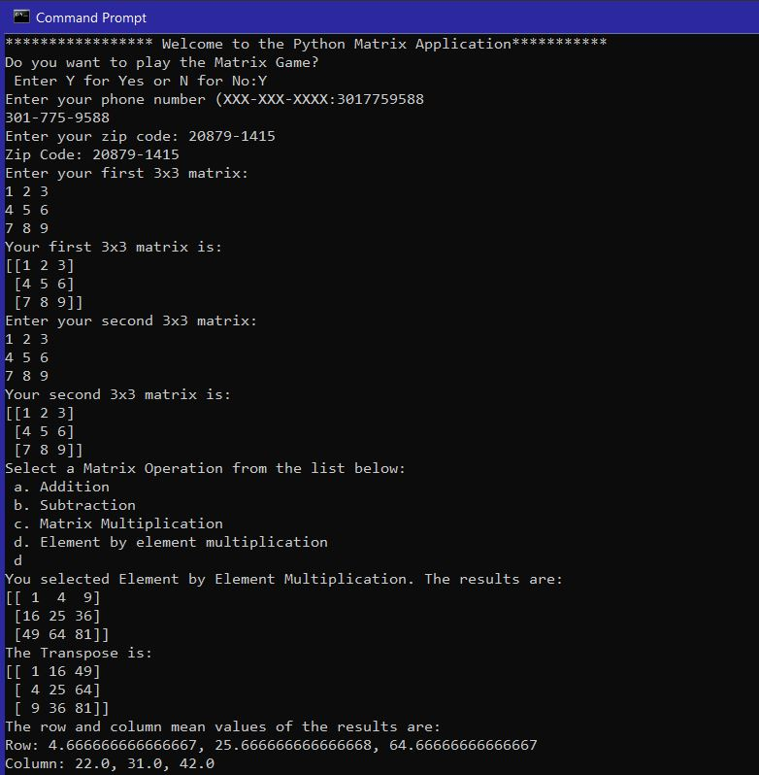

Pylint Discussion and Snapshots:

Before: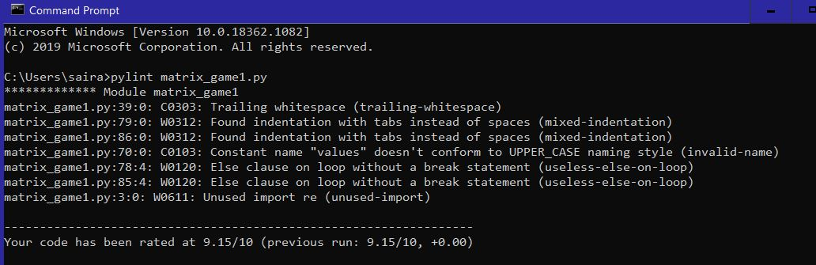

I originally had a 9.15/10 pylint rate due to trailing whitespace, inconsistent indentation, unsatisfied variable name requirements, unnecessary else statements after while loop, and an unused regex import. Many of these conventions were not at all complicated to fix. I originally thought the else statements were the only way for the code to work properly until I was convinced that all that was needed was how the statement was indented. I had originally imported the regex (re) because I thought that I was going to use that for inputting the 9 digit zip code with the dash ‘-‘ after the first 5 digits and before the last 4 digits. I ended up using a delimiter instead.

After:

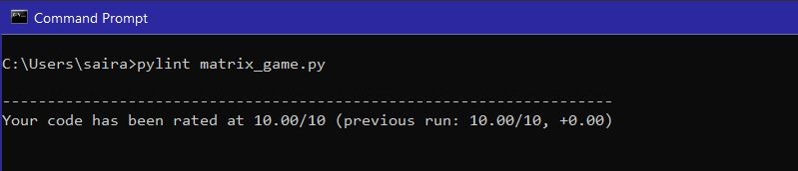

With all the fixes I made from the previous snapshot, my program was able to compute the following operations for matrices, such as addition, subtraction, matrix multiplication, and element-by-element multiplication. I was also able to successfully transpose the matrices for every operation performed. I had a little bit of a struggle figuring out how to take the mean of the rows and columns. I was eventually able to get it to work.