Sairam Soundararajan

SDEV300: Building Secure Python Applications

University of Maryland Global Campus

Professor Howards

|  |  |  |  |  |
| --- | --- | --- | --- | --- |
| Test Case | Input | Expected Output | Actual Output | Pass? |
| 1 | ***************** Welcome to the Python Data Analysis App**********  Select the file you want to analyze:  1. Population Data  2. Housing Data  3. Exit the Program  ================================================  Select an Option:1  Select the Column you want to analyze: a | You have entered Population Data.  a. Pop Apr 1  b. Pop Jul 1  c. Change Pop  d. Exit Column  You selected Pop Apr 1  The statistics for this column are:  Count = 557  Mean = 56557.314183123875  Standard Deviation = 158127.10545434812  Min = 13519  Max = 3726157  The Histogram of this column is now displayed: | You have entered Population Data.  a. Pop Apr 1  b. Pop Jul 1  c. Change Pop  d. Exit Column  You selected Pop Apr 1  The statistics for this column are:  Count = 557  Mean = 56557.314183123875  Standard Deviation = 158127.10545434812  Min = 13519  Max = 3726157  The Histogram of this column is now displayed: | Yes |
| 2 | The Histogram of this column is now displayed:  a. Pop Apr 1  b. Pop Jul 1  c. Change Pop  d. Exit Column  Select the Column you want to analyze: c | You selected Change Pop  The statistics for this column are:  Count = 557  Mean = -798.8294434470376  Standard Deviation = 22711.352869824655  Min = -531004  Max = 22363 | You selected Change Pop  The statistics for this column are:  Count = 557  Mean = -798.8294434470376  Standard Deviation = 22711.352869824655  Min = -531004  Max = 22363 | yes |
| 3 | Select the Column you want to analyze: d  Exiting column....  ***************** Welcome to the Python Data Analysis App**********  Select the file you want to analyze:  1. Population Data  2. Housing Data  3. Exit the Program  =============================================  ===  Select the Column you want to analyze:a  Select an Option:2 | You have entered Housing Data.  a. AGE  b. BEDRMS  c. BUILT  d. ROOMS  e. UTILITY  f. Exit Column  You selected AGE  The statistics for this column are:  Count = 10042  Mean = 47.2194781915953  Standard Deviation = 23.149798767083286  Min = -9.0  Max = 93.0  The Histogram of this column is now displayed: | You have entered Housing Data.  a. AGE  b. BEDRMS  c. BUILT  d. ROOMS  e. UTILITY  f. Exit Column  You selected AGE  The statistics for this column are:  Count = 10042  Mean = 47.2194781915953  Standard Deviation = 23.149798767083286  Min = -9.0  Max = 93.0  The Histogram of this column is now displayed: | yes |
| 4 | Select the Column you want to analyze:e | You selected UTILITY  The statistics for this column are:  Count = 10042  Mean = 189.58596395143397  Standard Deviation = 128.92876648751212  Min = 0.0  Max = 1107.583333  The Histogram of this column is now displayed:  Select the Column you want to analyze: | You selected UTILITY  The statistics for this column are:  Count = 10042  Mean = 189.58596395143397  Standard Deviation = 128.92876648751212  Min = 0.0  Max = 1107.583333  The Histogram of this column is now displayed:  Select the Column you want to analyze: | yes |

Snapshots of Test Run:

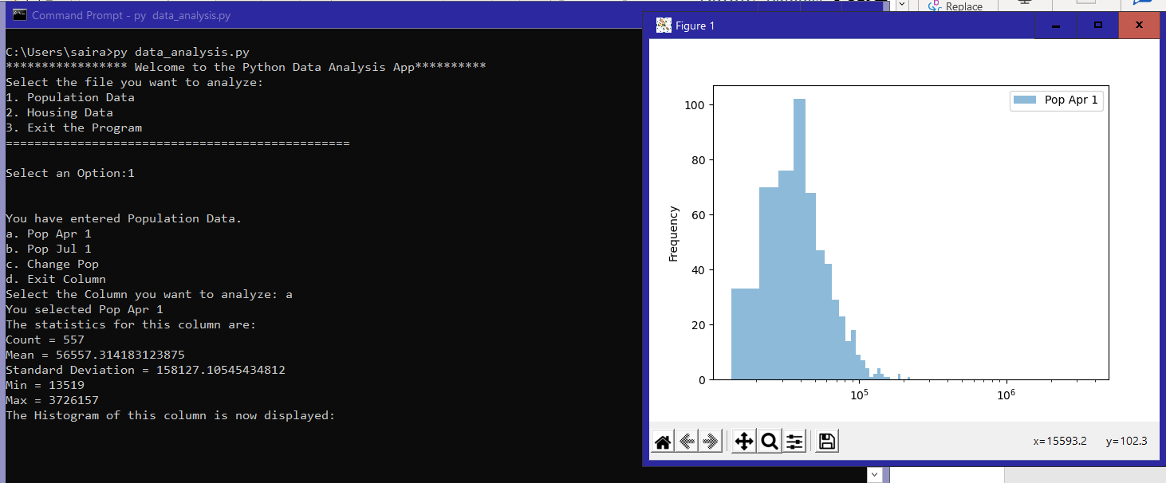

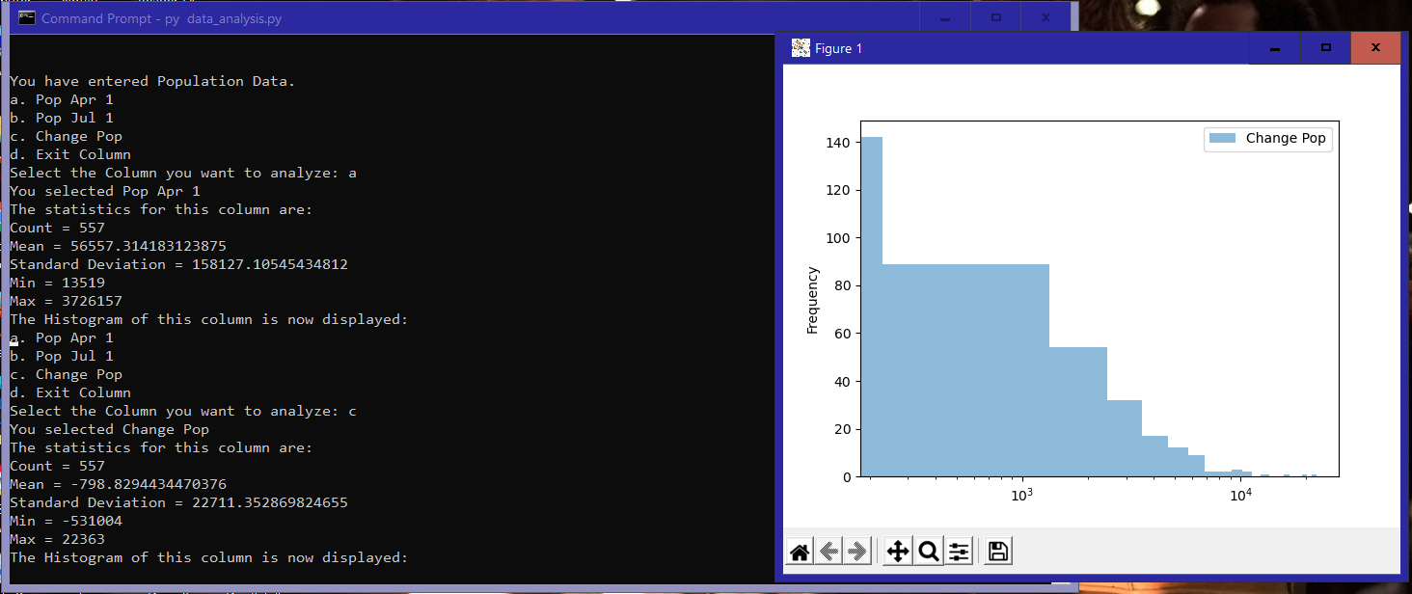

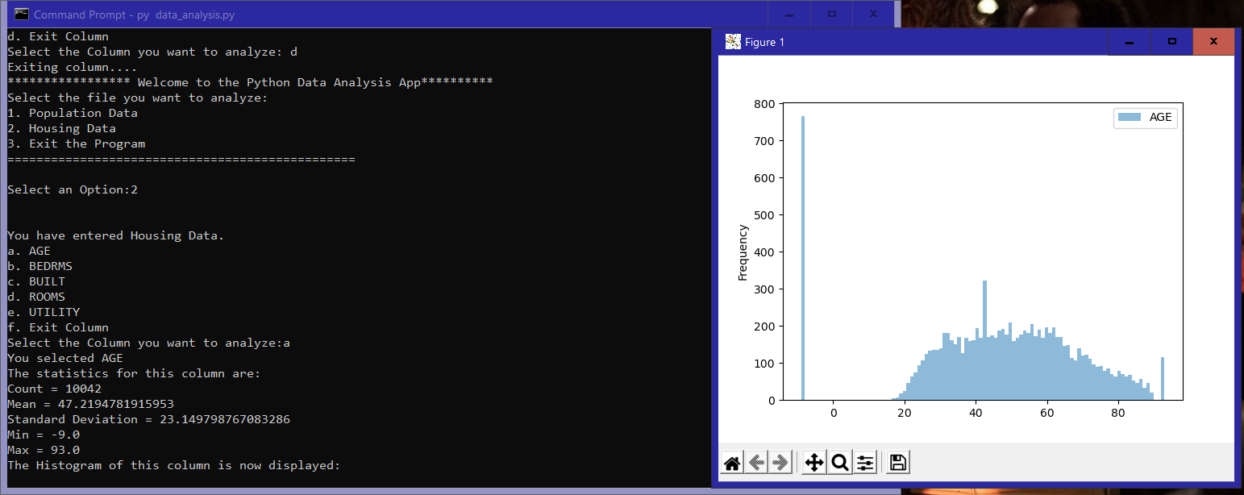

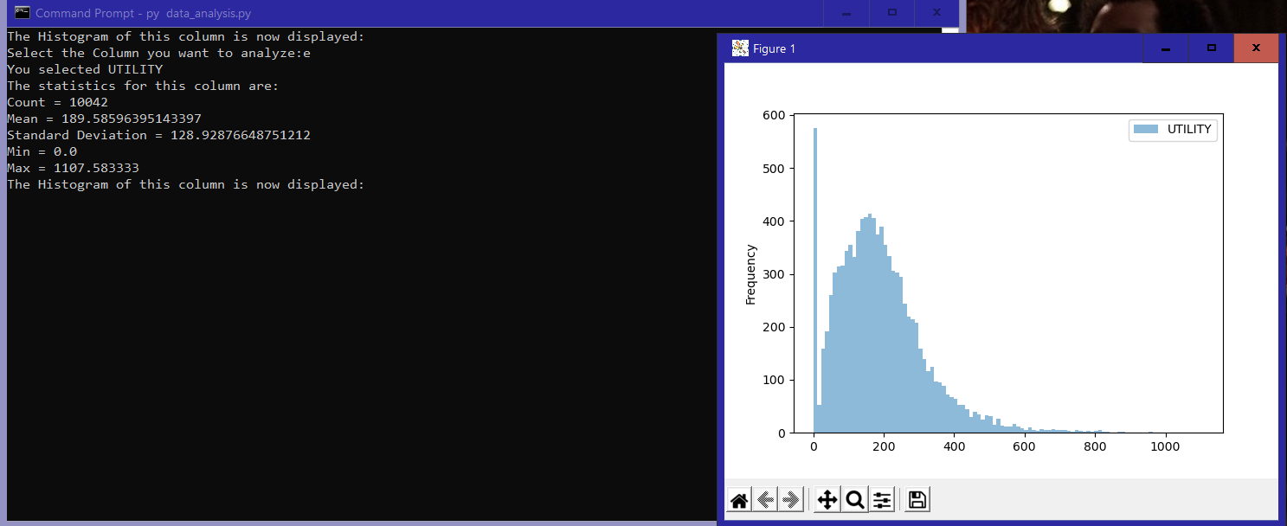

Pylint Discussion and Snapshots:

Before: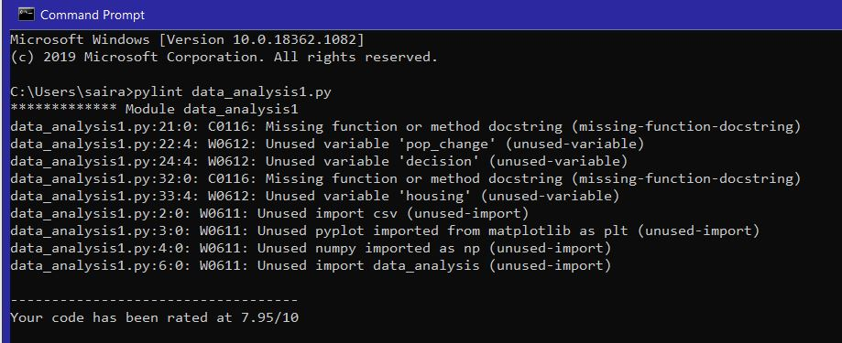

Before continuing to finish my program, I had a 7.95/10 when I was halfway completed. The most important conventions out of all that Pylint list were unused variables and imports. I ended up not using numpy, data_analysis, and csv as imports. The unused variable conventions disappeared once I proceeded with the program. Towards the end of completing my program, I had conventions such as trailing whitespace and possibly too long lines but I never got a chance to take a snapshot before fixing those conventions.

After: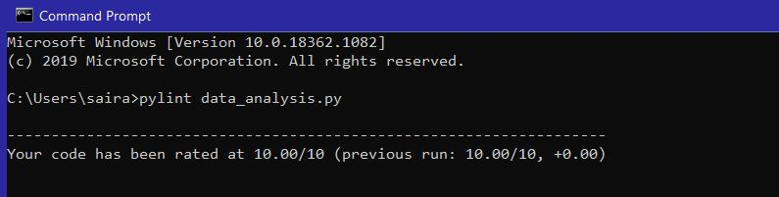

After fixing all the conventions and refactors, I was able to successfully receive a 10.00/10.

Bandit Discussion:

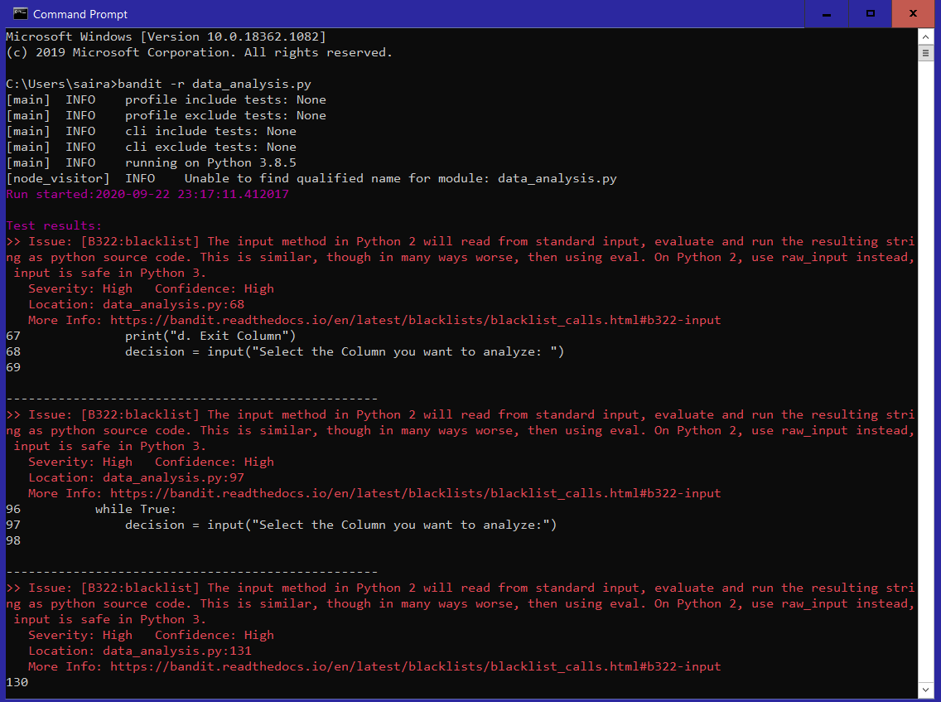

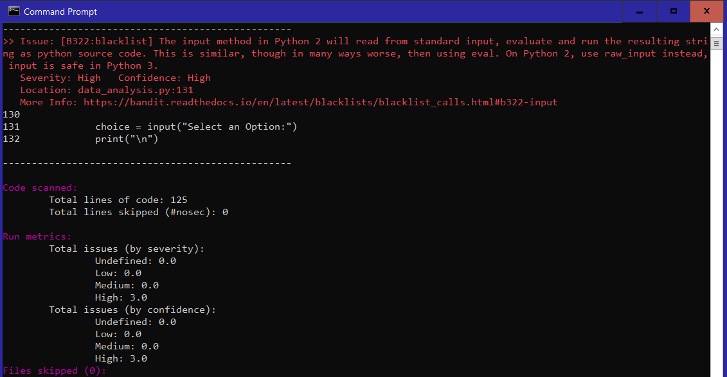

I recently started using Bandit, which is a Python plugin that detects for vulnerability in a Python program. I noticed that every time I use “input”, it will say that I need to use “raw_input” instead of “input” if I am using any version of Python under 3. I learned that this vulnerability does not apply to Python 3. Therefore, I decided it was best to disregard that bandit issue, which was the only issue I received.