Sairam Soundararajan

SDEV300: Building Secure Python Applications

University of Maryland Global Campus

Professor Howards

|  |  |  |  |  |
| --- | --- | --- | --- | --- |
| Test Case | Input | Expected Output | Actual Output | Pass? |
| 1 | This program does not contain user input within the code since this is an HTML program. | * Serving Flask app "website_program" (lazy loading)  * Environment: production  WARNING: This is a development server. Do not use it in a production deployment.  Use a production WSGI server instead.  * Debug mode: off  * Running on http://127.0.0.1:5000/ (Press CTRL+C to quit) | * Serving Flask app "website_program" (lazy loading)  * Environment: production  WARNING: This is a development server. Do not use it in a production deployment.  Use a production WSGI server instead.  * Debug mode: off  * Running on http://127.0.0.1:5000/ (Press CTRL+C to quit) | Yes |

Snapshots of Test Run:

The website will only operate during test run. Once the test run is over, the website will be inaccessible until the program is run again.

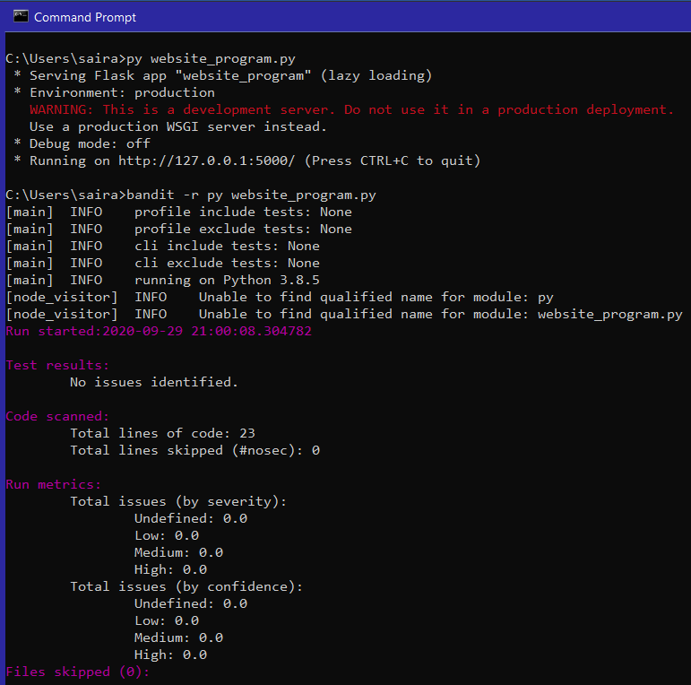





Pylint Discussion and Snapshots:

Before: I did not snapshot the conventions, refactors, and score of Pylint before fixing them. But I had conventions such as missing docstring, spacing corrections, and trailing whitespaces.

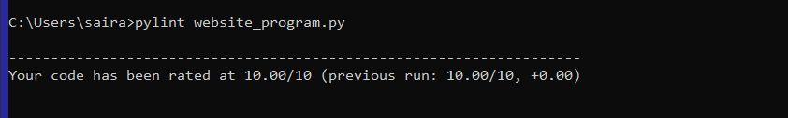

After:

It was not difficult to receive a 10.00/10 pylint score.

Bandit Discussion:



Before, I had “debug = true” inside the run() parameters of app.run(). It was marked high by severity in bandit. Once I removed the “debug = true”, bandit detected no issues in the program.